Candidate Name: Sedinam Azanu

Year 13

Contents

Problem Analysis 4

The end user 4

Stakeholders: 5

Investigation and analysis 5

Initial interview results 5

Analysis of interview results 6

Existing solutions and appropriate features 8

Essential features of the program 12

Limitations 12

System Requirements 13

Success Criteria 14

Design 15

Design: Structure of the solution 16

Design: Parts of the solutions using algorithms 18

Design: Algorithms 18

Design: Data dictionary 22

Design: Testing table 25

Iterative development and testing 28

Creating table: 28

Creating the add a record to the table function 29

Review of current stage 1 30

Creating my editing table function 31

Review of current stage 2 32

Creating my delete table function 33

Review of current stage 3 33

Creating my matrix table 34

Prototype 1 34

Prototype 2 35

Prototype 3 37

Creating find holiday function: 38

Review of current stage 4 47

Creating a menu for my code 49

Review of current stage 5 50

Review of current stage 6 56

Development 58

Introduction 58

Main Components 58

Adding a new record to the table 58

Deleting record from the table 63

Updates any of the current records in the table 68

Distance matrix, using haversine algorithm which finds distance between cities in the matrix 76

Function that takes user package and city input to print out other cities and their distance from starting city 82

Create a menu which allows the user to access specific functions in the code. 90

Evaluation 102

Testing of evaluation 102

1: Changing a record that is currently in the table 105

2: Editing a record that doesn’t exist in the table 109

3: Adding a new record to the table 110

4: Deleting a record from the table 115

5: Deleting a record that does not exist in the table 117

6: Function that allows for records to be displayed in ascending order of distance 119

7: User types in package type that does not exist in the table 120

8: User types in a package type that does exist in the table 121

9: User inputs city they want to start from that doesn’t exist in the list 122

10: User inputs city they want to start from that does exist in the list 122

11: Display all the records currently in the package table 123

12: Type in any number not in the range when asked to access the menu options 124

13: Type in all menu options in range 127

14: Type in all admin menu options not in range 129

15: Type in all admin options in range 129

16: Type in any number when deciding how many cities that the user wants to visit 131

17: Entering any other username and password when trying to get access to the admin menu 132

Usability testing 133

Evaluation of solution 136

Limitations 140

Maintenance 141

Further development 141

# Problem Analysis

## The end user

My end user approached me as he wanted to go on a package holiday but was not sure as to where they wanted to visit. The problem that he was facing is that he was unsure of which cities he wanted to visit. He knew that the cities that he wanted to visit should not be too far from but is unsure and does not have the time to conduct research into finding suitable cities to visit on their holiday.

The client is a friend of mine who often enjoys travelling to several places during his holiday breaks and he found that recently due to having to put more time into work now, he can still go on his holidays, unable to easily plan where he wants to visit without putting in lots of research

He currently has to separately plan flights and times to each of the cities, find out prices and information about all the hotels and how far they are from the airport. He wants to be able to plan another holiday one this year, but he does not have the time to do so.

Future Processes

* Adding new cities
* Editing city records
* Deleting city records
* Adding new packages
* Editing Package records
* Deleting package records

|  |  |
| --- | --- |
| Input | Description |
| Record to be inputted (Add record to database) | Consists of the city information and package information. Information asked for is City, Country, language, Time Zone, Airport and package |
| RecordID to be changed (Deleted or edited) | Would ask the user for the PackageID if they want to change the package record or CityID if they want to change the city record. |

|  |  |
| --- | --- |
| Output | Description |
| City information | List of each of the cities that the company offer for holidays. Information stored is: City ID, City, Country, National language, Time Zone, Airport and Package ID |
| Package information | List of the packages the company offer. Information stored is: Package ID, Package, Cities that fall under the package |

## Stakeholders:

The stakeholders for this will be people of all ages above 18 who travel frequently. They will find use in this program if they aim to plan a holiday or trip in the later future as they would be able to use the program to help them find the type of holiday they enjoy and the cities that would interest them. Students may also want to visit many cities during their holiday or during their gap year whilst they are off of school, however may want to plan a trip that would be as cheap as possible, but still be able go to many places.

I decided to interview some of my stakeholders that may be interested in planning their own trip during the holiday or during their gap year so that I would have a good idea of what kind of places they would like visiting during a holiday.

## Investigation and analysis

I decided that I will create a questionnaire to give to my stakeholders to get a clear idea of what they want the program to provide for them. The questions that I intend to ask are:

* From your first location, how far would you feel comfortable travelling?
* How many cities would you like to travel to on a package holiday?
* What kind of holidays would you like to go on?
* Who do you plan to go with?
* What popular destinations do you like or would like to visit?

## Initial interview results

I interviewed twenty people that were interested in having some sort of holiday in the near future. Each of the responses were open box which meant they could input whatever they want. I will be able to base the development on my project upon the information I have been given by the people I asked.

From your first location, how far would you feel comfortable travelling?

* Any distance [11]
* Same country [3]
* Within 4 hours of flying time [2]
* Within 8 hours of flying time [4]

How many cities would you like to travel to on a package holiday?

* One city [5]
* Two cities [8]
* Three cities [5]
* Three to five cities [1]
* One to three cities [1]

What kind of holidays would you like to go on?

* All-inclusive [4]
* Self-catering [1]
* Adventure/skiing/travelling [3]
* Urban/Outdoor [1]
* Disney holidays [3]
* Family holidays [5]
* Beach holidays [2]
* Touring holiday [1]

Who do you plan to go with?

* Friends [5]
* Family [8]
* Wife [7]

What popular destinations do you like or would like to visit?

* Paris [2]
* London [1]
* Malaga [2]
* Brussels [1]
* Toronto [2]
* New York [4]
* Berlin [1]
* Sydney [1]
* Orlando [2]
* Dubai [2]
* Barcelona [1]
* Tokyo [1]

### Analysis of interview results

The questions that I asked to the people I interviewed will influence how I will develop my program to suit their needs

With my first question, I wanted to know how far people would be willing to travel so that I could see whether I should allow for an unlimited number of cities to appear for the customer, or whether I should limit this amount. About half of the interviewees stated they would be willing to travel any distance, whereas three would not want to leave the country and the others would only be willing to travel for a maximum of four to six hours. As a result, I can use this to show the customer a list of cities from anywhere in the world, providing that they fall under the criteria that they are asking for, which is the type of package and the location they are starting from.

With my second question, I wanted to see the maximum number of cities that my customers wanted to travel to on a package holiday from their starting city so that I could allow for a maximum number of cities that could be visited by the customer during the holiday. I found that the majority wanted to visit 3 or less cities, whereas one interviewee stated they would be fine with three to five. Therefore, I should aim to develop my project to show the customer three to five cities close by.

My third question would allow me to see the types of holidays that people would enjoy going on during their holidays. I found that they were all interested in a variety of holidays, having a total of 8 different types of holidays, so I should aim to put in as many different holiday types for the customer as possible.

My fourth question is regarding the people that customers wanted to go with on their holidays. With my interview results, it shows that none of my customers wanted to go on this holiday on their own. Instead, they all wanted to go with at least one person. Therefore, I would rule out the types of holidays that a customer would usually want to do on their own.

My last question gives me a view into the types of cities that people would like to visit. With research and finding out the kinds of holidays that then cities would offer, I would be able to use this to offer appropriate packages to each of them. New York was the most popular option, showing that people would be more into sightseeing and tourism holidays, and so should try and find packages that involve that.

How is the problem solvable by computational methods?

One of the methods I will use to approach the problem will be by using decomposition. As the problem is rather complex to solve, I will need to break it down into smaller tasks that are much easier to solve so that I can make the whole problem simpler to work out.

Iteration involves simplifying algorithms by stating that certain steps in the code will be repeated until the variable meets the requirements of the code. This is important for my project because including unnecessary code can take up lots of time as a result, which can be used in more important areas of the project. It also means fewer errors can come up due to not having to type up code all over again.

Backtracking is also going to be a major part of my project. This is because whilst I am creating the code, I may find that I am having problems during my coding and I am getting errors. I would end up logging what went wrong whilst I was coding, and then I would go back to the point where I knew there were no problems and continue from there until I encountered another problem.

Another technique I may have to use within my coding is the use of heuristics. Sometimes during my programming, I may come across a problem where I have no idea on how to continue and research may not help me with solving the solution. Instead I would have to use a trial and error method where I would have to attempt to see if code that I put in works for the function or still continues to fail until I have managed to solve the problem.

Abstraction is used to make the solution easier to solve so that unnecessary data does not need to be added. For example, in the tables I’m going to make, I would not need to include all the cities in the world because I am not going to be able to add every single city. With the algorithm I am going to make, this will be able to add in cities later, so I do not need to add everything in from the beginning

In a selection structure, the user is asked a question and depending on the answer given, the program can take several courses of action which allow specific events to happen afterwards. This logic structure is important in my project as I plan for my project to have several functions available for the user, and the user would have to input specific values to access any of these functions. Decisions can also allow for errors to be identified as only specific values can be allowed, the code can be designed in a way that means that they would be asked for an acceptable input again if the given input cannot be accepted or not recognised by the programme.

I also plan to include functions and procedures in my project due to there being sections of code that I may want to reuse. Time can be saved in my code by just calling a function or parameter when it is required instead of just writing out the whole code all over again.

The main example of a query that I plan to use in the project is the example I included above where the user inputs the starting city and the type of holiday they want so that all cities offering the type of holiday are displayed with cities close by being at the top of list and those further at the bottom.

## Existing solutions and appropriate features

An example of a similar system is a site called [www.travelnation.co.uk](http://www.travelnation.co.uk)

This website tries to save people who want to travel the world money by comparing flight costs and discovery the most convenient prices for the customer. It gives the option for the customer to choose any class of their choice, the month they want to leave and the continents they want to visit. The countries are not chosen by the customer, but rather by the company so it may not be the customers preferred choice of countries.

This website was used by my client who found many problems whilst using this site, especially with trying to choose specific cities that he wanted to visit. He would have to go through the process of creating a quote to directly be able to pick what he wanted, which was a very long process especially with waiting to receive back details from the company.

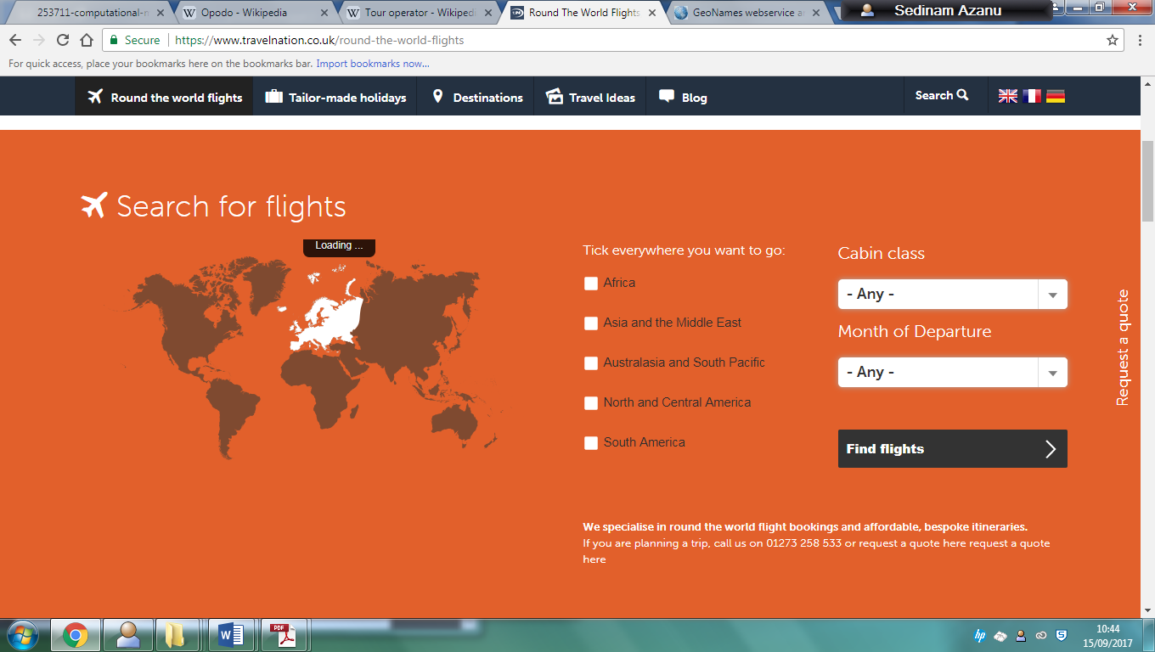

An issue with this site is that it does not specially choose places where the customer would like to go. It instead chooses places that they think the customer would enjoy to visit and picks the most convenient place to go to, so the customer does not have a choice in where they would like to go. In my program, I aim to have the option to give the client the specific cities they may want to visit.

Furthermore, the website only works for people that are in London, Paris and Frankfurt. This is because it is impossible to change the starting city for the person using the website as on the top right of the website; there are 3 options for languages, and the starting city changes depending on which language is selected. As a result, this means that people in other areas of these countries may have issues travelling from an airport close to where they live or may have to go to another country before going on your holiday if you do not live in the 3 countries covered by the website. My programme does not specifically pick which cities to start from, but the start position will depend on where they come from.

The only way that the customer can decide which airport they can leave from is by clicking the “Request a quote” button to the right of the page which allows for the customer to discuss with the company what kind of holiday they want

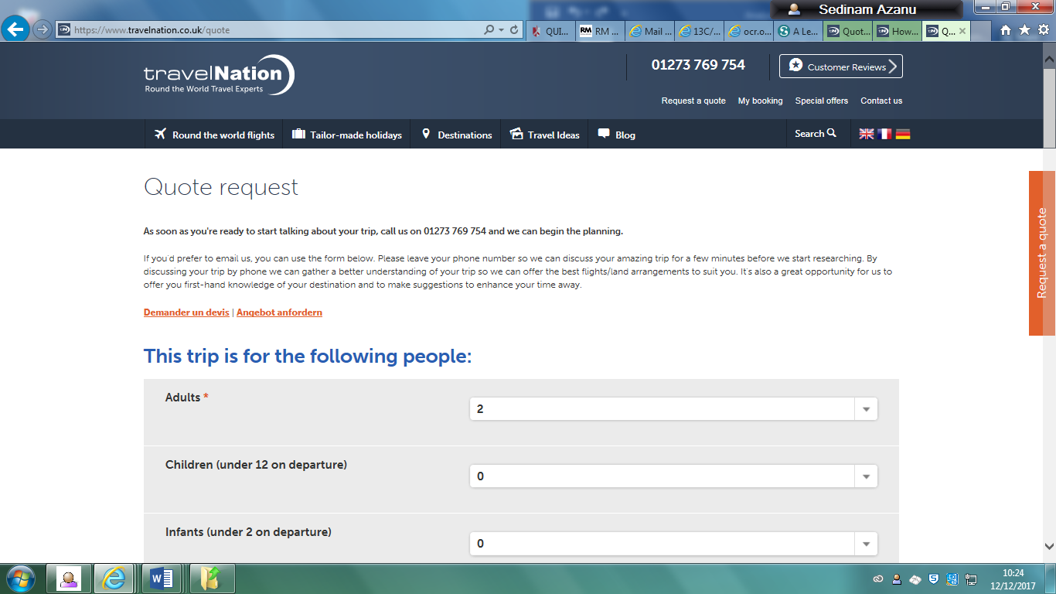

There is a field below that allows the customer to decide which airport they want to fly to and from for the trip, but it is unclear whether the customer will be able to fly outside of the three countries mentioned.

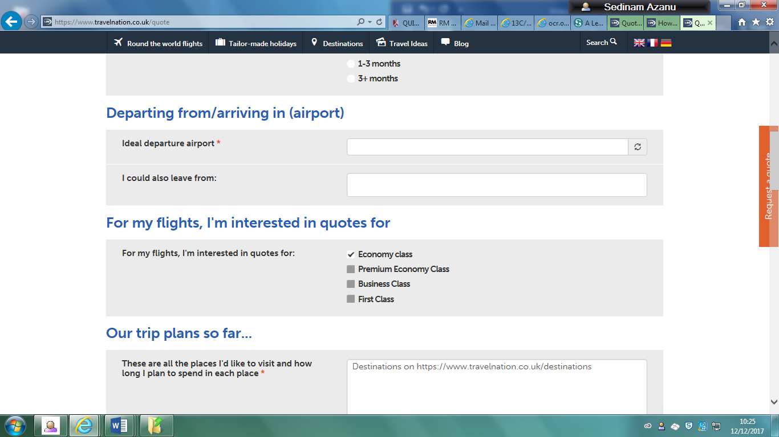

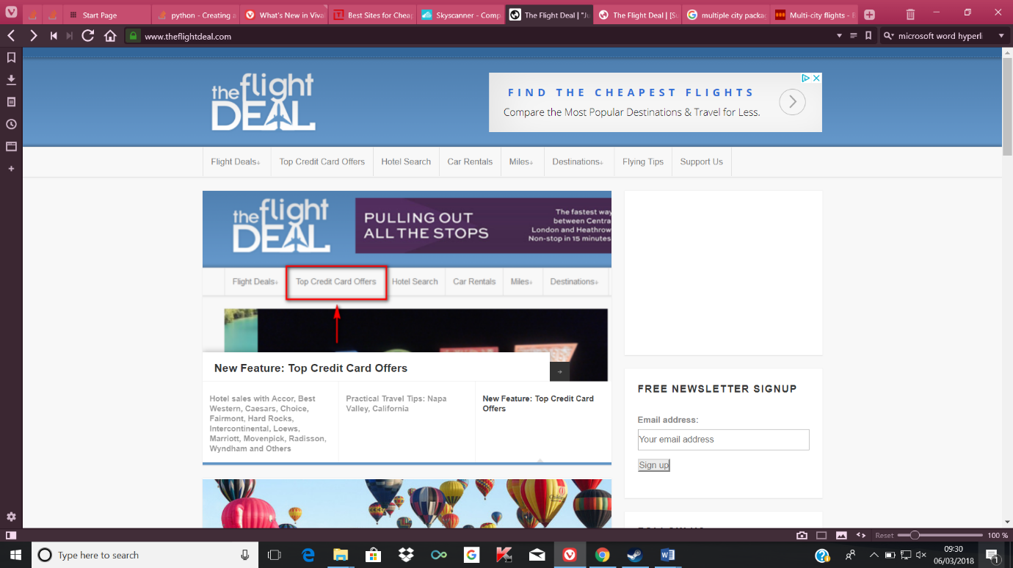Another example of a website that I found is one called <https://www.theflightdeal.com>

This website gives examples of holidays that the person using the website may be interested in. It provides a wide variety of different kinds of cities that they can choose to visit for their holiday. This tries to give the user the best price options for holidays they may be interested in, although the prices given can be gone quickly.

An advantage of using this website is all the prices found by the company are already determined prices including things like taxes, so the person using the site knows how much they would be paying for the full flight. The fare is also available for different times so the user does not have to use the sample date that is given to them, however the customer has to stay for a minimum amount of time for this price to apply, and they may not be staying for that minimum amount of time.

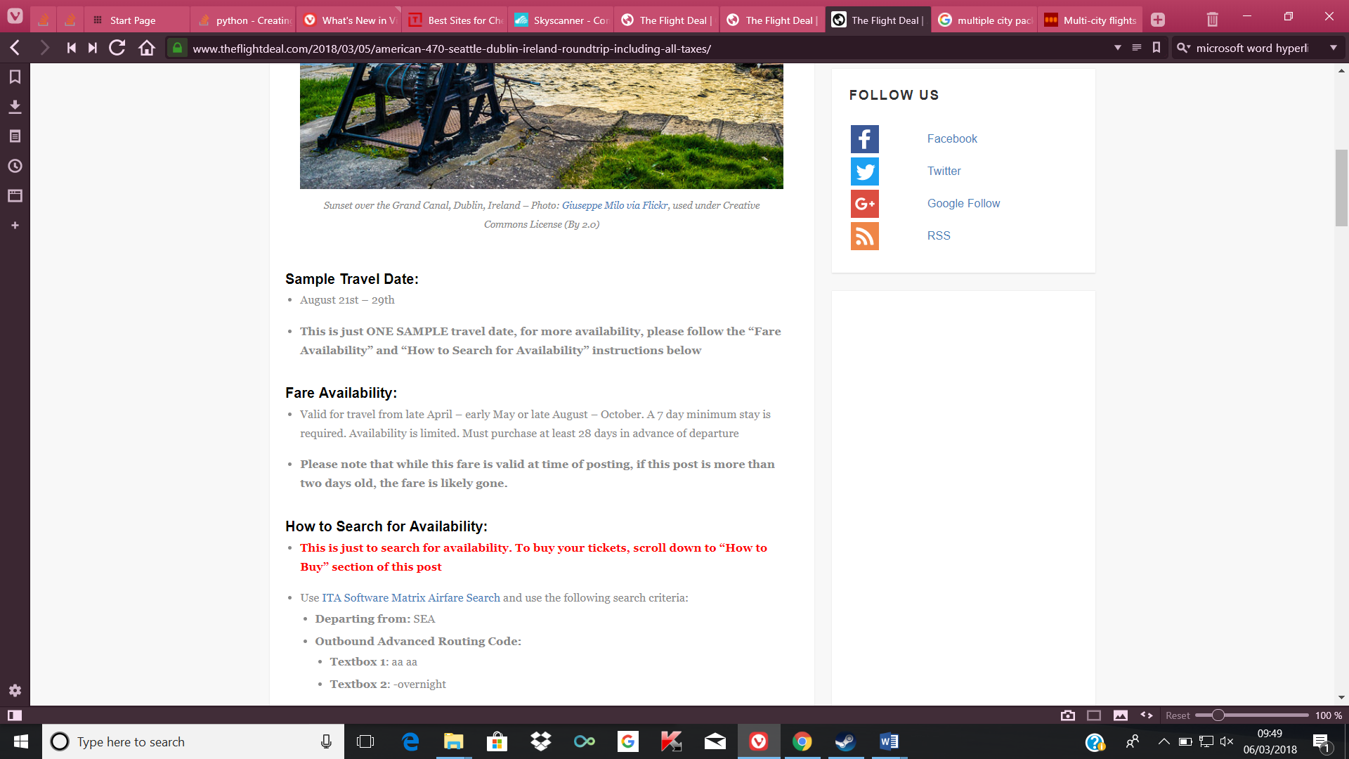

The website is also helpful by providing information regarding fares and whether they are still available for the customer so that they don’t have to waste their time, but still keep the information on the website if they are still interested in the holiday regardless of the new price.

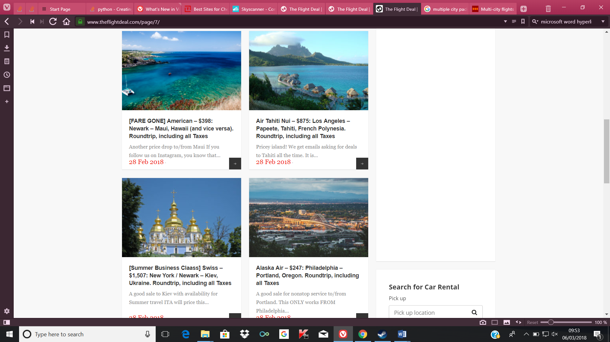

My client looked at this website before, however he did not like this website because one of the big disadvantages of this website is that it does not take into consideration where the user is starting from, meaning that they would have to pay extra for another flight to get to the starting destination, when it would just be easier to get a direct flight to the city he wants to go to. The majority of the flights start at a city in the United States.

Also, another disadvantage of this site is that not all the flights given provide stopovers during the trip, meaning that the user would not be able to include further places to visit during their trip. Even if stopovers are permitted during the trip, they are not always available for the person planning their holiday, which means they would have to adjust the day they want to visit if they really wanted the stopover time, or just not include the stopover time period.

However, this website is able to find the cheapest options and see if these stopovers can be included in the holiday, which is a big bonus compared to other holiday planning sites which may just charge extra.

## Essential features of the program

The most important feature that my program offers is a search system fitting the user’s criteria to find a holiday that they feel they would enjoy most. This is an important feature of the program as it would help them be able to think of other places to visit besides the starting city without the hassle of further research needed to plan what they want.

After inputting in the needed data which would be the city of origin and the data package they want, an output of other cities that fall under the same package would be given, including the hotel that they would be offered to stay at, and the distance from the city of origin.

Another major feature of my program is the fact that it is a database. The information of each of the cities and their distances from each other can be stored in that database so that when somebody wants to view the information regarding the cities that are currently a part of the database, it is all already available for them to see. The user will also be able to alter and delete specific records within the database if they require changing, for example if they wanted to delete a record, all they would need to input is the RecordID of that specific record, which would be the primary key, then the entire table would be deleted.

A user interface must be made to give the user a clear view of what to input and how they would be able to input it, for example the data type that is required when typing in. A user would receive an error if they inputted in a string value when an integer value is needed.

Even though there are only 10 cities available in the matrix, different types of holiday packages can be offered under the same city multiple times. For example, city 1 could potentially have a romantic or family option. This is useful when these options are available for the user, so there will be a function where they will be able to input new records in the database for them to access.

## Limitations

One of the main limitations with my idea is that although I would be able to include the information about the countries, I would not be able to put in a price for the flight from specific countries themselves. This is due to the fact that the prices of flights are always changing and can even change at last minute. For example, a ticket that originally cost £200 can end up costing £800 if the customer ended up buying the ticket on the day of the flight or a few days before. Summer is also the most popular time for flights so ticket prices can be unpredictable and expensive. It is impossible to be able to predict the prices for a holiday so I feel that this limitation is justified.

The number of holiday packages and cities available to the user may also be a limitation of my system. It will be very expensive to identify and negotiate a large number holiday packages to be included in the system. Designing a search engine to search holiday packages advertised by other websites could be a solution but very much beyond my abilities at the moment.

Another limitation that my system may have for the user is the size of the text that is shown for the user. If my client were to have problems with their eyesight, it may have difficulties when they have to enter the information or make searches on the system to find holiday packages. This problem arose because input text sizes cannot be changed in Python Scripter which l am using to design my system and could make it harder for people with bad eyesight to navigate the system.

## System Requirements

System:

* I am running the database using Python Scripter running on Python version 3.2.1.
* The system requirements are based on my school computer systems, which run Microsoft Windows 7.

Hardware:

* A computer keyboard is required so that inputs can be used in order to receive the outputs from using the program.
* A compatible pointing device is needed as well so that the user can start the program itself.
* 1 gigahertz (GHz) or faster 32-bit (x86) or 64-bit (x64) processor as these are the minimum requirements for Windows 7
* A minimum of 1GB of RAM on a 32-bit computer or 2GB RAM of a 64-bit computer for Windows 7, as this is the minimum RAM needed for Windows 7.
* Due to the database not taking up too much space on a desktop, not that much space is required for it, however 16GB of available hard disk space for a 32-bit computer or 20GB for a 64-bit is the minimum required for Windows 7 to be installed.
* The computer being used has the following specifications:
* Microsoft Windows 7 Professional 32 bit. However, the programs I am using are compatible on 32-bit operating systems.
* Intel® Pentium® G4400 @ 3.30GHz
* 4GB DDR4 2400 NECC UNB

From research I found on the internet regarding python and the requirements needed, the majority of computers are able to run python, even on lower end computers due to not needing much of the RAM, so this program will most likely have no issues on computers with more than 2GB of ram available and a processor that is powerful enough to run the code which is not too complex.

Python 3.3 can work on a Windows 2000 professional computer, and I am using 3.2

Therefore, the minimum requirements to be able to use this program would be:

* 133 MHz or higher Pentium-compatible CPU.
* 64 megabytes (MB) of RAM recommended minimum; more memory generally improves responsiveness [4 gigabytes (GB) RAM maximum.]
* 2 GB hard disk with a minimum of 650 MB of free space. (Additional free hard disk space is required if you are installing over a network.)

## Success Criteria

* For the program to be able to take the input of a city that the user is starting at, and the package type that the user wants to select. This would output other cities that fall under the same package type, and their distance from the starting city in order of ascending distance. For example: If London, Paris, Malaga and Brussels were in the same package and London was inputted, the output would be: London is 199 miles from Brussels, London is 214 miles from Paris, London is 1044 miles from Malaga.
* To display each outputted city with its record so that the information about each city can be shown to the user along with its distance from the starting city. For example, when Brussels is outputted, it would include the package type that the user wants, the hotel on offer and any other information that may be useful like the airport, the country it is in, and the national language.
* For a distance matrix to be included within the code, so that all the distances between each of the cities can be stored in a database, and for new cities to be able to be inputted so that distances can be found when using the program without having the user to research the distance on the internet every time a holiday is being planned.
* To give the person using my program an option to be able to decide how many cities they want to be able to visit. In my interviews, many people mentioned a specific amount of cities they wanted to visit, so being able to give them that choice would appeal to them. This will not include the starting city as it is assumed that is where they will be starting from.
* The interface and results that lists the cities in order is clear to the user of the program and that they are able to understand what is being shown to them through the program.
* For the user to have an easy time being able to change any aspects of the package database that may require changing. For example, if a new record needs to be added or a record needs to be changed, those functions can easily be accessed and used without any problems occurring. The maintainability will involve updating and adding new packages and cities that may later be available for offer.
* To have a working program that does not include any errors by testing the potential input mistakes that people may make, and adding validation checks to prevent this from happening.
* To include menus that allow the options for the program to be shown to the user in a clearer way, and include an admin menu so that only authorised users can get access to functions that may change information that exists in the table.

# Design

## Design: Structure of the solution

Validated record

City input

Package type input

Validate record

Package types that are same as input are taken

Cities that don’t have same package type are ignored

This structure chart breaks down the overall program into component parts that I plan to make for my program and how each of them will work.

Record of distances compared to input

Module 1: Adding new records to the table.

This module’s main purpose is to allow the user to add a new record to the table, which will be done by taking in the inputs of the city, the package type and the hotel option, which then will be stored in the database as one of the records.

Module 2: Delete any records from the table

This modules purpose is to delete any records from the table that are no longer required. This is done by taking the recordID of the specific table that needs to be changed. If this ID is found, then the record is deleted from the table. This is more likely to be suitable for packages that are no longer available and there is no other one to replace them.

Module 3: Updating any records

If information regarding one of the current records needs changing, this module can be used to update that specific record that needs changing. This is broken down into 3 different functions, the first getting the input of the record that needs to be changed, the second checking to see if this record is a valid one that exists in the table and the third that gets the inputs for the city, the package and the hotel so that they can be changed to more suitable information.

Module 4: Orders the records in ascending distance from initial city

This module is broken down into one main function and 6 different smaller function parts which are required as one finds the cities with the same package and the other finds the distance between the inputted city and the rest of the cities that still exist in the record.

With the first part, the user would input the package type they want, and the program would check to see if this package type exists in the table, then removes all the other records that don’t have the same package type as the requested one. After this, the city the user wants to start from is inputted, and the database is checked to see if that specific city exists in the database. Afterwards, the distances of all the other cities that are still available are compared with the inputted city, then the city along with its distance from the inputted city are stored in a list. The list is then ordered in ascending order so the user knows which cities are nearby to them.

This function is created mainly for the users that may want to visit multiple cities, but in a limited distance if they do not have enough money for example, or they don’t like flights for too long.

Module 5: Interface for the program.

This module’s main purpose is to provide the user with an interface that allows the user a clear idea of how to input and receive information. This is broken down into two parts with one part of it being the part where the user has to input their values, and the second aspect where they are given an output as a result of their previous inputs into the program. This is created to make it easier for the user to see what they are doing in the program and how they would be able to access each of the functions available to them in the program.

## Design: Parts of the solutions using algorithms

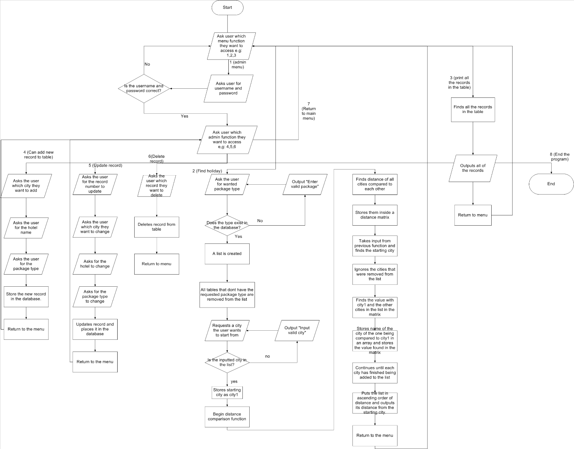

This flowchart shows each of the three different functions of my code and how I plan to get them to function in my project. For example, the first one is the add a city function which shows how the user would be able to add a new record.

The main loop is the function which requires an input to gain access to these functions, and each of the functions in the code will return back to this initial function until the user wants to stop using the program.

## Design: Algorithms

Initially, I am going to write the algorithms that I plan to make in pseudocode to give myself an idea of how I would need to create the actual code. In pseudocode, there is no need to follow any specific programming language type, therefore if I were to have to use a different language to python, I would still have an idea of how to write the code.

The main algorithms that I plan to make for this project are:

* A menu and an admin menu that allows the user to gain access to the main functions in the code.
* A function that requires the user to enter a username and password to gain access to the admin menu
* A function that allows the user to decide which city they want to be able to start from and get outputs from the other cities that also fall under the same package.
* A function that allows the user to see how many records are currently in the table.
* A function that allows the user to add a new record to the table
* A function that allows the user to edit a record that currently exists in the table.

**Main menu**

OUTPUT “input 1 for admin menu, input 2 to choose holiday package, input 3 to view all existing records, 0 to exit function”

user input for menu choice

IF user input = 1,

LOAD signin

Else, if user input = 2,

LOAD holiday function

Else, if user input = 3

LOAD record function

ELSE, if user input = 7,

Exit program

else, output “Please enter a valid menu value”

**Gaining access to admin menu**

Output “enter the user name”

Username = input1

Output “enter the password”

Password = Input2

If username is not equal to admin, or password is not equal to password:

Output “incorrect username or password”

Return to main menu

Else:

Load admin menu

**Admin menu**

Output “input 4 to add new record, input 5 to edit table, input 6 to return to main menu”

If user input = 4,

Load new record function

Else, if user input = 5,

Load edit table function

Else, if user input = 6,

Load main menu function

Else, output “Please enter a valid menu value”

**Find holiday function**

OUTPUT “what package type do you want”

INPUT user inputs package type

STORE user input in package1 variable

IF package1 exists in database:

CREATE list where cities have Package = package1

ELSE: OUTPUT “Enter valid package”

Return to beginning of function

OUTPUT “What city would you like to start from”

INPUT user inputs city

STORE user input in city1 variable

If city1 exists in list

Begin distance comparison function

ELSE: OUTPUT “Enter valid city”

Return to city INPUT

**Distance comparison function**

Finds latitude and longitude of all cities from database

Stores city along with latitude and longitude in array.

Uses formula to find distances between every remaining city in the list

Stores the other cities, along with their distance in the matrix from city1 in an array

Continues until each city has finished being added to the list

Puts the list in ascending order of its distance from city1

OUTPUT each city and its distance from city one

Return to main menu function

**Output all packages function**

Select all Records from table package

OUTPUT all selected records

**Add new record to table**

OUTPUT “what city do you want to input”

INPUT user inputs city

STORE user input in city1 variable

OUTPUT “What package do you want to input

INPUT user inputs package type

STORE user input in package1 variable

OUTPUT “What hotel do you want to input”

INPUT user inputs hotel

STORE user input in hotel1 variable

STORE (city1, package1, hotel1) as new record in table package

**Edit record on table**

OUPUT “Which record would you like to change”

INPUT user inputs recorded

STORE user input in recordID1 variable

OUTPUT “what city do you want to input”

INPUT user inputs city

STORE user input in city1 variable

OUTPUT “What package do you want to input

INPUT user inputs package type

STORE user input in package1 variable

OUTPUT “What hotel do you want to input”

INPUT user inputs hotel

STORE user input in hotel1 variable

UPDATE record where recordID = recordID1, Replace (city, package, hotel) with (city1, package1, hotel1)

**Delete record on table**

OUTPUT “Which record would you like to delete?”

INPUT user input recorded

STORE user input in RECORDID1 variable

DELETE record where RecordID = RECORDID1

I believe these algorithms will be able to form a complete solution, as there is available to the user functions that allow the user to change aspects of the database in case anything is changed, for example with the add, edit and delete record algorithms, and the algorithm that the user can use to plan a holiday, which is for example, the find holiday function. There are also menu options to provide the user with an interface instead of just separating the program into separate modules so that the user can easily access each of the different parts of the program. There is also an algorithm that outputs all of the existing records in the table in case a user wants to know what is currently available in the database.

Design: Usability features

Example: When someone inputs city London and wants a Romantic holiday:

* City1
* Hotel de Fleurie
* Romantic
* 300 miles

EXIT

Exit button to close window

These boxes display the information of the cities that also fall under the romantic holiday package for example, and information on where the city is, what hotel is offered for them to stay at and how far the city is from the initial city is displayed to the user. Up to a maximum of five cities would be displayed

* City2
* Crowne Plaza
* Romantic
* 700 miles
* City3
* Aqua
* Romantic
* 1234 miles

This is the GUI screen that will be displayed after the user inputs the city and package needed, which in this case is London and a Romantic holiday.

The information shown in each of the boxes represents one of the records that may be in the package table.

## Design: Data dictionary

|  |  |  |  |  |  |  |  |
| --- | --- | --- | --- | --- | --- | --- | --- |
| Field Name | Data Type | Field Size | Description | Example | Validation | Constraint | Justification |
| PackageID | Integer | 10 | Unique number for each separate package type | 2 | User cannot set value of PackageID | Primary key | This is needed as it is a unique value for a column with which the entire row can be referenced, so the entirety of the record, or parts of the record can be taken. |
| Package Type | String | 20 | The type of package that is on offer | “Romantic” | Cannot have any integer values in the string  Error message is returned as a result | Not null | This is the title of the package type so that the user knows the actual name of the package type and can use it within the program. |
| CityID | Integer | 10 | Unique number for each separate city | “3” | User cannot set value of PackageID | Primary key | This is needed as it is a unique value for a column with which the entire row can be referenced, so the entirety of the record, or parts of the record can be taken. |
| City | String | 20 | The city that falls under the package type | “London” | Cannot have any integer values in the string  Error message is returned as a result | Not null | This is the title of the city which may be needed within the program for example when the user is told to select a city they want to start from. |
| Hotel | String | 20 | The hotel that is on offer within that package. | “Hilton Hotel” |  | Not null | This is an extra piece of information that is given to the user so they would have a place they are given to stay as part of the package |
| Latitude | Float | 20 | The angular distance of a place north or south of the earths equator, usually expressed in degrees and minutes | **51.509865** | Has to be an angular value | Not null | This is needed for the formula which is able to find the distance between each of the cities in the program. |
| Longitude | Float | 20 | The angular distance of a place east or west of the Greenwich meridian, usually expressed in degrees and minutes. | **-0.118092** | Has to be an angular value | Not null. | This is needed for the formula which is able to find the distance between each of the cities in the program. |

## Design: Testing table

Below is my testing table which includes the tests I plan to carry out for each of the features I plan to have available on my program. Validation is important in this section because certain values may not work for specific features. For example, if a menu has a limit between 1-5 and the user enters a 6, the program should be able to tell the person to re-enter their value.

|  |  |  |  |  |  |
| --- | --- | --- | --- | --- | --- |
| Function being tested | Input | What type of test | Expected result | Validation | Justification |
| 1:Changing a record that is currently in the table | Inputting record ID, inputting new city, inputting new package, inputting new hotel  Example “2” to access function from menu, “London, Romantic, Hotel” | Typical | For the record in the table to have been updated in the table permanently. | Cannot have a value that is less than or larger than the number of record ID’s or a string | This is to test whether the program can properly change any of the values within a table without causing any problems within the program. |
| 2: Editing a record that doesn’t exist in the table | Inputting an incorrect recordID | Erroneous | To return an output stating that the value doesn’t exist. | Cannot be a string value as the recordID is not a string | This test is needed as if the user inputs a record to be edited that doesn’t exist within the table, they will be returned with an error, therefore it is useful to prevent these errors from appearing to prevent the program from stopping due to an error |
| 3: Adding a new record to the table | Inputting new city, inputting new package, inputting new hotel  Example: “1” to access function from menu, “London, Romantic, Hotel” | Typical | Adds a new record to the table with a new record ID | None | This test is done to see if the function that allows the user to add a new record to the table works properly. This will show that one of the main functions of the program will be able to run properly. |
| 4: Deleting a record from the table | Inputs yes when asked if they want the record with a specific id to be deleted | Typical | Removes the record from the table and the database. | Cannot put in a string as recordID has to be an integer | This test is done to see if the function that allows the user to delete records from the table works properly. This will show that one of the main functions of the program will be working properly |
| 5: Deleting a record that does not exist in the table | Inputs a recordID that does not exist in the table | Erroneous | Returns an error stating that the record does not exist | Cannot put in a string as recordID has to be an integer | This test is done in case the user inputs a value that is out of range of the currently existing records. If the user enters a value that is not in range, they will receive an error so this test will be done afterwards to see if the validation is added so that the program will not stop due to an error. |
| 6: Function that allows for records to be displayed in ascending order of distance | Input the package type and the city that they want | Typical | Lists in order of distance from starting city the records in an interface. | The package type has to exist inside the table. | This is to test whether the function that outputs the distances from the starting cities does so in ascending order rather in any other order like random etc which will show that the code has been made properly for this program. |
| 7: User types in package type that does not exist in the table | For example when using the choosing holiday function, types in “dsgflng”, which is not a valid package | Erroneous | Returns “Please enter a valid package type” | Package type must not have any integer values included. | When the user is choosing a package type they want, they will have to enter one that exists in the table, otherwise an error will be given as this package doesn’t exist, and will force the program to exit. I decided to put this as a test because I will add validation to make sure that the code knows when the user is inputting values that will exist within the database. This will prevent errors from happening due to inputting incorrect values. |
| 8: User types in a package type that does exist in the table | For example when using the choosing holiday function, types in “Romantic”, which is a valid package | Typical | Returns “Package type is in table” | Package type must not have any integer values included | This is a part of the holiday choice function that will test to see whether the program will react properly when the user enters a holiday type that does exist within the database, and allow the algorithm to continue |
| 9: User inputs city they want to start from that doesn’t exist in list | For example, inputs “aaa” instead of existing city in list | Erroneous | Returns “Enter a valid city” | None | When the user inputs the package, all the cities that fall under that package will be put in a list and the user has to decide which one they want to start from. If the user inputs a value that doesn’t exist within that list, then the program will error out. This test is to make sure that the program knows when an invalid input has been inputted and knows how to deal with that |
| 10: User inputs city they want to start from that does exist in list | For example, inputs “London” | Typical | Returns “Is a valid city” | None | When the user is able to enter a city that they want to start from that does exist within the list, the program should allow the function to go ahead and continue. This test will show that this will work properly. |
| 11: Display all the records currently in the package table | Go to the menu and input the option that displays all the records in the package table | Typical | Lists every record currently in the package table | Menu will have specific number values and the input cannot be more or less than that | This function may be needed if the user is unclear which record types currently exist in the table. This test exists to make sure that the function which allows the user to know which records exist in the table works properly. |
| 12: Type in any number not in the range when asked to access the menu options | Input for example “9” or “sfd” when there are only options of 1-6 | Erroneous | Asks the user to input a new number for the table. | Has to be the number of the menu options, cannot be less or more. | This is the first function that the user will come across and if they enter a value that doesn’t fall within the range, then an error will be returned if there is no validation. This test has been created so that it is shown how the program will be able to deal with this value that doesn’t fall within that range |
| 13: Type in all menu options in range | Input for example “6” when there options of 1-6 | Boundary | Let’s the user access those functions | Has to be an integer value | This test is created to make sure that the menu is able to get the user access to each of the functions within the table properly, so that there are no problems when they need to access a specific function. |
| 14: Type in admin menu options not in range | Input for example “5” when options of 1-3 | Erroneous | Returns an error for the user to enter a valid value | Has to be an integer value. | If the user enters a value that doesn’t fall within the range, then an error will be returned if there is no validation. This test has been created so that it is shown how the program will be able to deal with this value that doesn’t fall within that range |
| 15: Type in all admin menu options in range | Input for example “3” when options of 1-3 | Boundary | Lets the user access each of the functions | Has to be an integer value. | This test is created to make sure that the menu is able to get the user access to each of the functions within the table properly, so that there are no problems when they need to access a specific function. |
| 16: Type in any number when deciding how many cities that the user wants to visit | Input for example “900” when there are only 5 cities in the list, or “0” | Erroneous | To output that the program will use the maximum amount of cities in the list | Must be an integer, otherwise will be told to input a new value | This test is created in case someone enters a very high value which does not represent how many cities there are to choose from. This makes sure the program knows what to do in case any value is inputted. |
| 17: Entering in a string when deciding how many cities the user wants to visit | Input for example “afnkla” when the program only accepts integers | Erroneous | Told by the program to input a proper value. | Must be an integer, otherwise will be told to input a new value | This test will be done to show that I have been able to prevent potential errors where the program would crash as a result of the user entering an invalid value that the program would be unable to accept. |
| 18: Entering any other username and password when trying to get access to the admin menu | Input for example “jjj” for username and “jjj” for password | Erroneous | Output three values as the user will have three guesses before being sent back to the menu | None | This test is created as if the user keeps entering incorrect values for the username or password, it will show they do not know the login and will be prevented access. This is important to show that the user will need the required information to be able to log in properly. |

**Additionally, this pseudocode was added in after I used up the Haversine formula:**

The reason I ended up using this method instead is due to the fact that this pseudocode directly shows the formula that I will end up using, called the haversine formula which is able to find the distances between two points given the latitude and longitude on a great circle. A great circle of a sphere is the intersection of the sphere and a plane that passes through the center point of the sphere. The reason I used algorithm instead of just having a matrix is because with a matrix, every time a new city needs to be added, the distance between all the other cities would have to be searched online, which can become very long as the list increases, however with this formula, all that will be needed is the latitude and longitude of each city, which can be found in a much shorter time.

The main problem with the haversine formula however, is the fact that it is not suitable for long distances due to rounding issues, so none of my values will be as accurate as they could be.

Another formula I was able to find was the Vincenty formula which can find accurately the distance between points for an ellipsoid with equal major and minor axes. The formula is shown below:

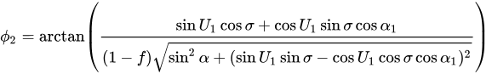

However, I later found there were many different variations of this formula, and it was also appearing to be very long to type up, with several different variables I was unsure of how to implement into my program, even after research, so I decided to not use this formula. For example, f represents the flattening of the ellipsoid, which is equal to (a-b)/(a). In terms of terms of the earth, a would be the equatorial radius and b would be the polar radius.

**Distance comparison function**

Finds latitude and longitude of all cities from database

Stores city along with latitude and longitude in array.

Radius = 6371e3

Uses formula to find distances between every remaining city in the list:

For city1 and latitude1 and longitude 2 in array ##Goes through each city in array

For city2 and latitude2 and longitude2 in array##Goes through each city in the array again

X = Radians(Latitude1)

Y= Radians(Latitude2)

M = Radians(latitude2 – latitude1)

N = Radians(longitude2 – longitude1

A = sin(M/2) * sin(M/2) + cosX * CosY * sin(N/2)* sin(N/2)

C = 2* arctan(sqrt(A), sqrt(1-A))

D = Radius * C

Store in Matrix[city1][city2]

Next city 2

Next city1

Stores the other cities, along with their distance in the matrix from city1 in an array

Continues until each city has finished being added to the list

Puts the list in ascending order of its distance from city1

OUTPUT each city and its distance from city one

Return to main menu function

# Iterative development and testing

## Creating table:

To create my table for the entire program, I would have to create a function that creates the function with the fields that I want, which are the packageID, city, package and hotel, with packageID being the primary key.

The first problem I ran into involved creating the tables for the database. To test whether the database was saving the code, I ran the code for the first time, with the function get_posts() being used to print the table as it currently is at the moment. The get_posts() function just selects every single record from the table and then outputs it.

An error that I found was when I tried to run the code for the second time, the table values were not saving.

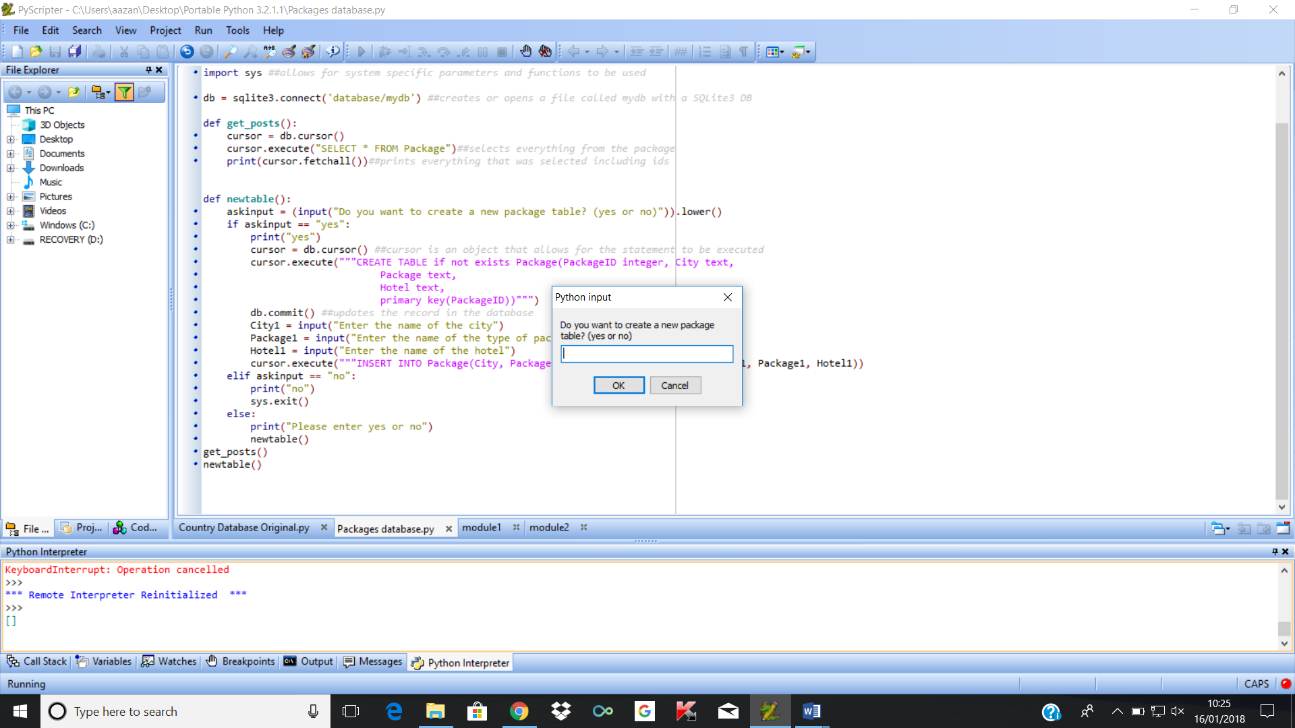

I eventually realised this was due to not including the db.commit() function after inserting the new values into the table. This is important as the db.commit() function updates changes made to the table and without it, the database wont update.

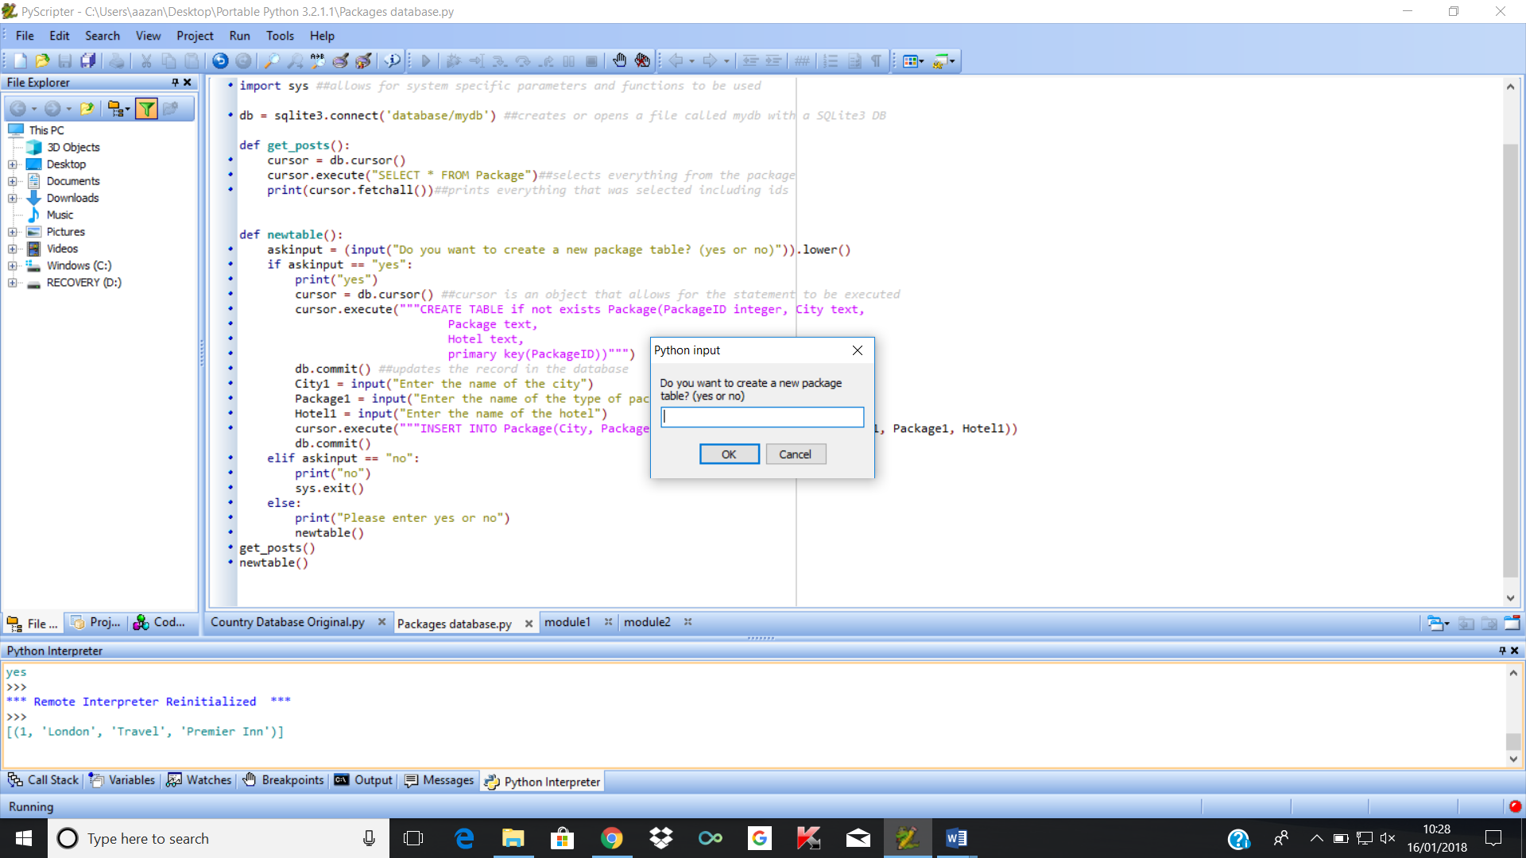

## Creating the add a record to the table function

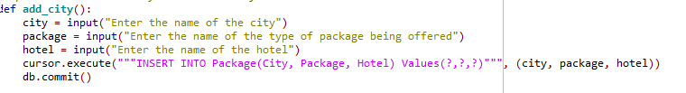One of the main features of my program will be for the user to be able to add records to the table. I did this by using SQL functions that allow changes in the database to occur. The code below is the code I made to allow a new city to be inputted.

How this code works is asks the user the name of the city they want to add, the package type they want for that city and the hotel for that city. This will then be placed into the table under the fields City, Package and Hotel, and will be stored there unless anything needs to be edited.

I decided to also add in a print function so when the user inputs want they want, an edited table is outputted

For example, if I input Paris, Romantic and Hype Hotel, I would get this as an output as the first record was already put in the table firstly:

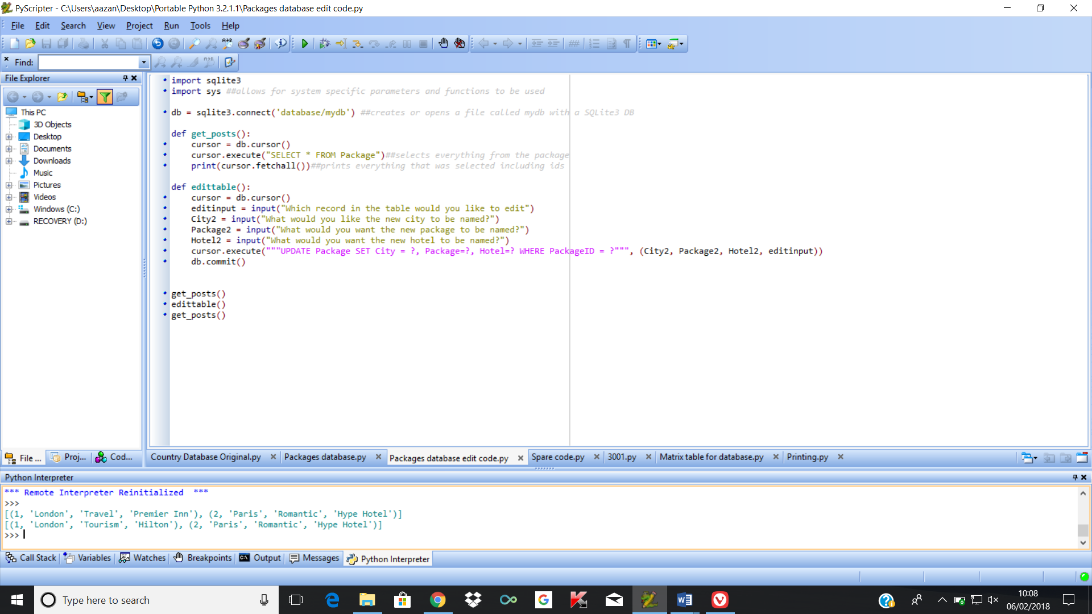

## Review of current stage 1

At this point in the development, only one working function has been created, however, if any of the users decide that they want to be able to provide feedback that may allow for the function to improve, it would allow for functions to be adapted in a way that would be suitable for them.

|  |  |  |  |
| --- | --- | --- | --- |
| Key functions | Have the success criteria been met? | Feedback | How I plan to improve this function |
| Add package to the database | The user can easily add records to the table with the criteria they want | It was simple to the user how to input what they wanted into the record | No further improvements mentioned |
| Edit packages in the table | This has not been met yet. | The user wants a system where they can easily be able to know which record is which so that they can easily change information if a change is required. | No further improvements mentioned |
| Delete records from table | This has not been met yet. | The user has not provided feedback for this function yet | No further improvements mentioned |
| Allow for function that allows distances to be found by storing latitudes and longitudes | This has not been met yet. | The user has not provided feedback for this function yet | No further improvements mentioned |
| Have a function that allows the user to choose holiday they want | This has not been met yet. | The user has not provided feedback for this function yet | No further improvements mentioned |
| Allow the user to choose how many cities they want to visit | This has not been met yet. | The user wants to add a limit because they may not want to go past a certain distance. | No further improvements mentioned |
| A menu that provides an interface for the user will be provided. | This has not been met yet. | User wants menu that allows them to access each of the functions easily. | No further improvements mentioned |

## Creating my editing table function

Another feature of the program that is required is the method of editing tables in case information ends up changing later on. This was the code that I used to allow the user to change record in the table.

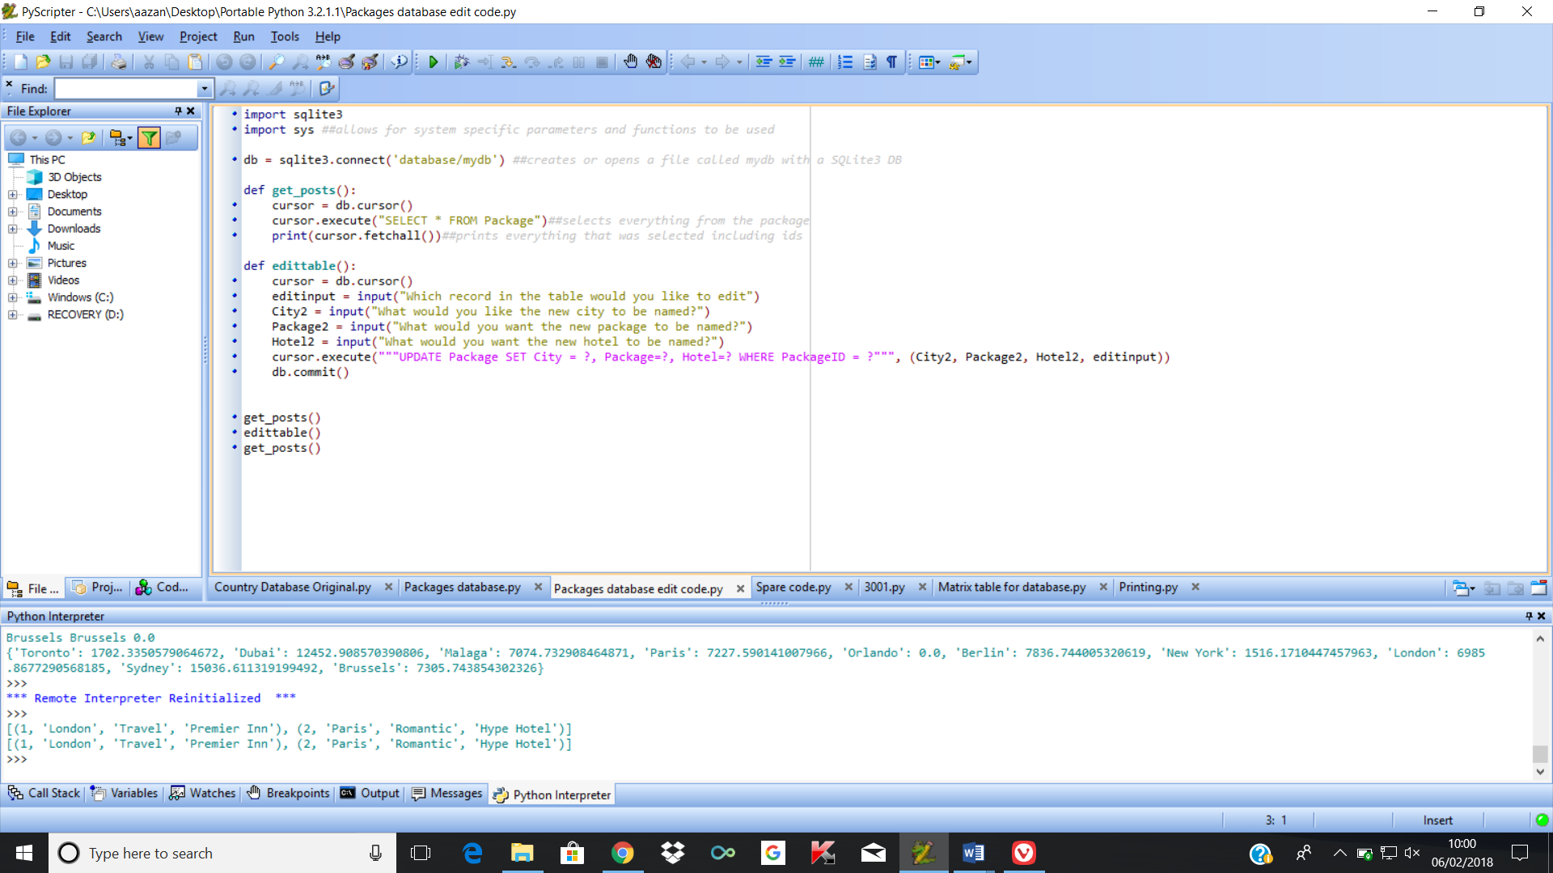

This code has the current records in the table printed out then asks which record the user of the table would like to change. The user would then have to input one of the recordID’s given.

Afterwards it asks the user to input a new city input to replace the current one, a new package input to replace the current one, then a new hotel input to replace the current one. This afterwards then updates the record that is currently in the table.



This shows that the record with city name London has the values for the holiday type and the hotel changed.

## Review of current stage 2

I have been able to complete the function that allows the user to edit records in the table, so I decided to allow some of my stakeholders to test the current program to get their opinions on the functions as of now.

|  |  |  |  |
| --- | --- | --- | --- |
| Key functions | Have the success criteria been met? | Feedback | How I plan to improve this function |
| Add package to the database | The user can easily add records to the table with the criteria they want | It was simple to the user how to input what they wanted into the record | No further improvements mentioned |
| Edit packages in the table | This meets the criteria that allows the user to be able to edit currently existing records in the table | It was simple to change the record they wanted changes for, however they could input any value outside the range of recordID’s and still input values and nothing would happen as that recordID does not exist. | To add validation so that values outside of the range cannot be inputted by the user |
| Delete records from the table | This has not been met yet | The user has not provided feedback on this function yet | No further improvements mentioned |
| Allow for function that allows distances to be found by storing latitudes and longitudes | This has not been met yet. | The user has not provided feedback on this function yet | No further improvements mentioned |
| Have a function that allows the user to choose holiday they want | This has not been met yet. | The user has not provided feedback on this function yet | No further improvements mentioned |
| Allow the user to choose how many cities they want to visit | This has not been met yet. | The user wants to add a limit because they may not want to go past a certain distance. | No further improvements mentioned |
| A menu that provides an interface for the user will be provided. | This has not been met yet. | User wants menu that allows them to access each of the functions easily. | No further improvements mentioned |

## Creating my delete table function

The next main function I am making for my program is the function to allow records to be deleted. This will also be coded in SQL. This will take in the input of the recordID that the user wants changed, then remove it from the database.

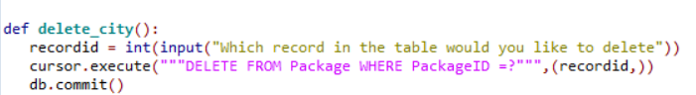

The whole record is deleted from the database, then the db.commit is used to update the database.

## Review of current stage 3

I have been able to complete the function that allows the user to edit records in the table, so I decided to allow some of my stakeholders to test the current program to get their opinions on the functions as of now.

|  |  |  |  |
| --- | --- | --- | --- |
| Key functions | Have the success criteria been met? | Feedback | How I plan to improve this function |
| Add package to the database | The user can easily add records to the table with the criteria they want | It was simple to the user how to input what they wanted into the record | No further improvements mentioned |
| Edit packages in the table | This meets the criteria that allows the user to be able to edit currently existing records in the table | It was simple to change the record they wanted changes for, however they could input any value outside the range of recordID’s and still input values and nothing would happen as that recordID does not exist. | To add validation so that values outside of the range cannot be inputted by the user |
| Delete records in the table | This meets the criteria that allows the user to change information within the table. | It was simple to the user how to be able to delete the record, however if they inputted a value that does not exist, an error is returned. | To make sure the user cannot enter string values, and to only accept the values in range |
| Allow for function that allows distances to be found by storing latitudes and longitudes | This has not been met yet. | The user has not provided feedback on this function yet | No further improvements mentioned |
| Have a function that allows the user to choose holiday they want | This has not been met yet. | The user has not provided feedback on this function yet | No further improvements mentioned |
| Allow the user to choose how many cities they want to visit | This has not been met yet. | The user wants to add a limit because they may not want to go past a certain distance. | No further improvements mentioned |
| A menu that provides an interface for the user will be provided. | This has not been met yet. | User wants menu that allows them to access each of the functions easily. | No further improvements mentioned |

## Creating my matrix table

Introduction about the matrix table, why its needed and how it fits in the user requirements

For the main part of my program, which is the search function used to help the user plan which cities to visit, I decided I was going to use a distance matrix. This allows for all the distance between all the cities to be together in one table, allowing for an easier time displaying the cities in ascending order. This is useful for my user requirements, because one of the main requirements that I had for my program is for a search system that allows for nearby cities falling under the same holiday type they want to be displayed

### Prototype 1

Pandas – module

Reason for choosing it: I originally planned to use the pandas module to be able to create a distance matrix in my code. This would have required downloading a completely new module to my python, which I had issues with, therefore was not able to.

Information about pandas module: Pandas is an open source library that provides high performance data structures and data analysis tools for the python programming language. It is useful for data munging and preparation.

Limitations: One of the limitations is that I would have had to install this module, which I unfortunately struggled with doing so due to using a portable version of the python program, therefore was unable to get the module working

### Prototype 2

2D array – built in maths module

Reason for choosing it: It allowed me to be able to plug in the coordinates of each of the coordinates and get the distances between each of them on a graph

With the distances available, the code can be used to list cities in an ascending order given the initially starting city, which fits my user requirements for a search function where my user can find the closest cities.

Limitations: This only works on a 2d scale, and I wanted the program to be able to work on a 3d scale to find approximately the actual distance for the actual cities

Another feature I plan to include in my database is an included matrix table so that I can output the records based on their starting city. I was able to find code to help me to find the distance between two points. I used the longitude and latitude of the cities to be able to find this distance.

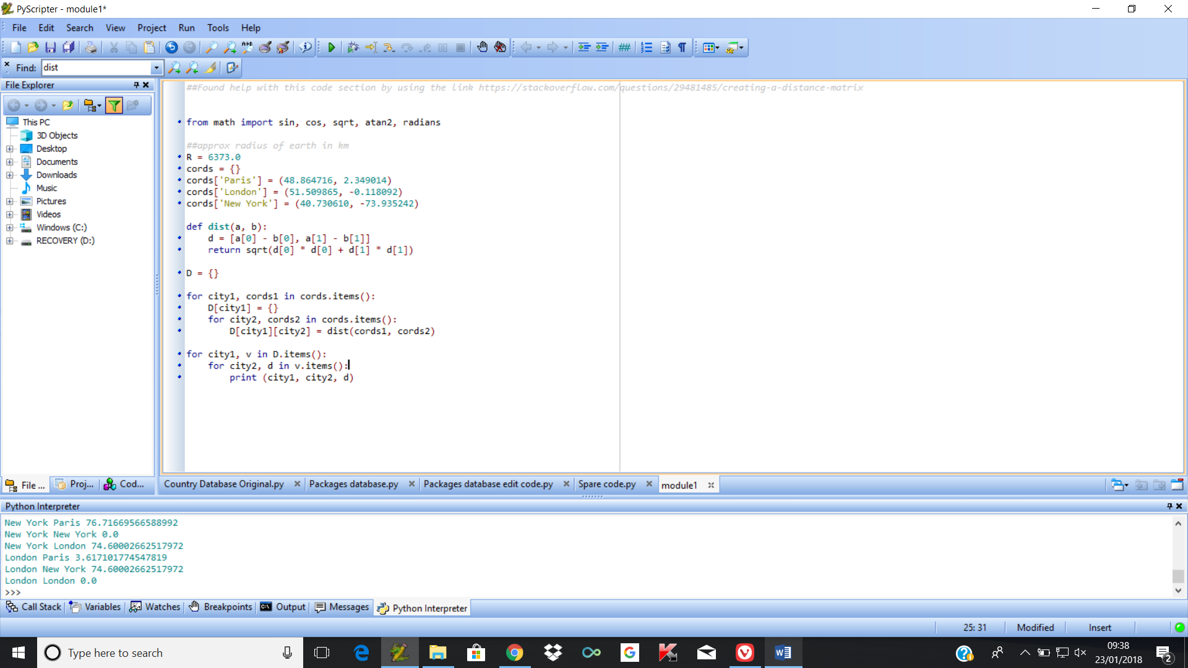

Unfortunately, this code is not suitable due to the fact that this code is only meant for 2d points, meaning that the actual distance found would have ended up being incorrect for the code. This meant that I would have to redo parts of the code, taking in the factor information like the radius of the earth to help find the actual distances.

On the website, <https://andrew.hedges.name/experiments/haversine/> , I found javascript code that uses the longitude and the latitude to find an approximate distance from the two locations:

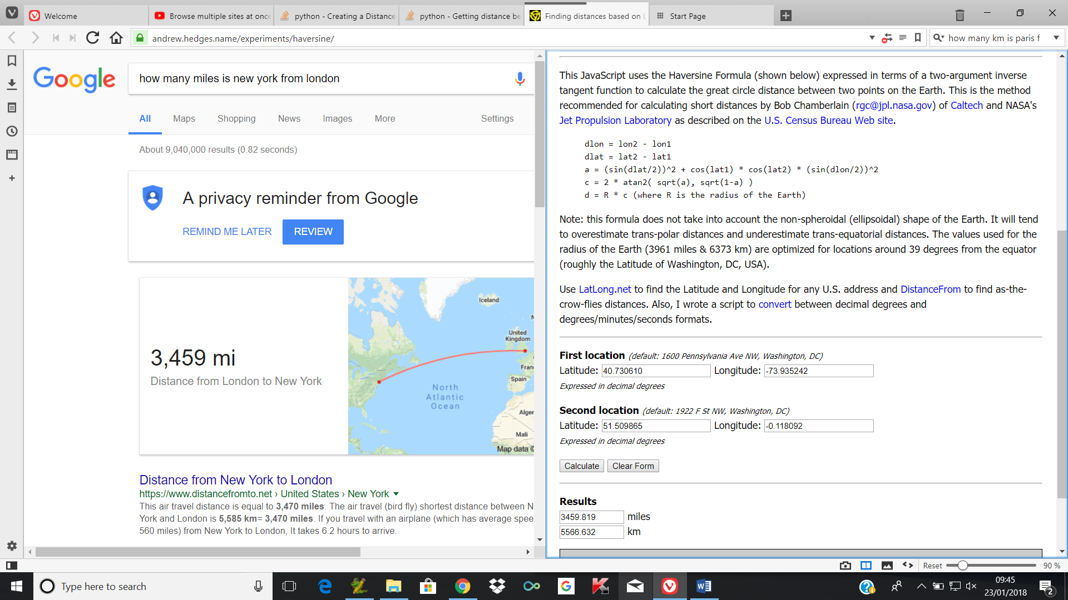

With help from this javascript code, I was able to change the python code I have and make it into a program that allows for an approximate value of the actual distance from each of these cities to be found:

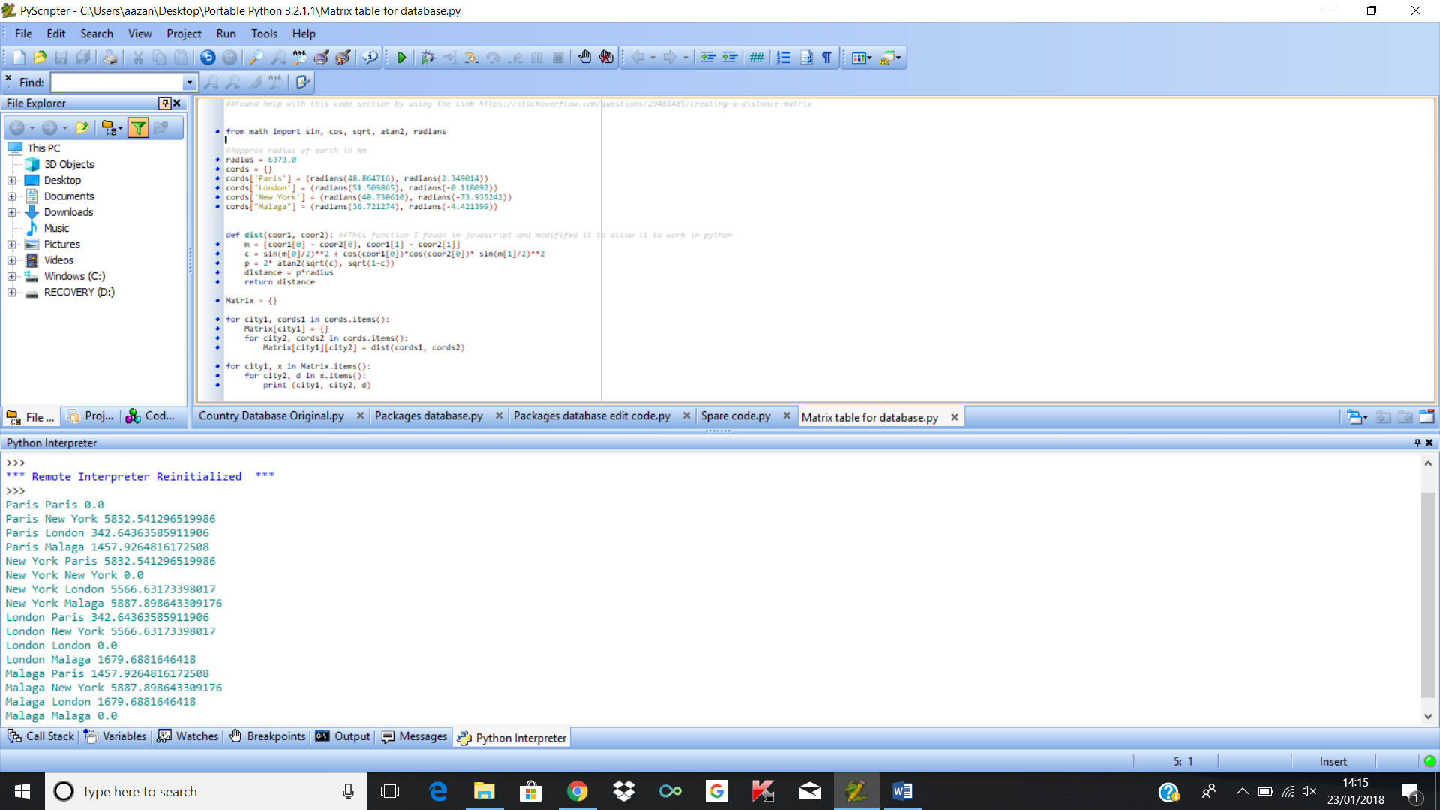

### Prototype 3

Using the haversine formula for an approximate distance

Reason for choosing it: It finds approximately the actual distance between two cities given the longitude and the latitude of each of the cities.

Due to being able to find the actual distance, this is more convenient and reliable in terms of being able to output the cities in ascending order.

Limitations: It currently requires for the information to already exist in the table to be outputted, and cannot be displayed in a table. The text can become a lot if more cities are entered into the array

Psuedocode for formula:

**Distance comparison function**

Finds latitude and longitude of all cities from database

Stores city along with latitude and longitude in array.

Radius = 6371e3

Uses formula to find distances between every remaining city in the list:

For city1 and latitude1 and longitude 2 in array ##Goes through each city in array

For city2 and latitude2 and longitude2 in array##Goes through each city in the array again

X = Radians(Latitude1)

Y= Radians(Latitude2)

M = Radians(latitude2 – latitude1)

N = Radians(longitude2 – longitude1

A = sin(M/2) * sin(M/2) + cosX * CosY * sin(N/2)* sin(N/2)

C = 2* arctan(sqrt(A), sqrt(1-A))

D = Radius * C

Store in Matrix[city1][city2]

Next city 2

Next city1

Stores the other cities, along with their distance in the matrix from city1 in an array

Continues until each city has finished being added to the list

Puts the list in ascending order of its distance from city1

OUTPUT each city and its distance from city one

Return to main menu function

One of the main problems that this matrix has however, is that because it is not part of the sql code, it cannot be stored to the database. This means that the information being used to store the latitude and longitude of each of the cities cannot be stored in a database, therefore already has to exist in the code for it to work. This can be a big problem if I need to add or change cities as code has to be directly changed. However, it is still more suitable than directly putting in a matrix due to the fact that the increase of cities could make it longer to find the distances between all the cities.

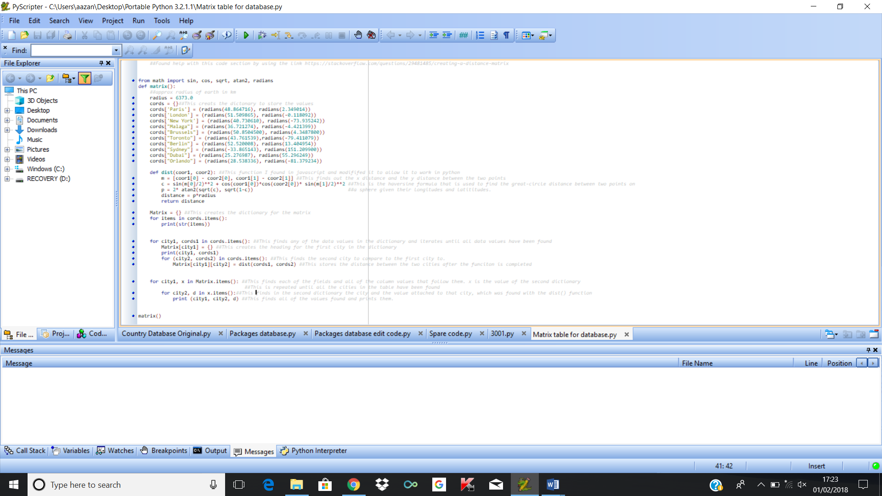

The information is stored in a matrix when it has finished running through the code.

## Creating find holiday function:

My next point of development involves allowing the user to get an output for the city they want when they input the package type.

Prototype 1:

Using the matrix to output cities in order

Whilst creating my search function, I ran into a program where the program was stating that I was using an incorrect number of bindings for the statement as it uses 1, and 7 were being supplied, as I was searching for a Tourism package.

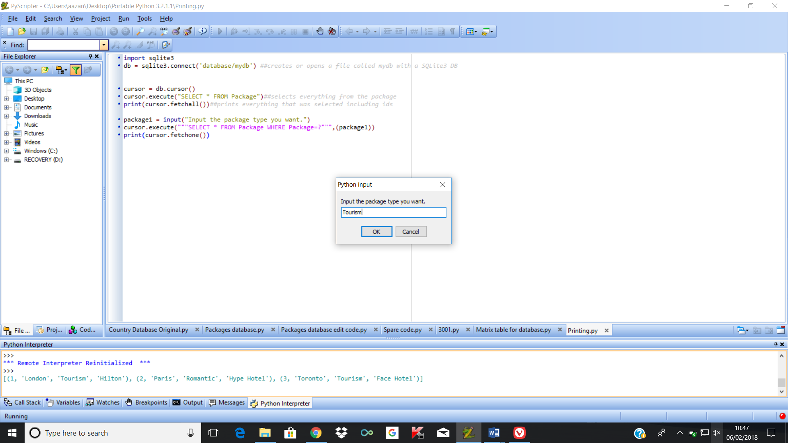

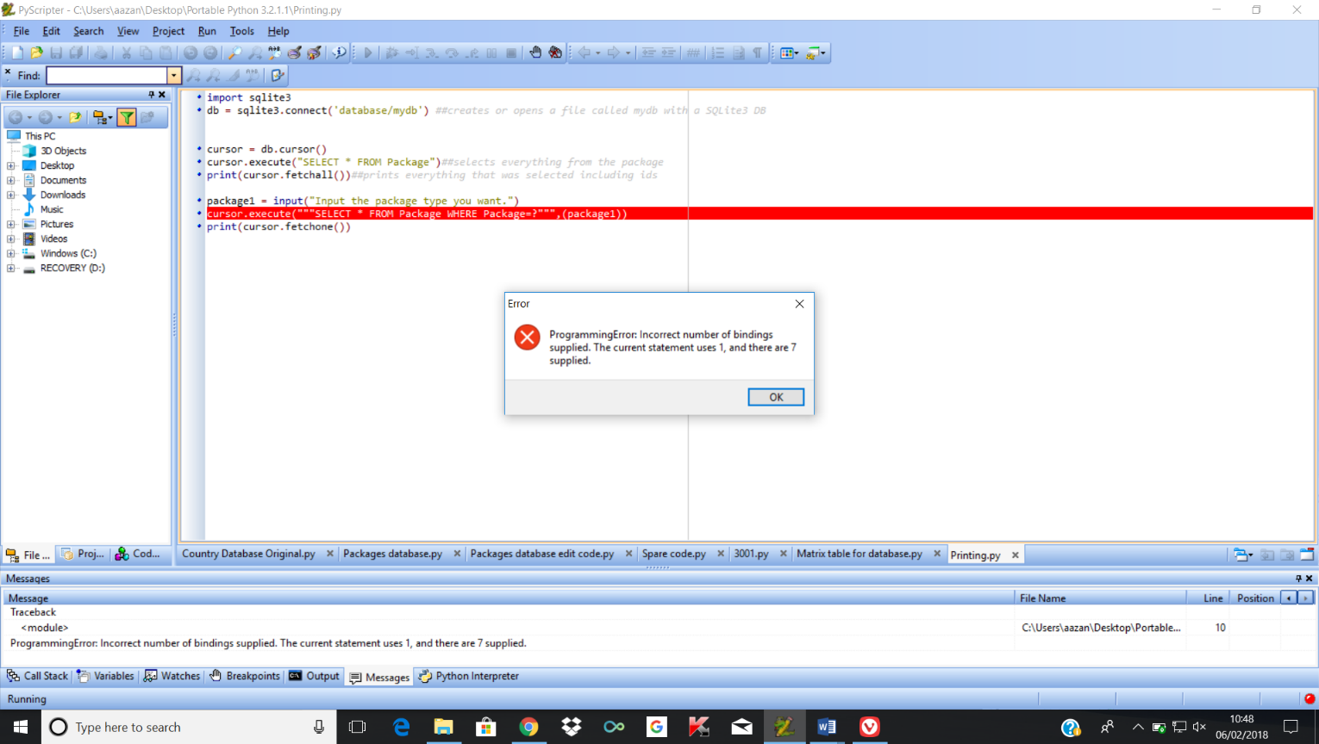

Online I was able to find out that this was due to not making the parameter as a tuple.

In the line of code cursor.execute("""SELECT * FROM Package WHERE Package=?""",(package1)), the package1 is being used as a grouped expression rather than a tuple, so the string is treated as the input sequence, so the bind values are based on the amount of characters that were inputted, which in this case were 7.

Adding the comma after the input creates it as a tuple so treats it as one value rather than the amount of characters it is worth.

For example, now if I input for holiday types falling under Tourism:

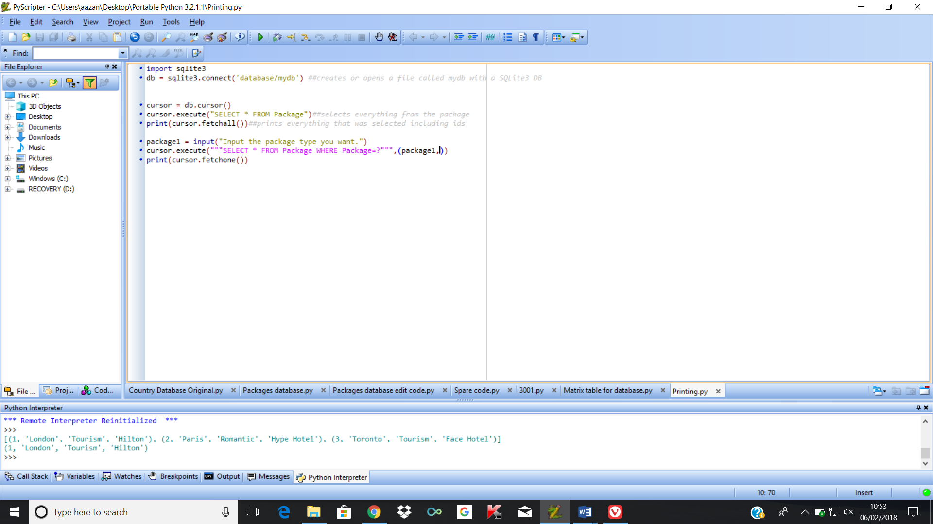

However, this created a brand-new problem as instead of outputting the values where the package was Tourism, it instead only outputted one of the records even though two with the same package type exist in the database.

It turned out this was due to using a fetchone() function when I went to print out the value, so only one of the found values were printing out. Instead using a fetchall() function would allow for all the records selected to be printed out.

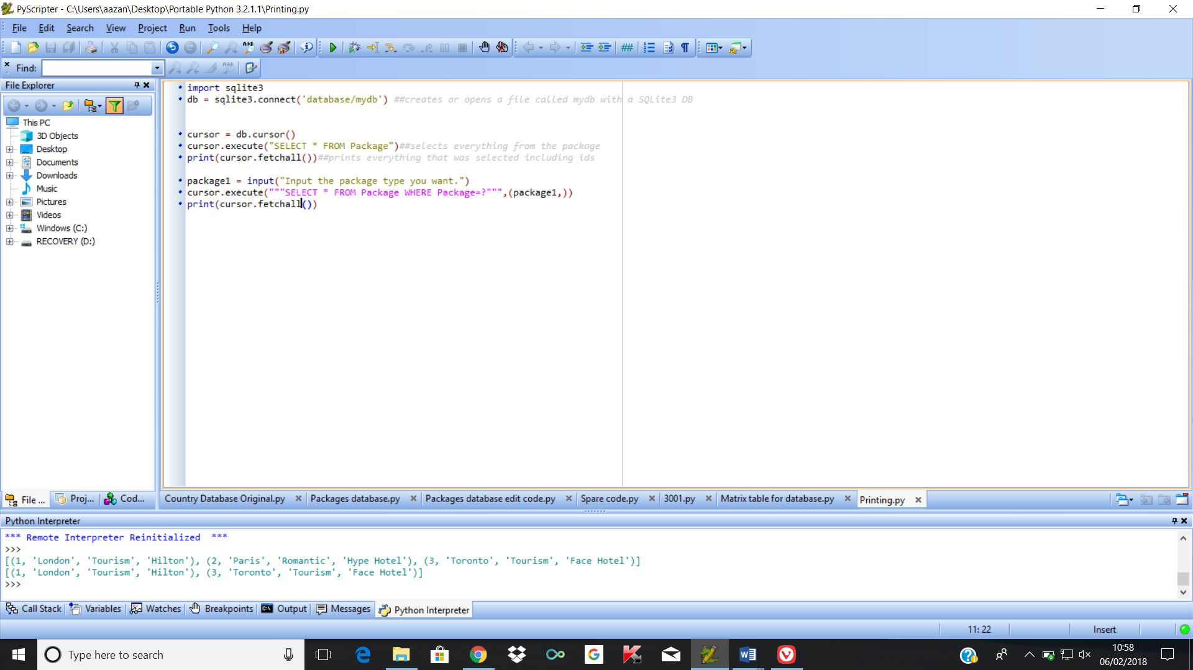

My next target is by inputting my matrix code in the printing algorithm to allow the packages to be outputted in order of distance from the starting city.

Firstly, I decided that instead of would convert my results into an array by converting the fetched outputs into a list so that I would have an output value in string form.

To make the information easier to access rather than leaving it in a tuple, I would then take the city names out of the tuple and into the array for the entire tuple list until there were no values left to take. This would mean I would have an array value, which would make it easier to access the city names.

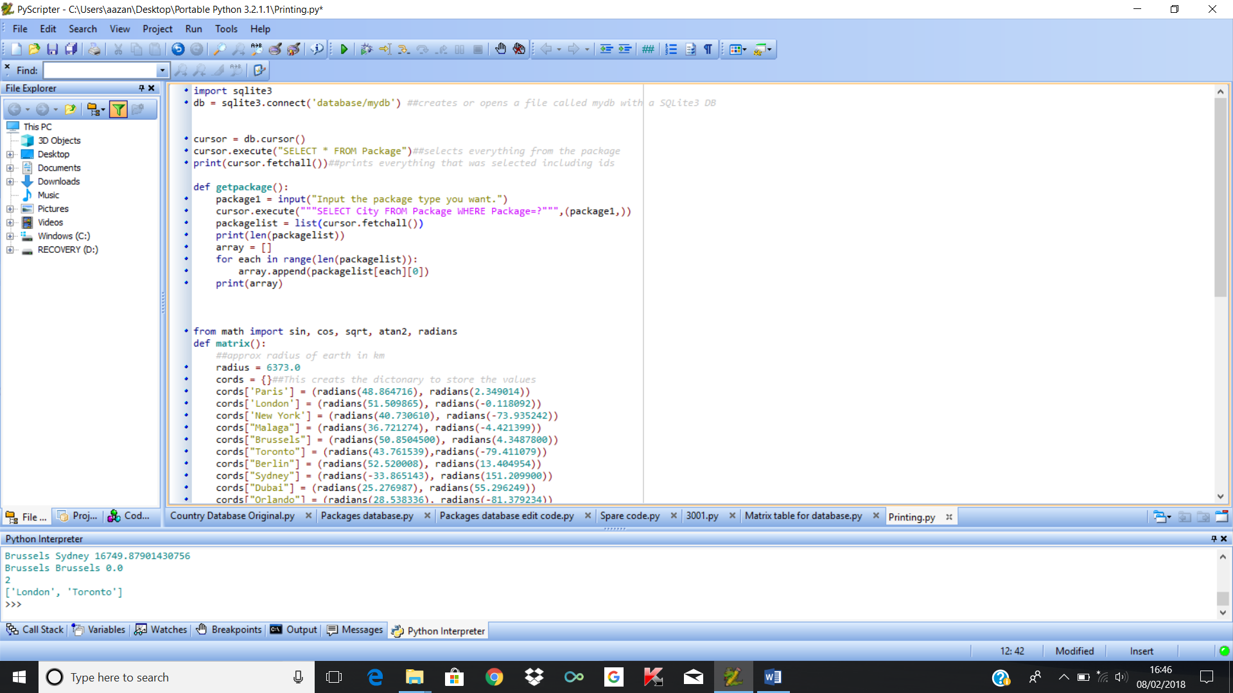

I decided to make the matrix() function return the actual matrix so that I could use it in the getpackage() and use my arrays to be able to return the distance of the cities dependent on the input of the package

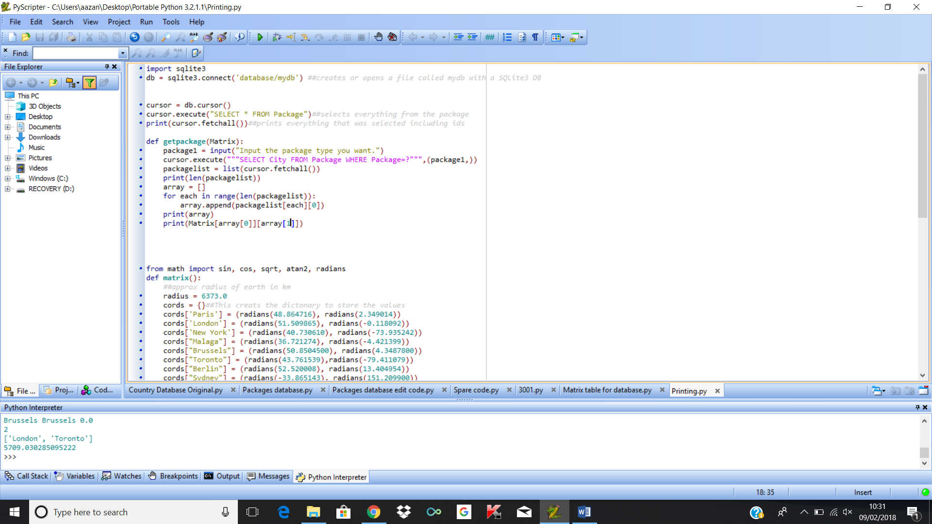

This finds the distance of the first two cities in the array. This was a test to see whether returning the matrix and using it in this function would work. The two values used were London and Toronto

This output is the approximate distance from London to Toronto in km

I also edited the printed message so that each time the outputs were listed; the message contains the distance of the other cities in the package from the initial city. To test this, I added more cities to the package, which were Malaga, Sydney and New York, which now all fall under the package type Tourism.

I also changed the order of the new list being made so that the city being compared with the rest of the of the cities would be moved to the end of the array so that I would be able to know its location in that array.

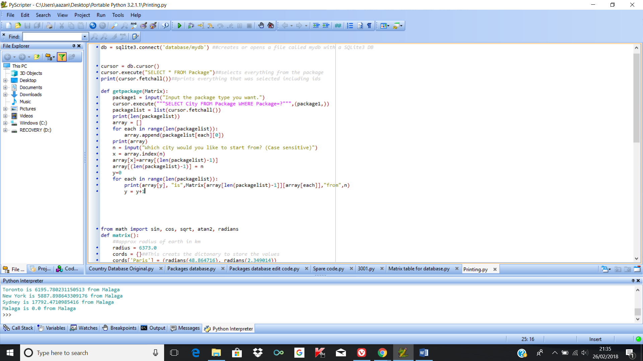

This swaps around the values in each of the arrays so that the city can be put into the last position of the array

This stores its location in the x variable so that it can be used later.

This line finds the city that the user wants to start from.

This prints out a message comparing one of the citys in the matix to the starting city

The reason I made the starting city be in the last position of the matrix is so that when outputting the distances, it would not output the distance between itself. This is because if I had left it in its original position, it would be much more difficult to not include the distance between itself as an answer than to just move it to the end of the matrix so I know where it is located:

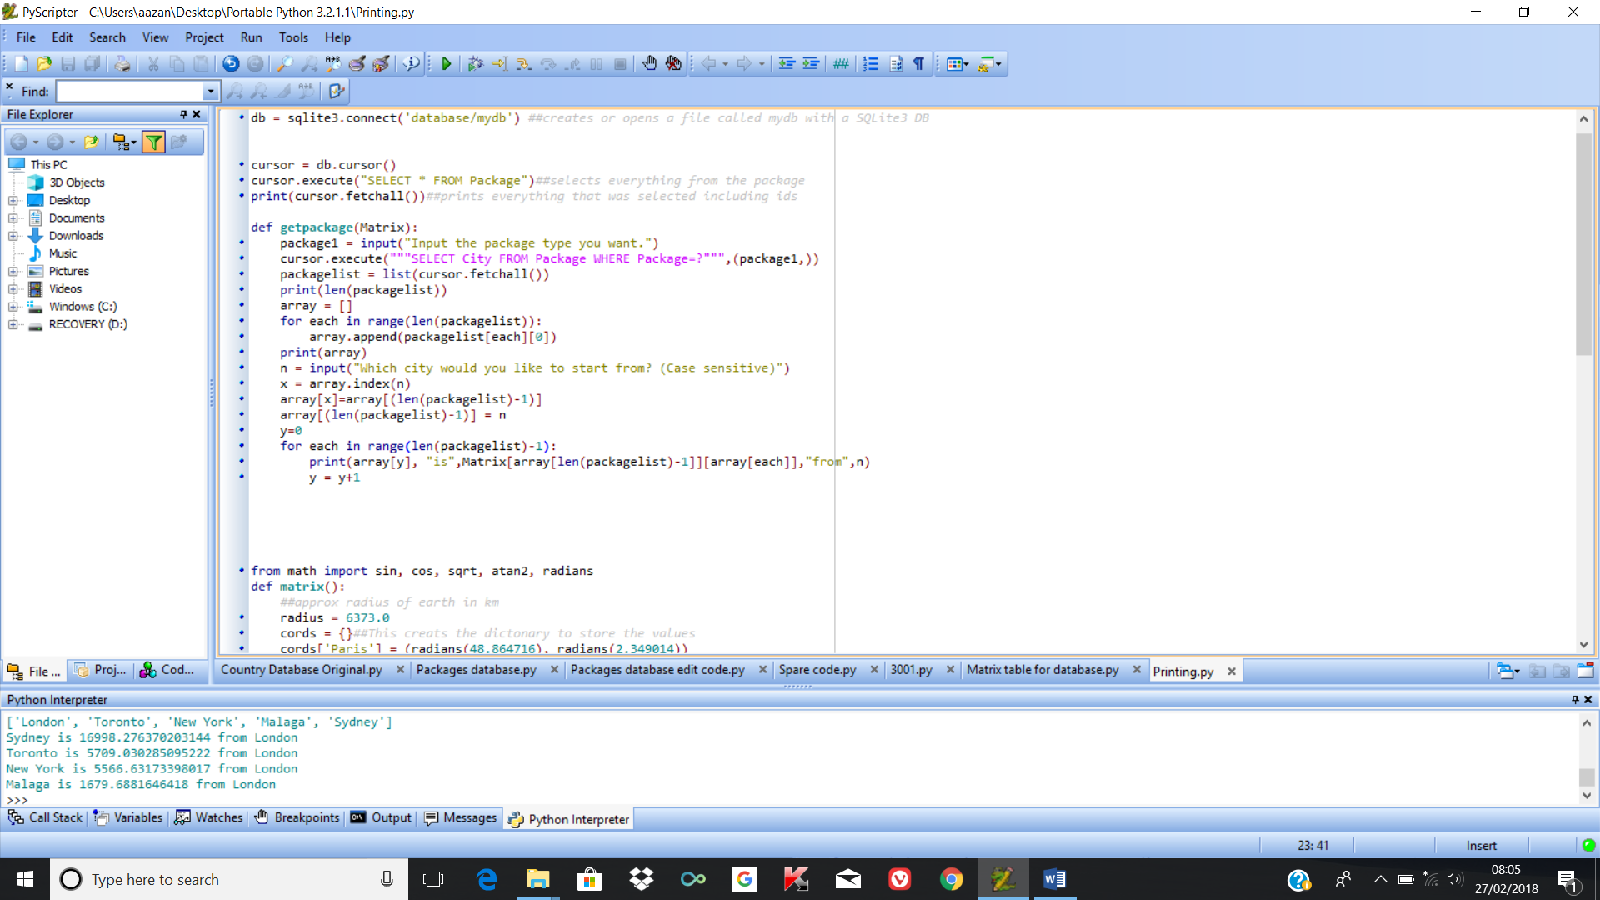

Changed length to length of array -1 so that the starting city is not considered as a distance that needs to be compared

My next aim is to now get the packages to be able to print in order of ascending size. The first attempt that I tried doing this by was by using the .sort() function which would sort the results in an array

However, due to the fact that the results are float results, the function did not work and returned this error:

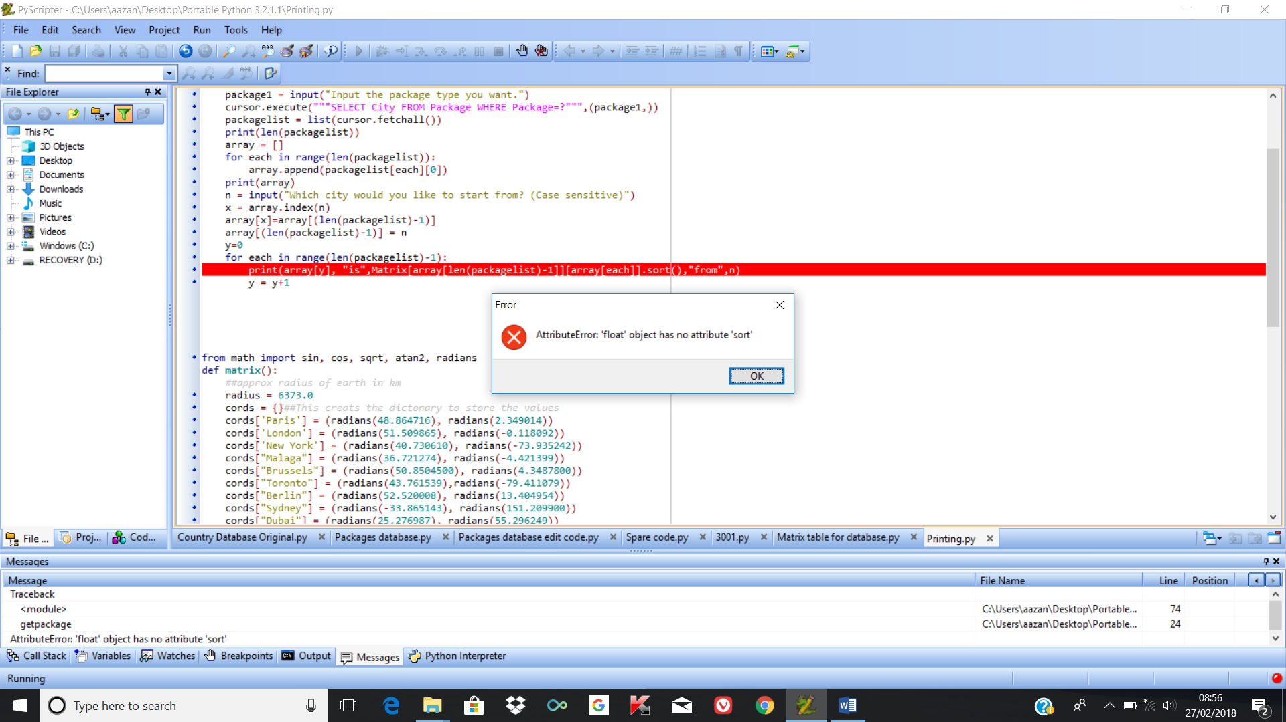

This was not going to work however, as due to going through an iteration, the values would not automatically come out as sorted, so I decided that instead I would append the results to another array so that the list could instead be outputted from there.

Firstly, I decided to create the array base, which would store the other cities and their distance from the city that was inputted previously. This allows me to get the distances in another array.

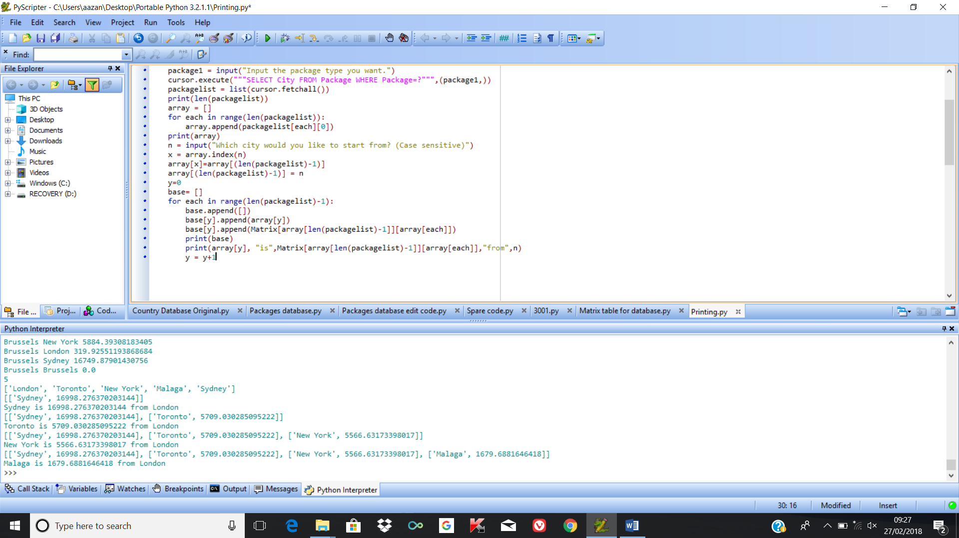

With each iteration, the list gets bigger until it has finished comparing each of the distances. Afterwards I decided I would sort the list by using a key. The sorted function allows for a key argument which can sort the array in order of rising value.

I used the sorted function to be able to achieve this. I used the key function so that only the float values would be considered when deciding on how to sort the list.

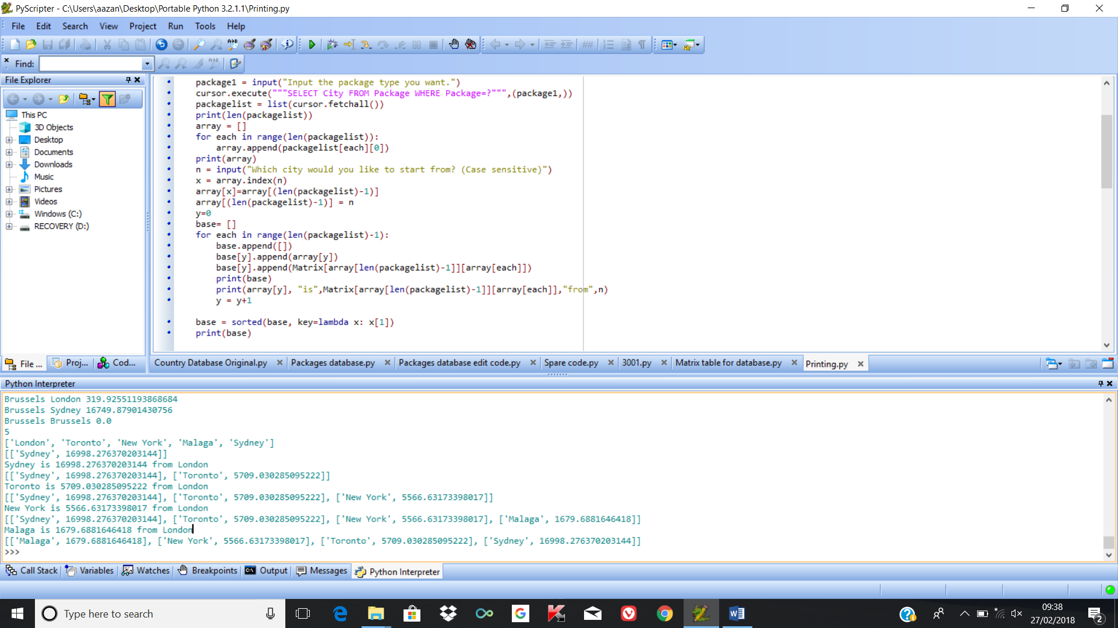

This meant that I could now use my new sorted list to print out the distances of the cities from the initial starting city input.

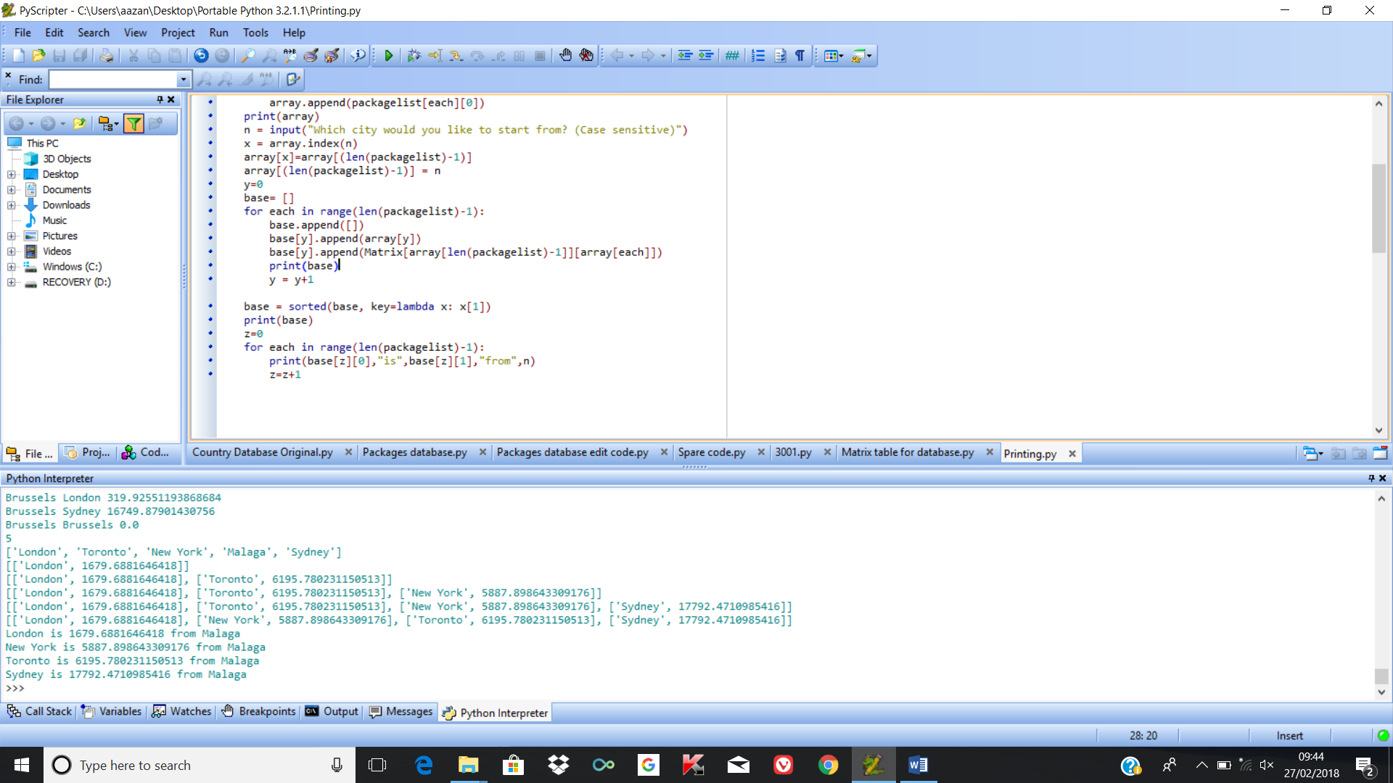

This now outputs all my cities in order of ascending distance from the starting city. To fully test this, I decided that I am going to add more package types to my table so that I can see whether it will work with more types.

For example, I added New York and Malaga Romantic packages along with Paris so I could check whether it would work with Romantic holidays too, which also turned out to the case:

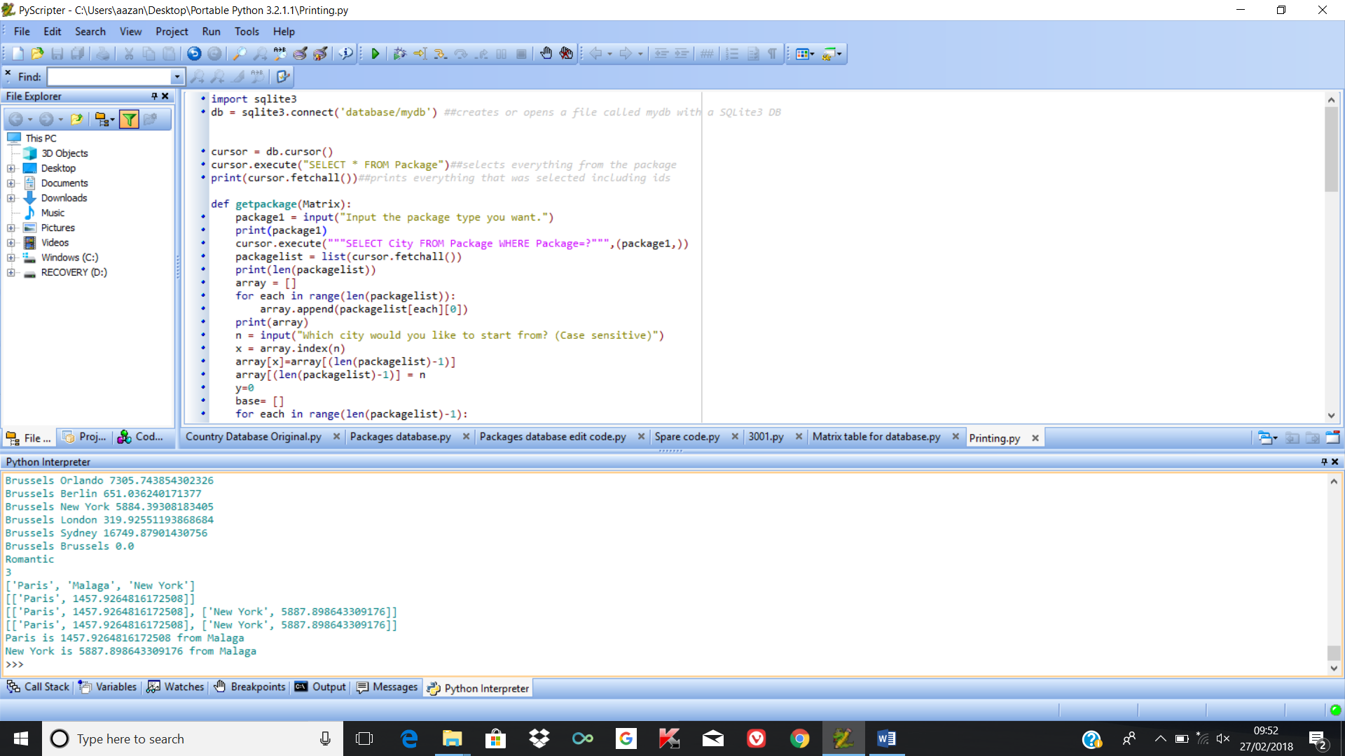

This is able to print out the approximate distance between Paris and Malaga, and New York and Malaga.

## Review of current stage 4

Currently I have been able to complete the holiday choice function, the edit table function, the add table function and the matrix algorithm. I decided that I should go back to some of my stakeholders to whom I gave the questionnaire, and ask for feedback for the current program, and if anything needs to be improved.

I decided that I would make a list of the main functions that I plan to make with my current program, and allow the user to test each of the functions to see whether the success criteria at this point had been met or not.

|  |  |  |  |
| --- | --- | --- | --- |
| Key functions | Have the success criteria been met? | Feedback | How I plan to improve this function |
| Add package to the database | This meets the criteria allows the user to be able to add new packages to the package table | It was simple to the user how to input what they wanted into the record | No further improvements mentioned |
| Edit packages in the table | This meets the criteria that allows the user to be able to edit currently existing records in the table | It was simple to change the record they wanted changes for, however they could input any value outside the range of recordID’s and still input values and nothing would happen as that recordID does not exist. | I plan to include validation that means that only the recordID’s that actually exist in the table would be available to change. |
| Delete records in the table | This meets the criteria that allows the user to change information within the table. | It was simple to the user how to be able to delete the record, however if they inputted a value that does not exist, an error is returned. | To make sure the user cannot enter string values, and to only accept the values in range |
| Allow for function that allows distances to be found by storing latitudes and longitudes | The cities latitude and longitude have been stored in code, but not in a database. Partially met. | The user tested a couple of the distances with the real life distance and they were approximately similar, so they found that this function was very useful. | To be able to store the latitudes and longitudes in the database so that they don’t have to be directly added to code. |
| Have a function that allows the user to choose holiday they want | The user can choose which city they want to start from and the other cities that also fall under the list will be outputted in ascending order. This meets the criteria | The user tested this and it worked well when correct inputs were made. When incorrect ones were put in however, this caused the program to return an error and it automatically stopped | To include validation in the function so that the program does not crash during execution |
| Allow the user to choose how many cities they want to visit | This has not been met yet. | The user wants to add a limit because they may not want to go past a certain distance. | No further improvements mentioned |
| A menu that provides an interface for the user will be provided. | This has not been met yet. | User wants menu that allows them to access each of the functions easily. | No further improvements mentioned |

## Creating a menu for my code

PROTOTYPE 1:

I decided that for my code to make more sense, I would instead add a menu and store my code as several different functions that the user can access when using the program. I did this so that the functions that involved changing the database directly could only be accessed by specific people, and to make it clear to the user which part does what.

I put each separate part of code that I made under functions that the user can gain access to, for example:

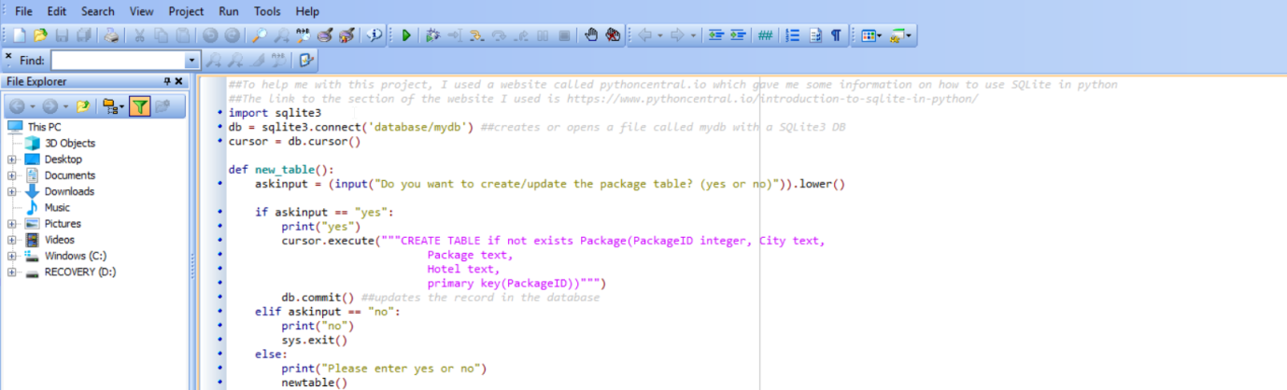

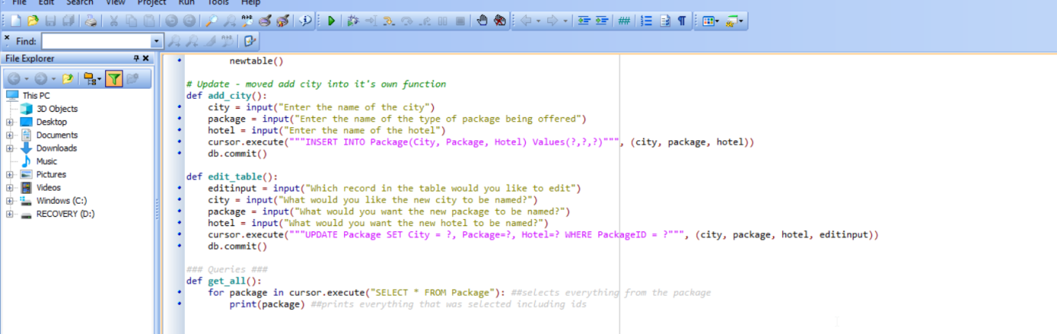

I also created a get_all() function if the user wanted to see all the records available in the database in its entirety.

I put these functions in a separate file so that they were not all in my main code page. I imported them into my main code so that they could just be called from the other section of code.

After this I added a display_menu() function which allows the user to decide which of the functions they want to access by inputting in a specific value, which they are given in the output so they know what has to be inserted.

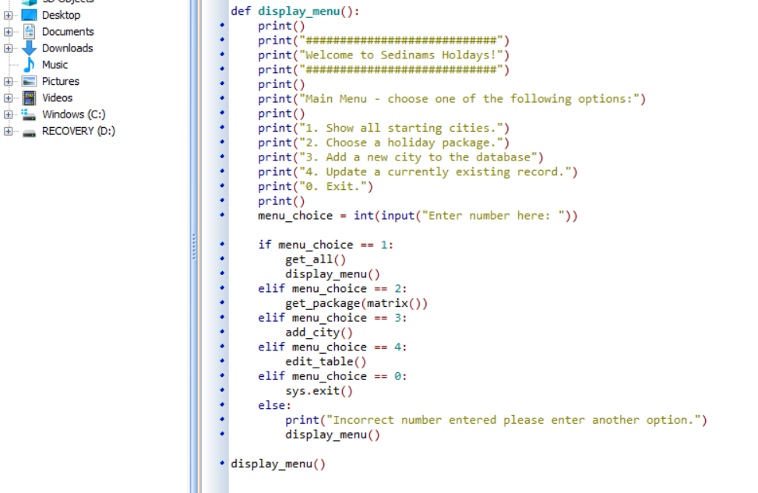

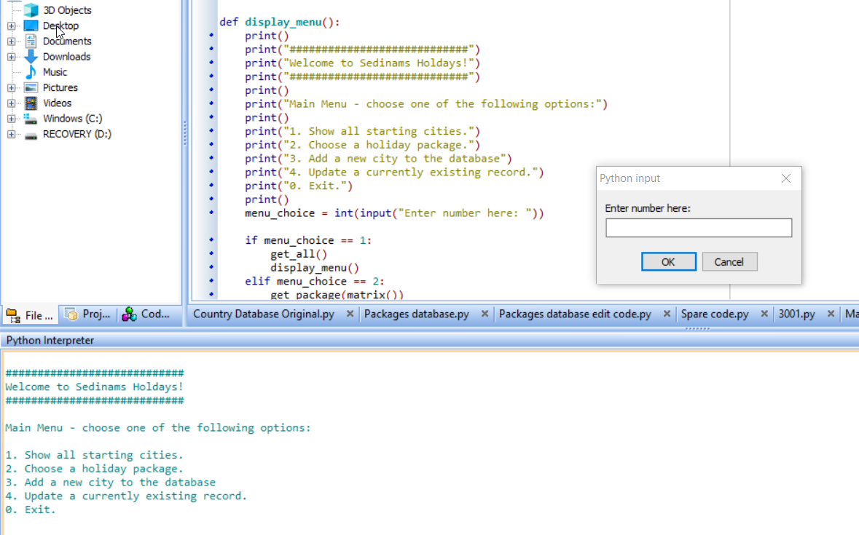

## Review of current stage 5

I have now been able to add a menu for my user so that they can easily gain access to several of the functions in the program. I decided to ask some of the stakeholders to test out whether the functions could easily be accessed and if they were in working order when they used to menu to gain access to them.

|  |  |  |  |
| --- | --- | --- | --- |
| Key functions | Have the success criteria been met? | Feedback | How I plan to improve this function |
| Add package to the database | This meets the criteria allows the user to be able to add new packages to the package table | It was simple to the user how to input what they wanted into the record | No further improvements mentioned |
| Edit packages in the table | This meets the criteria that allows the user to be able to edit currently existing records in the table | It was simple to change the record they wanted changes for, however they could input any value outside the range of recordID’s and still input values and nothing would happen as that recordID does not exist. | I plan to include validation that means that only the recordID’s that actually exist in the table would be available to change. |
| Delete records in the table | This meets the criteria that allows the user to change information within the table. | It was simple to the user how to be able to delete the record, however if they inputted a value that does not exist, an error is returned. | To make sure the user cannot enter string values, and to only accept the values in range |
| Allow for function that allows distances to be found by storing latitudes and longitudes | The cities latitude and longitude have been stored in code, but not in a database. Partially met. | The user tested a couple of the distances with the real life distance and they were approximately similar, so they found that this function was very useful. | To be able to store the latitudes and longitudes in the database so that they don’t have to be directly added to code. |
| Have a function that allows the user to choose holiday they want | The user can choose which city they want to start from and the other cities that also fall under the list will be outputted in ascending order. This meets the criteria | The user tested this and it worked well when correct inputs were made. When incorrect ones were put in however, this caused the program to return an error and it automatically stopped | To include validation in the function so that the program does not crash during execution |
| Allow the user to choose how many cities they want to visit | This has not been met yet. | The user wants to add a limit because they may not want to go past a certain distance. | No further improvements mentioned |
| A menu that provides an interface for the user will be provided. | This partially meets the success criteria, I will next need to create an admin menu for the program | The users found that this was helpful in providing them an interface to easily gain access to the menu | To create an admin menu with a login so that only authorised users can get access to those functions that allow for changes to the database |

PROTOTYPE 2: ADMIN MENU

Because I don’t want the user to be able to access the functions that allow them to edit the table, instead I decided that I would create an admin menu which allows someone with access to the user and the password of this function to be able to gain access to these functions.

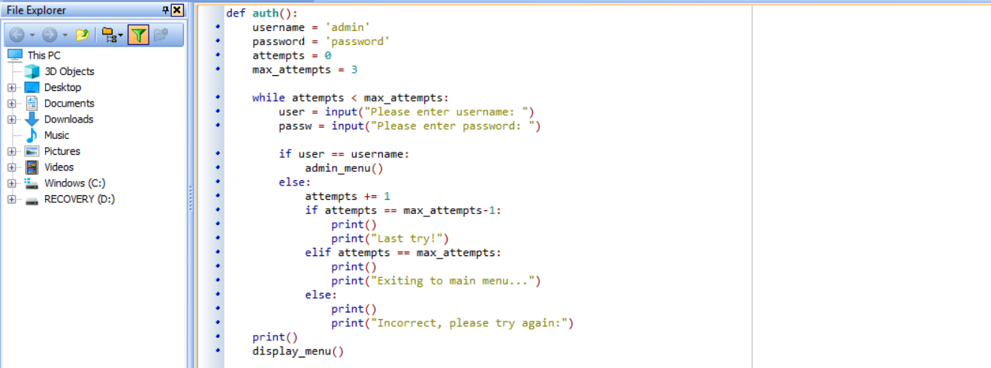

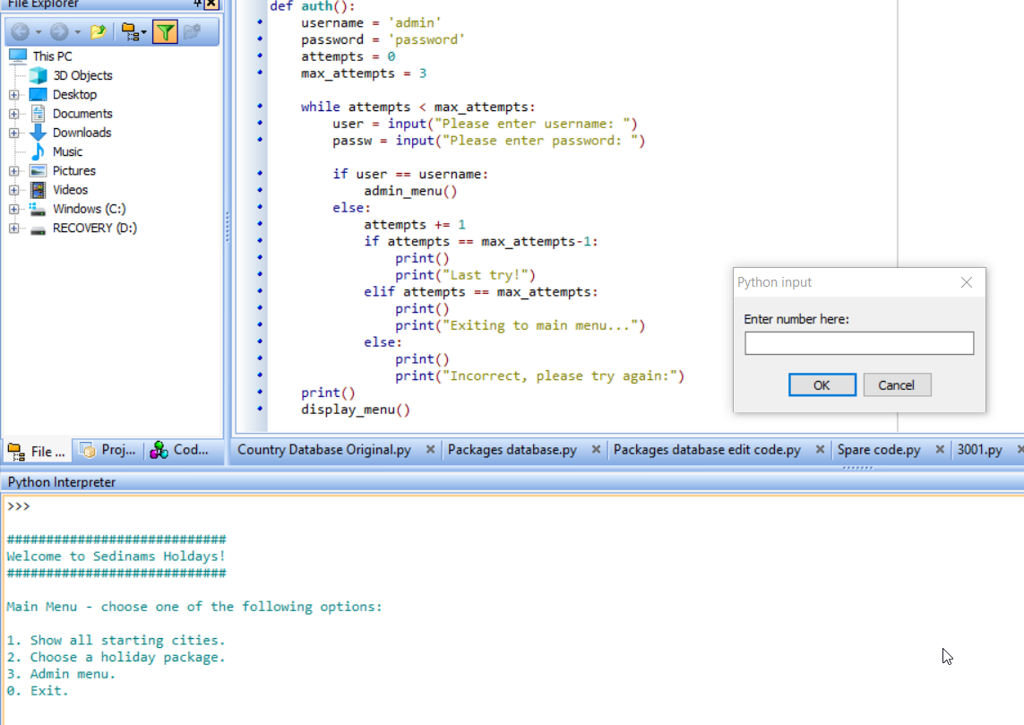

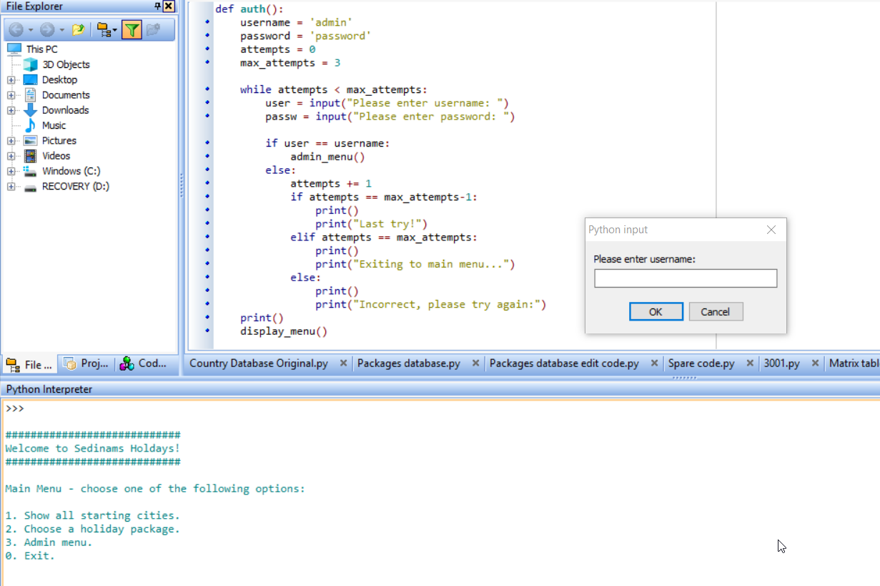

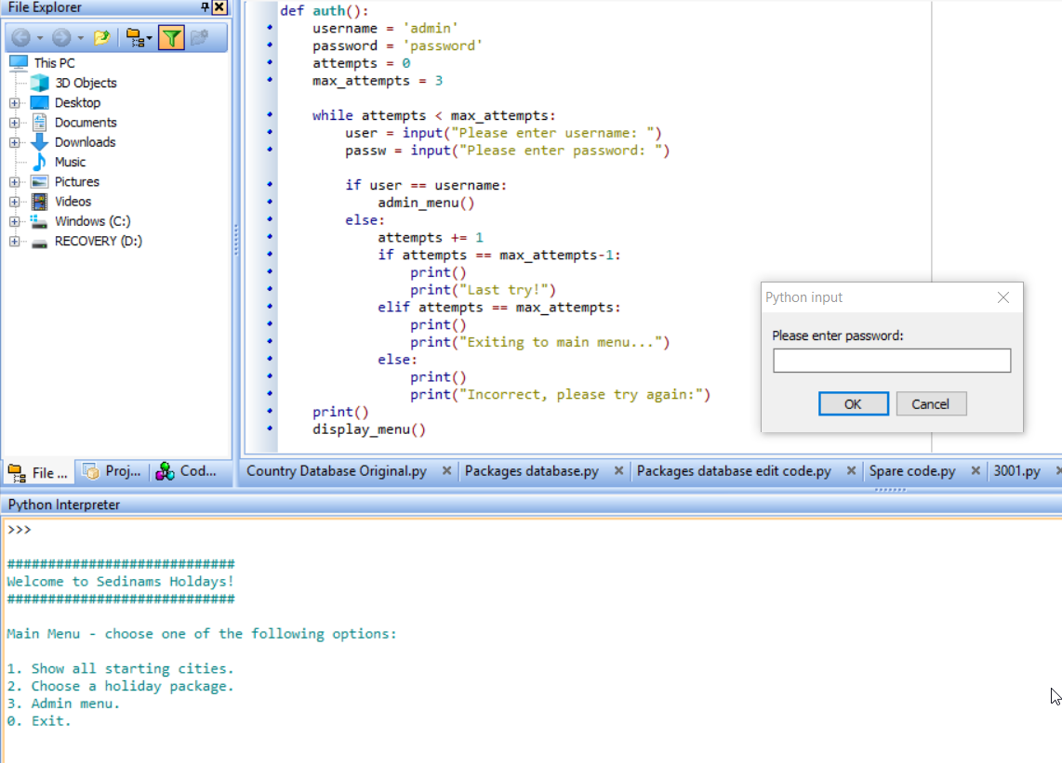

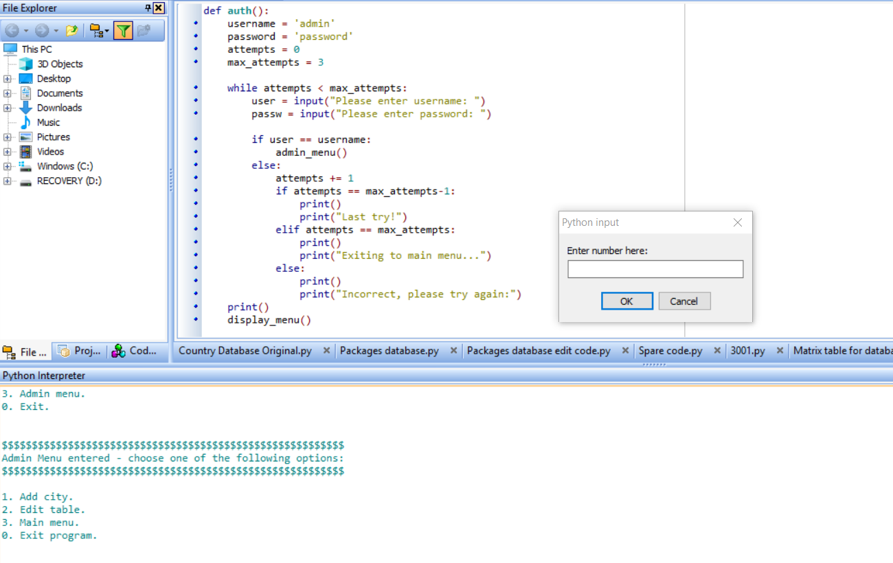

After the user has inputted the correct information required, this gives them access to the admin menu, however whilst testing if this would be secure enough, I ran into problems involving entering the correct username and password.

I realized that because the code only checks for the username, that no matter what password the user inputted, they would gain access to the admin menu. To counteract this, I attempted to try and make it so that they would get the error message if the wrong password was inputted, rather than inputting the wrong username.

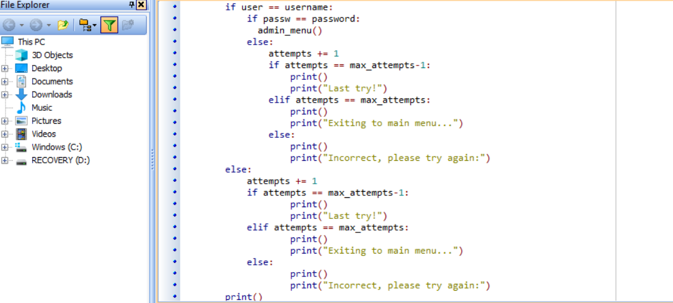I decided to use the same code for an incorrect password to appear if the username was also wrong, however, this did not work as even if I inputted an incorrect username, it would still ask for the password.

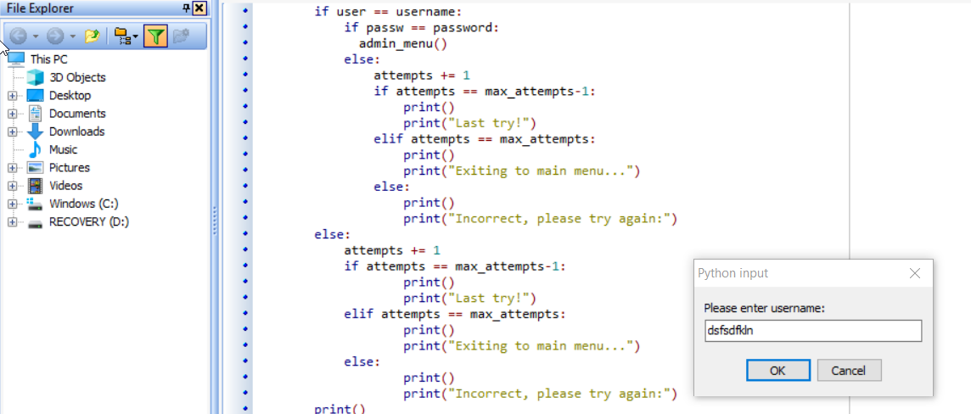

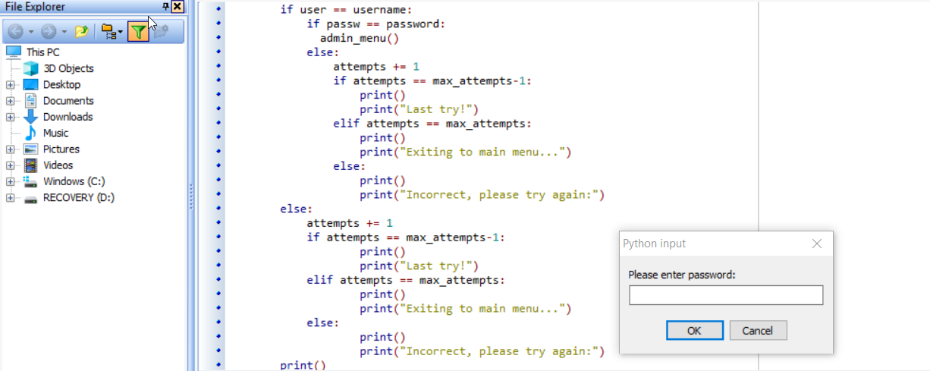

This was because I had the input for both the username and the password above, so I had to move the input for the password below so that it checks both separately. 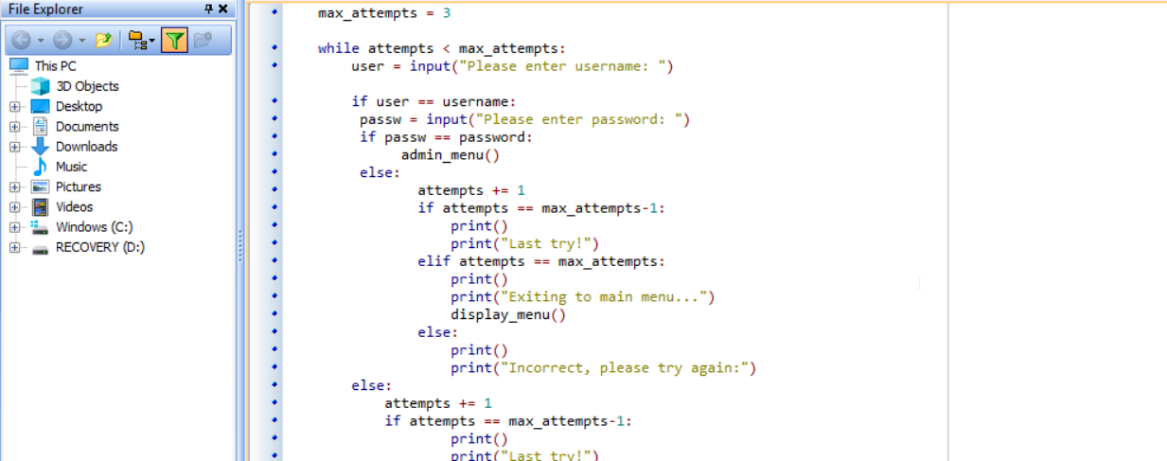

However, I eventually decided against this method, as it is not very secure, allowing the user to know if they managed to get the name of the user right, when they are not meant to get access to that part of the menu.

I instead decided to make it so that the validation for both the username and the password happens in one line. This means that the user cannot know which part of the login they got incorrect:

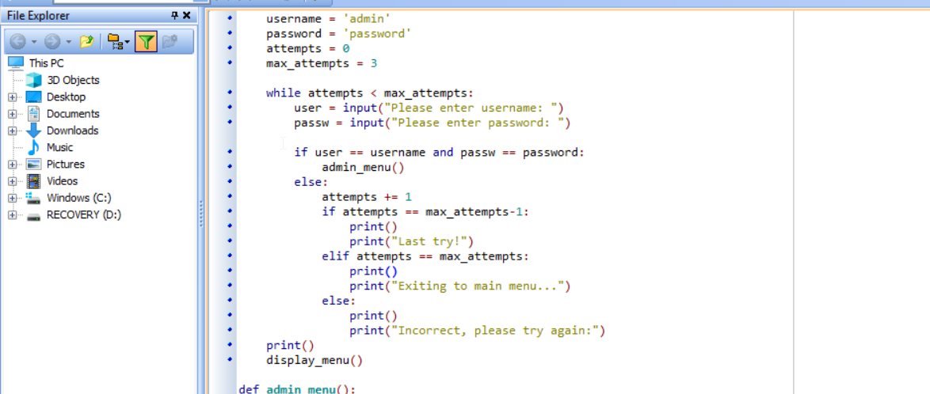

## Review of current stage 6

I have now been able to add both a menu and an admin for my user so that they can easily gain access to several of the functions in the program, and only the functions that don’t change any information in the database are given to the user. I went back to my stakeholders one more time to get their opinion with each of the functions.

|  |  |  |  |
| --- | --- | --- | --- |
| Key functions | Have the success criteria been met? | Feedback | How I plan to improve this function |
| Add package to the database | This meets the criteria allows the user to be able to add new packages to the package table | It was simple to the user how to input what they wanted into the record | No further improvements mentioned |
| Edit packages in the table | This meets the criteria that allows the user to be able to edit currently existing records in the table | It was simple to change the record they wanted changes for, however they could input any value outside the range of recordID’s and still input values and nothing would happen as that recordID does not exist. | I plan to include validation that means that only the recordID’s that actually exist in the table would be available to change. |
| Delete records in the table | This meets the criteria that allows the user to change information within the table. | It was simple to the user how to be able to delete the record, however if they inputted a value that does not exist, an error is returned. | To make sure the user cannot enter string values, and to only accept the values in range |
| Allow for function that allows distances to be found by storing latitudes and longitudes | The cities latitude and longitude have been stored in code, but not in a database. Partially met. | The user tested a couple of the distances with the real life distance and they were approximately similar, so they found that this function was very useful. | To be able to store the latitudes and longitudes in the database so that they don’t have to be directly added to code. |
| Have a function that allows the user to choose holiday they want | The user can choose which city they want to start from and the other cities that also fall under the list will be outputted in ascending order. This meets the criteria | The user tested this and it worked well when correct inputs were made. When incorrect ones were put in however, this caused the program to return an error and it automatically stopped | To include validation in the function so that the program does not crash during execution |
| Allow the user to choose how many cities they want to visit | This has not been met yet. | The user wants to add a limit because they may not want to go past a certain distance. | No further improvements mentioned |
| A menu that provides an interface for the user will be provided. | This now fully the success criteria, as there is now a menu and an admin menu to make it easier for the user to use functions | The users found that this was helpful in providing them an interface to easily gain access to the menu, and felt the admin menu was helpful so | No further improvements mentioned |

# Development

## Introduction

This section will be me explaining each of the different functions I created during my development and how I changed them overtime to be able to make them optimal for my overall program.

## Main Components

### Adding a new record to the table

#### Code

def add_city():

city = input("Enter the name of the city")

package = input("Enter the name of the type of package being offered")

hotel = input("Enter the name of the hotel")

cursor.execute("""INSERT INTO Package(City, Package, Hotel) Values(?,?,?)""", (city, package, hotel))

db.commit()

#### Intro

Because I decided to use a database in my program, there should be a way to be able to further add more records into the database regarding the city packages instead of them already existing in a database.

#### Prototype

This working version of my code allows the user to add a record that they want to include into the database. This function asks them for the city that they want to include, the type of package that it will fall under and the hotel that is a part of the offer.

##### How it hits the analysis criteria

This hits the required criteria that allows the user to have an easy time to change aspects of the database. It is clearly shown which function will allow the user to add a new city into this database and therefore allows an easy time changing information there.

##### What validation techniques have you used?

There are no validation techniques that are used in this part.

##### Testing

###### Proof of testing

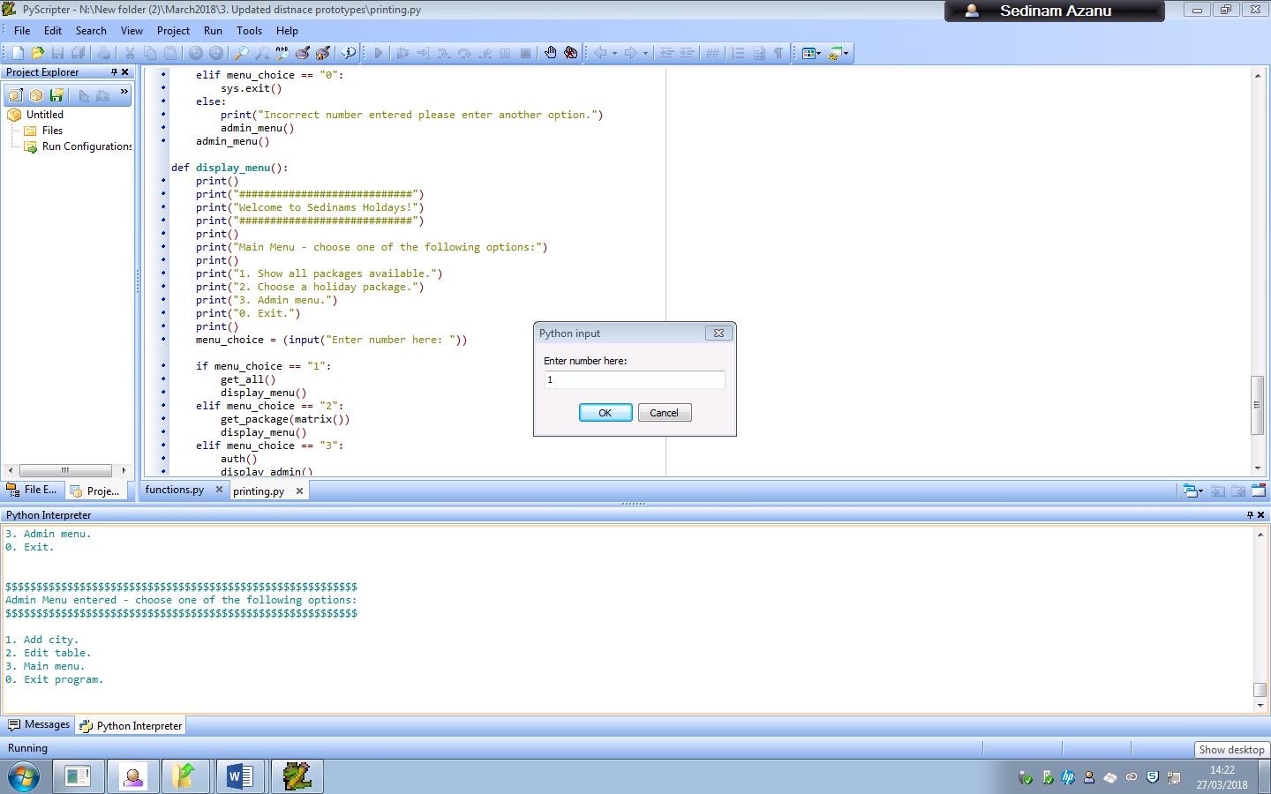

Entering 1 in the admin menu will allow the user to gain access to the add city function.

When the user enters the city, the package type and the hotel, it will then end up being in the package table.

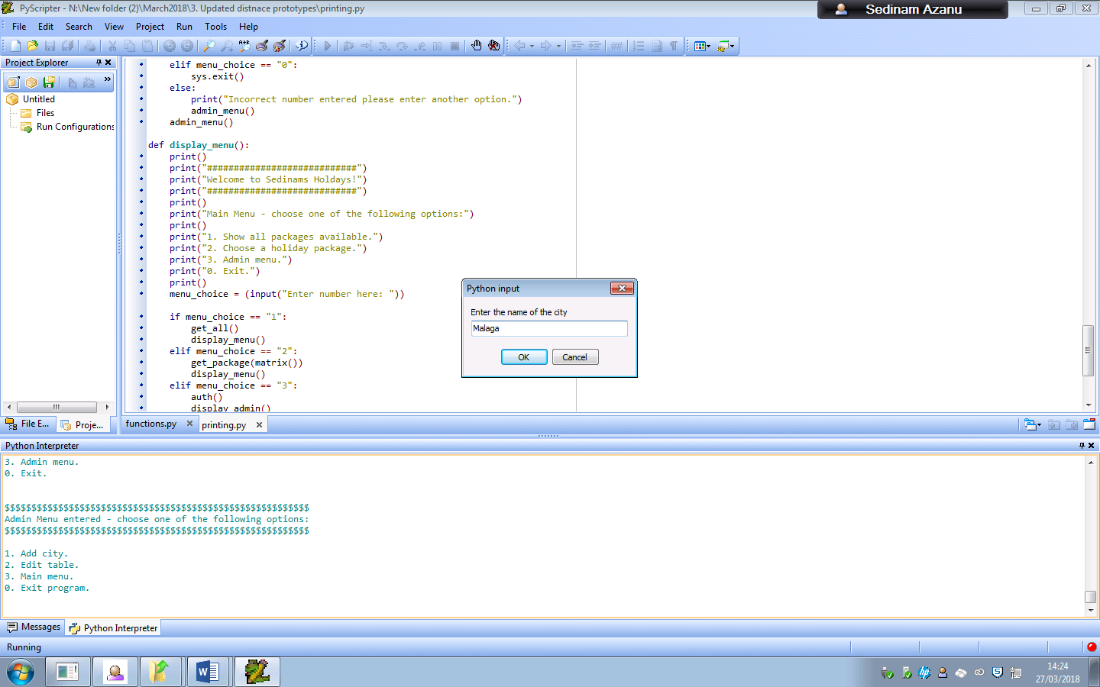

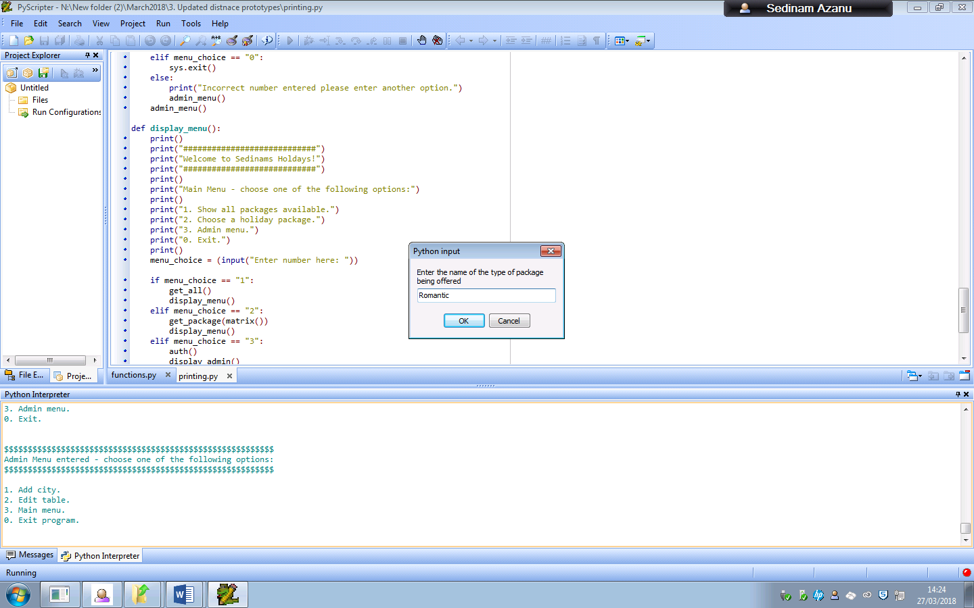

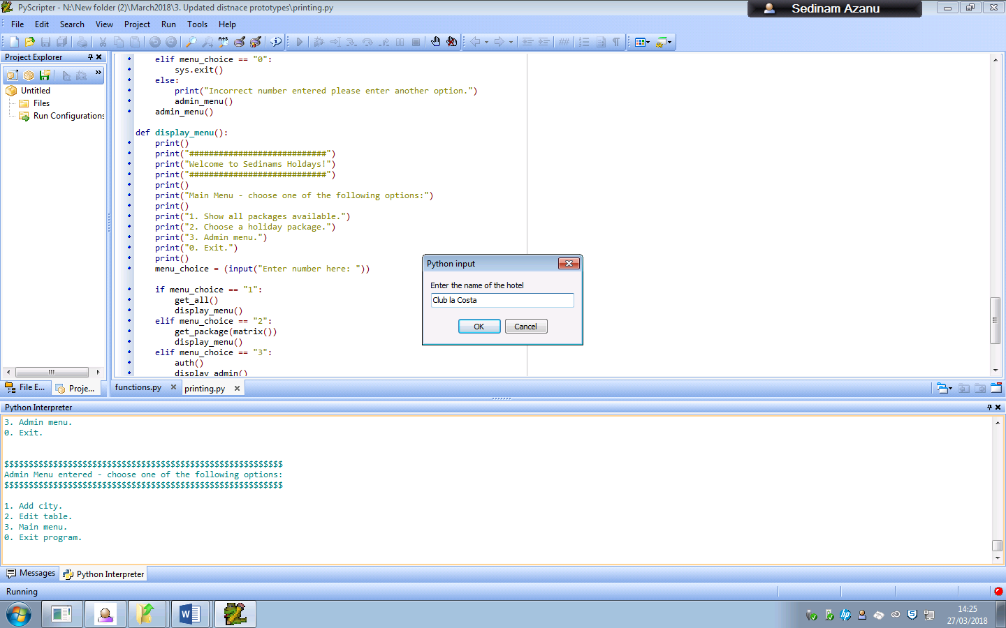

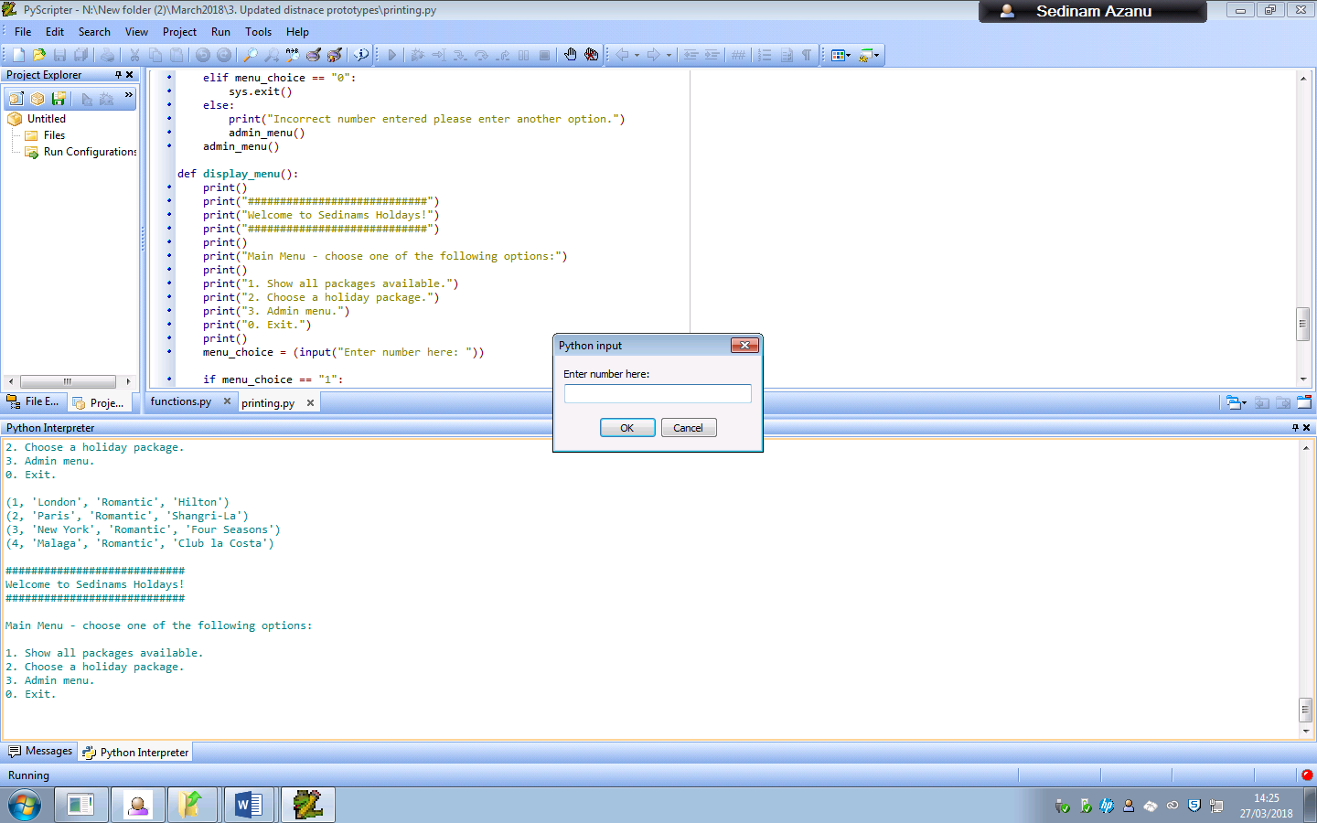

###### Problems

The user can enter unrealistic city, hotel and package name types whilst inputting these values, which may be accidental or intentional.

A method that I could use to counteract this would be to add a limit to the number of characters that the user will be allowed to enter. For example, the longest city name in the world is “Llanfairpwllgwyngyllgogerychwyrndrobwllllantysiliogogogoch” which is in Wales.

###### Action taken

I decided to input a limit to the amount of characters the user could input into this so that they cannot input unrealistic values.

###### Working version

New add city code:

def add_city():

city = input("Enter the name of the city")

while len(city)>len("Llanfairpwllgwyngyllgogerychwyrndrobwllllantysiliogogogoch"):

print("Please put in a serious city name")

city = input("Enter the name of the city")

package = input("Enter the name of the type of package being offered")

while len(package)>len("Disney Package"):

print("Please put in a serious package name")

package = input("Enter the nam of the type of package being offered")

hotel = input("Enter the name of the hotel")

while len(hotel)>40:

print("Please enter a seroius hotel name")

hotel = input("Enter the name of the hotel")

cursor.execute("""INSERT INTO Package(City, Package, Hotel) Values(?,?,?)""", (city, package, hotel))

db.commit()

I decided to test this to see if inputting the unrealistic values would work for the code. For each of these inputs I inputted the character A 50 times for each of them.

When I inputted a value longer than the name of the longest city, I received this output:

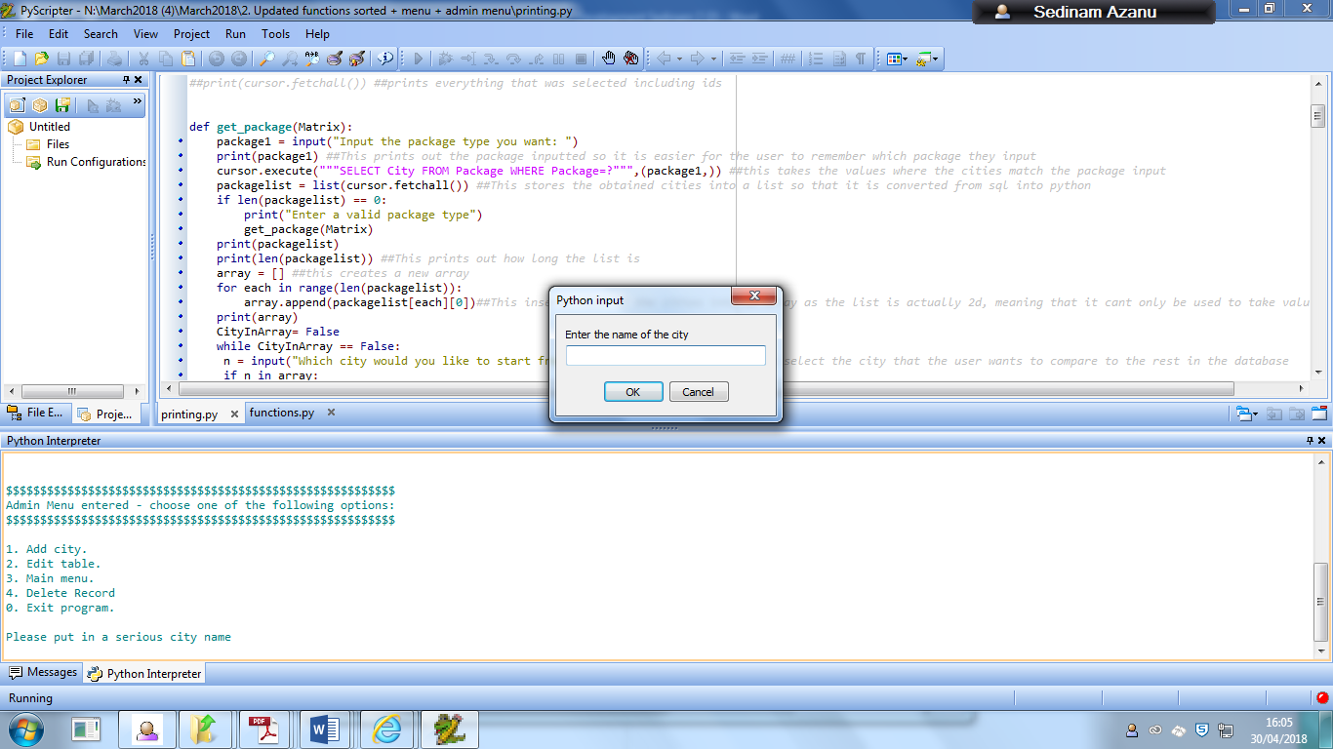

When I inputted a very long package name, I received this output:

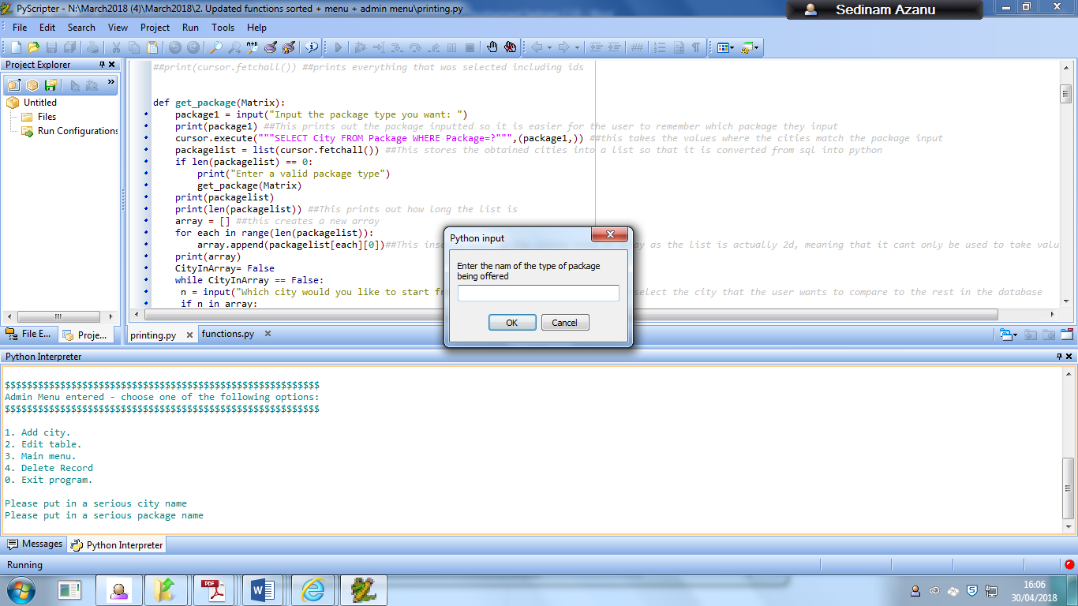

When I inputted a very long hotel name, I received this output:

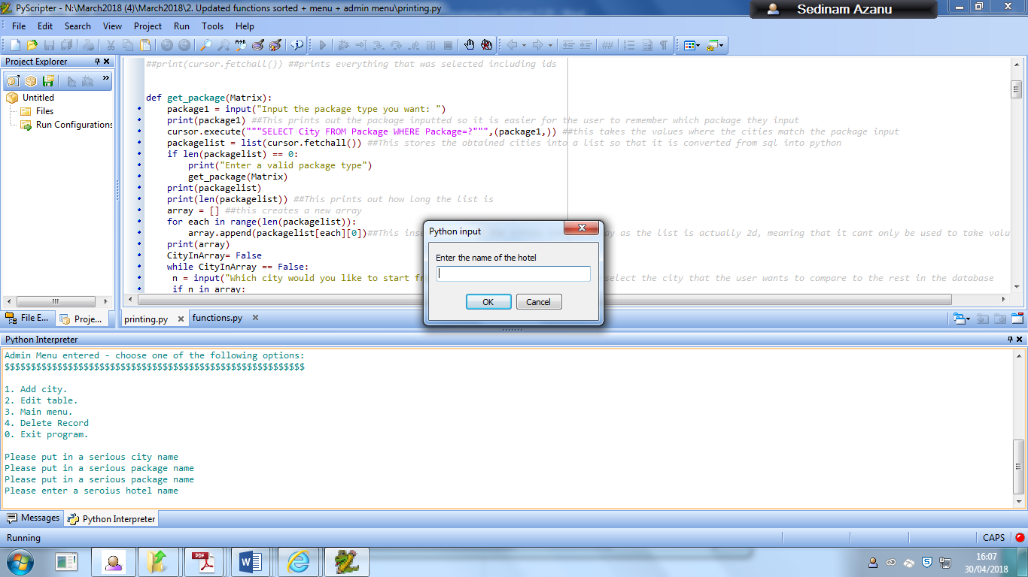

##### What validation techniques have you used?

There is a character limit for each of the inputs which the user cannot go over, where if they do they will be met with an error message.

### Deleting record from the table

#### Prototype 1

def delete_city():

get_all() ##this is the function which outputs every record currently in the database

recordid = int(input("Which record in the table would you like to delete"))

cursor.execute("""DELETE FROM Package WHERE PackageID =?""",(recordid,))

db.commit()

get_all()

#### Intro

Because I decided to use a database in my program, there should be a way to be able delete records in the database that are no longer required and cannot be replaced by another package

#### Working version

This working version of my code allows the user to delete any record in the table when they input the record of the record that they want to get rid of.

##### How it hits the analysis criteria

This hits the required criteria that allows the user to have an easy time to change aspects of the database. It is clearly shown which function will allow the user to remove packages from the table, and how to delete it.

##### Testing

###### Proof of testing

Entering 4 in the admin menu allows the user to be able to access the function which allows the user to choose which record they would like to delete.

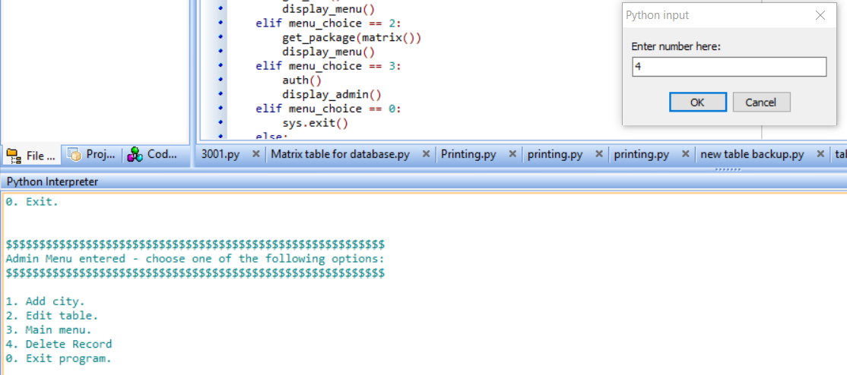

The user is then asked which record they would like to delete from a list of outputted ones. In this case I will input 3 to be deleted

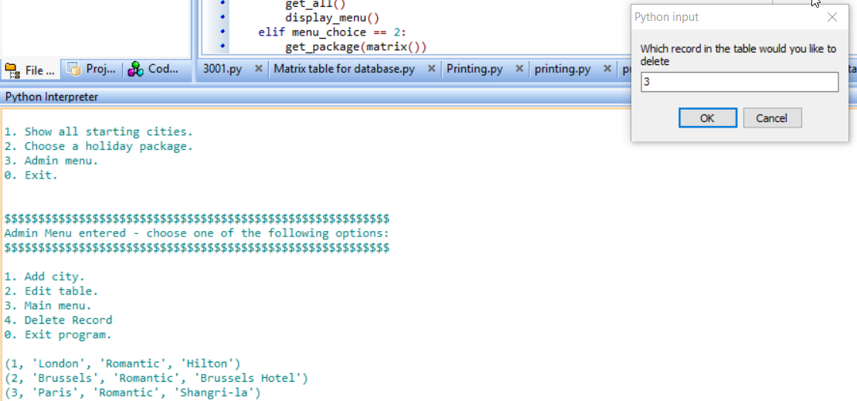

The updated record is now posted below the old one, and the user is returned to the admin menu.

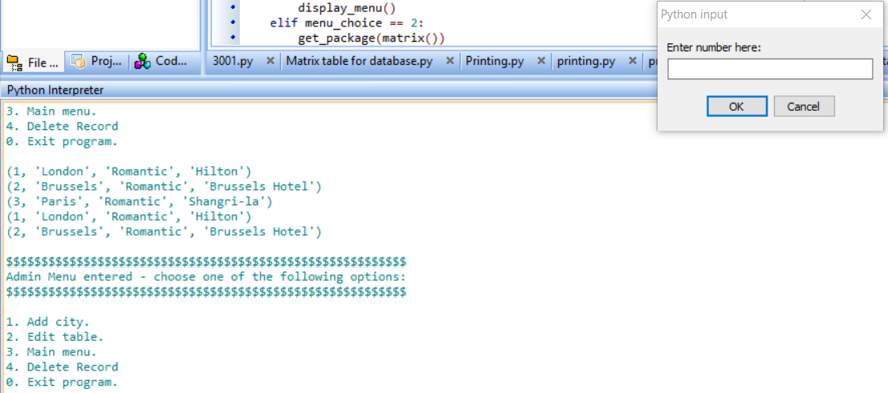

###### Problems

The user can enter any recordID into the code and the program will still go on with deleting the record, even if it doesn’t exist, however nothing will happen. Also if the user enters a string, an error will be outputted

A method that I could use to counteract this would be to take all the recordID values and store them in another array. Afterwards the code would check to see if the recordID exists in the table. If the ID does exist, it would let the user continue with editing that specific recordID, else it would tell them that the value that they entered is invalid.

###### Action taken

I decided to change the code so that it would check to see if the values that the person was entering were valid so that they won’t receive errors afterwards.

###### Working version

### Queries ###

def get_all():

for package in cursor.execute("SELECT * FROM Package"): ##selects everything from the package

print(package) ##prints everything that was selected including ids

Delete table function

def delete_city():

get_all() ##this is the function which outputs every record currently in the database

try:

recordid = int(input("Which record in the table would you like to delete"))

except ValueError:

print("Enter a valid RecordID")

edit_table()

cursor.execute("""SELECT PackageID FROM Package""")

recordlist = list(cursor.fetchall())

print(recordlist)

array = [] ##this creates a new array

for each in range(len(recordlist)):

array.append(recordlist[each][0])##This inserts each of the recordIDs into an array to see which currently exist in the table

print(array)

if recordid in array:

print("RecordID is valid")

else:

print("Enter a valid RecordID")

edit_table()

cursor.execute("""DELETE FROM Package WHERE PackageID =?""",(recordid,))

db.commit()

get_all()

The update includes a try function so that the user cannot enter any string values, and the recordID’s inputted into the array will be compared with the inputted values to see if they are correct, otherwise they will be returned an error.

For example, if the user enters a string:

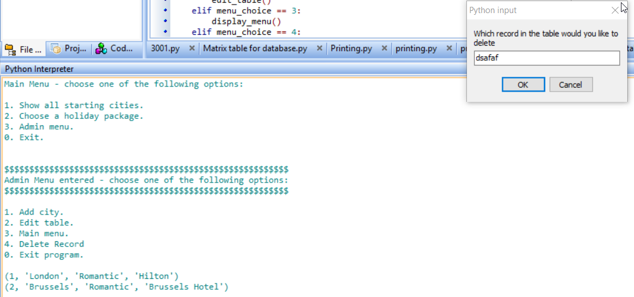

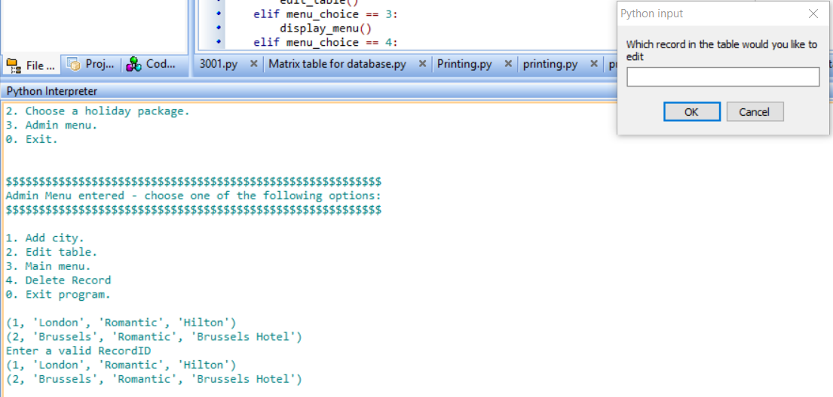

And if the user enters a value that is not in range:

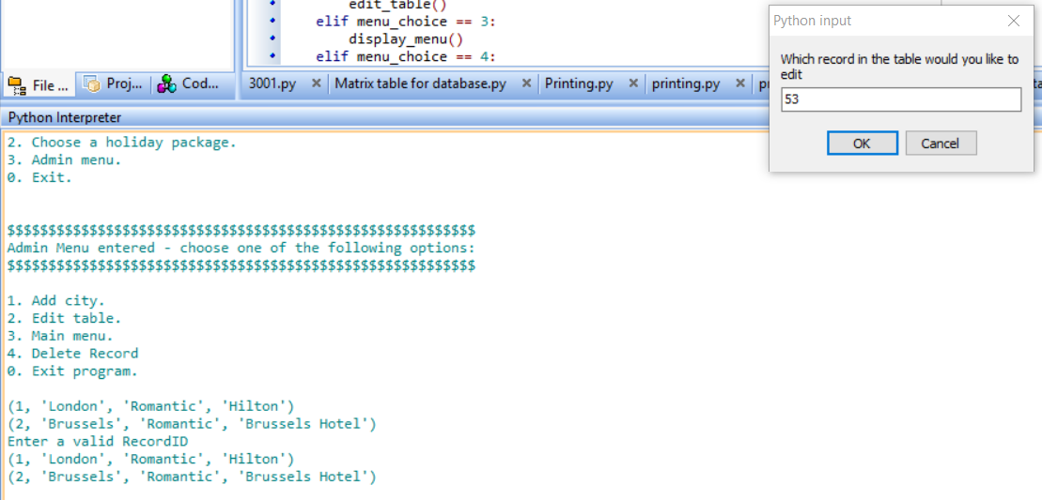

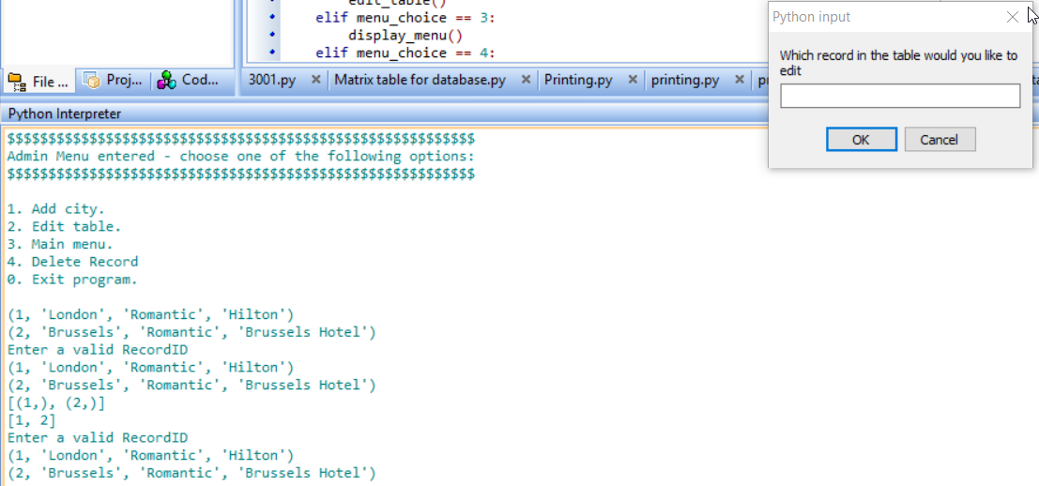

And if the user enters a value that is in range:

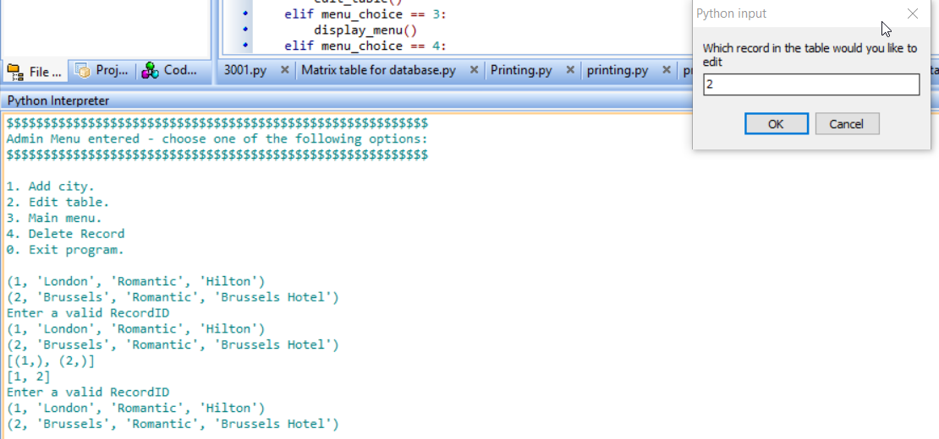

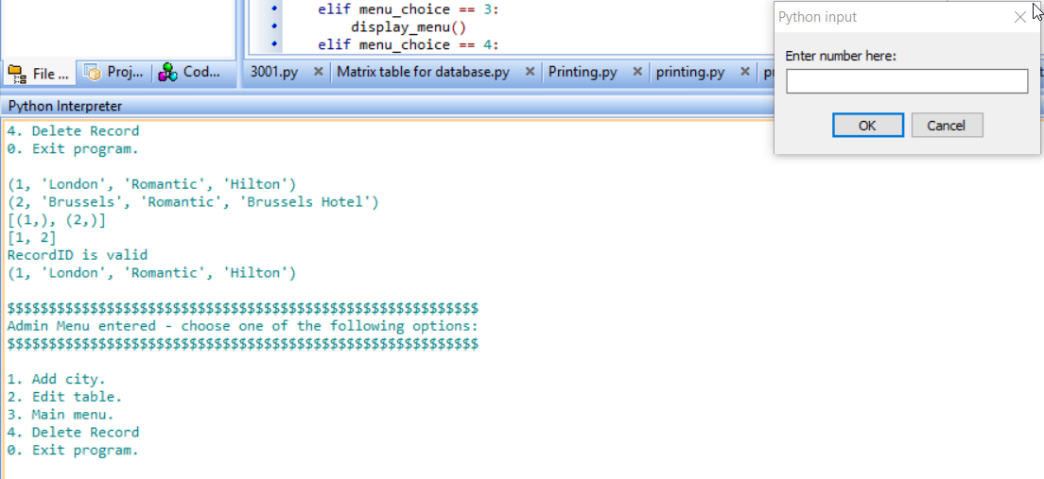

Therefore, this shows that it still works for all values and now has the required validation so that the user does not enter invalid values

##### How it hits the analysis criteria

This hits the criterion:

* For the user to have an easy time being able to change any aspects of the package database that may require changing. For example, if a new record needs to be added or a record needs to be changed, those functions can easily be accessed and used without any problems occurring. The maintainability will involve updating and adding new packages and cities that may later be available for offer.

As this function allows for the user to be able to change record information in the database by allowing the user to be able to delete a record from the table. The user can get access to the admin menu then get to the function from there, which allows them to delete a record of their choice.

##### What validation techniques have you used?

This checks to see if the user is using a recordID that exists in the table otherwise they will be given an error message, and also will not work if the user is attempting to use a string as an input.

### Updates any of the current records in the table

#### Intro

If any of the information that is in the database is outdated or requires changing, it would not be optimal to keep that data there, therefore I decided to include in my program a function that allows the user to change the information given the record ID of what they want to change.

#### Prototype 1

def edit_table():

editinput = input("Which record in the table would you like to edit")

city = input("What would you like the new city to be named?")

package = input("What would you want the new package to be named?")

hotel = input("What would you want the new hotel to be named?")

cursor.execute("""UPDATE Package SET City = ?, Package=?, Hotel=? WHERE PackageID = ?""", (city, package, hotel, editinput))

db.commit()

#### Working version

This function prints out all the current records in the package table and asks the user which record they would like to change. I feel this is useful in case the user is unsure of the location of the record they want changing and this would allow them to see which record requires changing. After they have put in the Package ID of the package they want to have changed, they will be asked for an input of the city, package and the hotel type that they want so that the information in the table can be updated according to the new information that they put in.

##### How it hits the analysis criteria

This hits the criterion:

* For the user to have an easy time being able to change any aspects of the database that may require changing. For example, if a new record needs to be added or a record needs to be changed, those functions can easily be accessed and used without any problems occurring. The maintainability will be regarding updating and adding new packages and cities that may later be available for offer.

As this requires the user to be able to change or edit parts of the table by using these functions, which I have created as shown.

##### Testing

###### Proof of testing

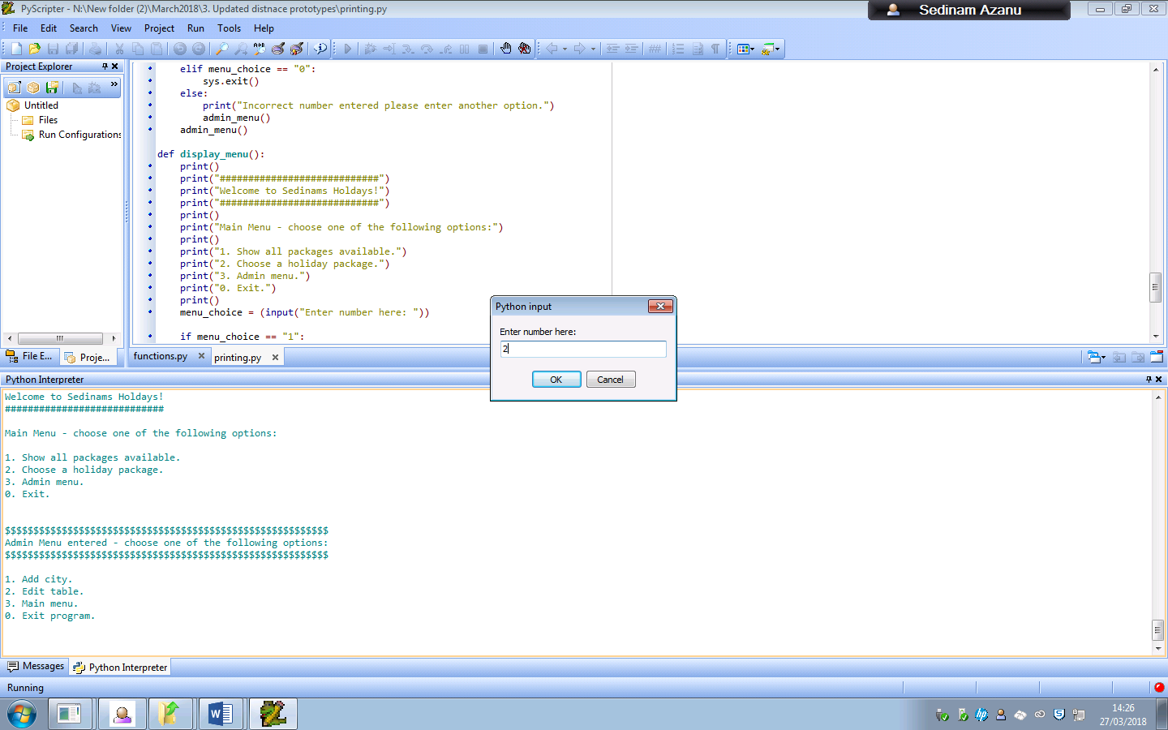

To gain access to this function, the user would enter 2 from the admin menu so that they would be able to change the record of their choice

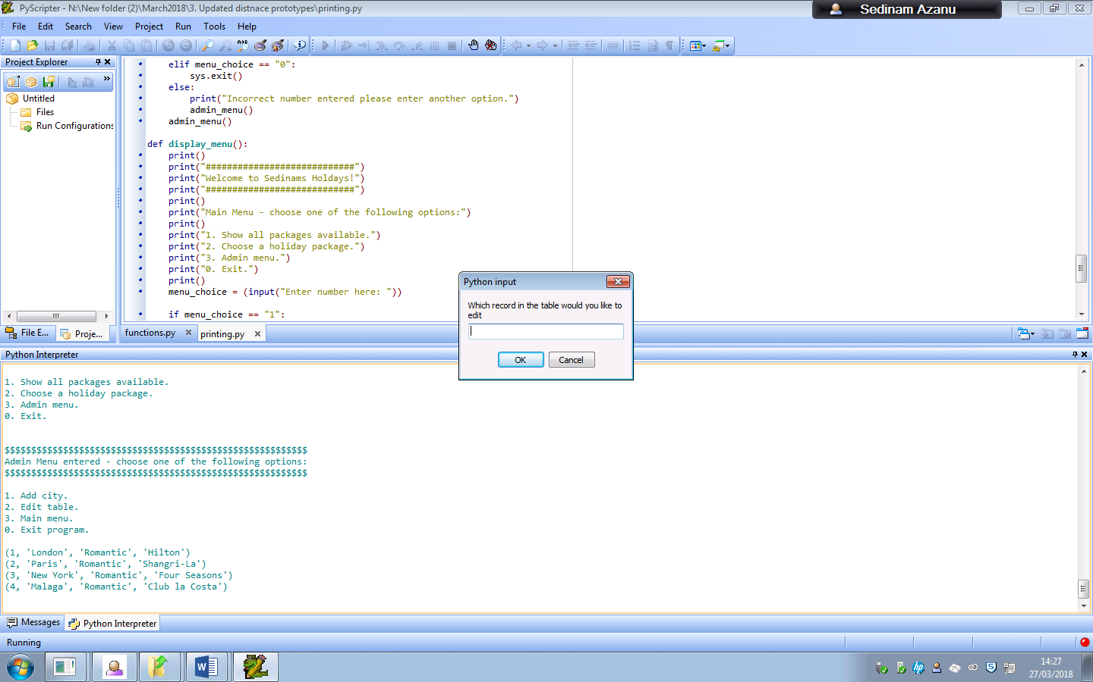

The program would then output the records that currently exist in the table so that the user would be able to know which of the records they would be able to update as a result.

For example, I am going to update the fourth record, Malaga.

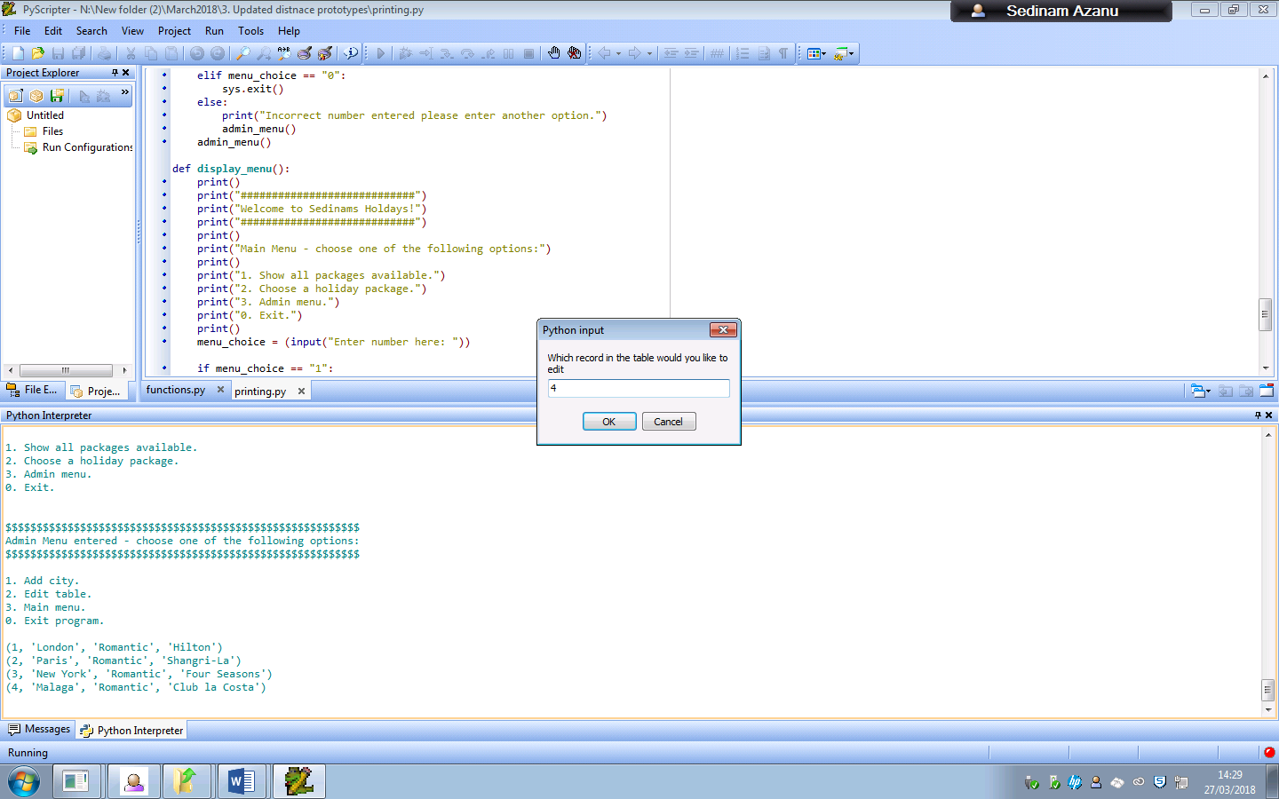

Entering 4 means that I will be able to change the values of that fourth record

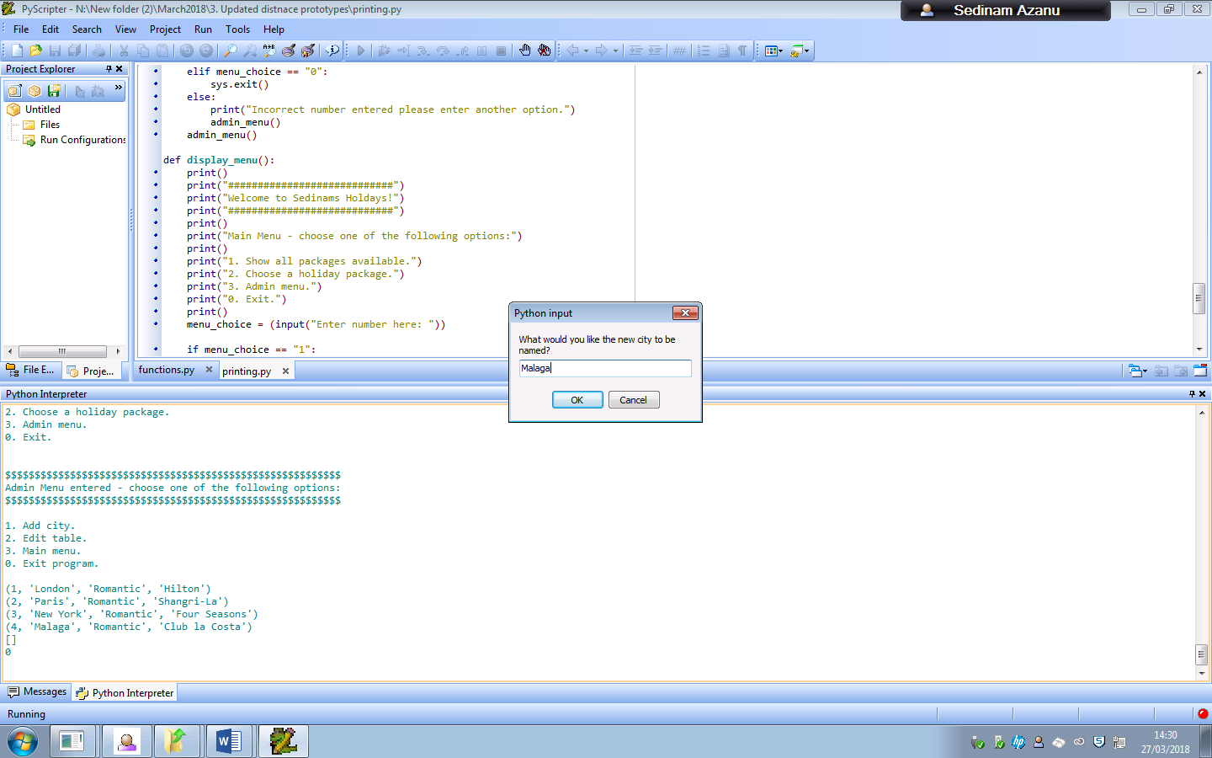

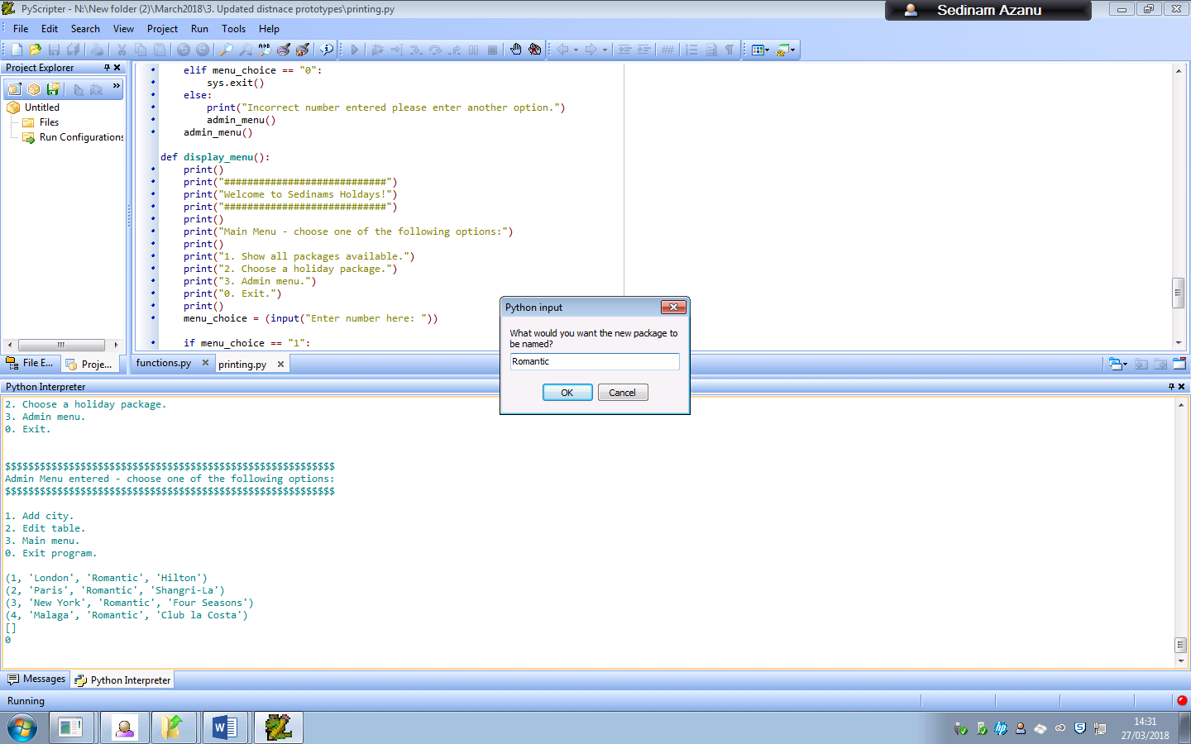

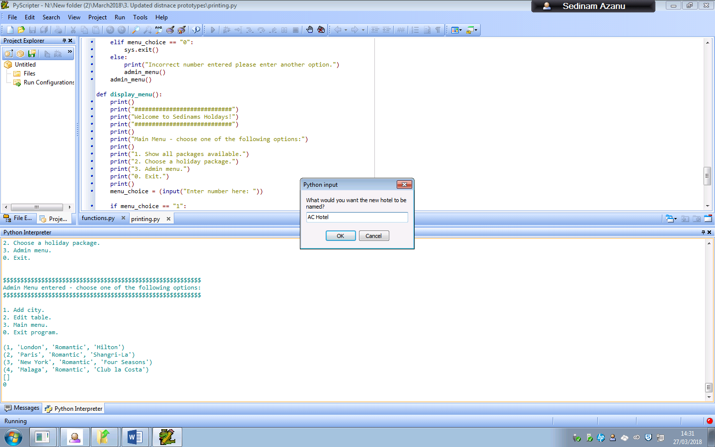

I decided I was going to change the name of the hotel in the record, so when I decide to view all the current records in the table, only the hotel name would have changed.

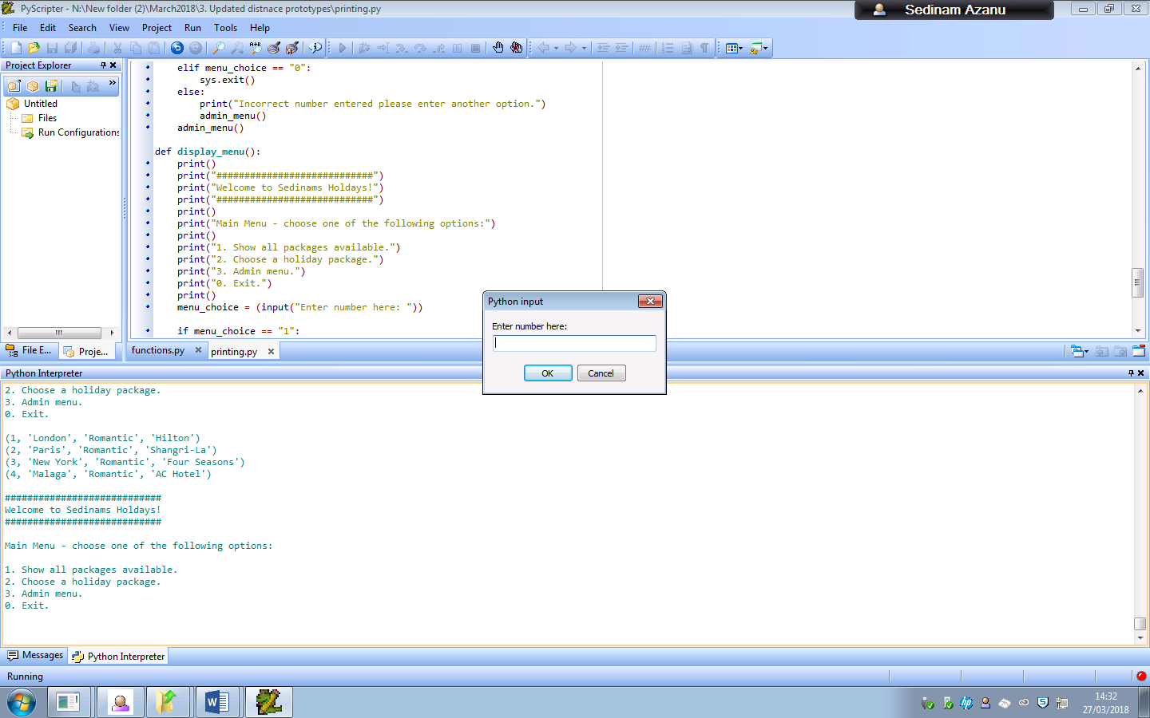

This is the result when I change the record values. The hotel club la costa has changed to AC Hotel instead.

###### Problems

The user can enter any recordID into the code and the program will still go on with updating the record, even if it doesn’t exist, however it will not appear in the database.

A method that I could use to counteract this would be to take all the recordID values and store them in another array. Afterwards the code would check to see if the recordID exists in the table. If the ID does exist, it would let the user continue with editing that specific recordID, else it would tell them that the value that they entered is invalid.

###### Action taken

I decided to change the code so that it would check to see if the values that the person was entering were valid so that they won’t receive errors afterwards.

I also added a get_all() function in the function which prints all the records currently in the table. This makes it easier for the user to know what information is currently available in the database.

###### Working version

### Queries ###

def get_all():

for package in cursor.execute("SELECT * FROM Package"): ##selects everything from the package

print(package) ##prints everything that was selected including ids

Edit table function

def edit_table():

get_all()

try:

editinput = int(input("Which record in the table would you like to edit"))

except ValueError:

print("Enter a valid RecordID")

edit_table()

cursor.execute("""SELECT PackageID FROM Package""")

recordlist = list(cursor.fetchall())

print(recordlist)

array = [] ##this creates a new array

for each in range(len(recordlist)):

array.append(recordlist[each][0])##This inserts each of the cities into an array as the list is actually 2d, meaning that it cant only be used to take values

print(array)

if editinput in array:

print("RecordID is valid")

else:

print("Enter a valid RecordID")

edit_table()

city = input("What would you like the new city to be named?")

package = input("What would you want the new package to be named?")

hotel = input("What would you want the new hotel to be named?")

cursor.execute("""UPDATE Package SET City = ?, Package=?, Hotel=? WHERE PackageID = ?""", (city, package, hotel, editinput))

db.commit()

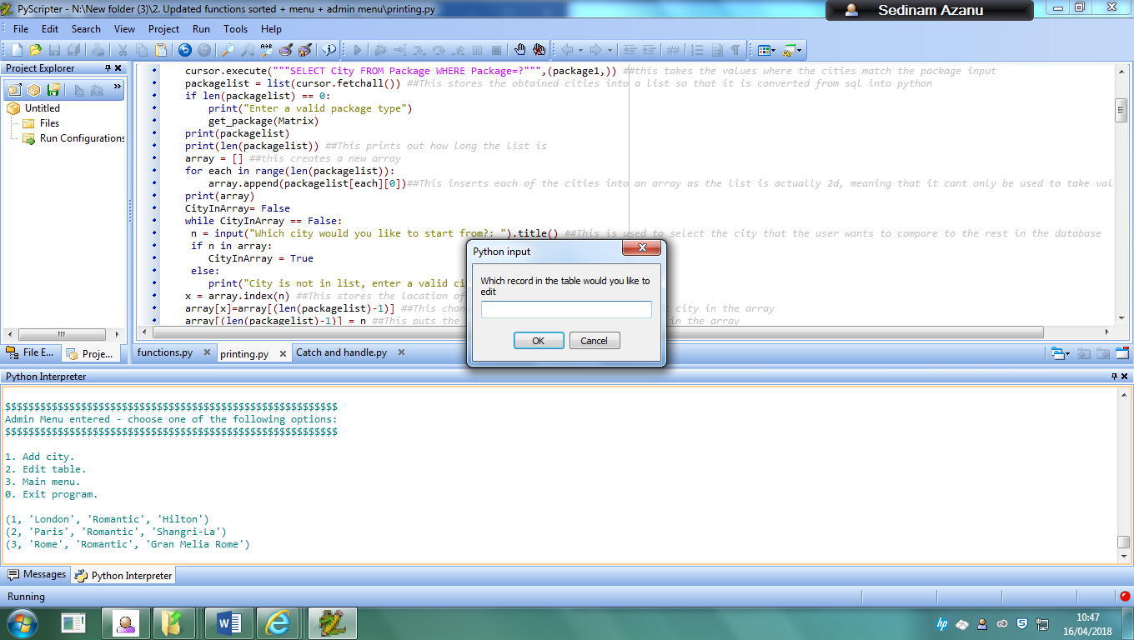

The get_all() function is used when the user gets access to the edit table function to show them what records currently exist in the table.

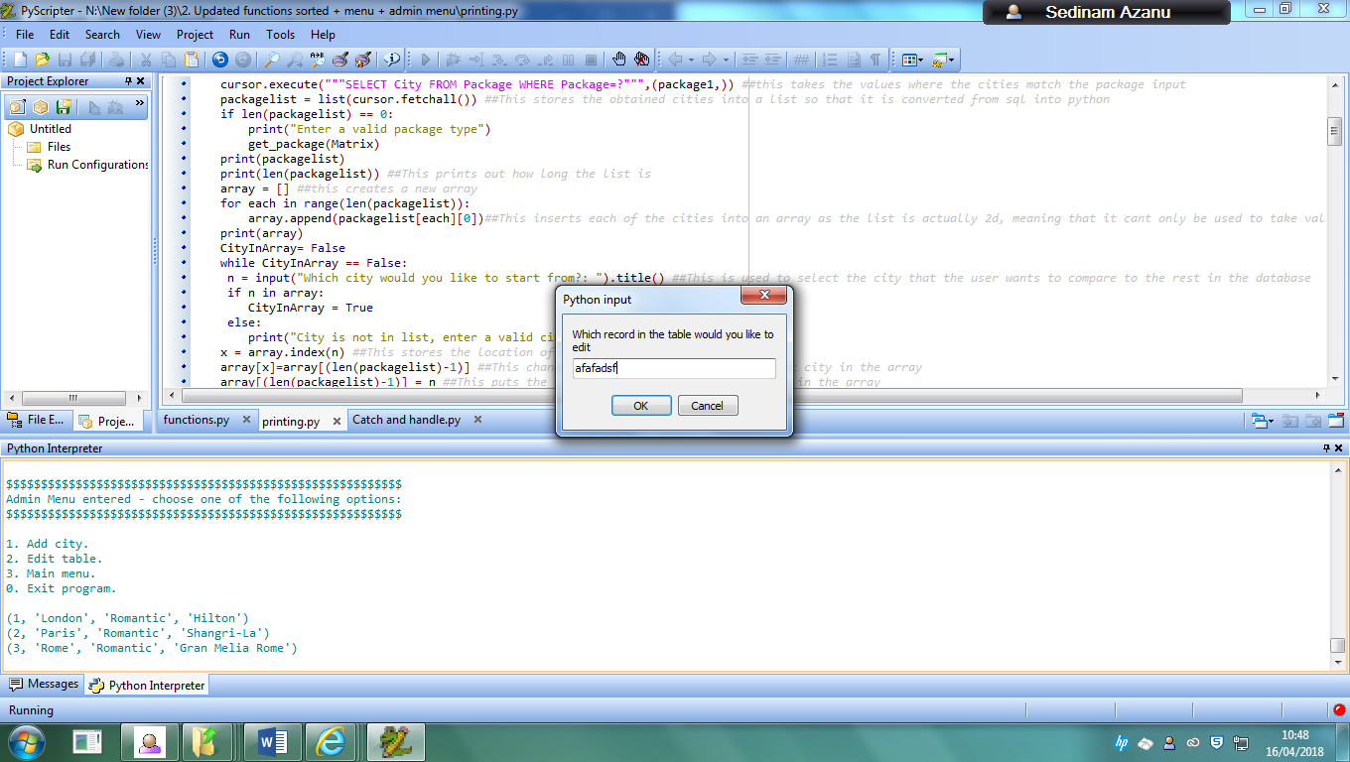

This screenshot above shows the user about to enter a string value into the function. As the code only accepts integers, the error will be caught and the user will be told to enter a valid value.

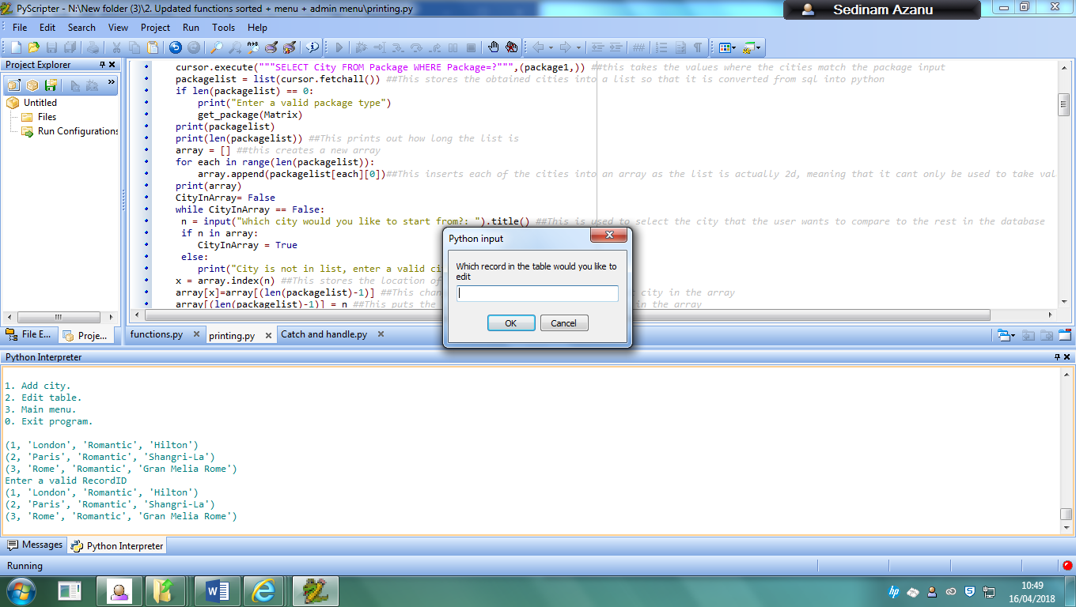

The screenshot above shows what is returned when the user enters a string value.

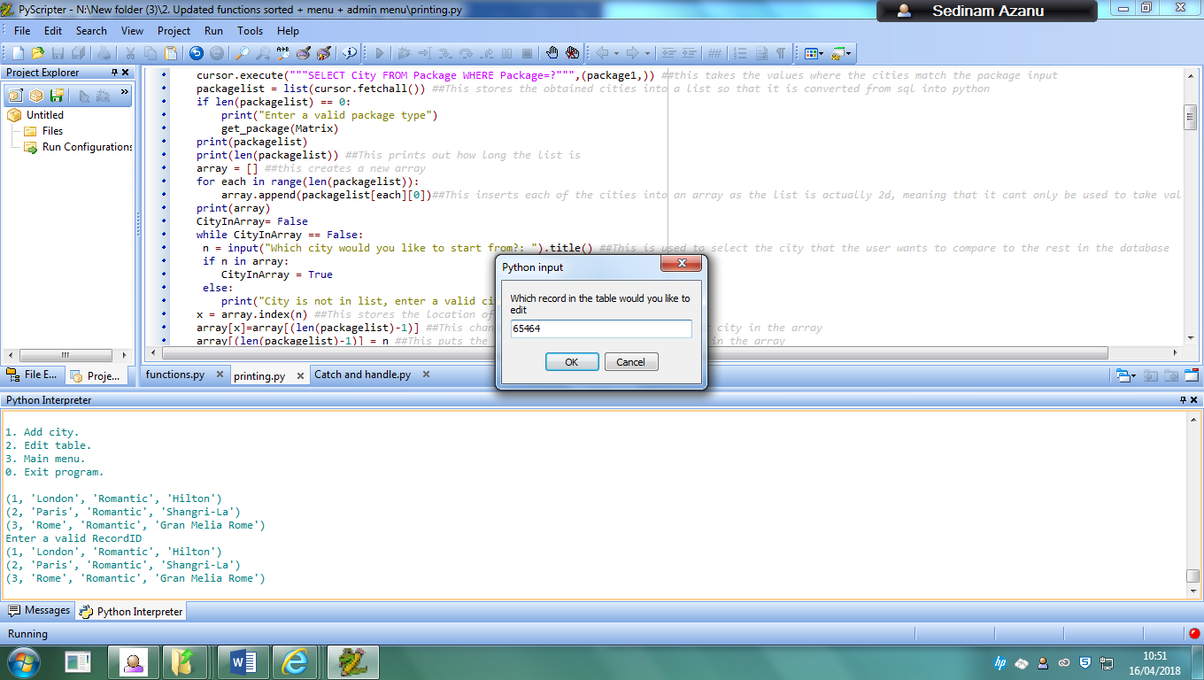

This above screenshot shows that the user is going to enter a recordID that does not currently exist in the table. 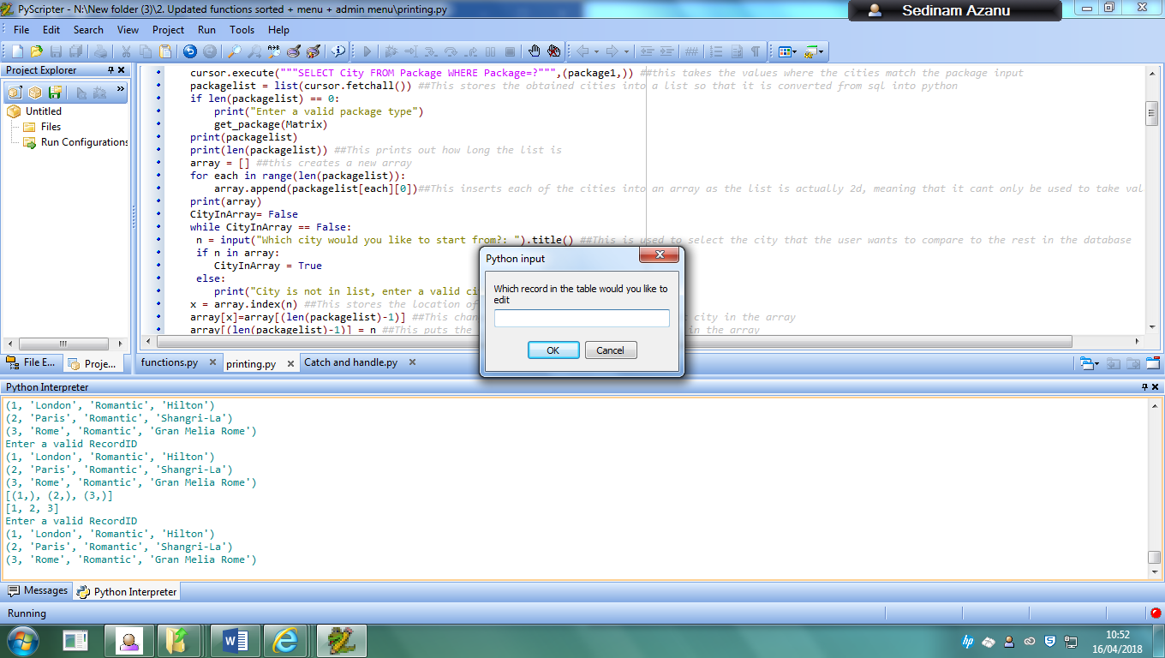

The number values show the recordID that are currently available in the table. Since the value the user entered does not exist in that array, it would return an error telling the user to enter a valid recordID. After this when the user enters a valid value, the program would work as normal.

##### What validation techniques have you used?

This checks to see if the user is using a recordID that exists in the table otherwise they will be given an error message, and also will not work if the user is attempting to use a string as an input.

### Distance matrix, using haversine algorithm which finds distance between cities in the matrix

#### Intro

This next module I made for my project will be used to find the distance between the cities that the person using the program wanted to visit for their holiday.

#### Prototype 1: Pandas

##### What is it?

The first prototype I attempted to use for this part of my program was the pandas module that can be used in python. This software library allows for data manipulation and analysis, especially offering data structures and operations that can manipulate numerical tables and time series. I was planning on creating a table in my program to store each of the cities and their distances from each other.

##### Did it work? Did you use it? If not, why?

I did not end up using this due to the fact that I was not able to install the library because I kept getting errors from the installation program, so I ended up not using this module and instead looked for alternatives. Another main issue is inputting new cities into the table would have taken longer as the amount of cities in the table began to increase.

#### Prototype 2

##### What is it?

The next prototype I attempted to use was to use code that allowed me to find the distances between two different sets of coordinates on a 2d plane.

##### Did it work? Did you use it? If not, why?

I did not end up using this due to the fact that this only works in a 2d plane, meaning that it would not work for finding the distance between cities due to the fact that the earth is round, meaning that data like the fact that the earth is a sphere would have to be taken into consideration whilst trying to find this distance.

#### Working version

Haversine formula, which finds distance between two points on a sphere given latitude and longitude.

##### Intro

This final working version of the program uses the haversine formula to be able to find the great-circle distance between two points on a sphere given their longitudes and latitudes. The great circle distance is the shortest distance between two points on the surface of a sphere, measured along the surface of the sphere, instead of a straight line that would go through the inside of a circle. This formula I felt would be more useful towards my program due to the fact that it takes into consideration the radius of the earth due to being a formula that finds locations on a sphere, and with the earth being a sphere this would be more suitable in finding distances.

##### How it hits the analysis criteria

This function firstly meets the criteria:

* For a distance matrix to be included within the code, so that all the distances between each of the cities can be stored in the code, and for new cities to be able to be inputted so that distances can be found for the user without having to research all this information.

as with the function that this was used for, after finding the distances between two specific cities, they are stored in part of the matrix and this code continues until there are no more cities that can be compared in the list.

##### Code

def matrix():

##approx radius of earth in km

radius = 6373.0

cords = {} ##This creates the dictionary to store the values

cords['Paris'] = (radians(48.864716), radians(2.349014))

cords['London'] = (radians(51.509865), radians(-0.118092))

cords['New York'] = (radians(40.730610), radians(-73.935242))

cords["Malaga"] = (radians(36.721274), radians(-4.421399))

cords["Brussels"] = (radians(50.8504500), radians(4.3487800))

cords["Toronto"] = (radians(43.761539), radians(-79.411079))

cords["Berlin"] = (radians(52.520008), radians(13.404954))

cords["Sydney"] = (radians(-33.865143), radians(151.209900))

cords["Dubai"] = (radians(25.276987), radians(55.296249))

cords["Orlando"] = (radians(28.538336), radians(-81.379234))

def dist(coor1, coor2): ##This function I found in javascript and modififed it to allow it to work in python

m = [coor1[0] - coor2[0], coor1[1] - coor2[1]] ##This finds out the x distance and the y distance between the two points

c = sin(m[0]/2)**2 + cos(coor1[0])*cos(coor2[0])* sin(m[1]/2)**2 ##This is the haversine formula that is used to find the great-circle distance between two points on

p = 2* atan2(sqrt(c), sqrt(1-c)) ##a sphere given their longitudes and latititudes.

distance = p*radius

return distance

Matrix = {} ##This creates the dictionary for the matrix

'''for items in cords.items():

print(str(items))'''

for city1, cords1 in cords.items(): ##This finds any of the data values in the dictionary and iterates until all data values have been found

Matrix[city1] = {} ##This creates the heading for the first city in the dictionary

## print(city1, cords1)

for (city2, cords2) in cords.items(): ##This finds the second city to compare to the first city to.

Matrix[city1][city2] = dist(cords1, cords2) ##This stores the distance between the two cities after the funciton is completed

'''for city1, x in Matrix.items(): ##This finds each of the fields and all of the column values that follow them. x is the value of the second dictionary

##This is repeated until all the cities in the table have been found

for city2, d in x.items(): ##This finds in the second dictionary the city and the value attached to that city, which was found with the dist() function

print (city1, city2, d) ##This finds all of the values found and prints them.#'''

return Matrix

##### Testing

###### Proof of testing

To test this section, I decided to use a website called snakify.org to show the step by step way that my program is able to create the matrix, due to the fact that the user cannot input anything in this function. I removed some of the cities as there were too many for the site to be able to show step by step methods.

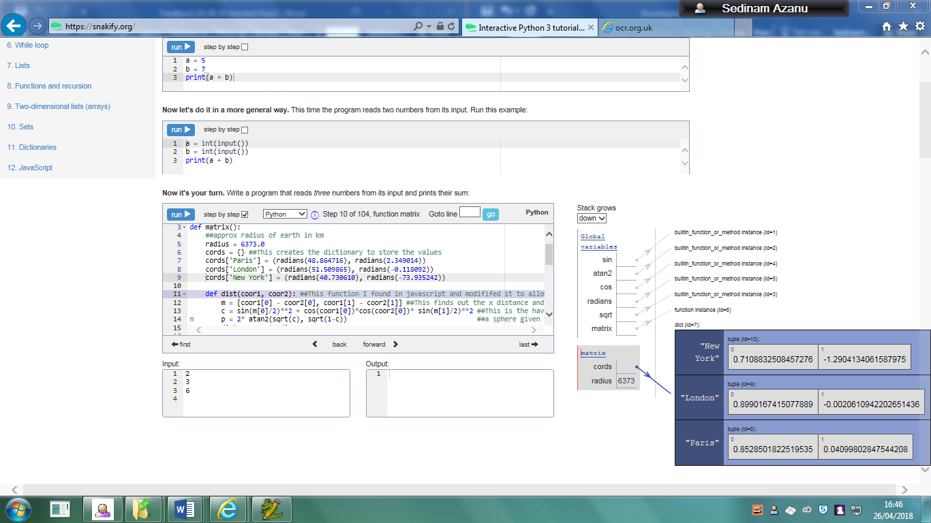

This shows the array that stores each of the cities and their latitude and longitude in radians so that it can be used in the havesine formula

The program then makes an empty matrix which will eventually store the distances. It is empty so it is not shown yet.

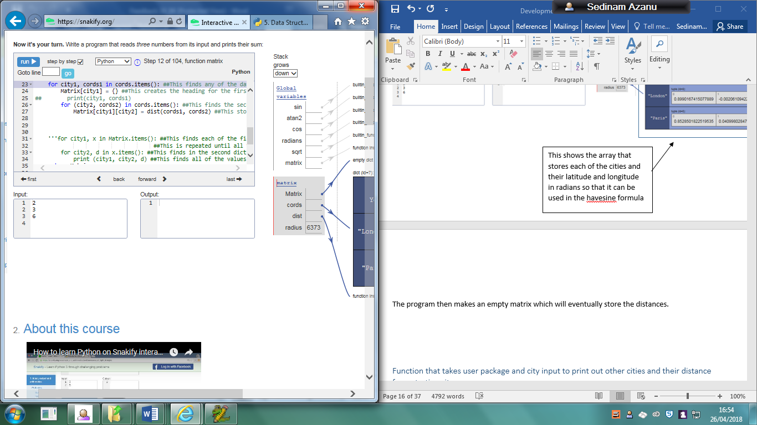

The first heading for the matrix is then made in the program

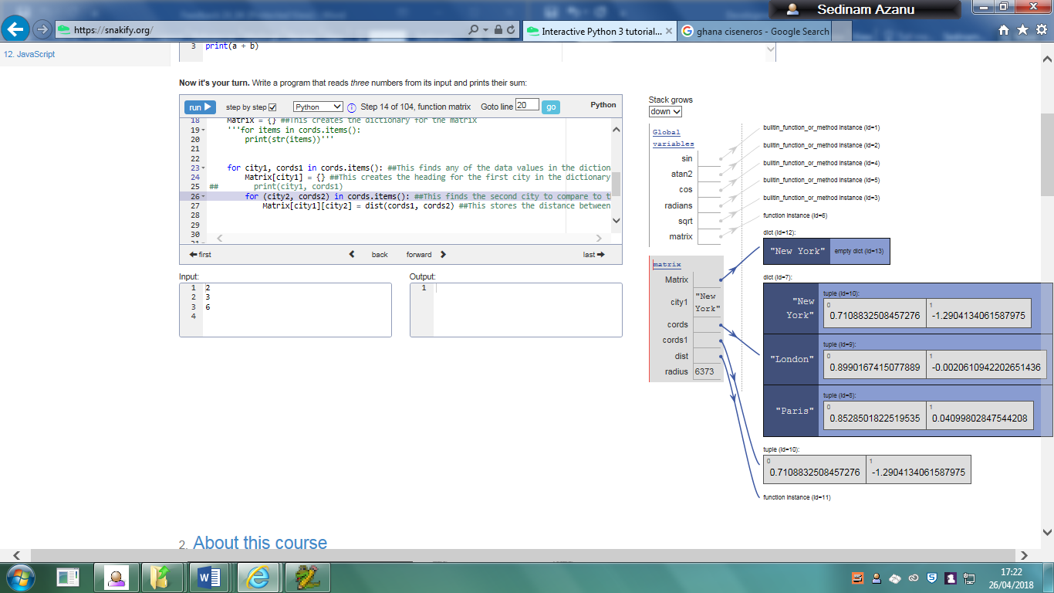

The program then collects the city name and coordinates of the first city in the list, and then gets the coordinates of the two selected cities so that the distance function can be run.

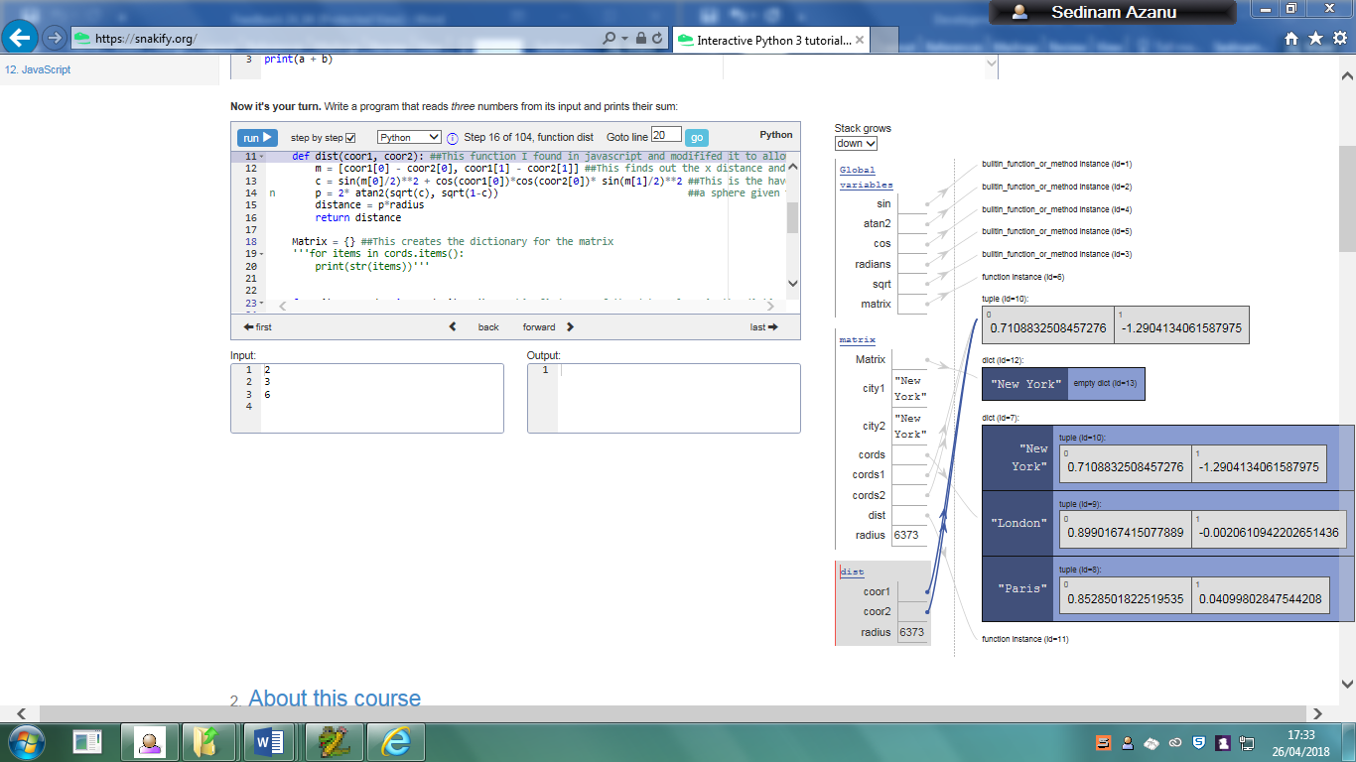

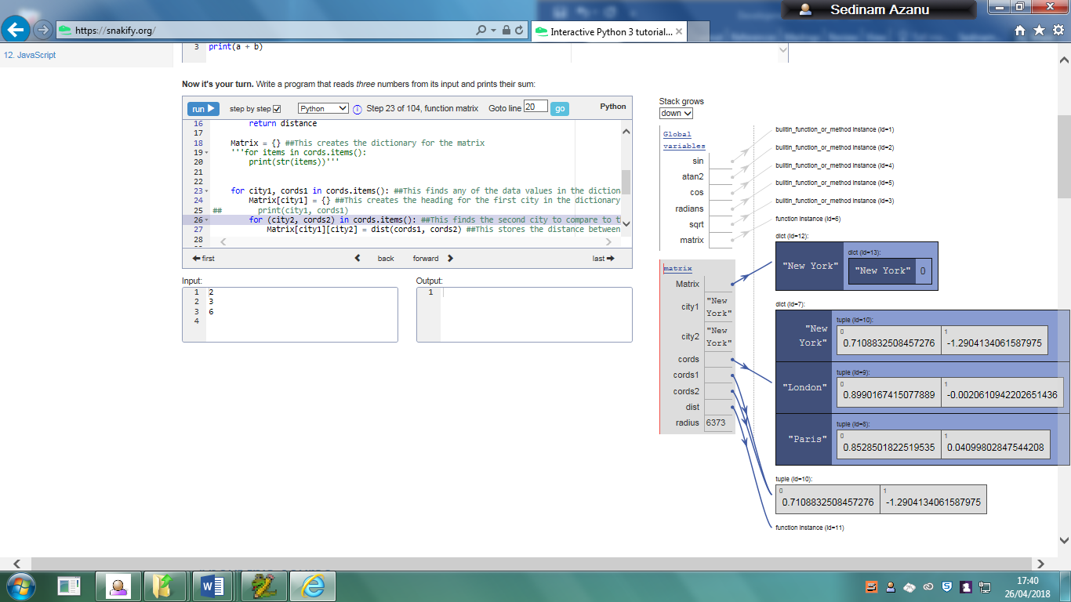

Due to the same city being compared, the distance is 0.

The next cities latitude and longitude are then collected to be compared with the first city.

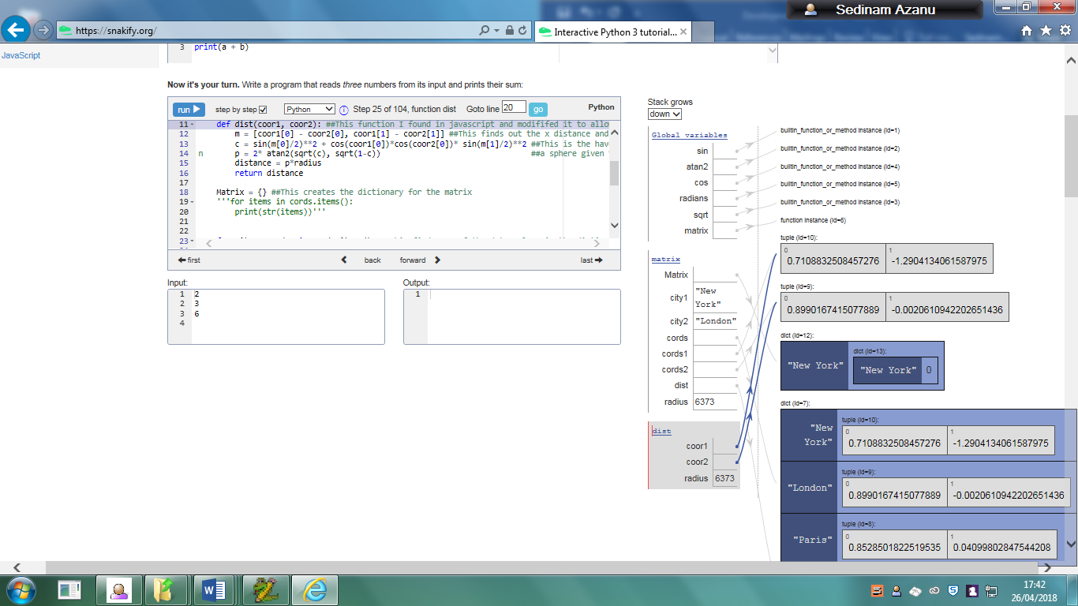

The algorithm that then finds the distance is then used again, except with two different latitudes and longitudes. The cities being compared are London and New York

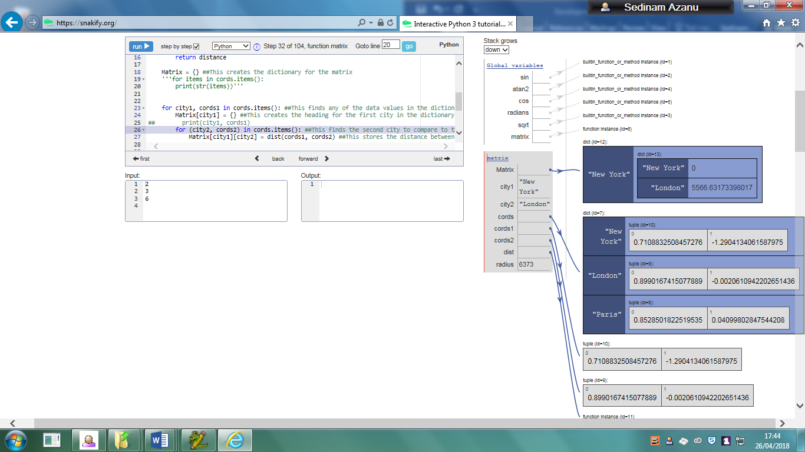

### Function that takes user package and city input to print out other cities and their distance from starting city

#### Intro

This is the main search function in my code which requires the user to input the package type that they would like and the city that they would like to start from.

#### Working version

This working version of the function uses the distance matrix section of my program that I talked about earlier which takes the package input to reduce the amount of cities in the list and the city they want to start from, so that the distances from that city can be found compared to everything else in the list.

##### Intro

##### How it hits the analysis criteria

This program hits the requirement for

* “the program to be able to take the input of a city that the user is starting at, and the package type that the user wants to select. This would output other cities that fall under the same package type, and their distance from the starting city in order of ascending size. For example: If London, Paris, Malaga and Brussels were in the same package and London was inputted, the output would be: London is 199 miles from Brussels, London is 214 miles from Paris, London is 1044 miles from Malaga.”

This function is able to take two inputs, one being the package the user wants and the city that the user wants to start from within that package. After this, they get an output of how far the other cities with the same package are from the city that they inputted.

This also hits the criteria requiring:

* The interface that lists the cities in order is clear to the user of the program and that they are able to understand what is being shown to them through the program.

The closest cities are outputted first and the distances that are larger are outputted at the end.

##### What validation techniques have you used?

When the user inputs the package type that they want, the code checks to see if the user has inputted an integer value, due to the fact that the package type is not meant to include any integer values. An error is returned until they enter a string value.

It also checks to see if the list generated by selecting the cities from the package type is empty. If this list is empty, it assumes that this package is not a valid one and will tell the user to enter another package type until there is something in the generated list.

Another one is where the user inputs their city and it is checked to see if the city that the user inputted is in the list. I used a while loop for this and have a variable kept to false. If this input is not in the list, then the variable will be kept false until the input is found in the list then it will let the user proceed.

##### Code

def get_package(Matrix):

package1 = input("Input the package type you want: ")

print(package1) ##This prints out the package inputted so it is easier for the user to remember which package they input

cursor.execute("""SELECT City FROM Package WHERE Package=?""",(package1,)) ##this takes the values where the cities match the package input

packagelist = list(cursor.fetchall()) ##This stores the obtained cities into a list so that it is converted from sql into python

if len(packagelist) == 0:

print("Enter a valid package type")

get_package(Matrix)

print(packagelist)

print(len(packagelist)) ##This prints out how long the list is

array = [] ##this creates a new array

for each in range(len(packagelist)):

array.append(packagelist[each][0])##This inserts each of the cities into an array as the list is actually 2d, meaning that it cant only be used to take values

print(array)

CityInArray= False

while CityInArray == False:

n = input("Which city would you like to start from?: ").title() ##This is used to select the city that the user wants to compare to the rest in the database

if n in array:

CityInArray = True

else:

print("City is not in list, enter a valid city")

x = array.index(n) ##This stores the location of that city in the array

array[x]=array[(len(packagelist)-1)] ##This changes the inputted city with the last city in the array

array[(len(packagelist)-1)] = n ##This puts the city inputted in the last position in the array

y=0

base= []##This new array is created to store the cities and their location from the inputted city

for each in range(len(packagelist)-1):

base.append([]) ##This creates a new section in the array.

base[y].append(array[y]) ##This adds the city and inputs it inside the first

base[y].append(Matrix[array[len(packagelist)-1]][array[each]])

print(base)

y = y+1

base = sorted(base, key=lambda x: x[1])##This sorts the array and changes the order to ascending order.

print(base)

z=0

for each in range(len(packagelist)-1):

print(base[z][0],"is",base[z][1],"from",n)

z=z+1

##### Testing

###### Proof of testing

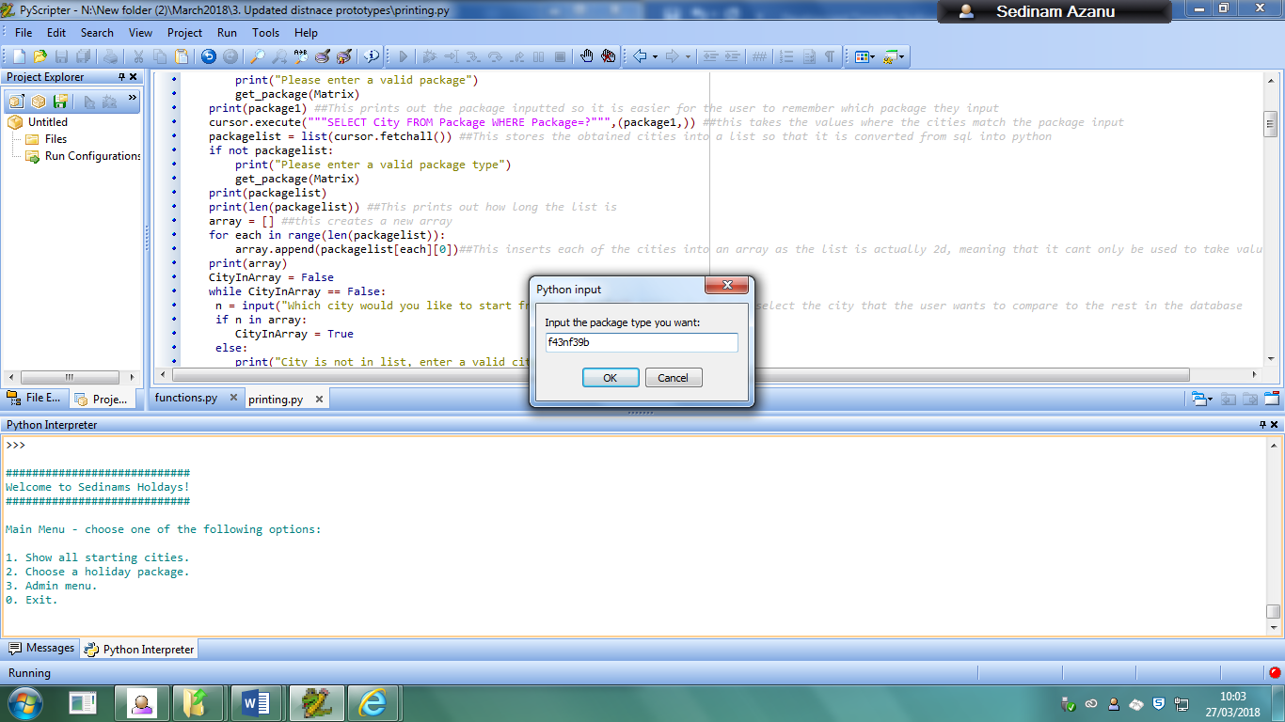

This above image shows what happens when the user selects the “choose a holiday package” function. It also shows the user about to input a package that contains an integer value

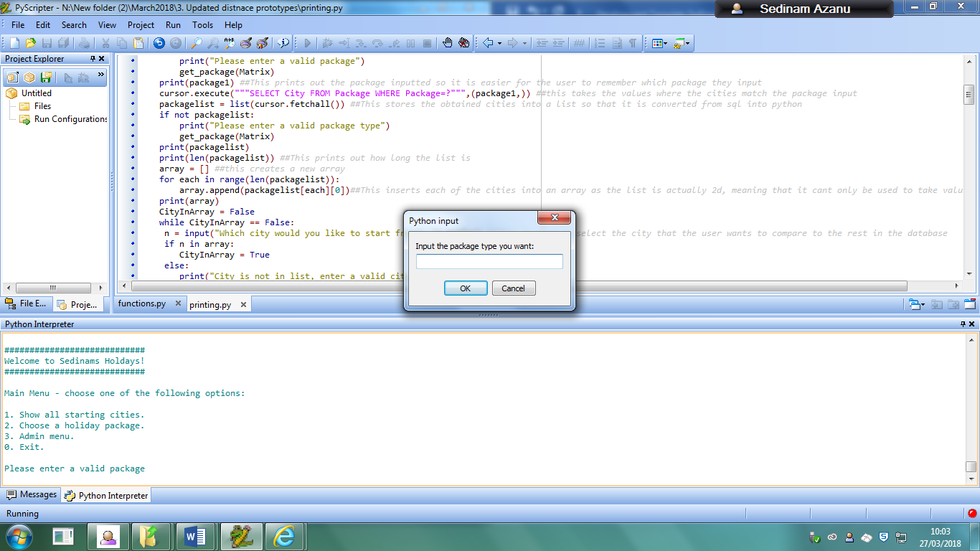

The highlighted result shows the output when a user inputs a package that contains an integer.

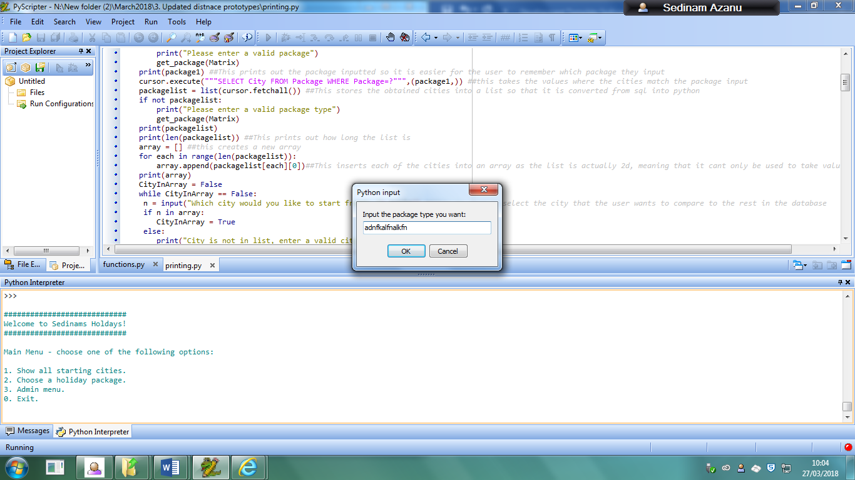

The above input shows that a user is about to input a random value in the function, this does not exist in the package table.

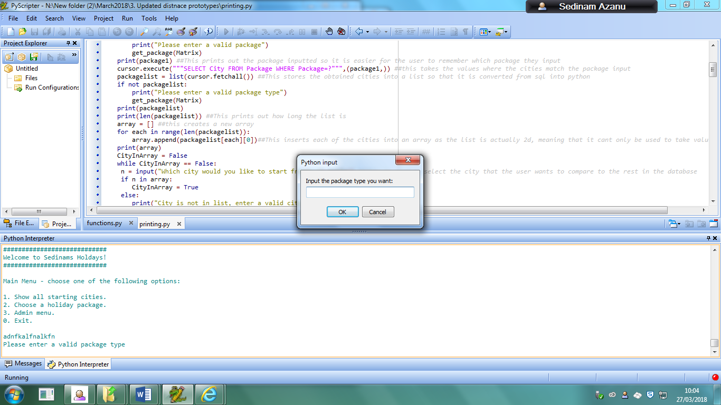

The highlighted value shows the result that is returned when the user inputs this value.

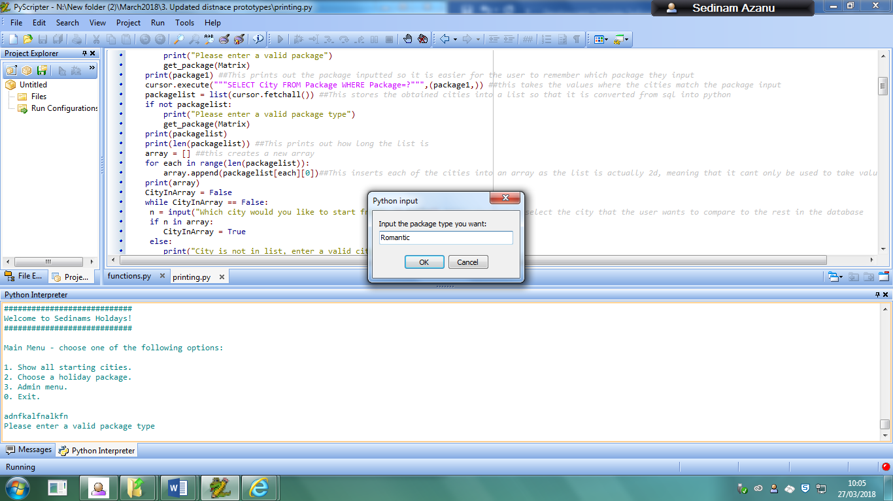

This screenshot above shows that a user about to input a package type. This package type does exist in the database so would let the user continue.

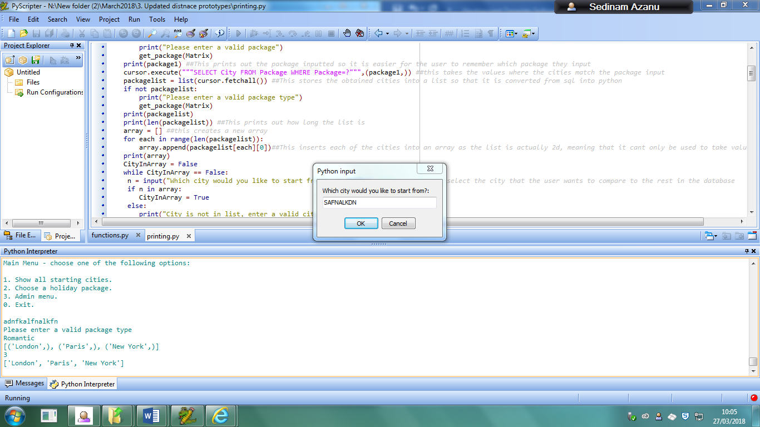

This output shows the cities that also exist in that package. It also shows that the user is about to input a city that does not exist in the array.

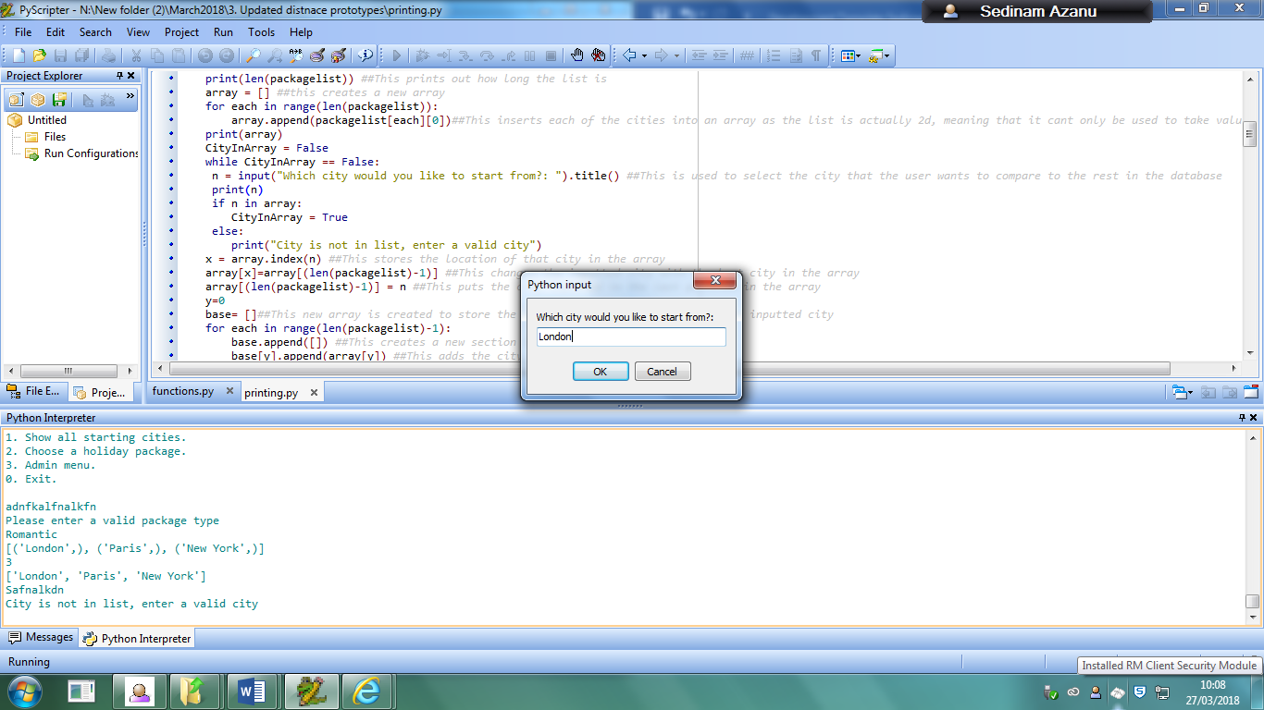

The highlighted output above shows what happens when the user does not enter a valid city in the array.

It also shows that a user is about to input a valid value that is in the array.

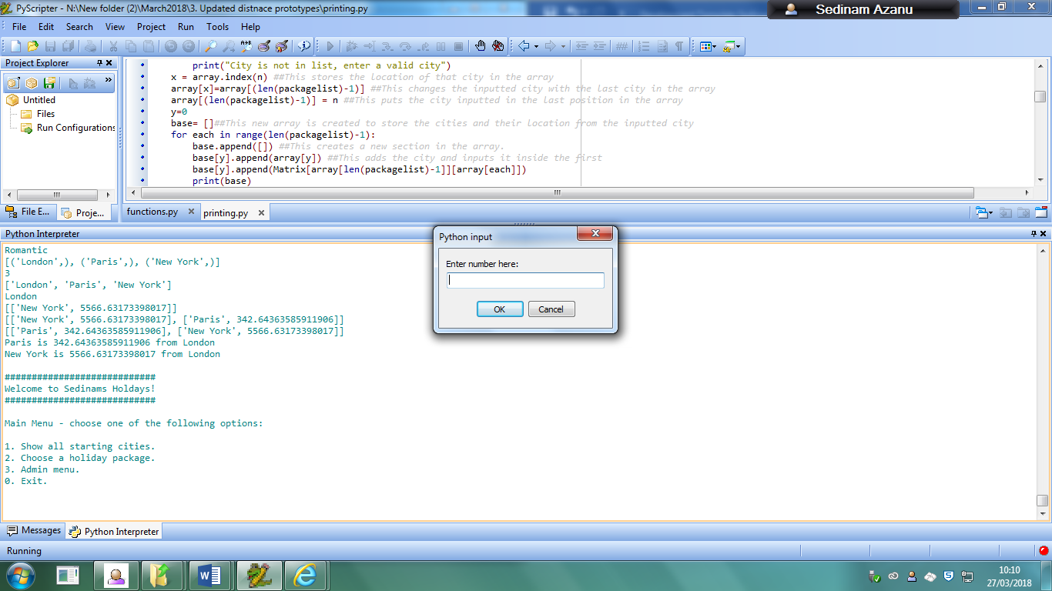

The highlighted area above shows the output given when the user gives the city that they want to start from.

###### Problems

The user directly has to put in the name of the city and the latitude and longitude into the code rather than keeping it in a database so that a user can directly change it by using the program

Also the user cannot decide how many cities that they want to visit on their holiday.

###### Action taken:

I decided to change my code slightly so that when they input the amount of cities that they want to visit, only the ones closest are outputted until the maximum amount of allowed cities are outputted.

###### Updated Code

def get_package(Matrix):

package1 = input("Input the package type you want: ")

print(package1) ##This prints out the package inputted so it is easier for the user to remember which package they input

cursor.execute("""SELECT City FROM Package WHERE Package=?""",(package1,)) ##this takes the values where the cities match the package input

packagelist = list(cursor.fetchall()) ##This stores the obtained cities into a list so that it is converted from sql into python

if len(packagelist) == 0:

print("Enter a valid package type")

get_package(Matrix)

print(packagelist)

print(len(packagelist)) ##This prints out how long the list is

arraylist = [] ##this creates a new array

for each in range(len(packagelist)):

arraylist.append(packagelist[each][0])##This inserts each of the cities into an array as the list is actually 2d, meaning that it cant only be used to take values

print(arraylist)

CityInArray= False

while CityInArray == False:

citychoice = input("Which city would you like to start from?: ").title() ##This is used to select the city that the user wants to compare to the rest in the database

if citychoice in arraylist:

print("Valid city inputted.")

CityInArray = True

else:

print("City is not in list, enter a valid city")

startcity = arraylist.index(citychoice) ##This stores the location of that city in the array

arraylist[startcity]=arraylist[(len(packagelist)-1)] ##This changes the inputted city with the last city in the array

arraylist[(len(packagelist)-1)] = citychoice ##This puts the city inputted in the last position in the array

insert=0

CityAmount = False

while CityAmount == False:

try:

Citiestovisit = int(input("How many cities would you like to visit in total?"))

if Citiestovisit == 0:

print("You cannot visit no cities, please enter a valid value!")

else:

CityAmount = True

except ValueError:

print("Enter a valid value")

overallvalue = len(arraylist)- Citiestovisit

packagelist2= []##This new array is created to store the cities and their location from the inputted city

for each in range(len(packagelist)-1):

packagelist2.append([insert]) ##This creates a new section in the array.

packagelist2[insert].append(arraylist[insert]) ##This adds the city and inputs it inside the first

packagelist2[insert].append(Matrix[arraylist[len(packagelist)-1]][arraylist[each]])

print(packagelist2)

insert = insert+1

packagelist2 = sorted(packagelist2, key=lambda variable: variable[1])##This sorts the array and changes the order to ascending order.

Packagelist3 = []

if overallvalue <= 0:

correction=len(arraylist)

if overallvalue <=0:

for each in range(correction-1):

print(packagelist2)

packagelist3.append(packagelist2[each])

print(packagelist3)

else:

for each in range(Citiestovisit):

print(packagelist2)

packagelist3.append(packagelist2[each])

print(packagelist3)

newlist=0

if overallvalue <= 0:

for each in range(correction-1):

print(packagelist3[newlist][0],"is",packagelist3[newlist][1],"from", citychoice)

newlist=newlist+1

else:

for each in range(Citiestovisit):

print(packagelist3[newlist][0],"is",packagelist3[newlist][1],"from", citychoice)

newlist=newlist+1

### Create a menu which allows the user to access specific functions in the code.

#### Intro

For my program, I decided to give the user a sort of interface that makes it easier for them to be able to access to the several functions that are available. They have to use specific inputs to get access to these functions.

#### Prototype 1

##### What is it?

This function gives the user a choice in which function that they want to access whilst using the program.

##### Did it work? Did you use it? If not, why?

This did work and the user could easily access all of the functions by using this, however I did not end up using this prototype due to the fact I decided I wanted to include an admin menu so that not just anyone could be able to gain access to the functions that can edit the database.

#### Working version

##### Intro

This includes an admin menu alongside the other functions so that only the authorized user will be able to change that information in the table, rather than anyone else who could have managed to gain access to the database. The main function of the program is still available for any normal user to use, but functions like updating the database and adding new records is only available through the admin menu.

##### How it hits the analysis criteria

This gives the user an interface by providing them with a menu where they can easily see which functions are which and what they have to input to be able to gain access to each one.

##### What validation techniques have you used?

For the main menu function, the user is required to enter specific numerical values, and anything else would be rejected and an error would be outputted to the user telling them that they would need to enter a valid value.

For the admin menu function, a specific username and password is needed for them to get access to the menu, otherwise if they entered it incorrectly 3 times, they would be returned back to the main menu. The admin menu also uses the same validation where they need to enter valid values when accessing any of the functions or they would be returned with an error where they would be required to enter a valid value.

##### Code

Main display menu function

def display_menu():

print()

print("############################")

print("Welcome to Sedinams Holdays!")

print("############################")

print()

print("Main Menu - choose one of the following options:")

print()

print("1. Show all starting cities.")

print("2. Choose a holiday package.")

print("3. Admin menu.")

print("0. Exit.")

print()

menu_choice = input("Enter number here: ")

if menu_choice == “1”:

get_all()

display_menu()

elif menu_choice == “2”:

get_package(matrix())

display_menu()

elif menu_choice == “3”:

auth()

display_admin()

elif menu_choice == 0:

sys.exit()

else:

print("Incorrect number entered please enter another option.")

display_menu()

Auth to gain access to admin menu

def auth():

username = 'admin'

password = 'password'

attempts = 0

max_attempts = 3

while attempts < max_attempts:

user = input("Please enter username: ")

passw = input("Please enter password: ")

if user == username and passw == password:

admin_menu()

else:

attempts += 1

if attempts == max_attempts-1:

print()

print("Last try!")

elif attempts == max_attempts:

print()

print("Exiting to main menu...")

else:

print()

print("Incorrect, please try again:")

print()

display_menu()

Admin menu function

def admin_menu():

print()

print("$$$$$$$$$$$$$$$$$$$$$$$$$$$$$$$$$$$$$$$$$$$$$$$$$$$$$$$$$")

print("Admin Menu entered - choose one of the following options:")

print("$$$$$$$$$$$$$$$$$$$$$$$$$$$$$$$$$$$$$$$$$$$$$$$$$$$$$$$$$")

print()

print("1. Add city.")

print("2. Edit table.")

print("3. Main menu.")

print("0. Exit program.")

print()

menu_choice = input("Enter number here: ")

if menu_choice == “1”:

add_city()

display_menu()

elif menu_choice == “2”:

edit_table()

elif menu_choice == “3”:

display_menu()

elif menu_choice == “0”:

sys.exit()

else:

print("Incorrect number entered please enter another option.")

admin_menu()

admin_menu()

##### Testing

###### Proof of testing

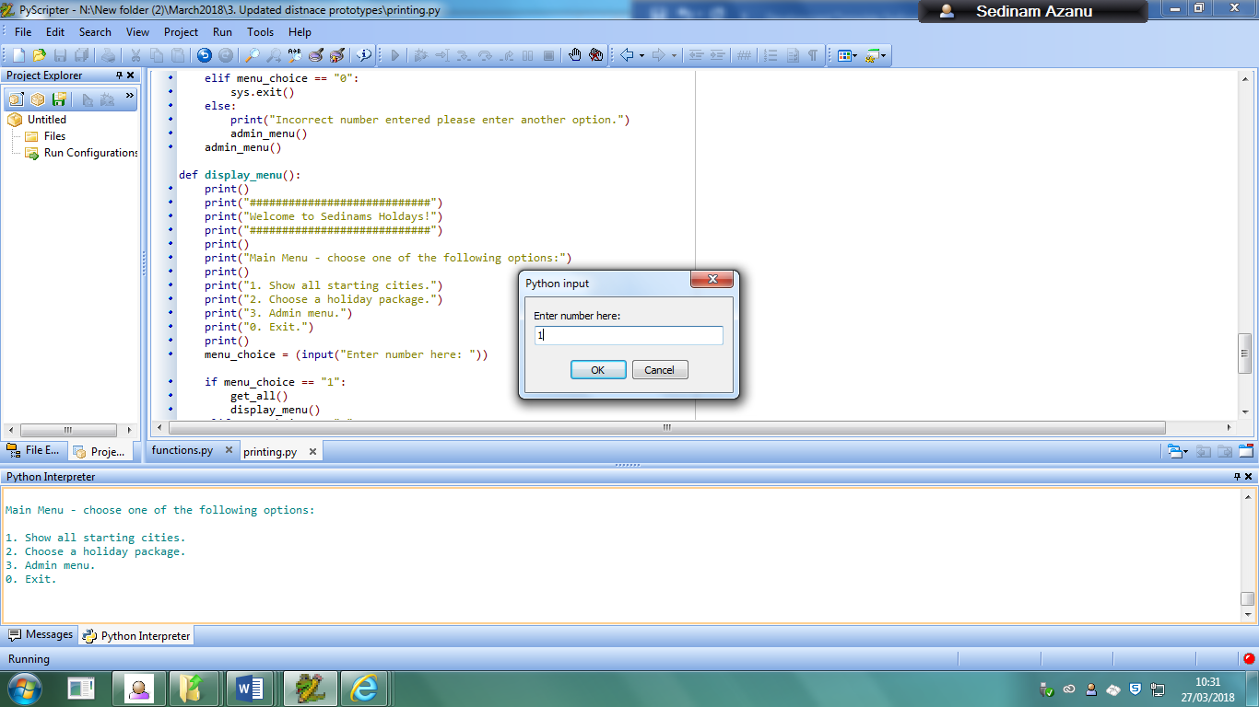

This first screenshot shows that the user is going to enter 1 so that they can access the first function that is available in the program.

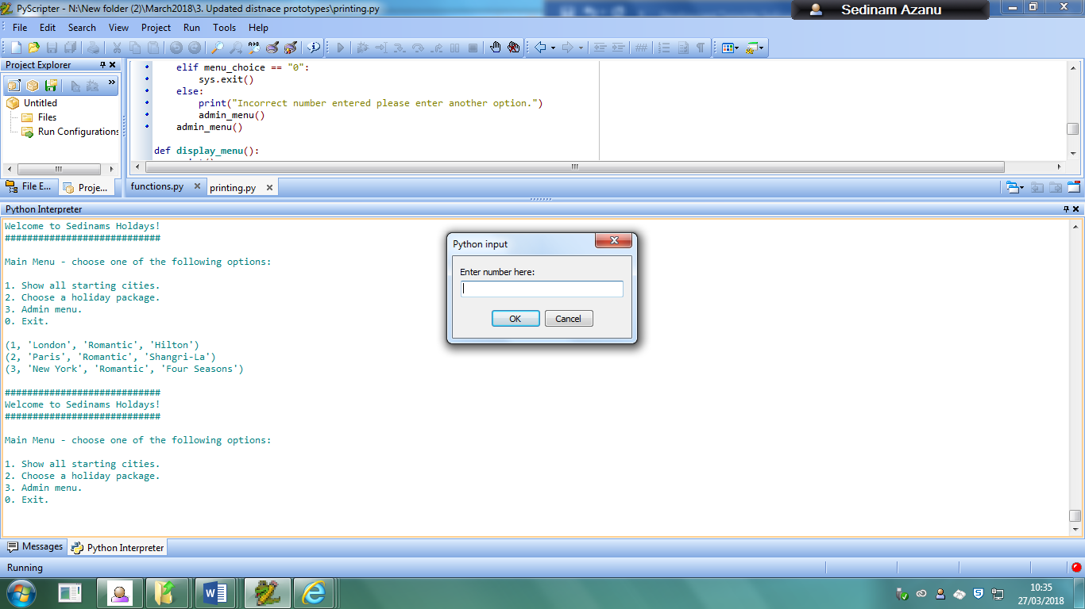

The highlighted area above shows the output that the user would receive when they use the function to show all of the records.

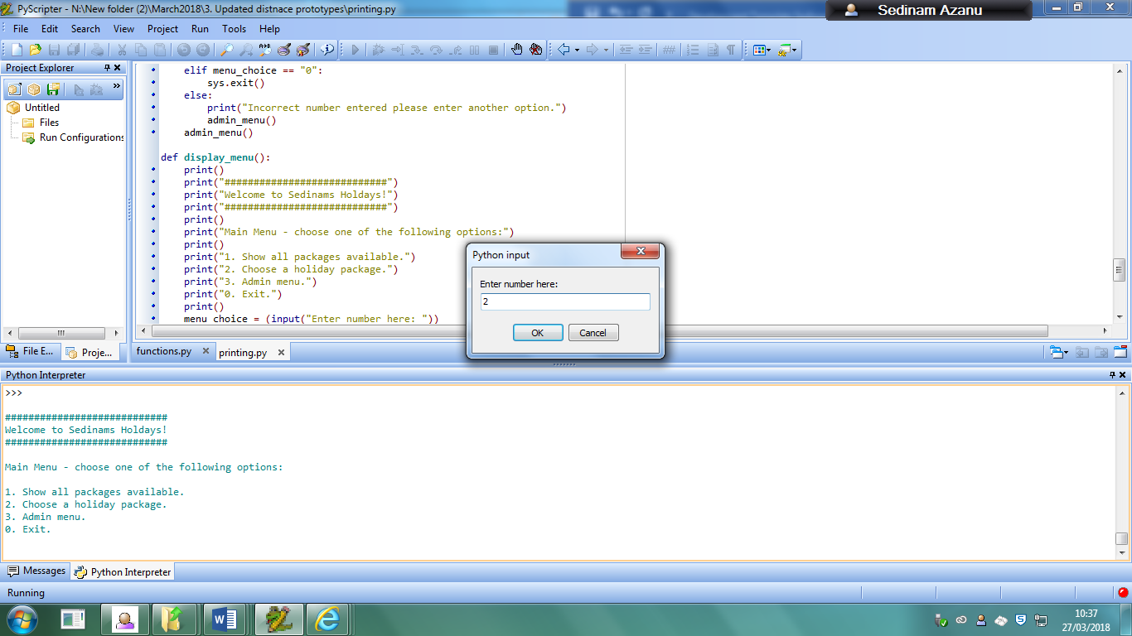

The screenshot above shows that the user is about to input the number 2 so that they can use the second function that allows them to choose their holiday package.

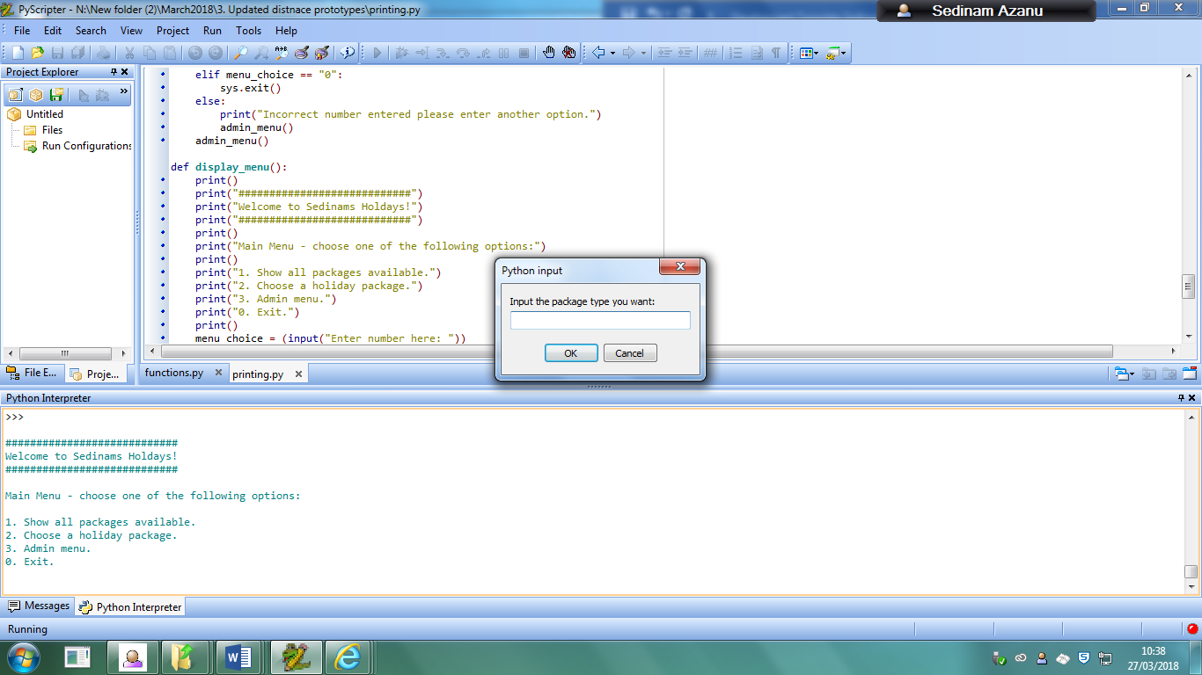

The image above shows what would happen after the user has inputted that value into the program. The input menu changes to ask them to input the package type they want.

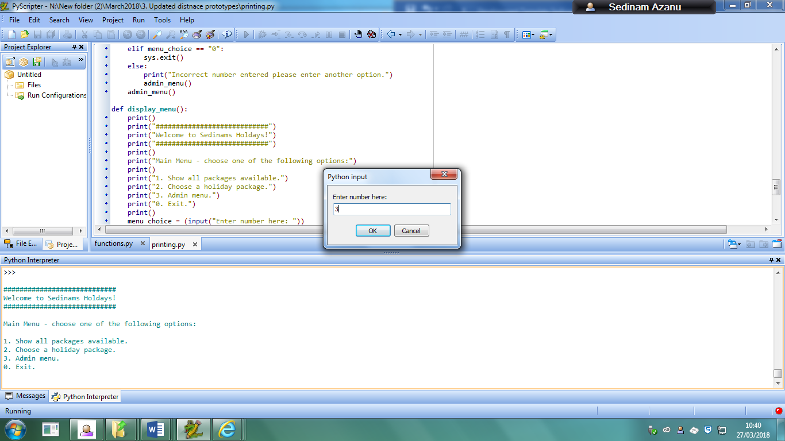

The above image shows the user is about to input the number 3 so that they can gain access to the third function of the program.

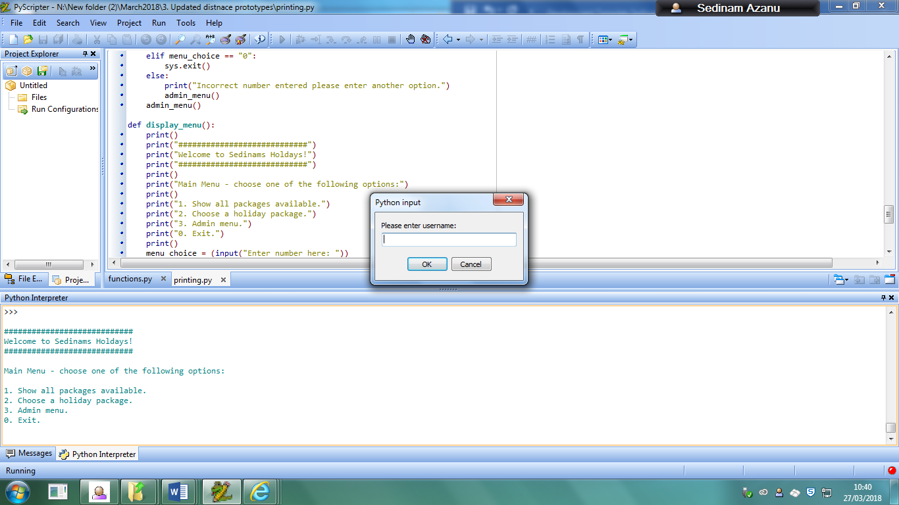

This then tells the user to enter specific values to log in so that they can gain access to the admin menu, which requires an input of admin and password afterwards.

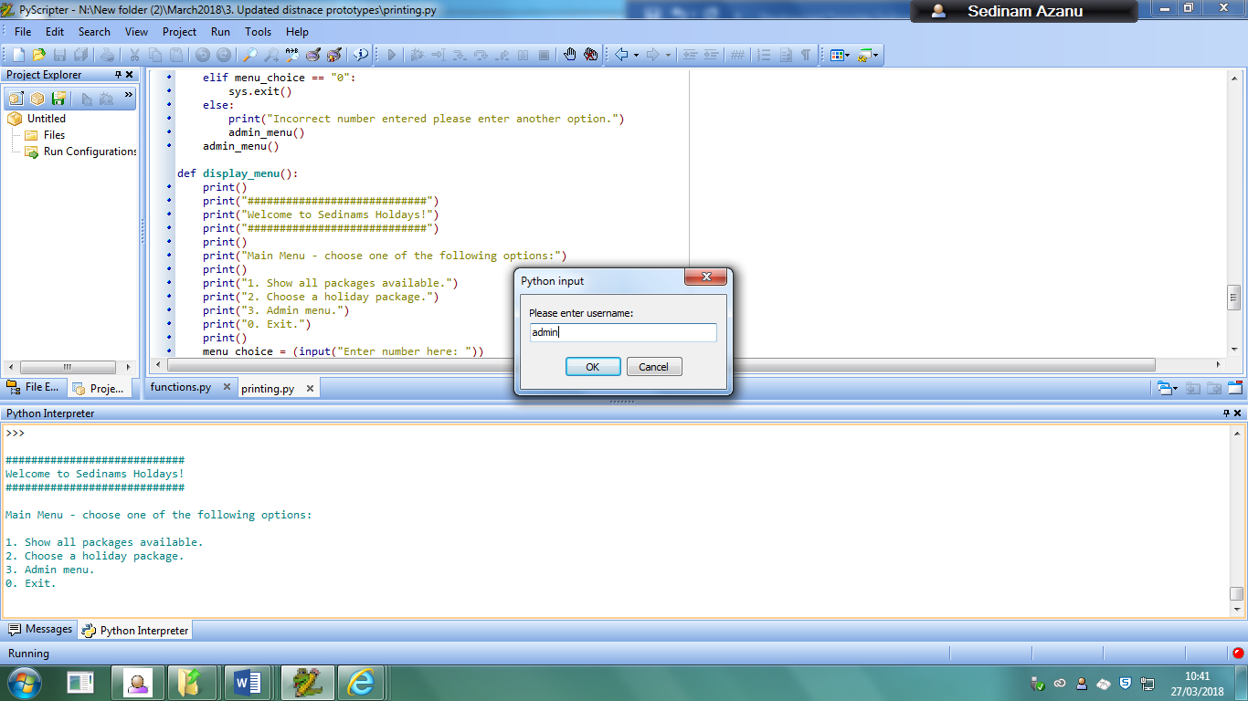

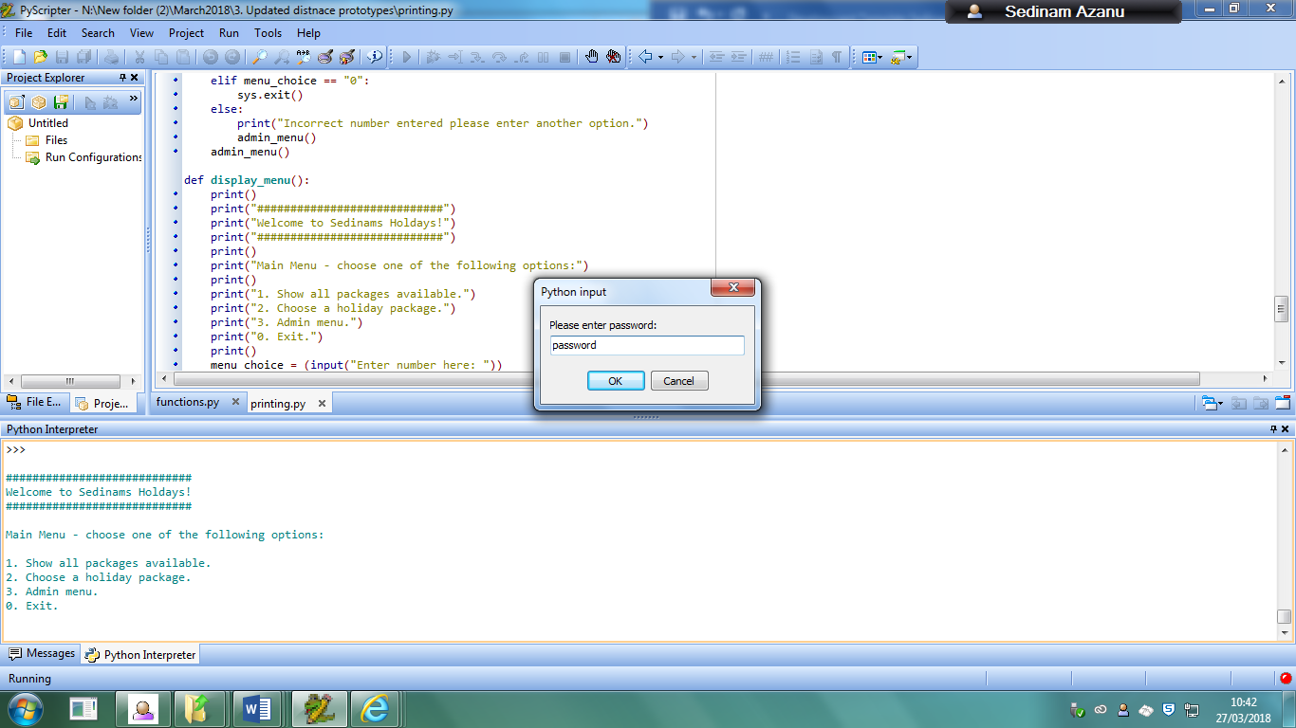

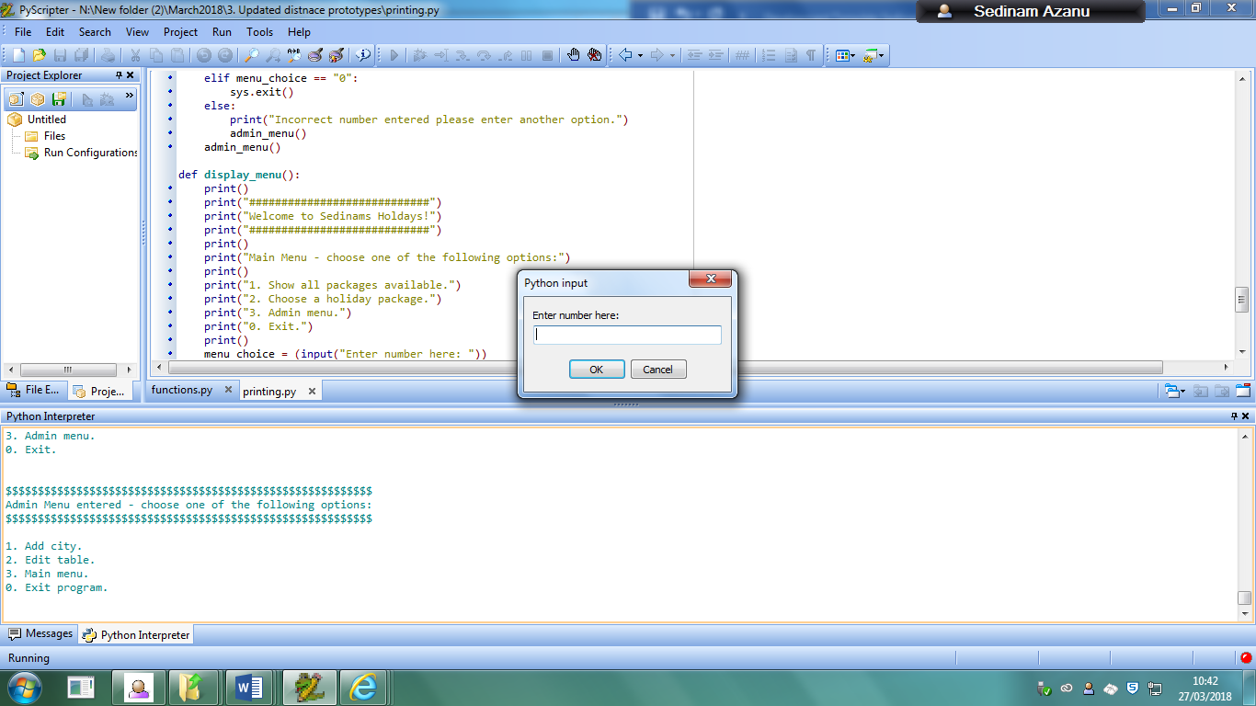

This eventually gives the user access to the admin menu which allows them to edit parts of the database directly.

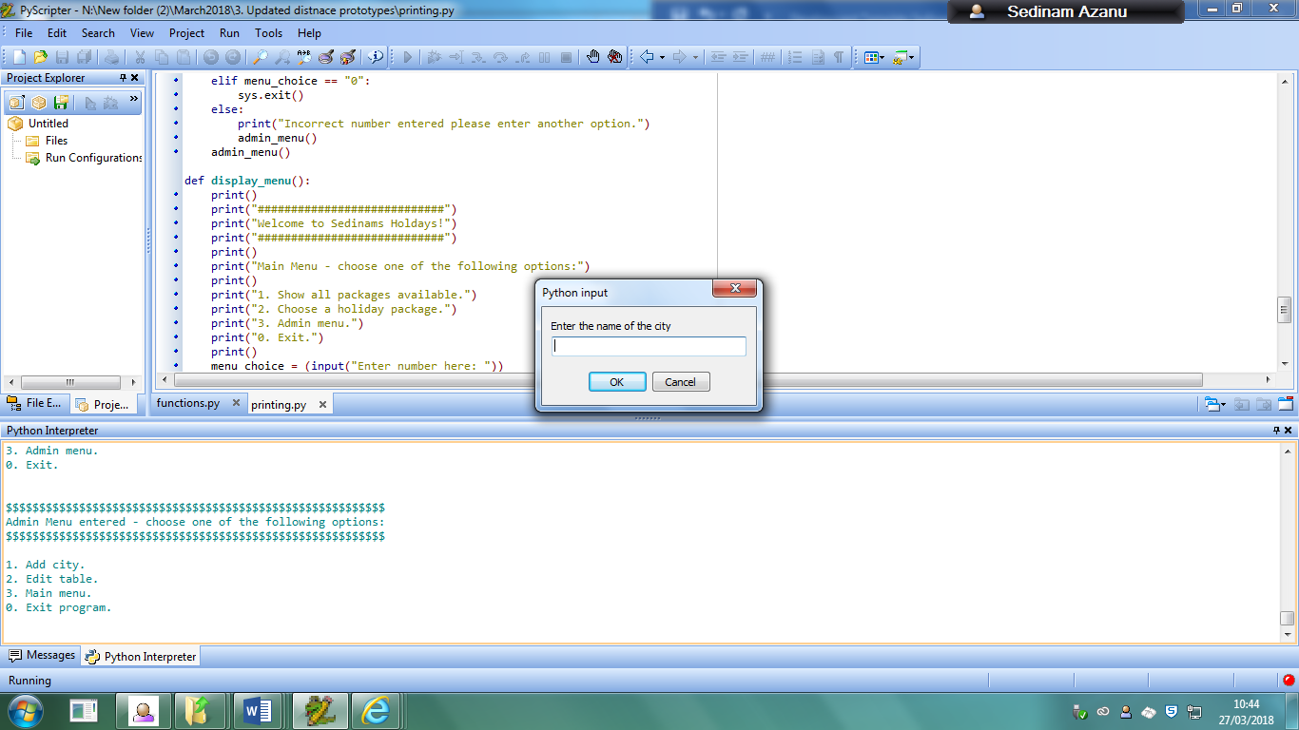

When the user inputs the value 1 when accessing the admin menu, the output will be the screenshot above

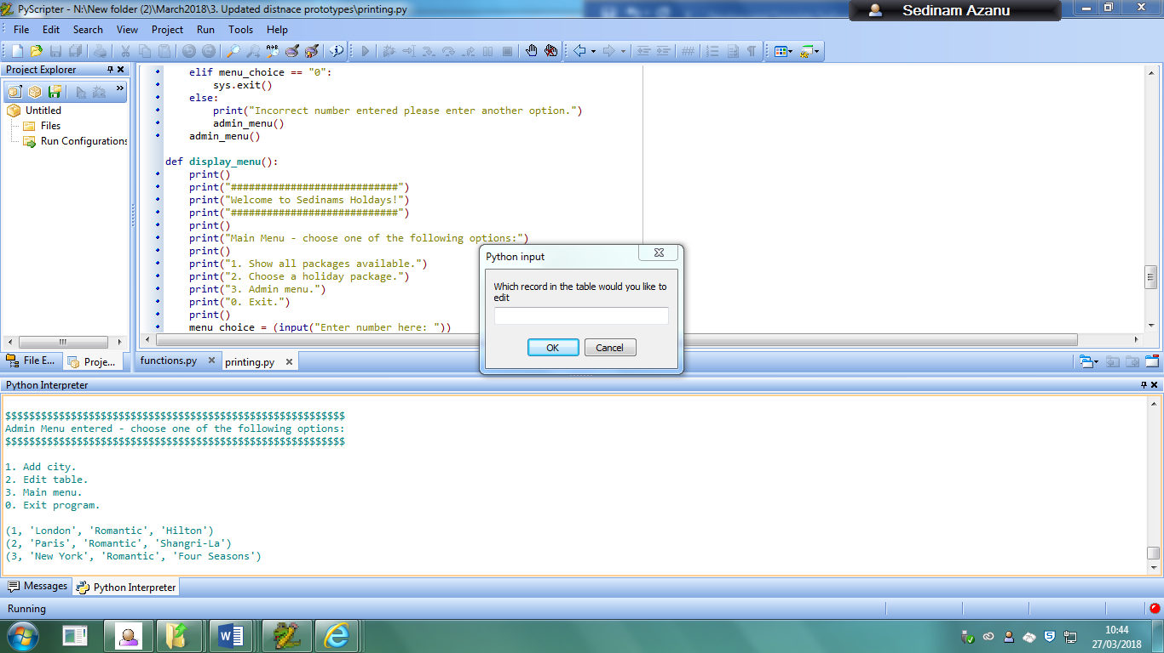

When the user inputs the value 2, they will be given the output above and the popup to input a specific value needed.

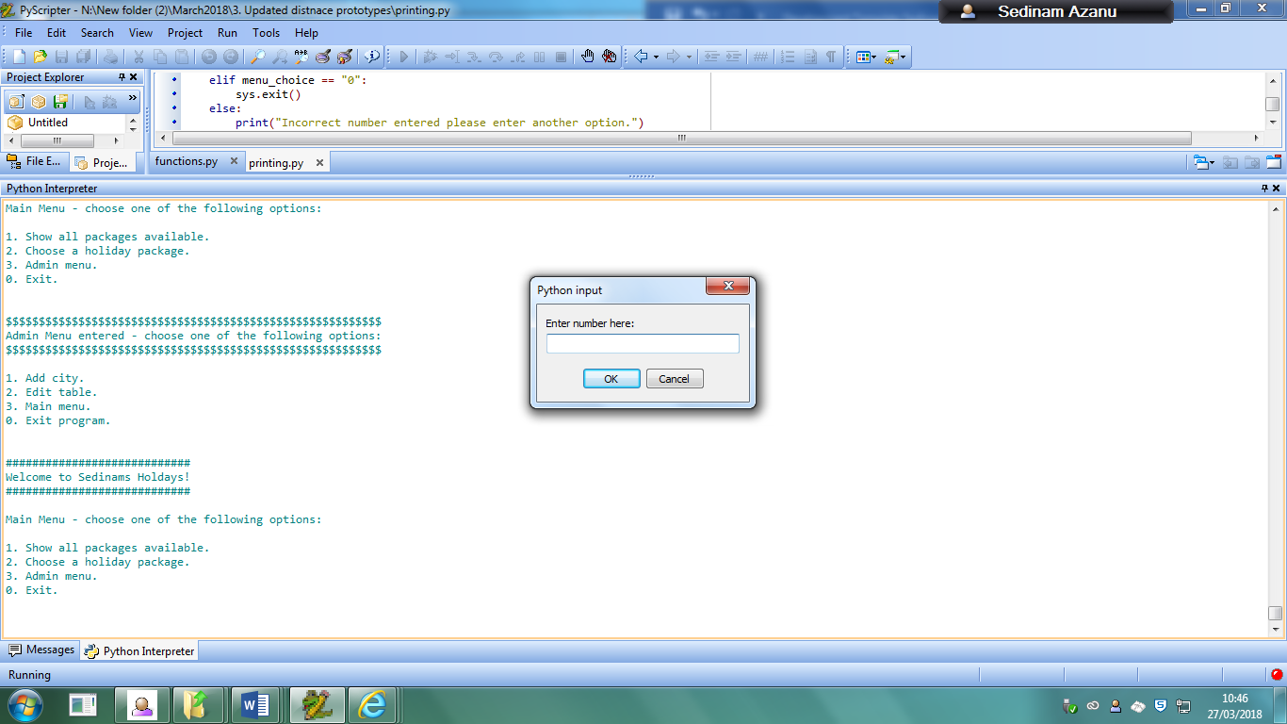

When the user inputs the value 3, this will return them back to the main menu from the admin menu.

When the user inputs 0 for either of the menus that are available, the program will just end as this is the function to exit the code.

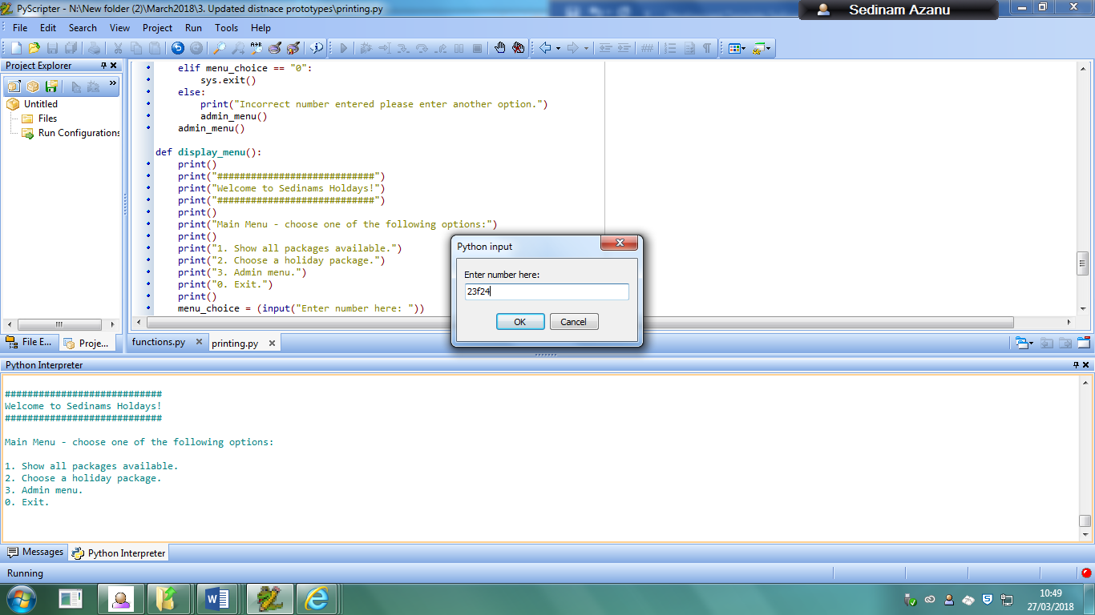

The image above shows that a user is about to enter a value that is not within the allowed values, as it is not 1,2,3 or 0 in the main menu.

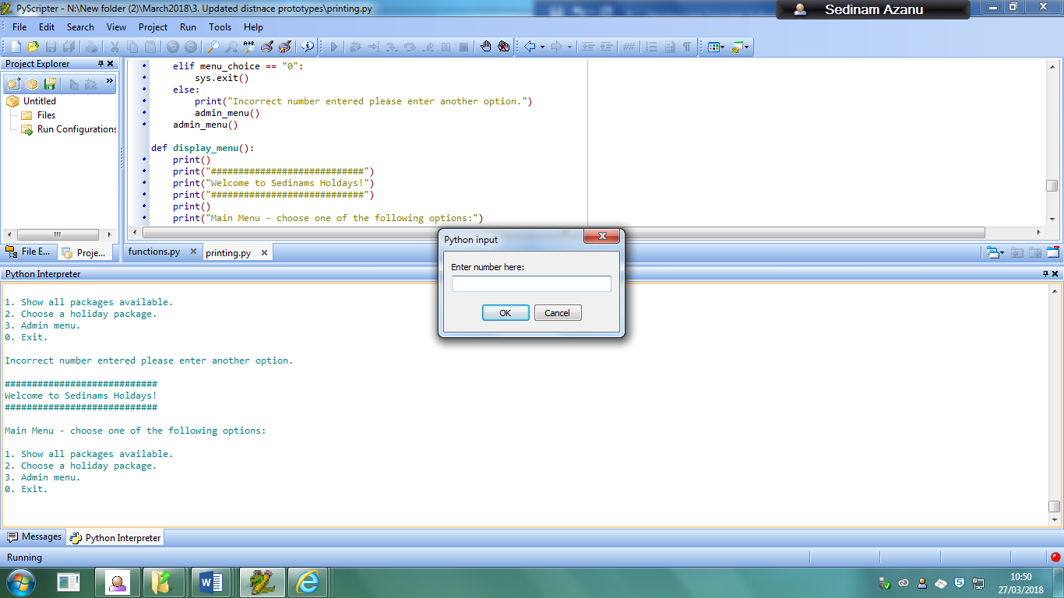

The above screenshot shows the output the user would receive when attempting to enter an incorrect value in the main menu, then returns them to the main menu.

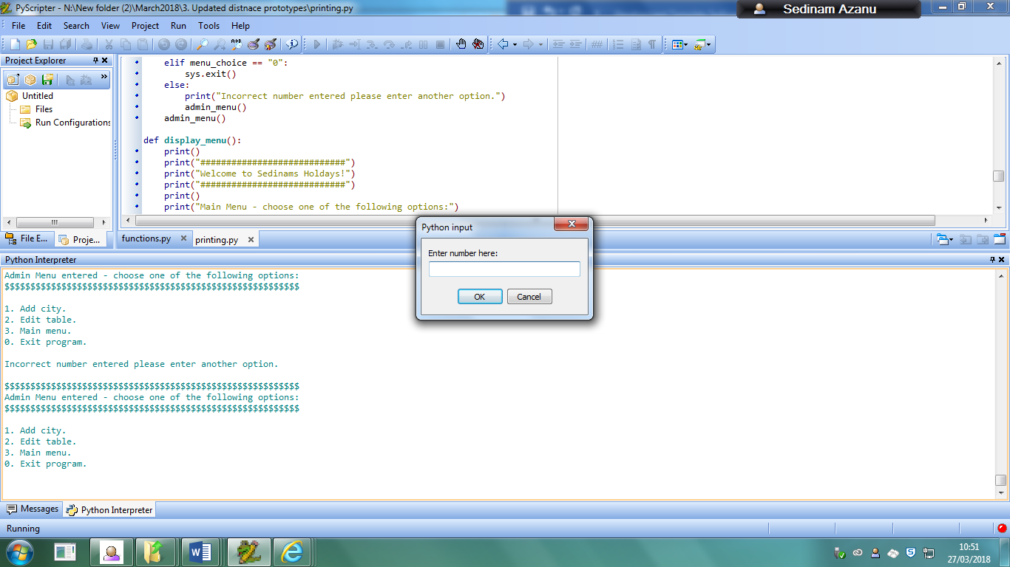

This above screenshot shows what would happen when the user enters an incorrect value in the admin menu, then would return them back to the admin menu.

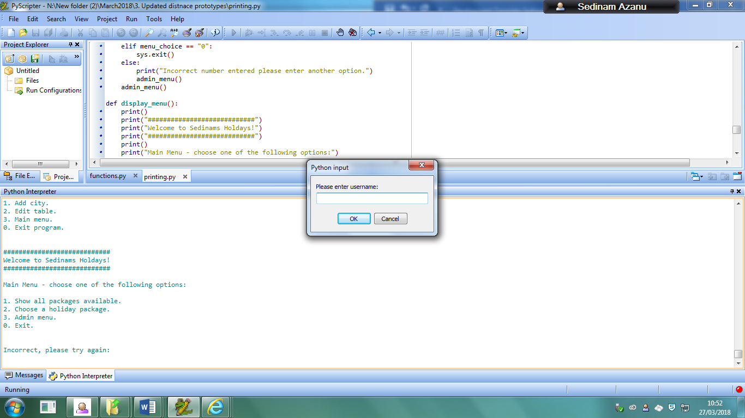

This above screenshot shows what happens when the user inputs a wrong username or password or both when trying to access the admin menu.

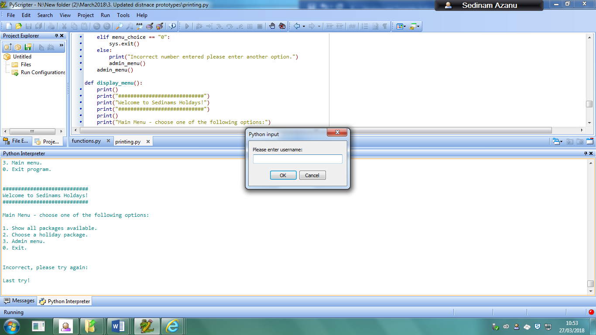

This is the message the user receives when they enter an incorrect value again.

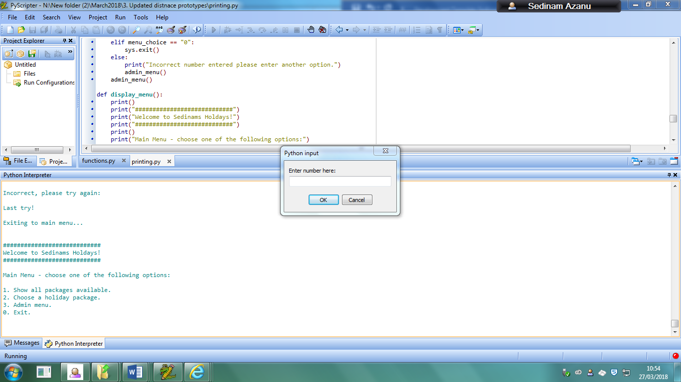

This then sends an output saying “Exiting to main menu…” when the user enters an incorrect username or password for the third time, and then returns them to the main menu.

# Evaluation

## Testing of evaluation

My testing table from my original design:

|  |  |  |  |  |
| --- | --- | --- | --- | --- |
| Function being tested | Input | What type of test | Expected result | Validation |
| 1:Changing a record that is currently in the table | Inputting record ID, inputting new city, inputting new package, inputting new hotel  Example “2” to access function from menu, “London, Romantic, Hotel” | Typical | For the record in the table to have been updated in the table permanently. | Cannot have a value that is less than or larger than the number of record ID’s or a string |
| 2: Editing a record that doesn’t exist in the table | Inputting an incorrect recordID | Erroneous | To return an output stating that the value doesn’t exist. | Cannot be a string value as the recordID is not a string |
| 3: Adding a new record to the table | Inputting new city, inputting new package, inputting new hotel  Example: “1” to access function from menu, “London, Romantic, Hotel” | Typical | Adds a new record to the table with a new record ID | None |
| 4: Deleting a record from the table | Inputs yes when asked if they want the record with a specific id to be deleted | Typical | Removes the record from the table and the database. | Cannot put in a string as recordID has to be an integer |
| 5: Deleting a record that does not exist in the table | Inputs a recordID that does not exist in the table | Erroneous | Returns an error stating that the record does not exist | Cannot put in a string as recordID has to be an integer |
| 6: Function that allows for records to be displayed in ascending order of distance | Input the package type and the city that they want | Typical | Lists in order of distance from starting city the records in an interface. | The package type has to exist inside the table. |
| 7: User types in package type that does not exist in the table | For example when using the choosing holiday function, types in “dsgflng”, which is not a valid package | Erroneous | Returns “Please enter a valid package type” | Package type must not have any integer values included. |
| 8: User types in a package type that does exist in the table | For example when using the choosing holiday function, types in “Romantic”, which is a valid package | Typical | Returns “Package type is in table” | Package type must not have any integer values included |
| 9: User inputs city they want to start from that doesn’t exist in list | For example, inputs “aaa” instead of existing city in list | Erroneous | Returns “Enter a valid city” | None |
| 10: User inputs city they want to start from that does exist in list | For example, inputs “London” | Typical | Returns “Is a valid city” | None |
| 11: Display all the records currently in the package table | Go to the menu and input the option that displays all the records in the package table | Typical | Lists every record currently in the package table | Menu will have specific number values and the input cannot be more or less than that |
| 12: Type in any number not in the range when asked to access the menu options | Input for example “9” or “sfd” when there are only options of 1-6 | Erroneous | Asks the user to input a new number for the table. | Has to be the number of the menu options, cannot be less or more. |
| 13: Type in all menu options in range | Input for example “6” when there options of 1-6 | Boundary | Let’s the user access those functions | Has to be an integer value |
| 14: Type in all admin menu options not in range | Input for example “5” when options of 1-3 | Erroneous | Returns an error for the user to enter a valid value | Has to be an integer value. |
| 15: Type in all admin menu options in range | Input for example “3” when options of 1-3 | Boundary | Lets the user access each of the functions | Has to be an integer value. |
| 16: Type in any number when deciding how many cities that the user wants to visit | Input for example “900” when there are only 5 cities in the list | Erroneous | To output that the program will use the maximum amount of cities in the list | Must be an integer, otherwise will be told to input a new value |
| 17: Entering in a string when deciding how many cities the user wants to visit | Input for example “afnkla” when the program only accepts integers | Erroneous | Told by the program to input a proper value. | Must be an integer, otherwise will be told to input a new value |
| 18: Entering any other username and password when trying to get access to the admin menu | Input for example “jjj” for username and “jjj” for password | Erroneous | Output three values as the user will have three guesses before being sent back to the menu | None |

### 1: Changing a record that is currently in the table

Firstly, I would gain access to the admin menu by inputting 3

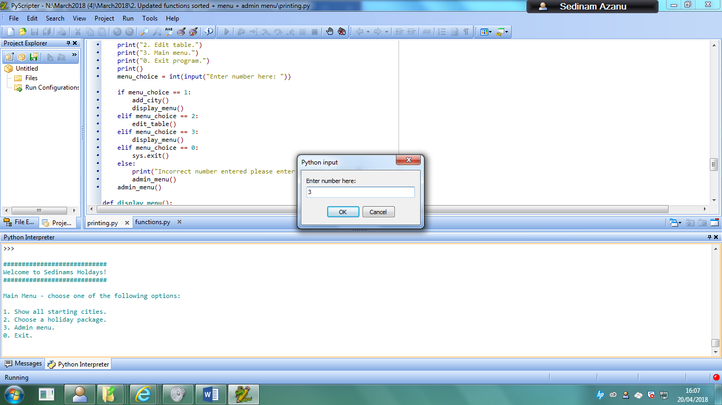

Then I would input the username and password to gain access to the admin menu

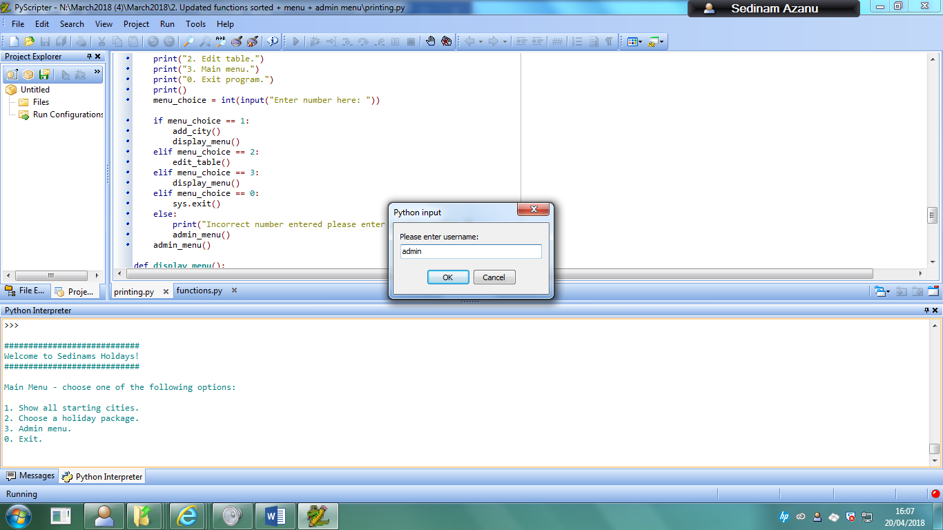

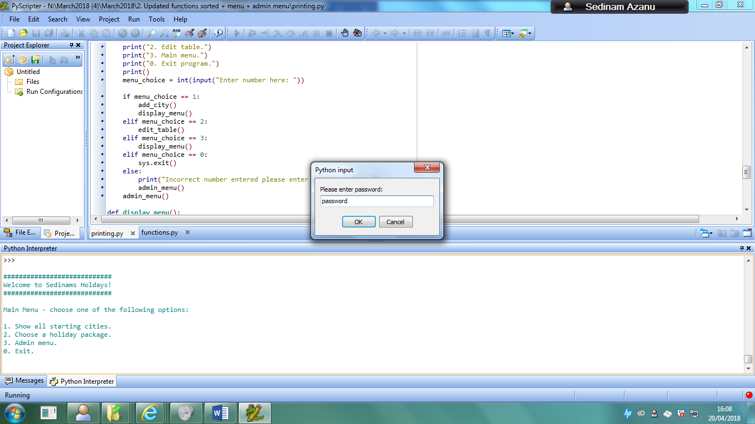

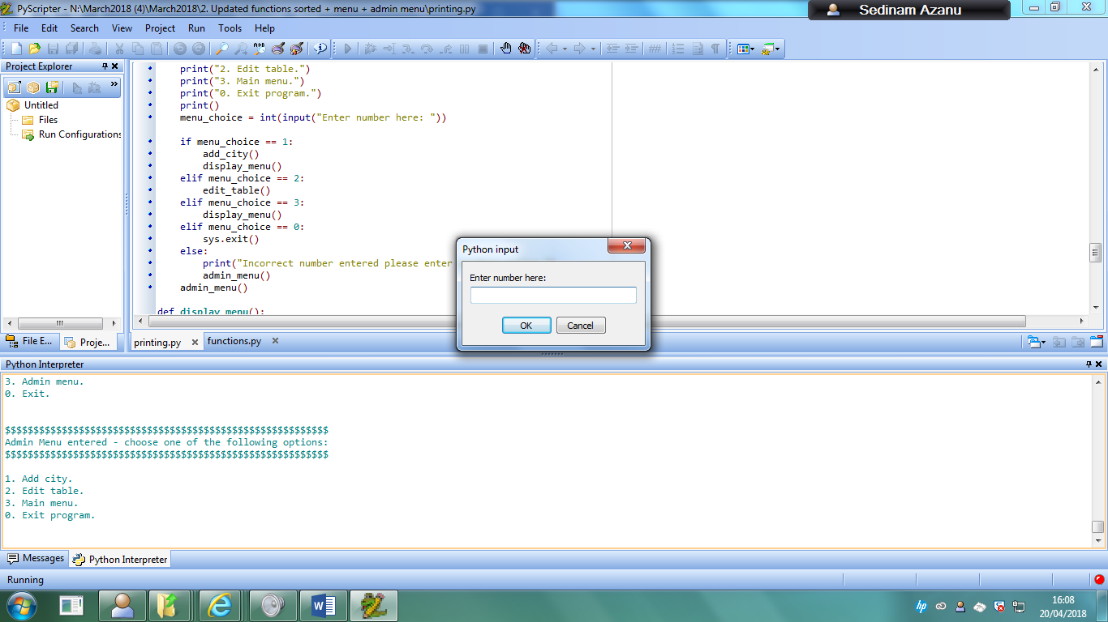

Inputting 2 as the record that I want to change

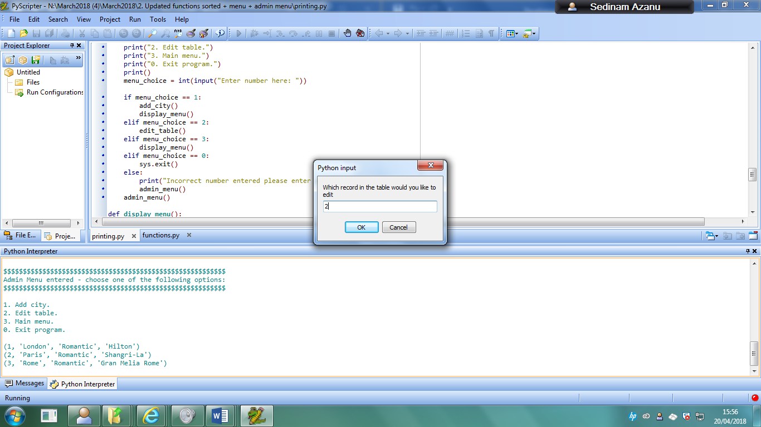

Changing the city from Rome to Brussels

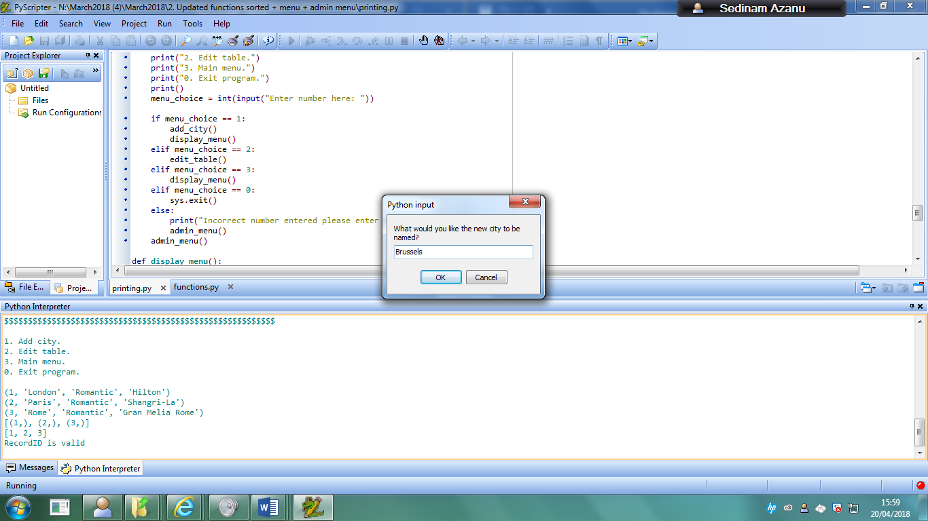

Keeping the package as Romantic

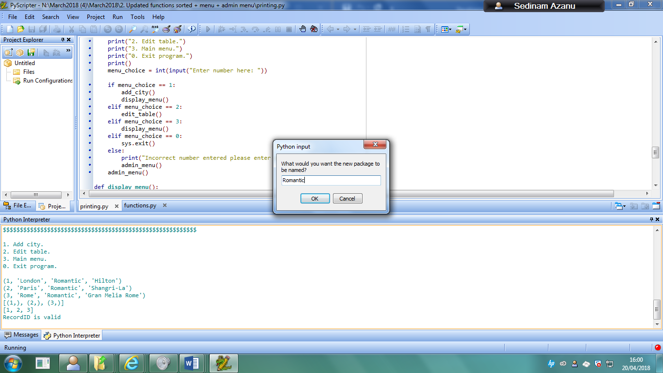

Changing the hotel to Brussels Hotel

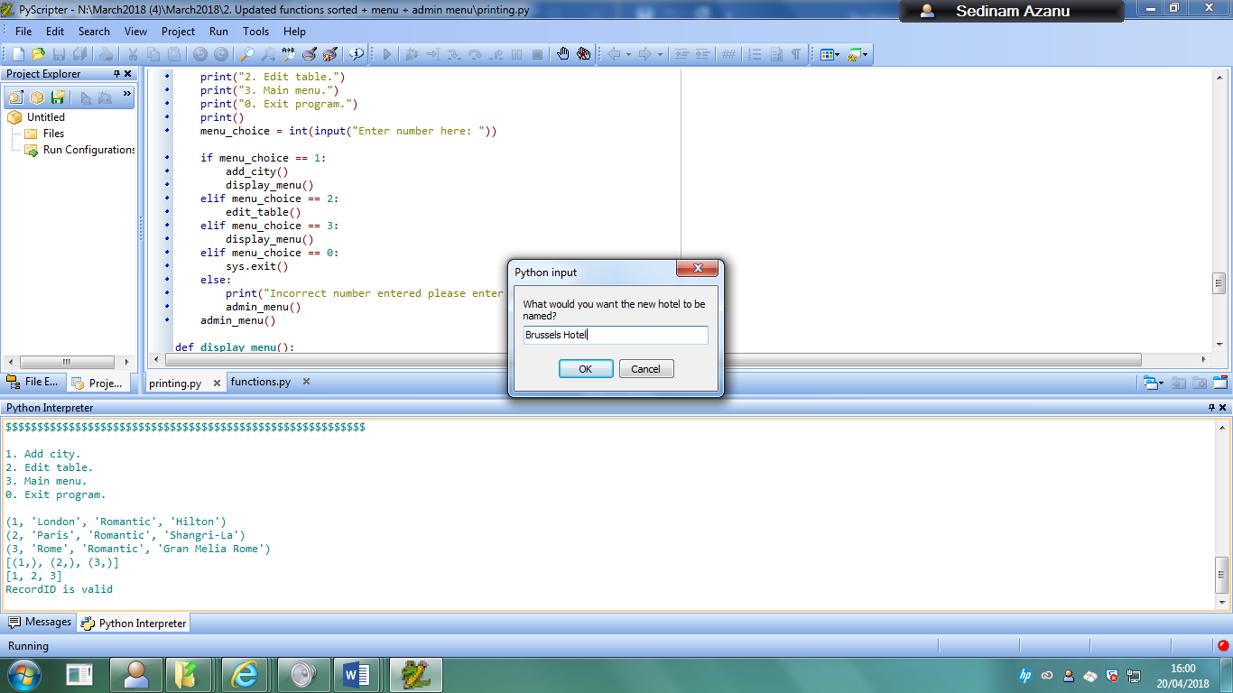

Using (Show all starting cities function to find new updated record)

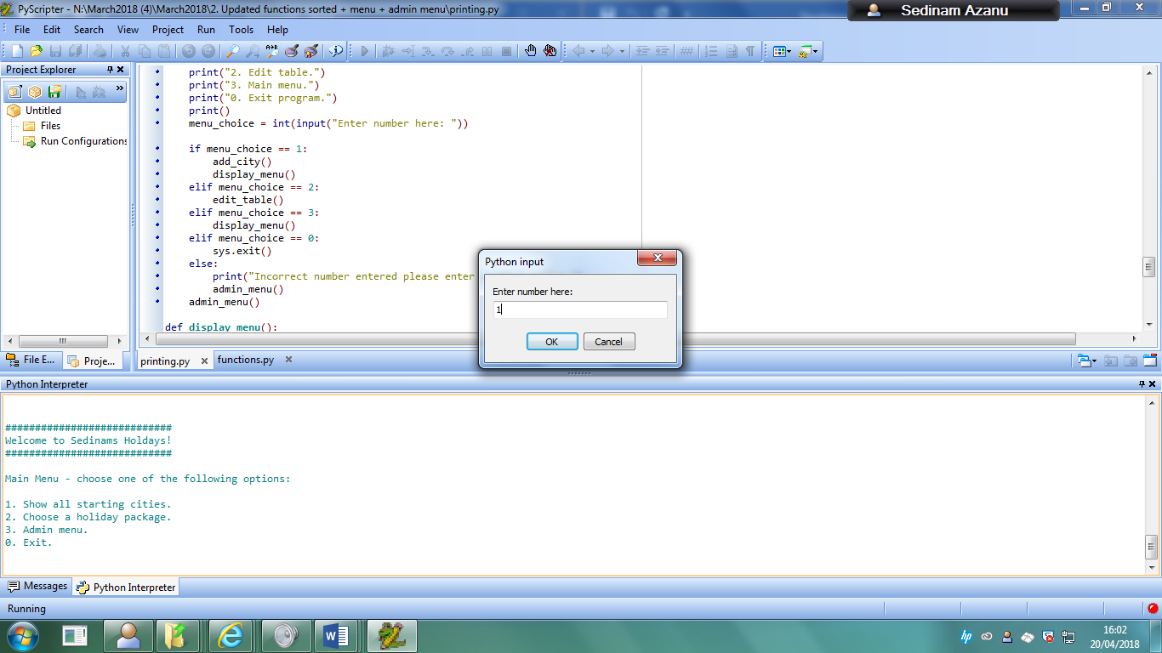

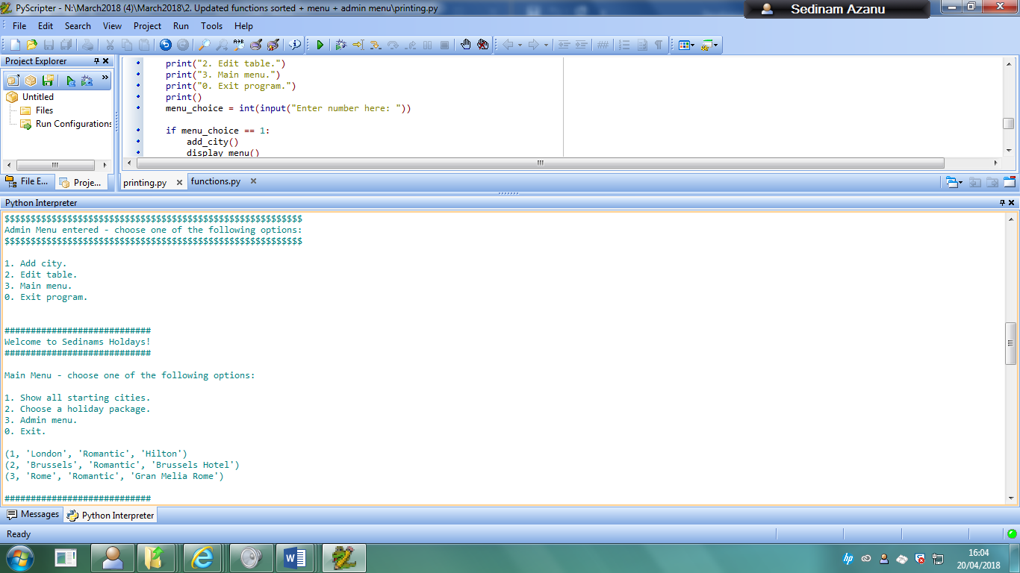

### 2: Editing a record that doesn’t exist in the table

When the user inputs a record that does not exist to be changed, they will be met with this error if the value is a string (because recordID cannot be a string):

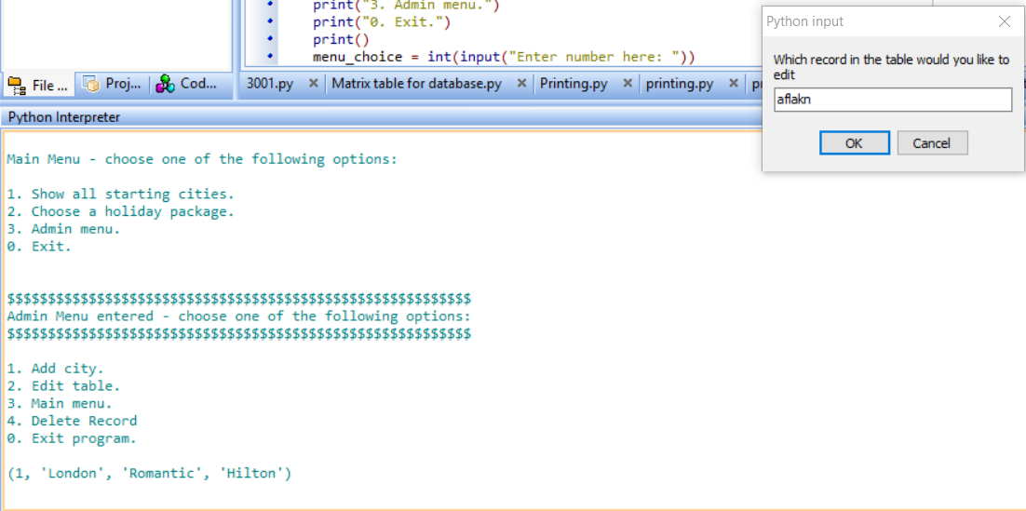

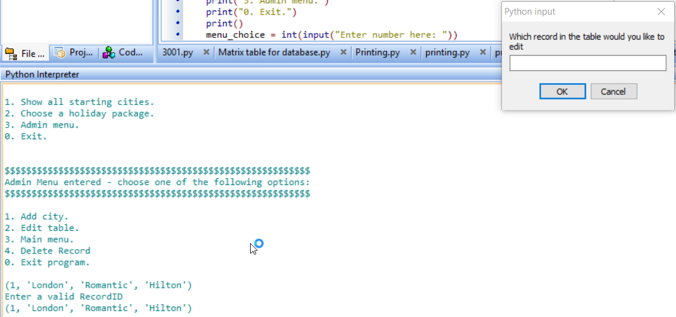

And will be given this error when the inputted integer is not a part of the recordID:

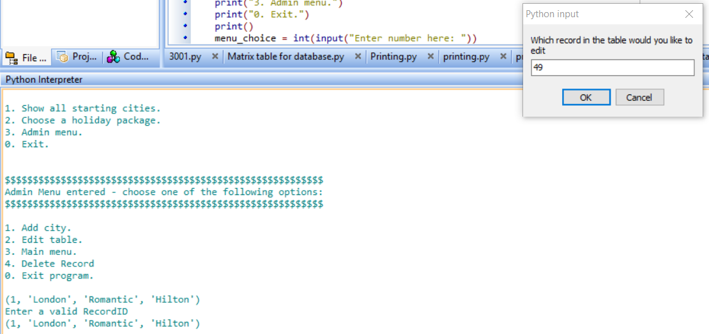

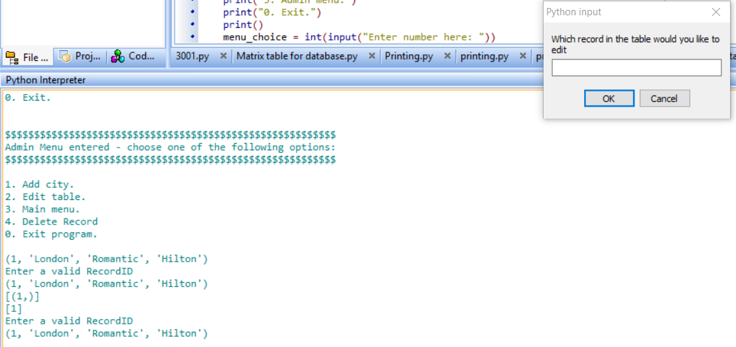

### 3: Adding a new record to the table

Firstly, I would gain access to the admin menu by inputting 3



Then I would input the username and password to gain access to the admin menu







Then I would input 1 to be able to get access to the function that allows me to input a new record into the table

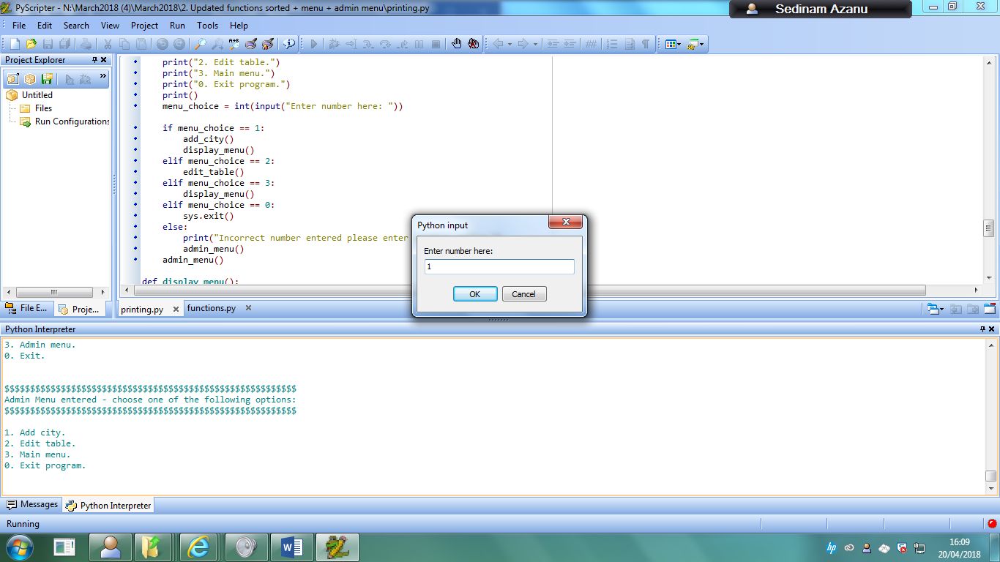

My input for the city is going to be New York

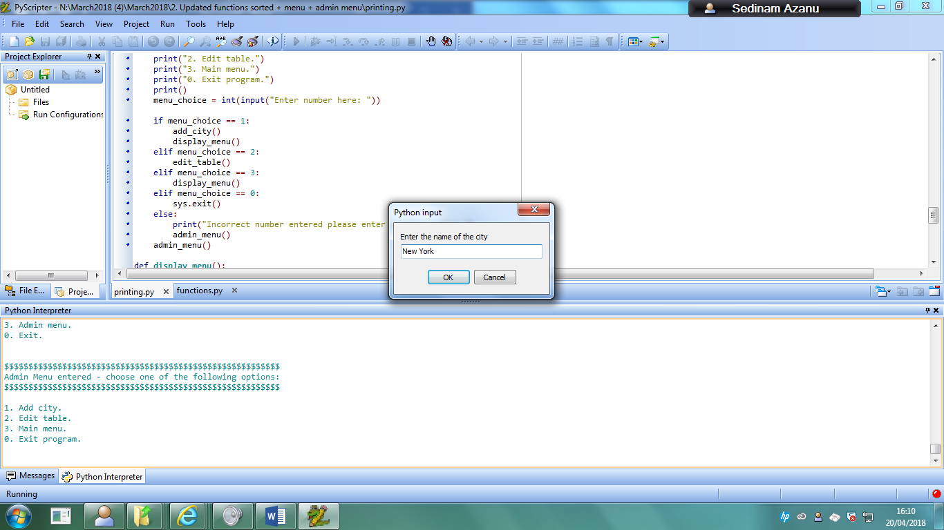

The input for the package is going to be Romantic

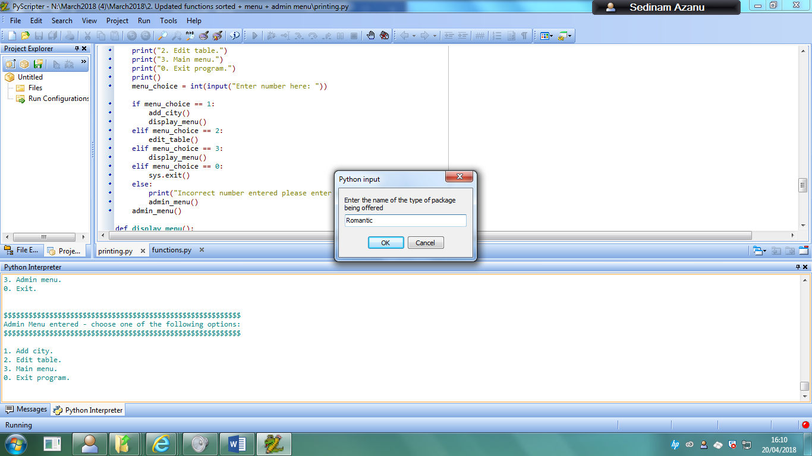

Then my input for the hotel type will be the four seasons hotel.

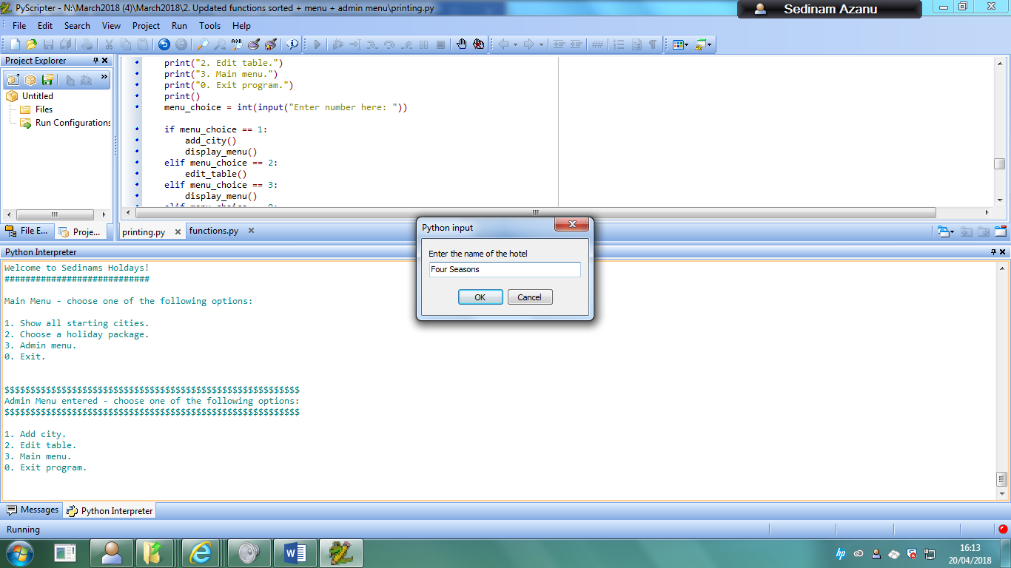

Using the show all records function



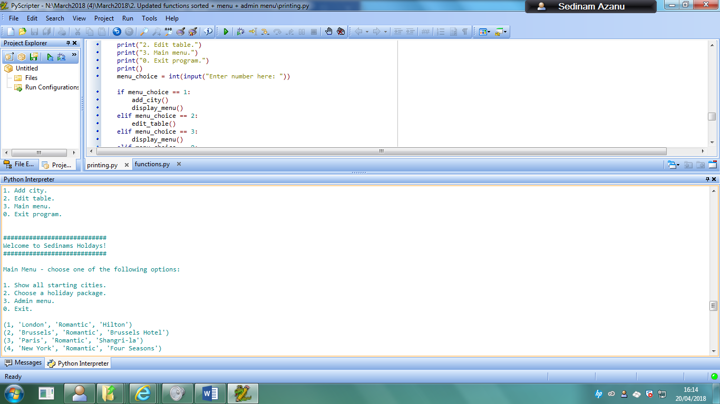

### 4: Deleting a record from the table

Firstly, I view how many tables that are currently in the table.



Then I would gain access to the admin menu by inputting 3



Then I would input the username and password to gain access to the admin menu





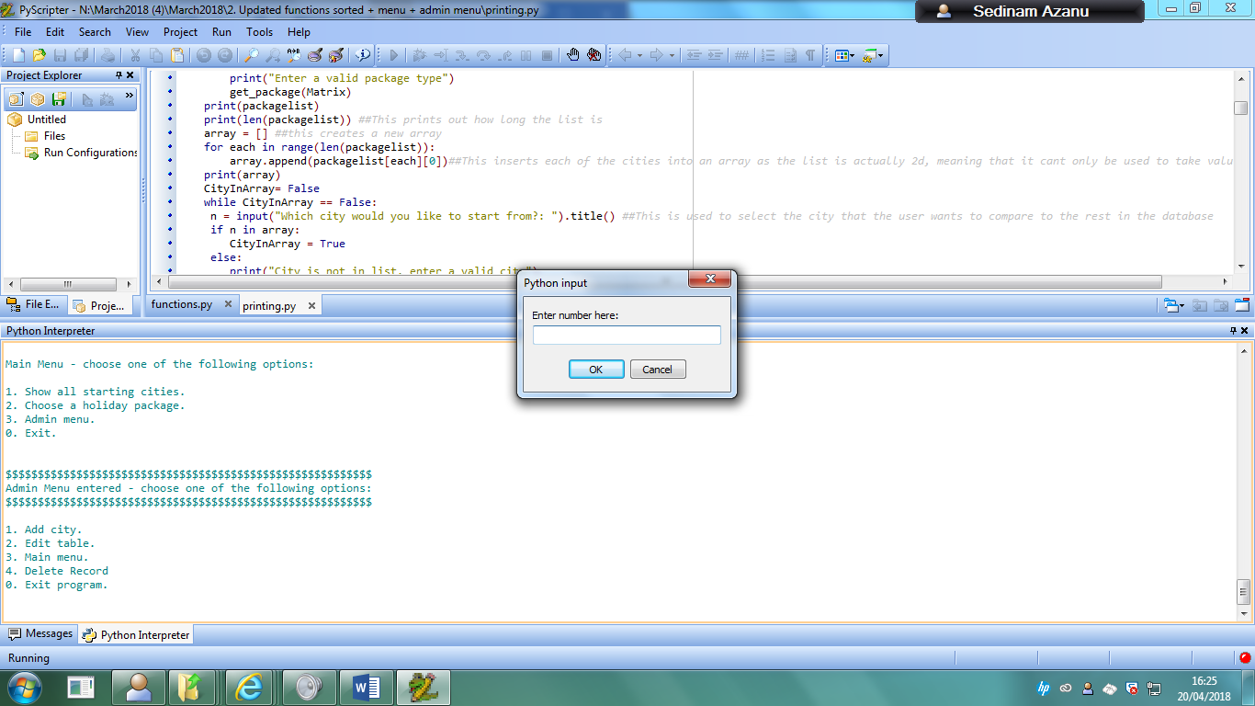

I then enter 4 to be able to get access to the delete record function

I then input 4 to delete the fourth record in the table

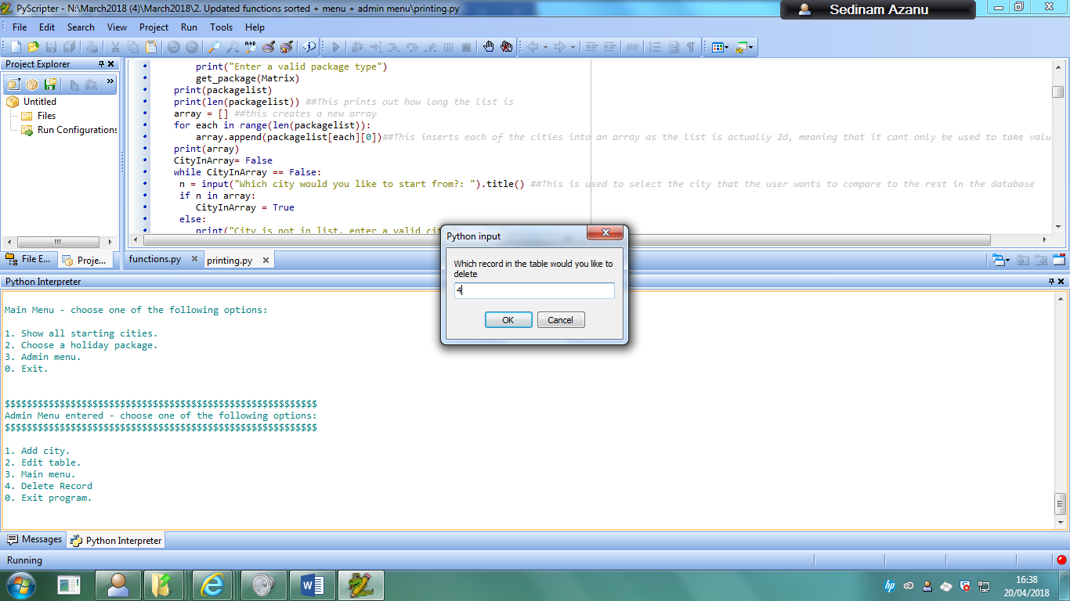

I then go back to the tables to view what is currently in the table.

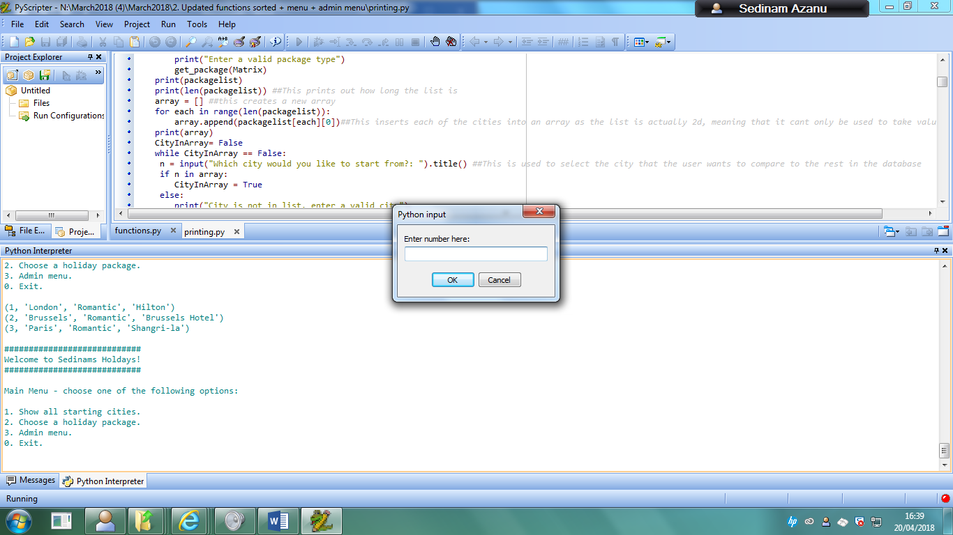

This shows that the value in the table has been removed.

### 5: Deleting a record that does not exist in the table

When the user enters a record that does not currently exist in the table, they will be met with this error if it is a string:

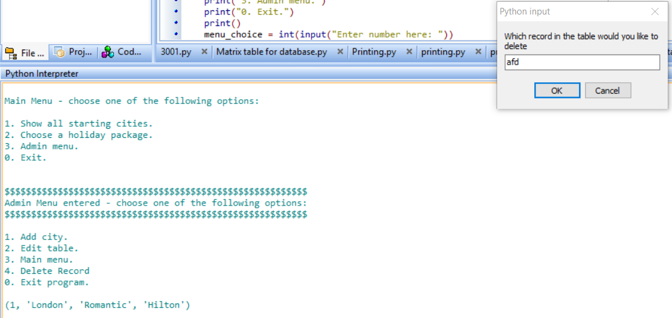

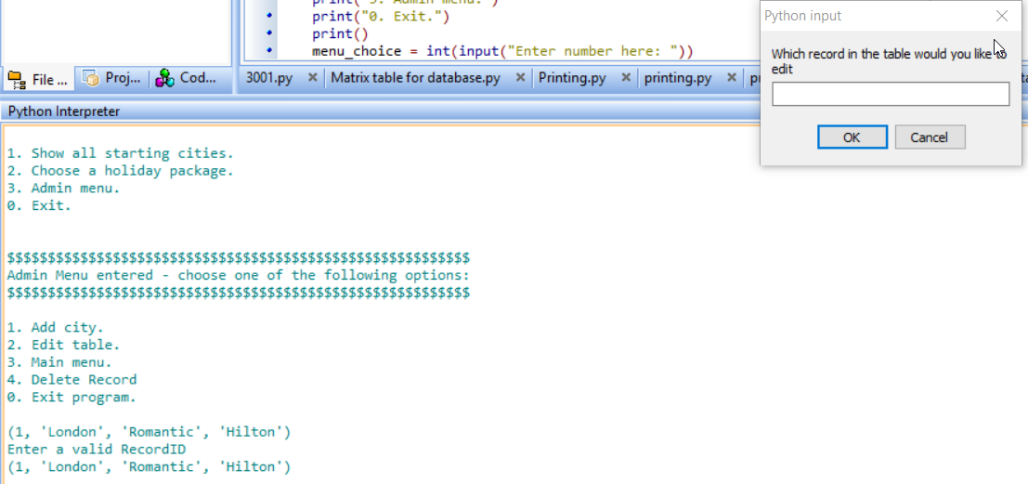

And the user will receive this error when the input is out of range:

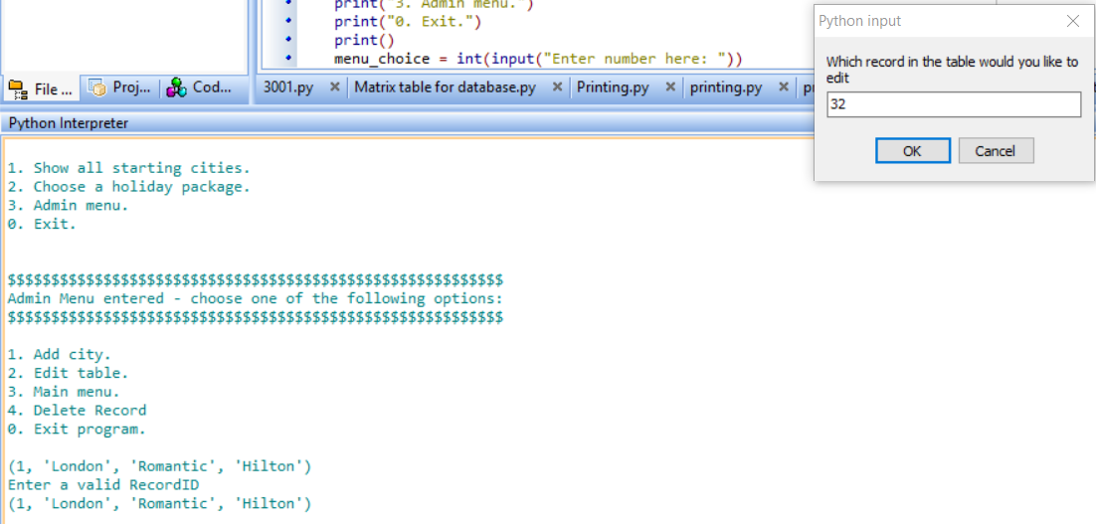

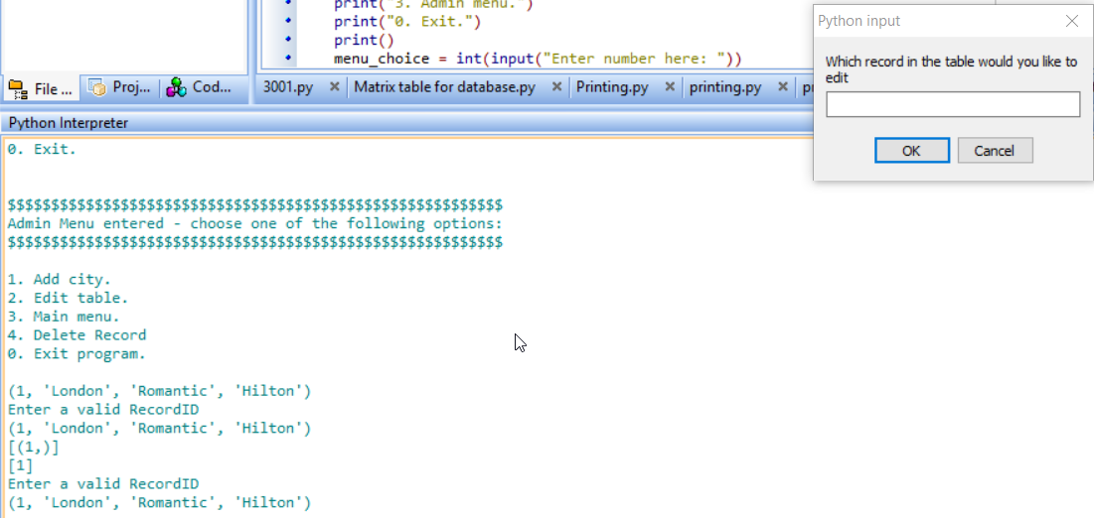

### 6: Function that allows for records to be displayed in ascending order of distance

For this I have to input 2 in the main menu function to be able to get access to that function.

I then input that I want a romantic holiday type

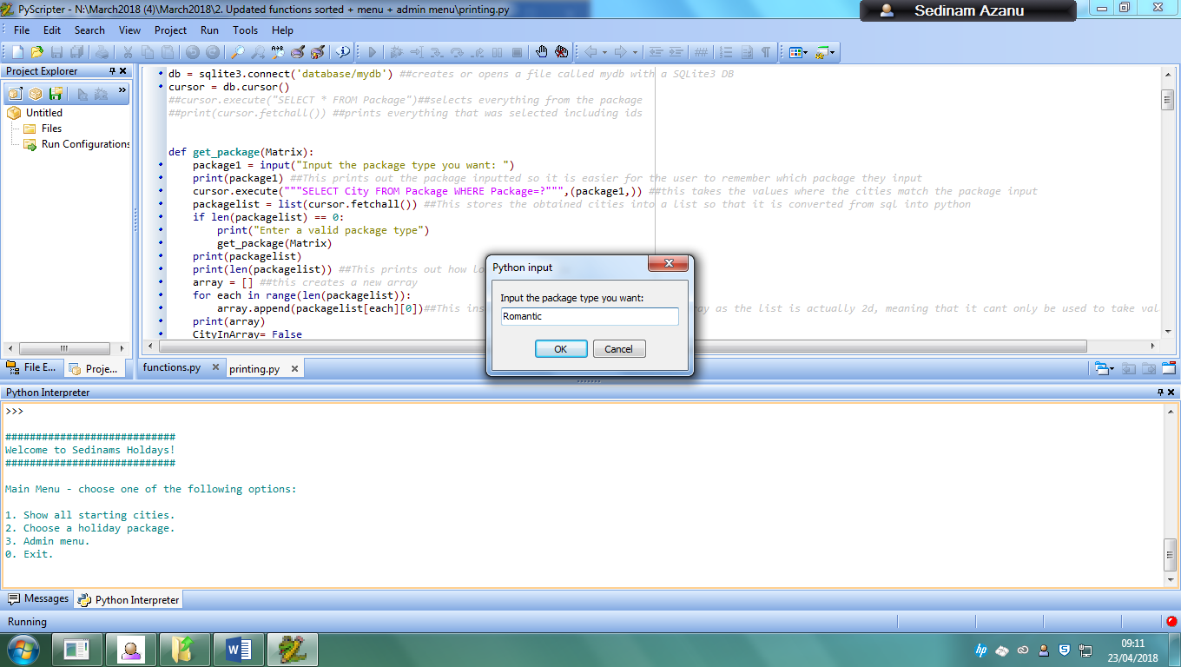

I get these options as results and I input that I want to start from London

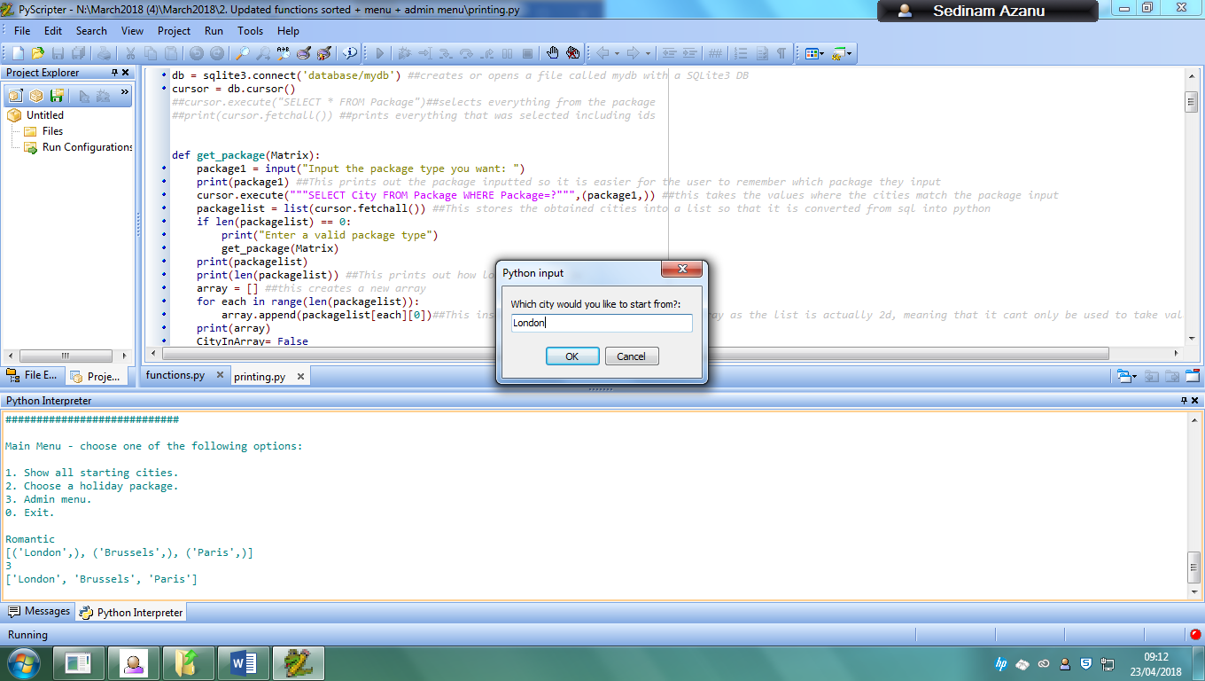

I then input I want to visit 900 cities, which then means I will get an output for all the other cities in the list.

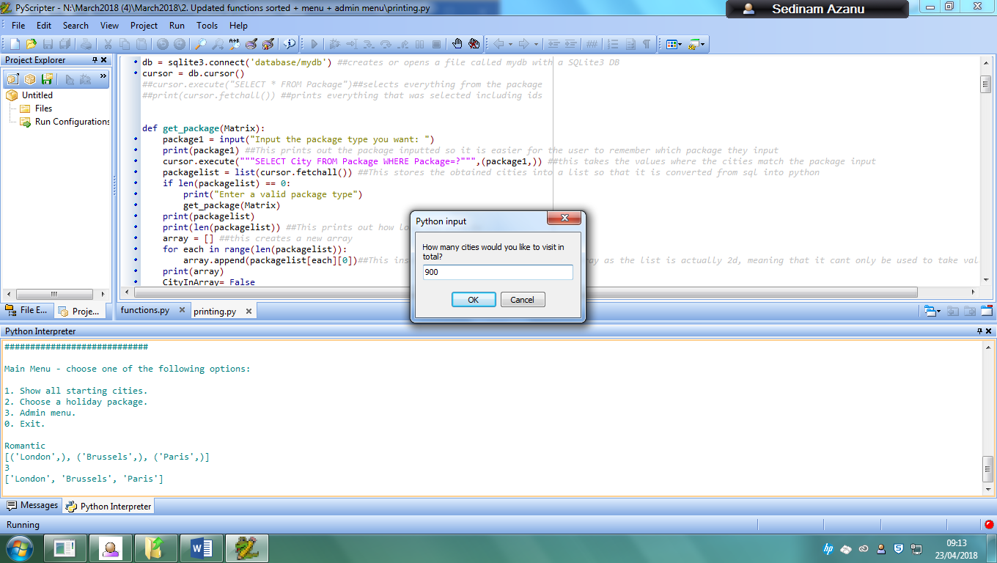

I receive this as an output

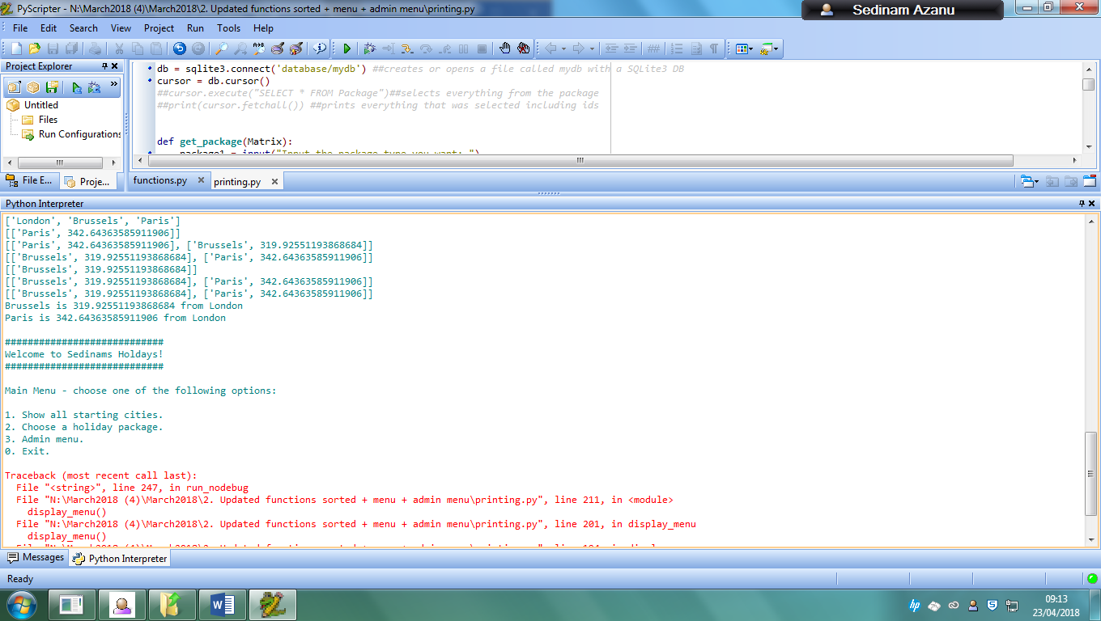

### 7: User types in package type that does not exist in the table

When the user is using the holiday function to get a holiday, if they input a package type that does not exist, they will receive this:

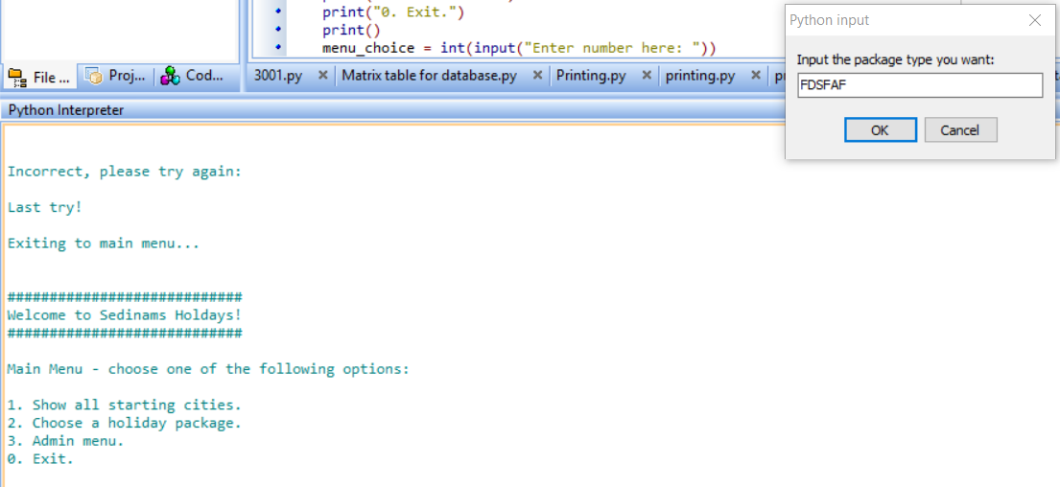

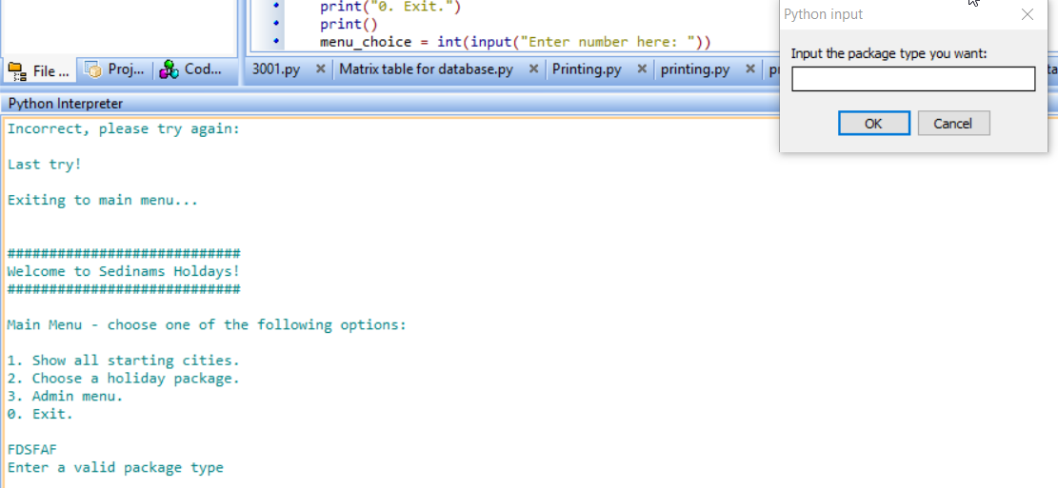

### 8: User types in a package type that does exist in the table

When the user inputs a package that does exist in the table instead, for example Romantic, they will receive this:

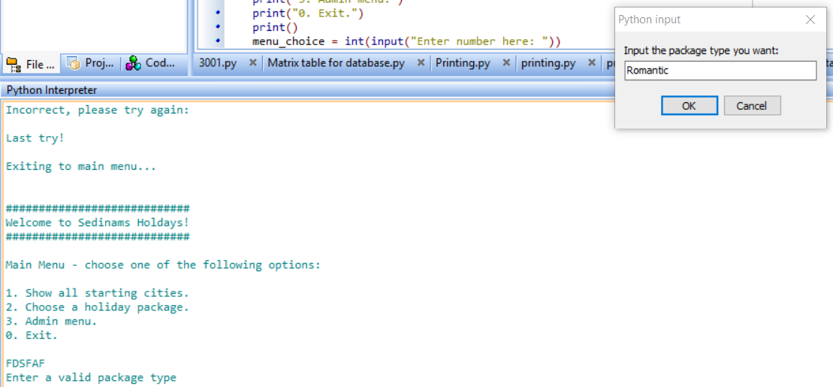

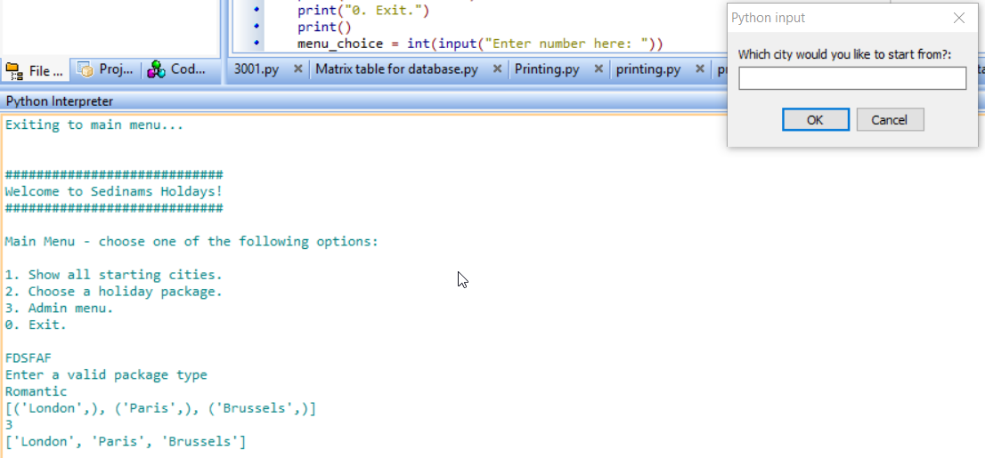

### 9: User inputs city they want to start from that doesn’t exist in the list

The user is given an output of the cities that fall under the package type. When they input a city that does not exist in that list they will receive this output:

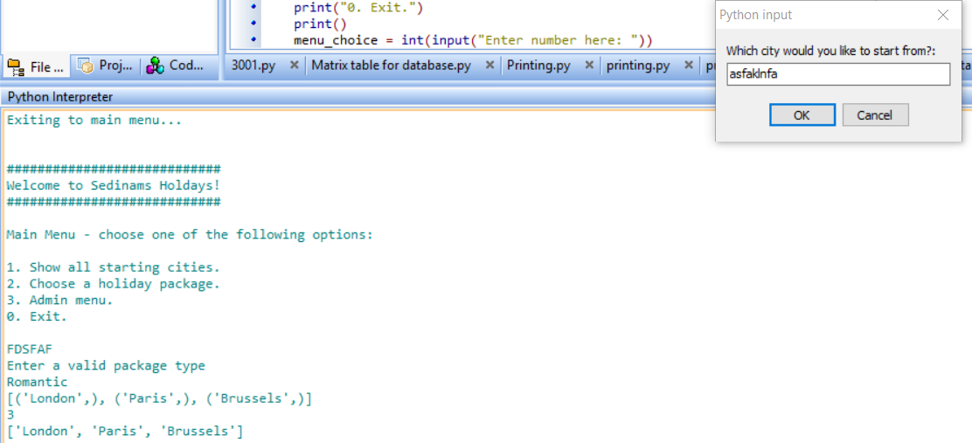

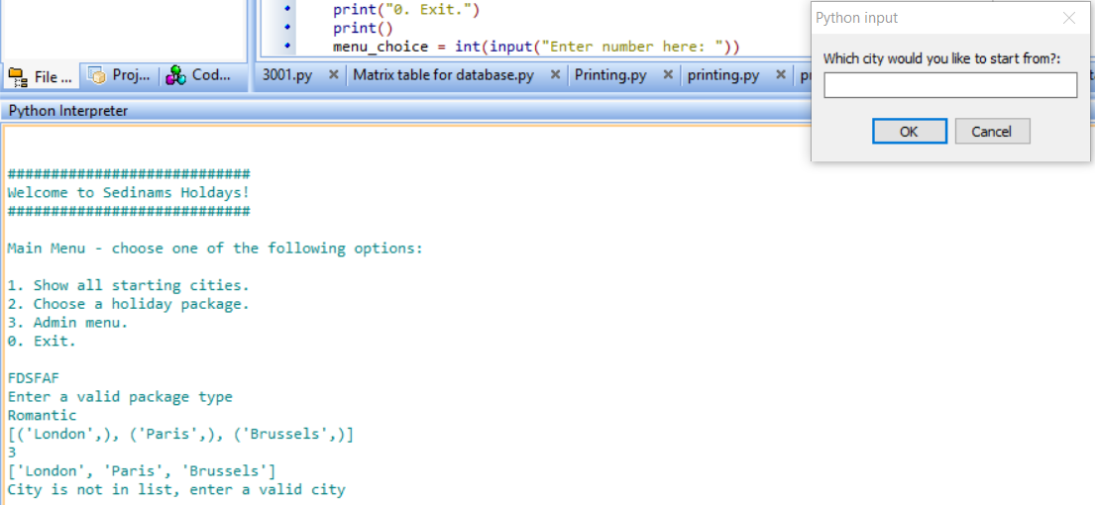

### 10: User inputs city they want to start from that does exist in the list

When the user is able to input a city that does exist, they will receive this output:

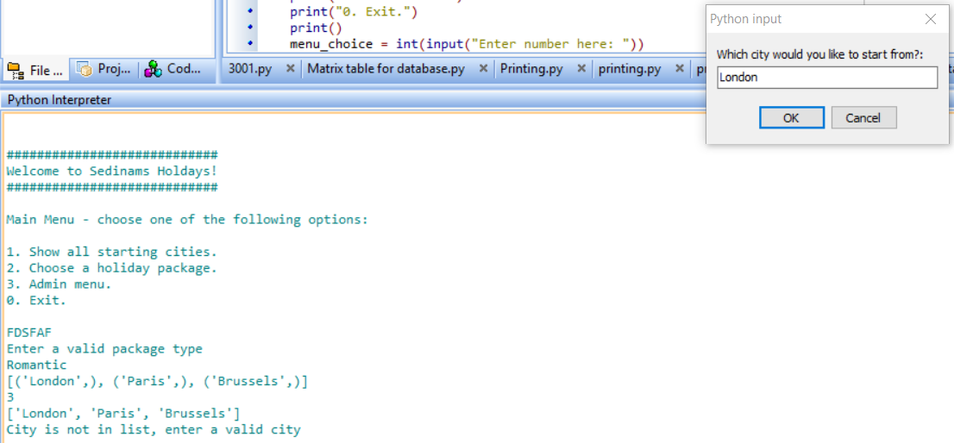

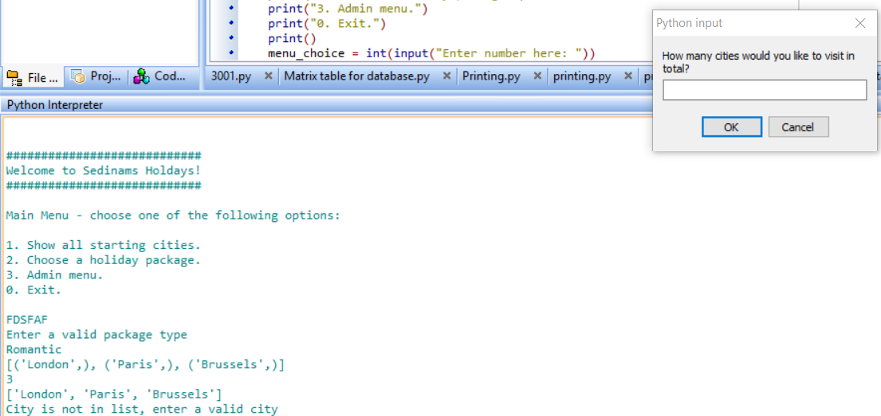

The next input that is required from the user will be given to them.

### 11: Display all the records currently in the package table

For this, I would need to input 1 at the main menu so that I get an output of how many records there are.

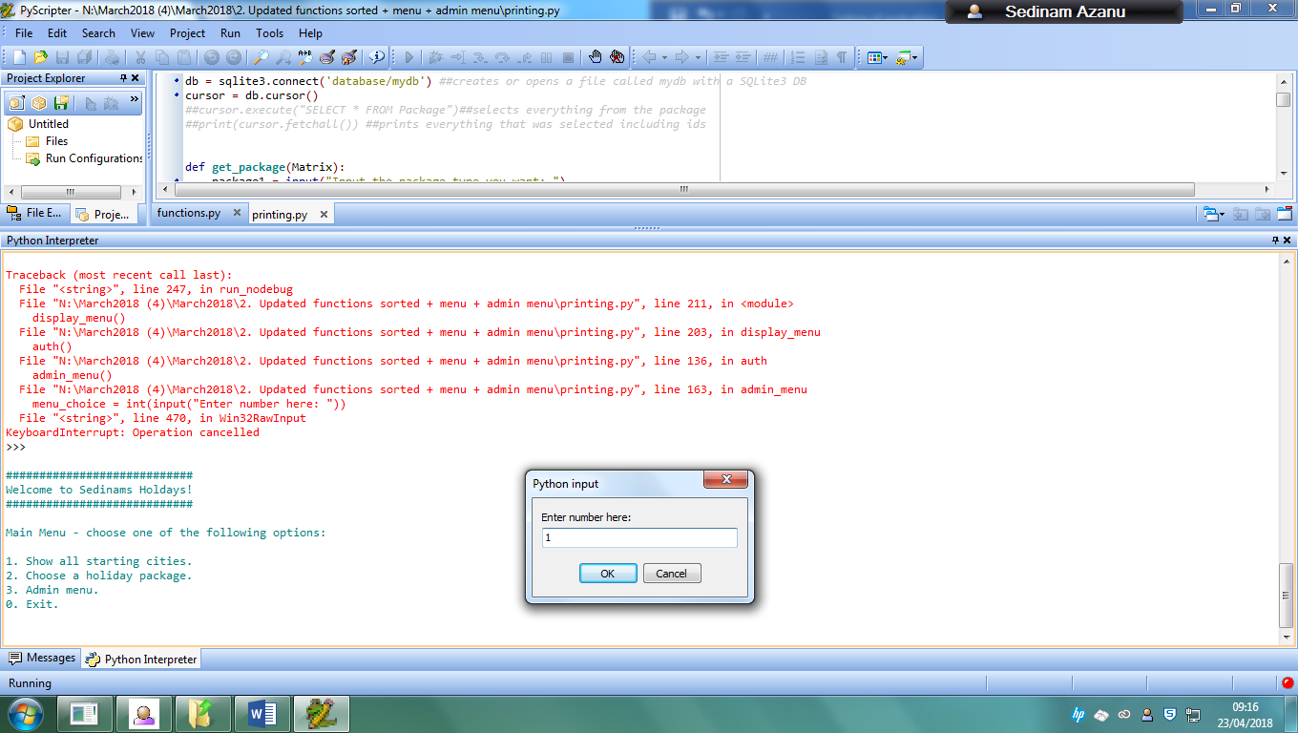

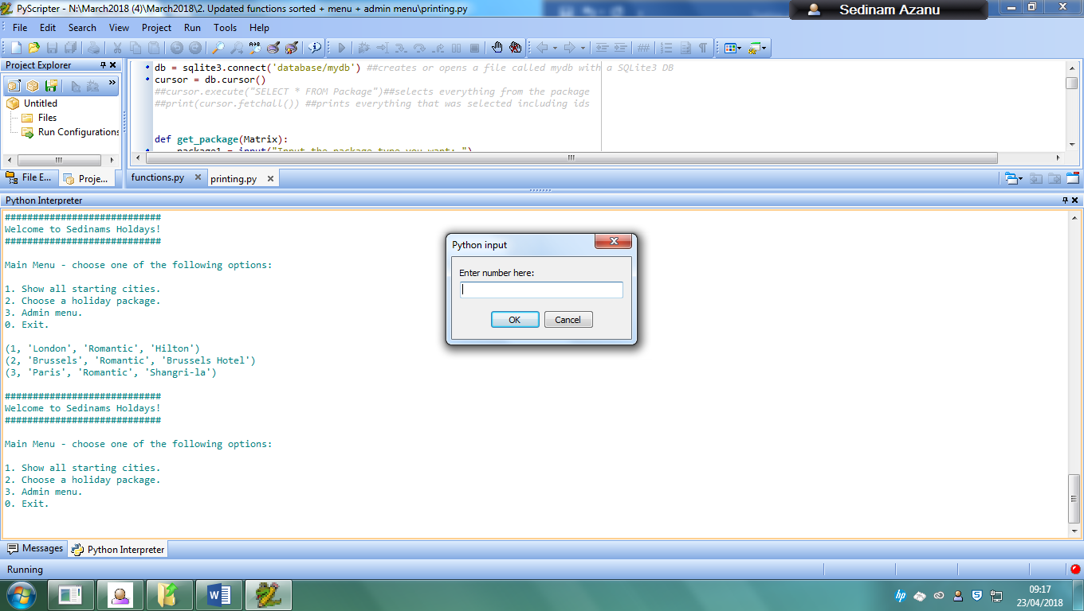

### 12: Type in any number not in the range when asked to access the menu options

For example, if I type in 8 when I want to access menu options, this would happen, where an error output would be given and the main menu would load again.

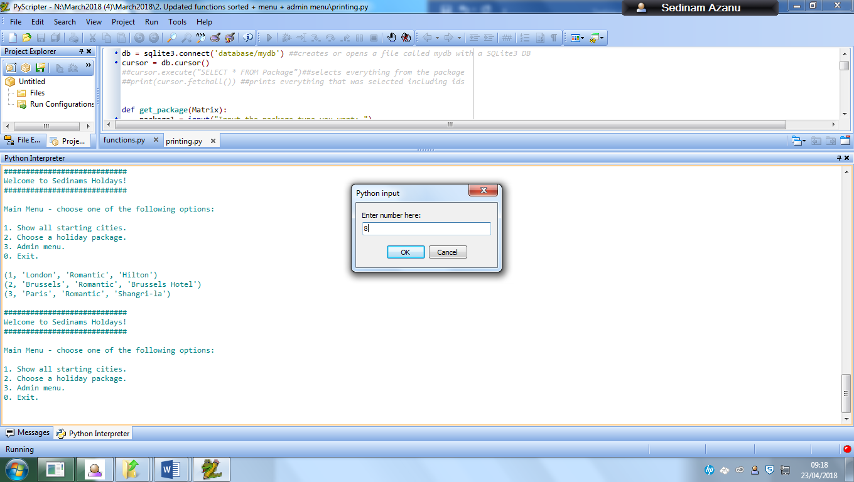

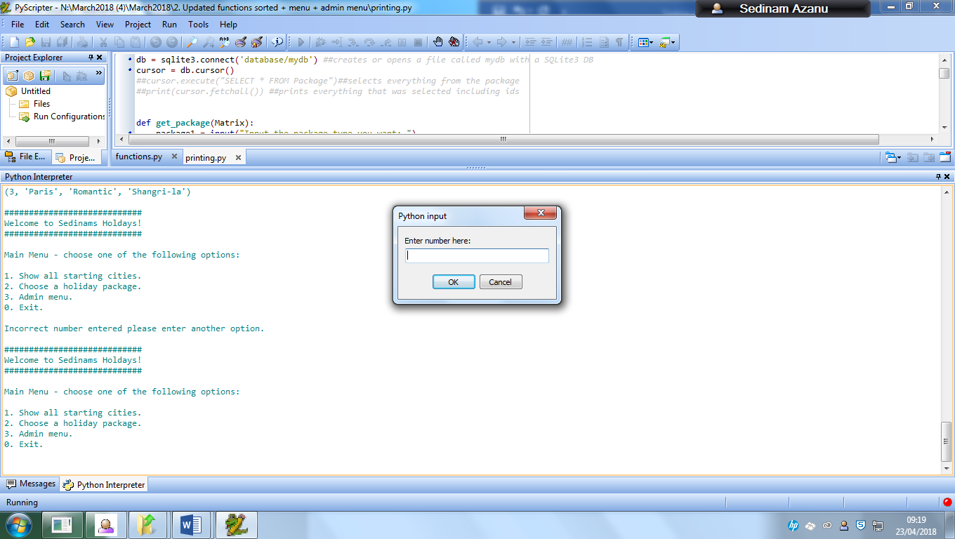

And if I type in a string value, this happens

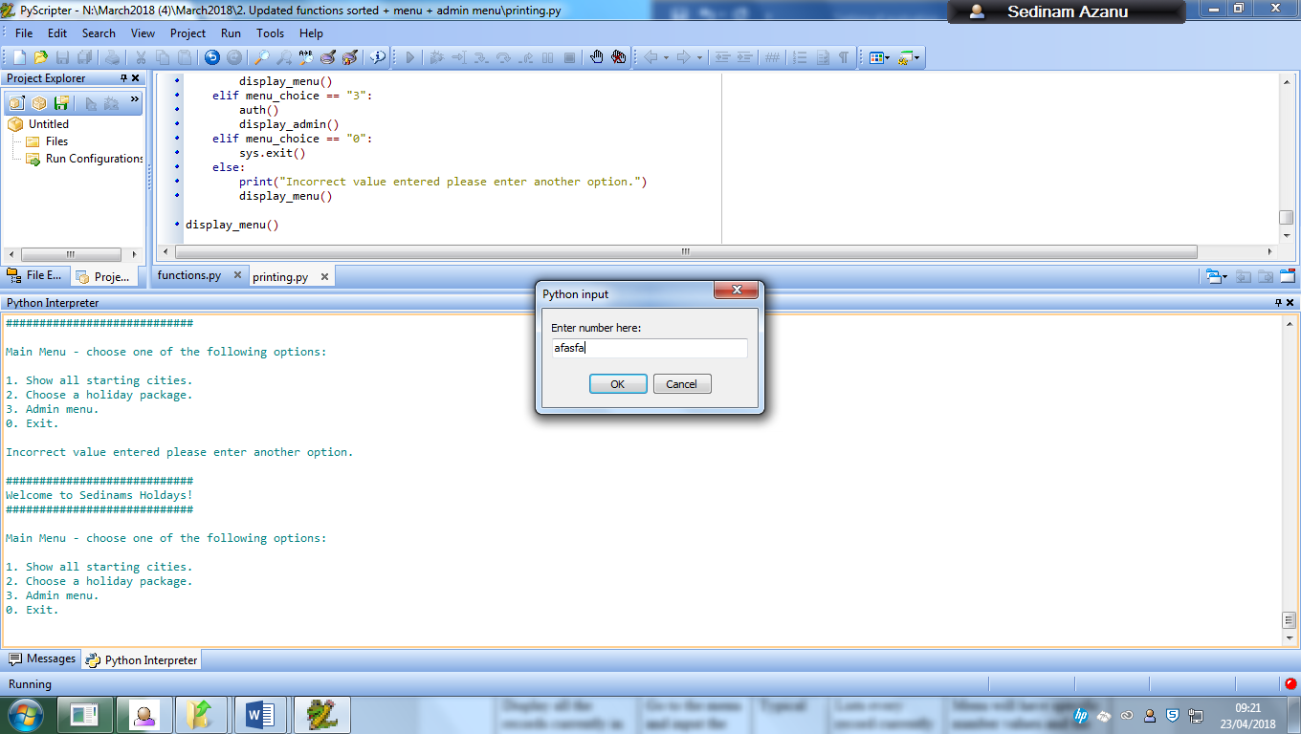

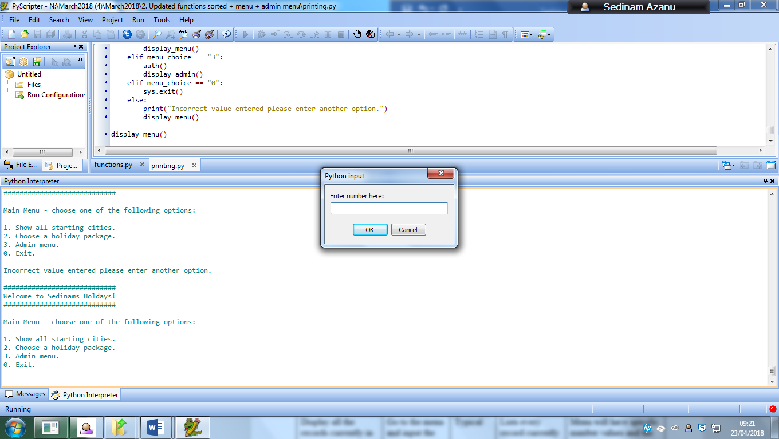

The same error will occur with the admin menu

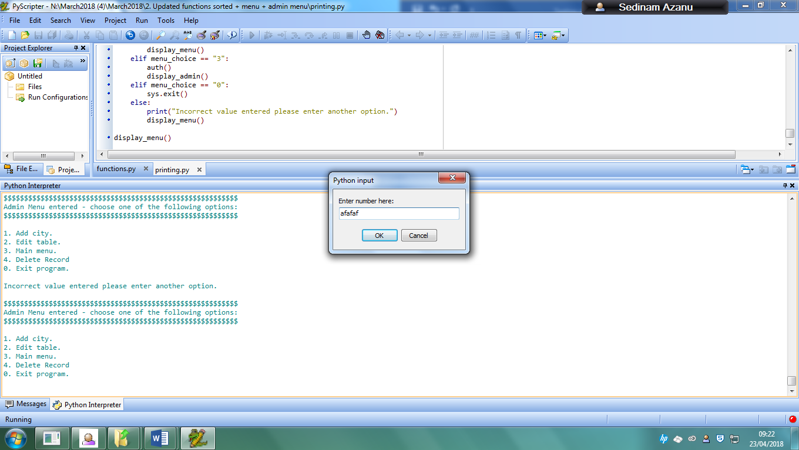

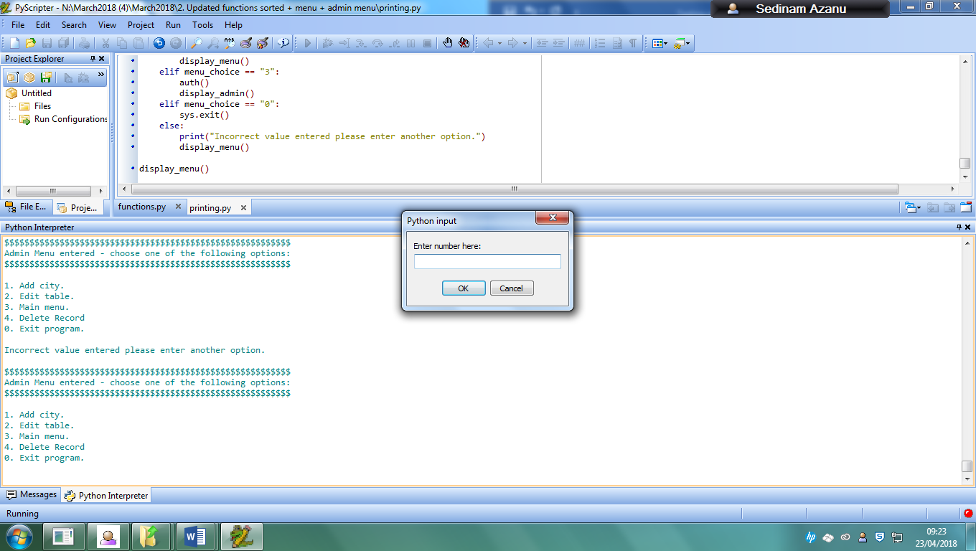

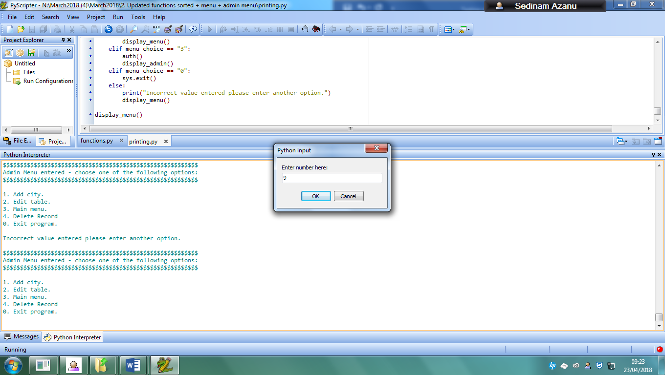

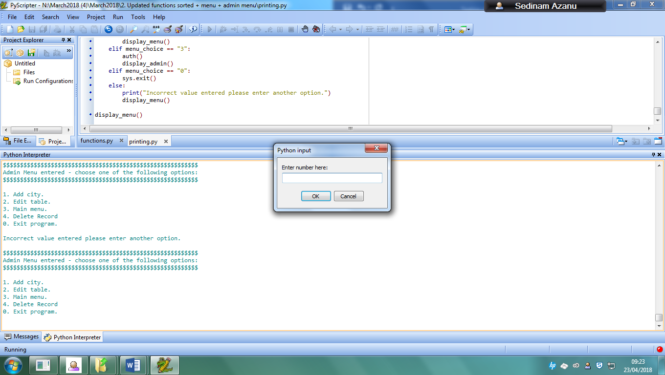

### 13: Type in all menu options in range

When the user inputs 1 for example, they will receive this:

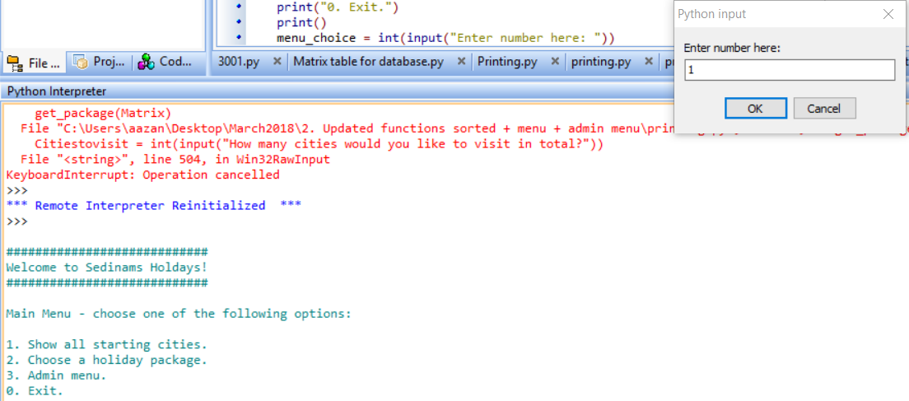

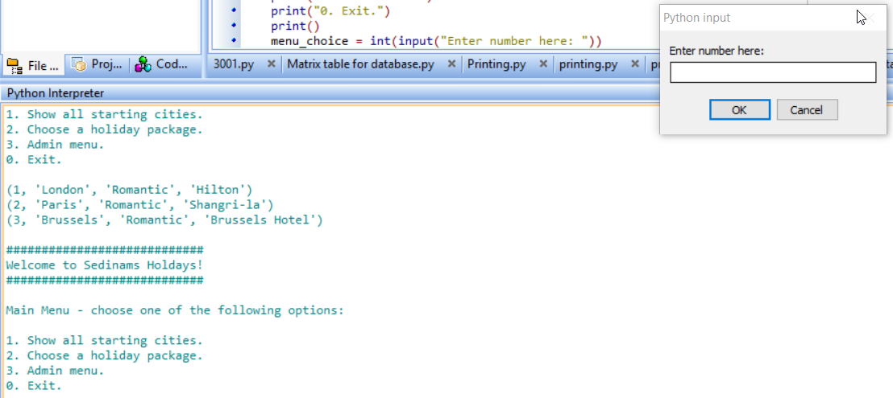

The user is given an output of all the records in the table and is returned to the menu.

When the user inputs 2 they are given this:

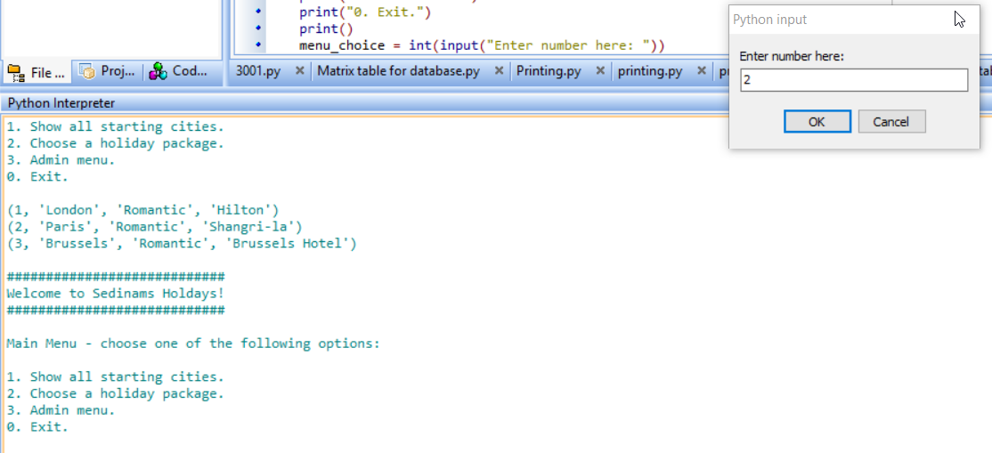

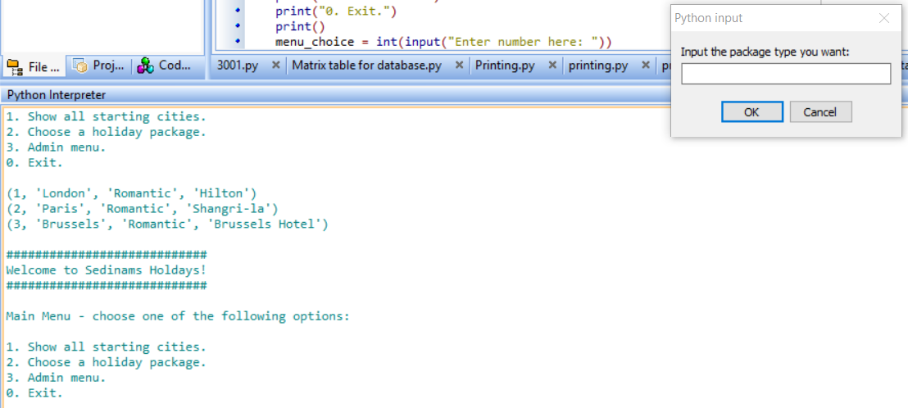

They are sent to the holiday choice function.

When the user inputs 3 they receive this:

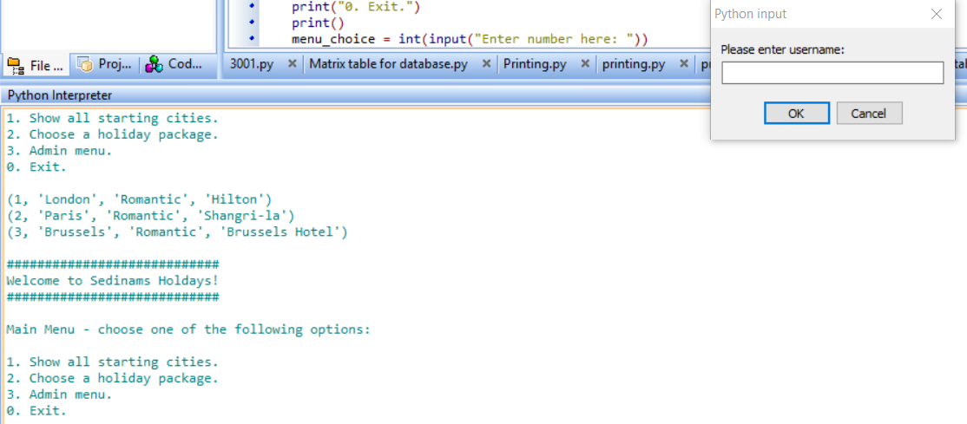

They are told to input a username and password to get access to the admin menu.

### 14: Type in all admin menu options not in range

When the user inputs 9 for example they are given this output:

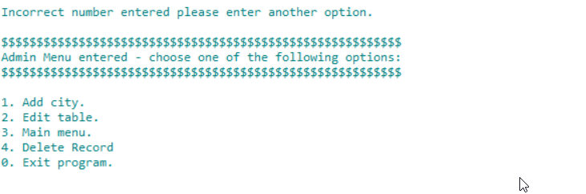

### 15: Type in all admin options in range

For my user to be able to gain access to the admin menu, they would have to go through the normal menu in the program and input 3 which would then tell the user to log in.:

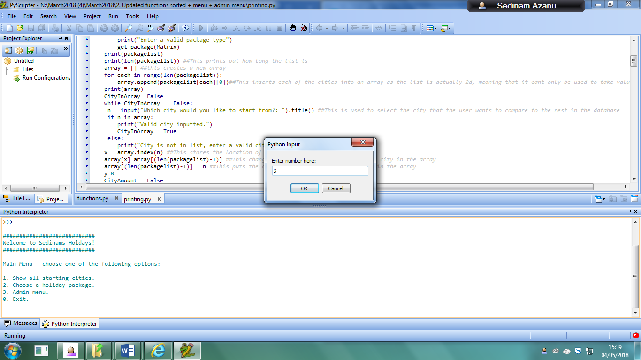

Then afterwards the user would be met with the login for the admin menu:

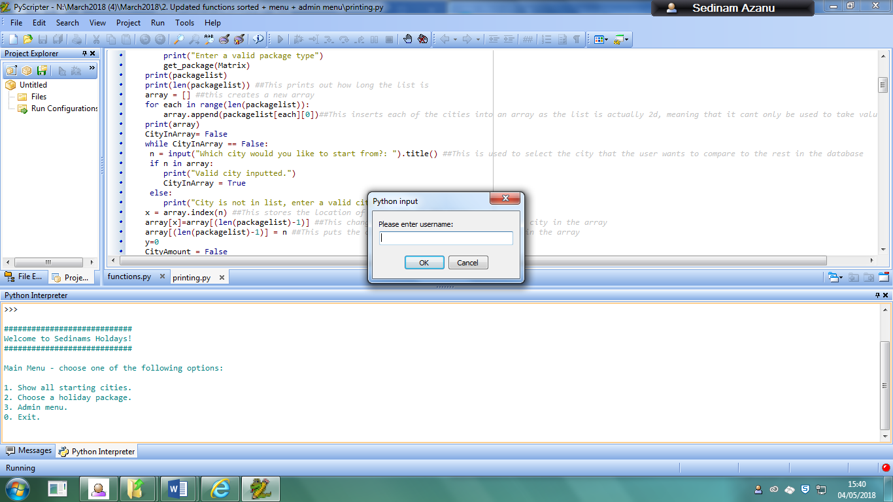

The user has to input the username “admin” and the password “password” to be able to gain access to this menu:

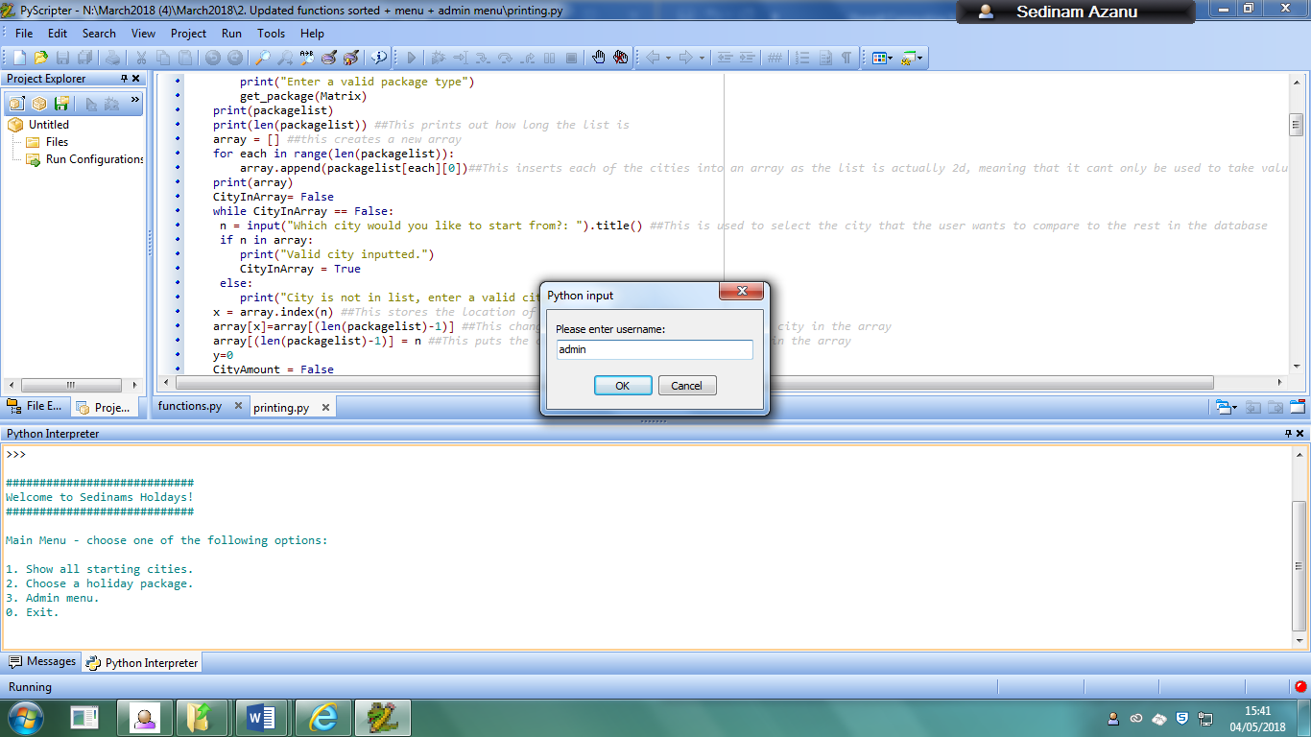

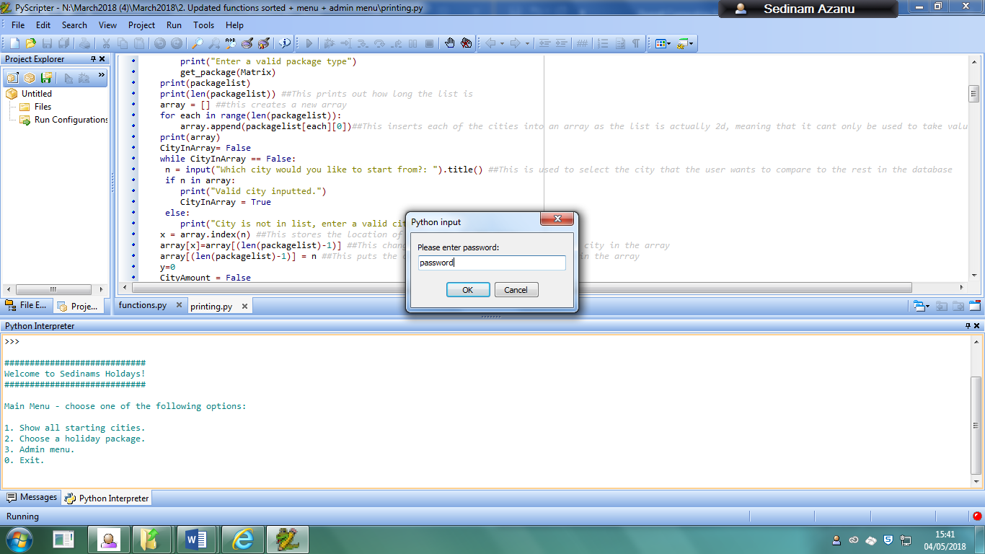

As the user has inputted in the correct username and password for the admin menu, they will be allowed access:

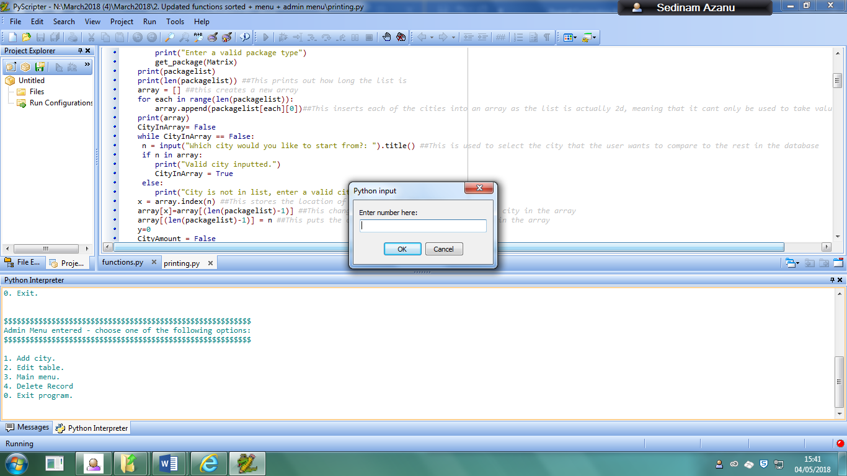

The user then has several functions to be able to access within the admin menu, being the add city function, the edit table function, the main menu function which returns them back to the original menu, and exit program which just ends the program.

When the user inputs 1 for example, they are given this output:

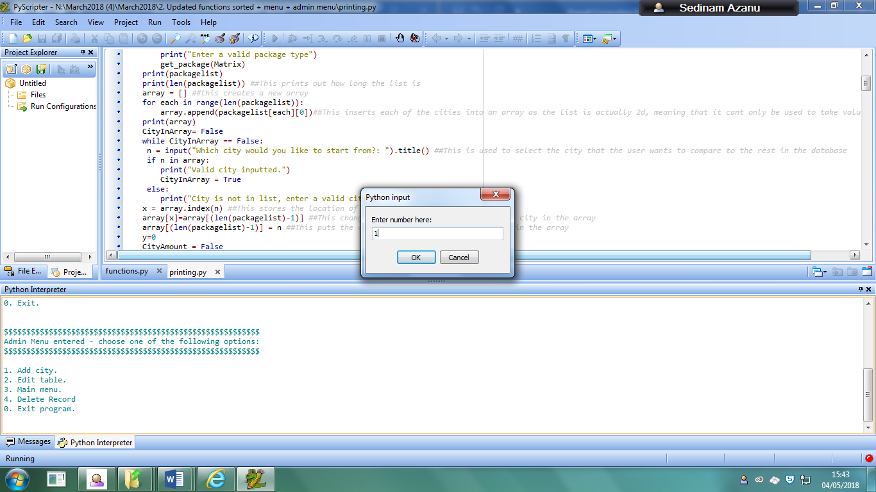

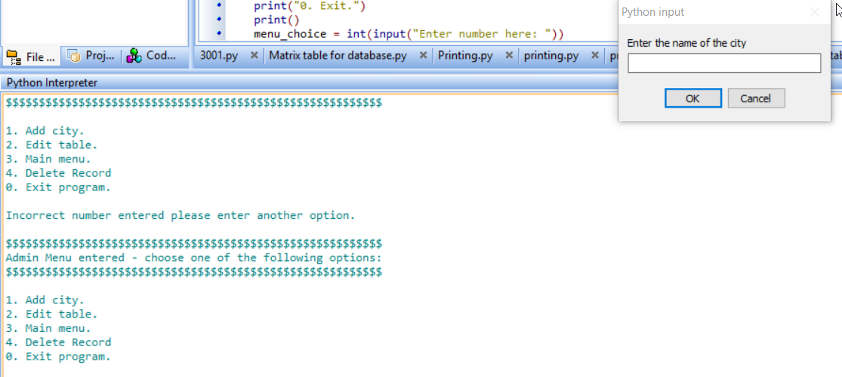

They are told to input a city for the add city function.

When the user inputs 2 they are given this output:

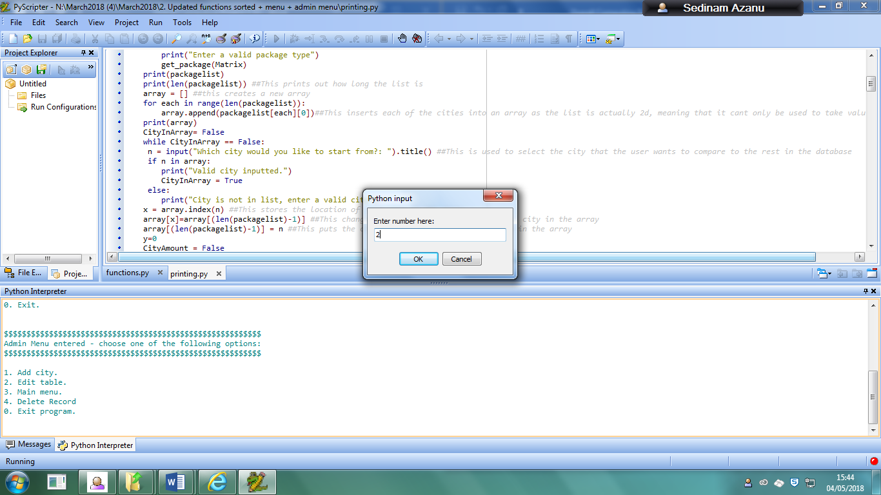

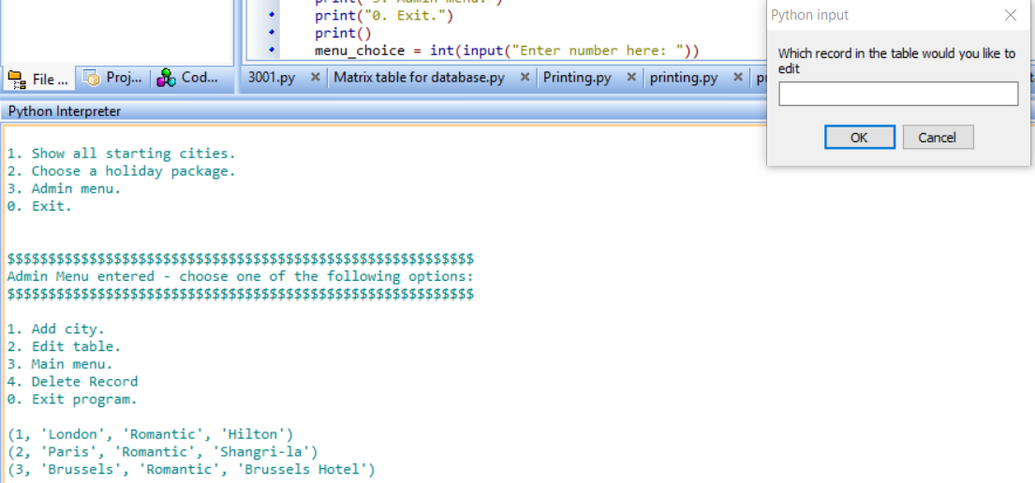

They are asked which record they want to update.

When the user inputs 3, they are returned to the main menu:

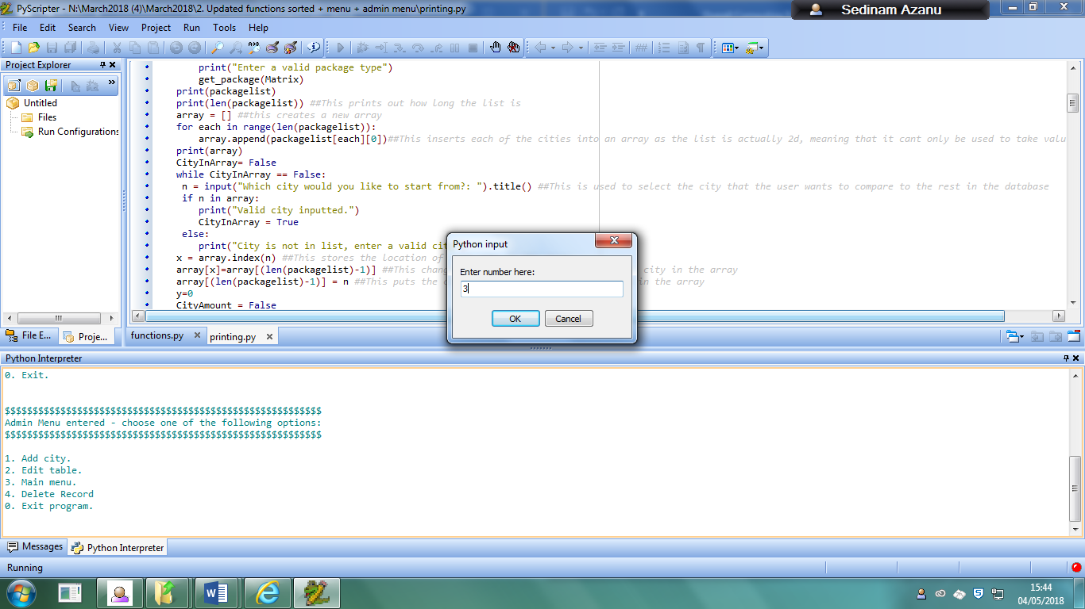

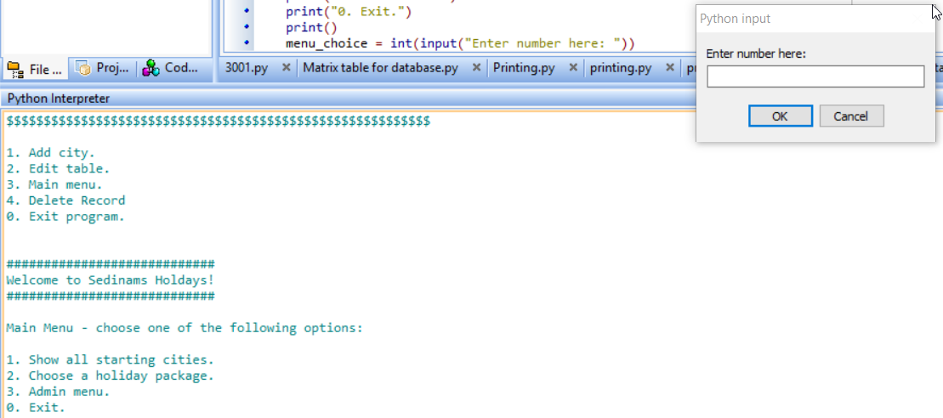

When the user inputs 4, they are given the output to be told to input the recordID of the record to delete:

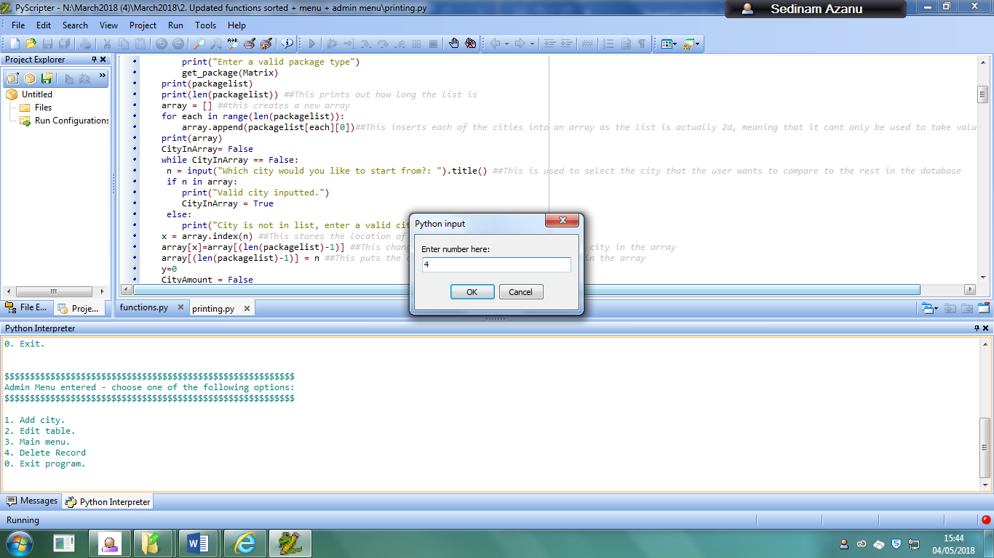

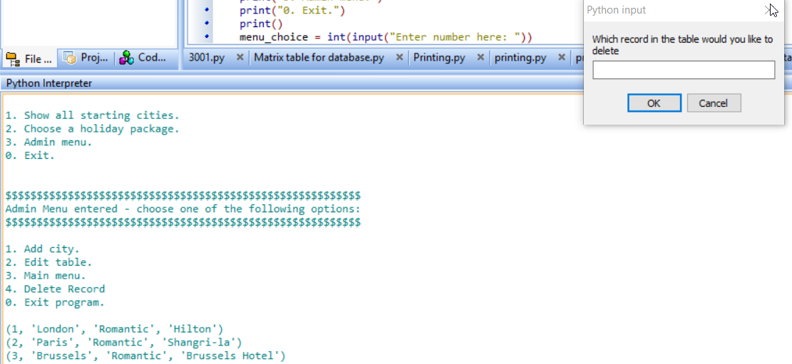

And when the user inputs 0, the program just ends:

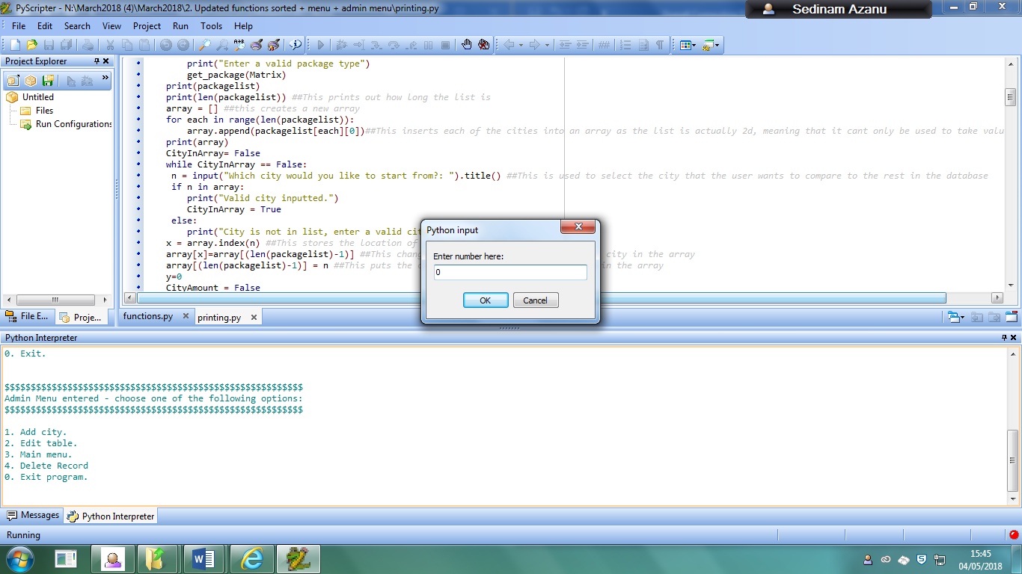

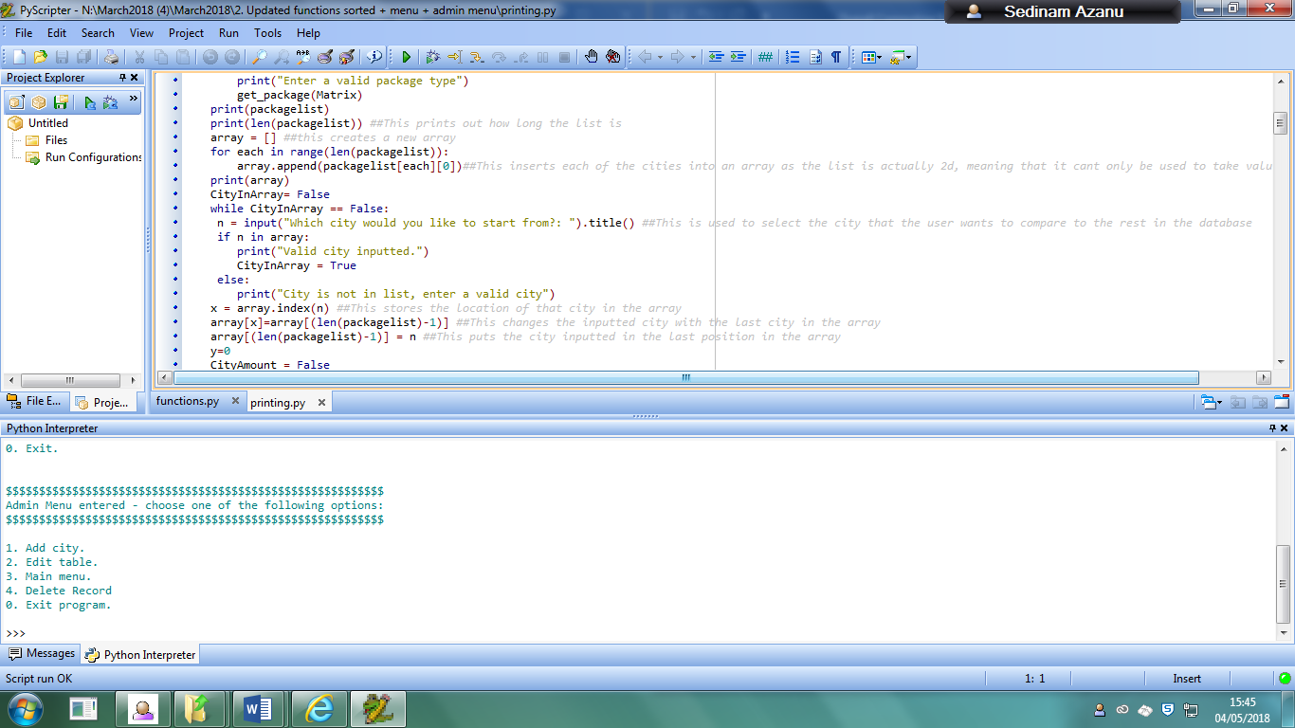

### 16: Type in any number when deciding how many cities that the user wants to visit

When the user is using the holiday function, they will be asked how many cities they would want to visit from what is currently listed after being asked which city they want to start from

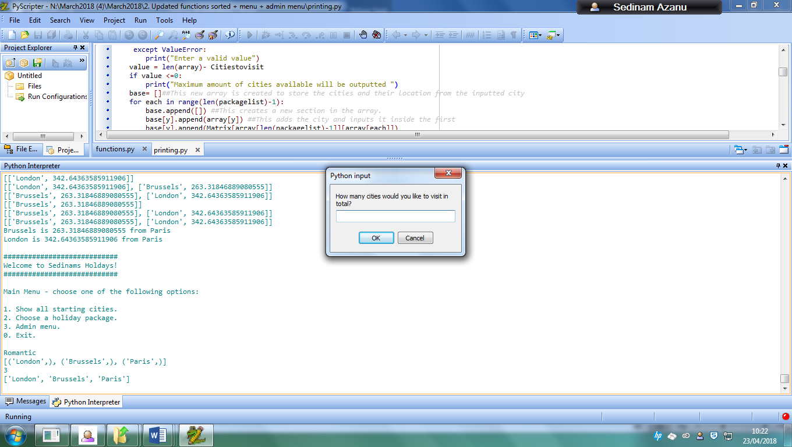

If the user inputs a value that is higher than the number of cities that are available in the list -1 (as the user has to start from one of the cities), an output will be given stating that the maximum number of cities available will be outputted. The reason I am going to test 900 is because I randomly thought of a value that would not be in the range of the number of cities in the list, and therefore would definitely be higher than the maximum amount of cities that can be visited.

if I input 900:

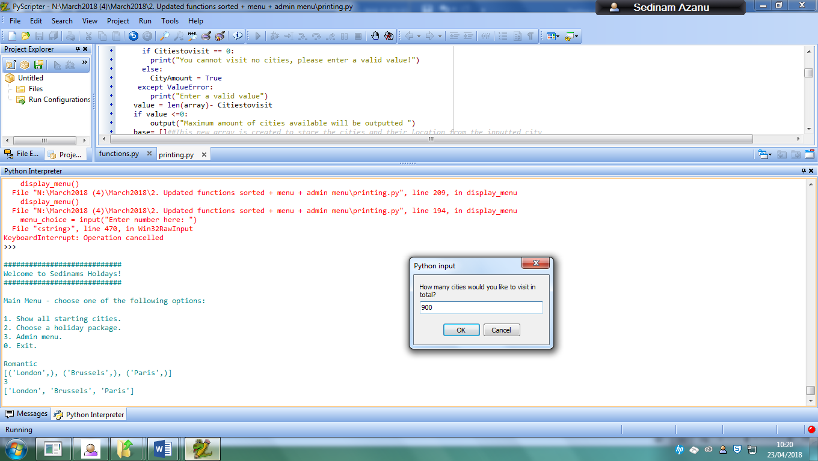

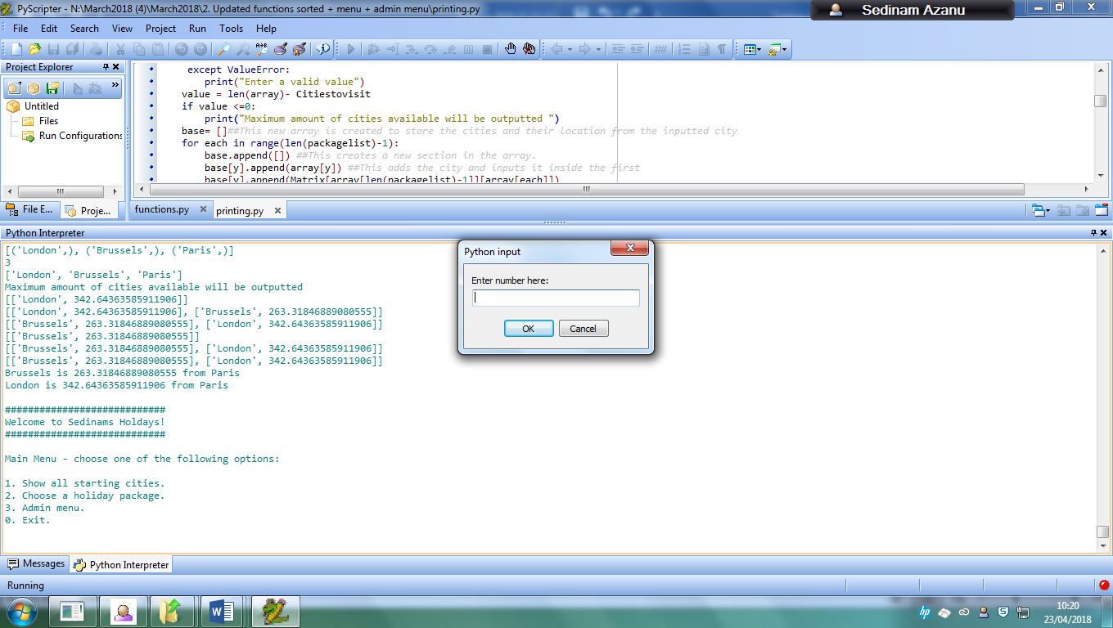

When the user inputs 0 when getting cities, they will receive this output, as you can’t visit no cities:

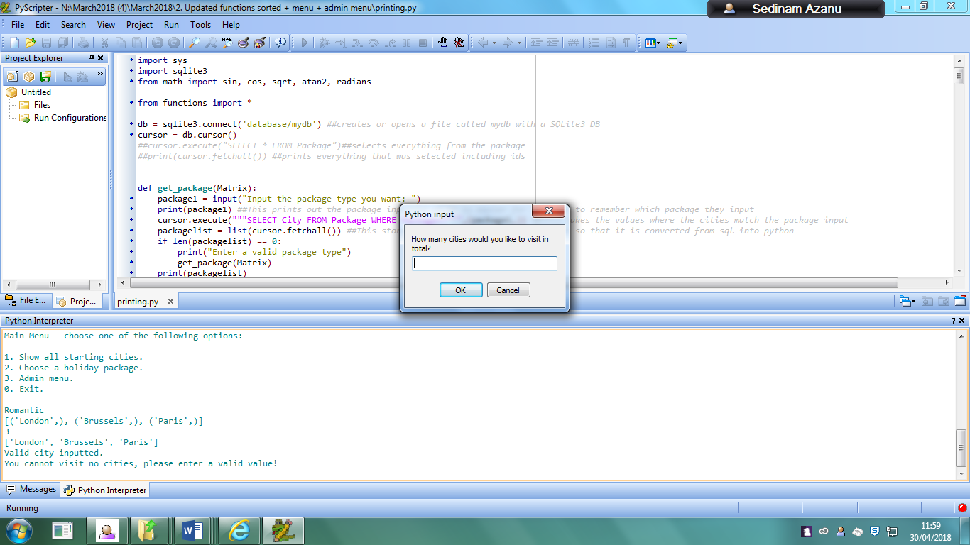

I also tested this function further by adding 2 more cities into the list to have a total of 5 packages available. The added cities were Dubai and Malaga. If the user inputs to start from Paris and wants to visit one city they would get this output:

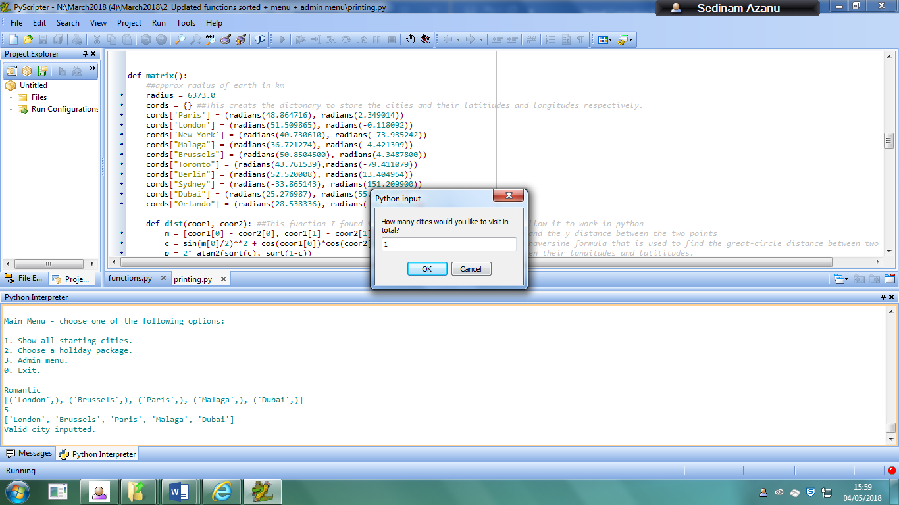

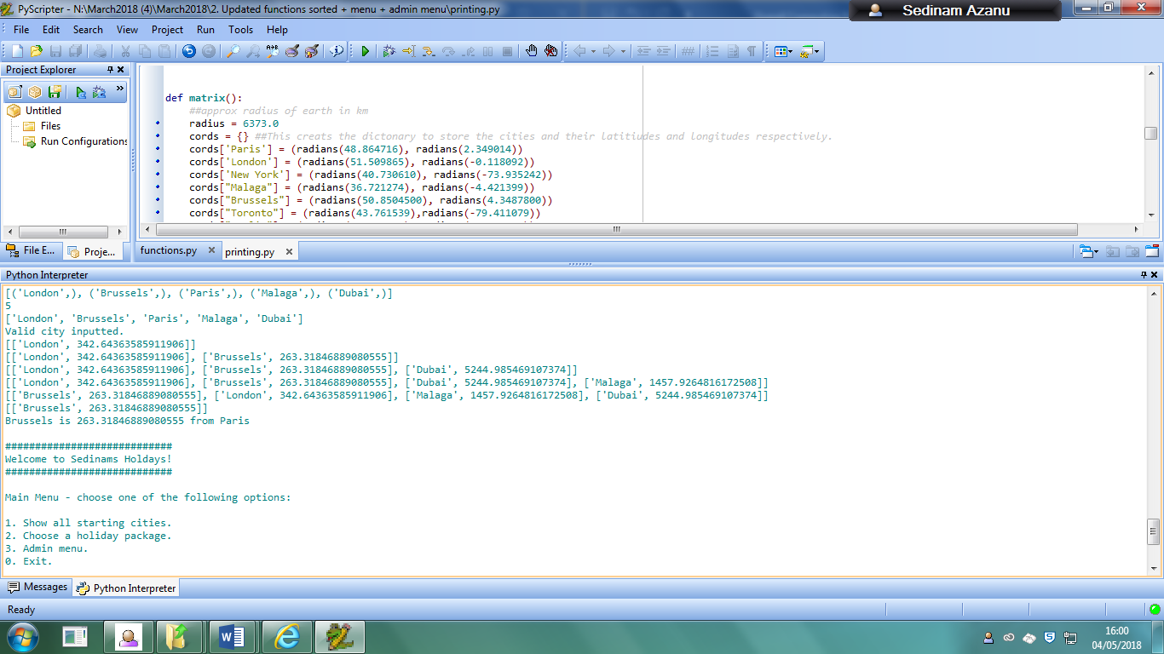

If the user inputs that they want to visit 3 cities instead, they would get this output from the program:

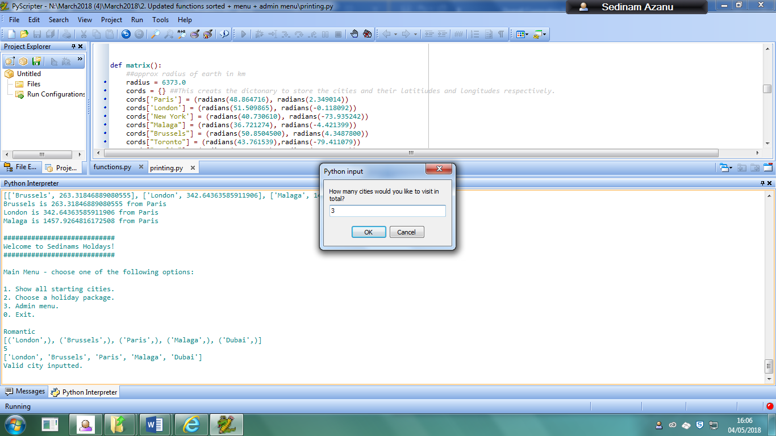

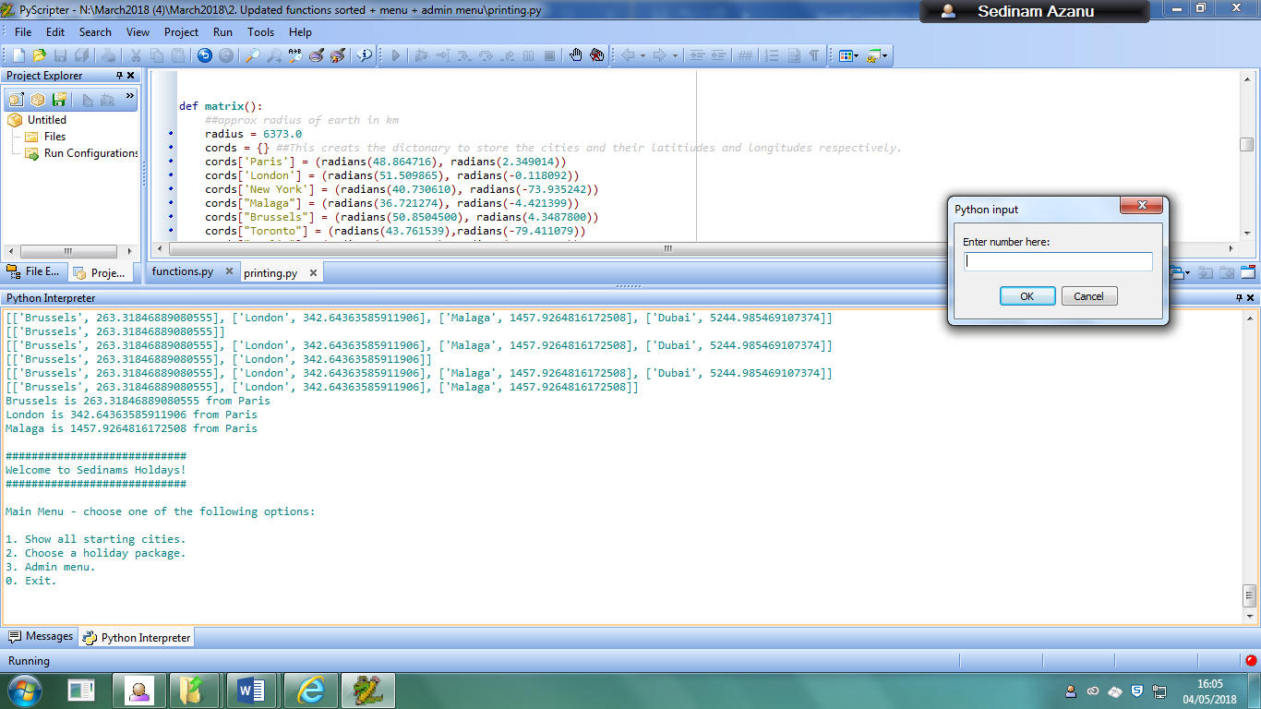

If the users input that they want to visit 4 cities (The maximum number of cities the user can visit is one less than the total number of cities in the list), then they would input and receive this from the program:

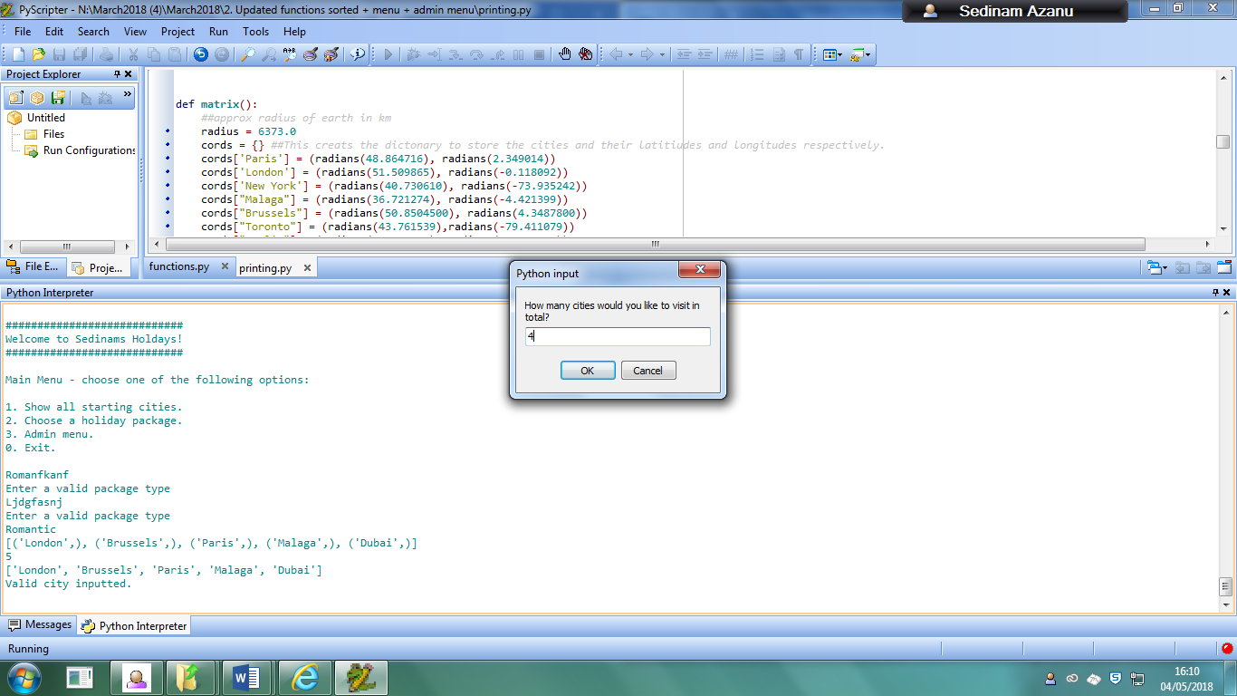

This is the output:

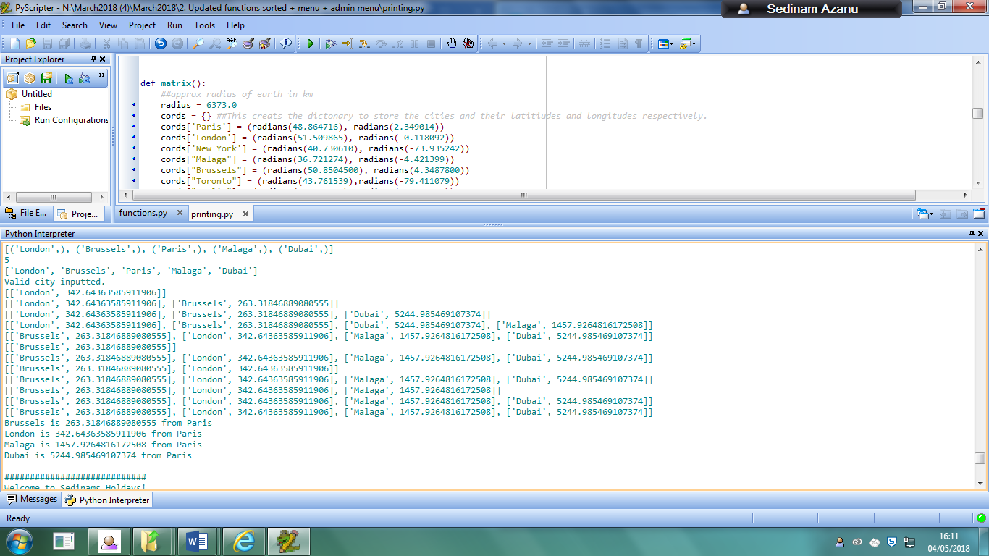

And if the user inputs a negative value, no distances would be outputted for the user. This is shown below:

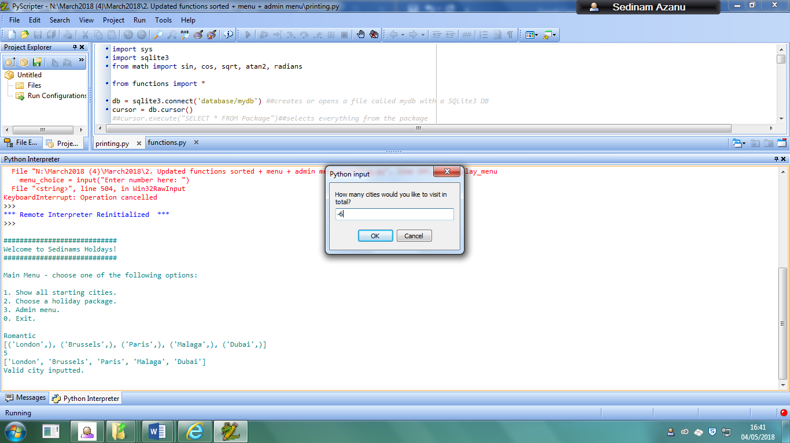

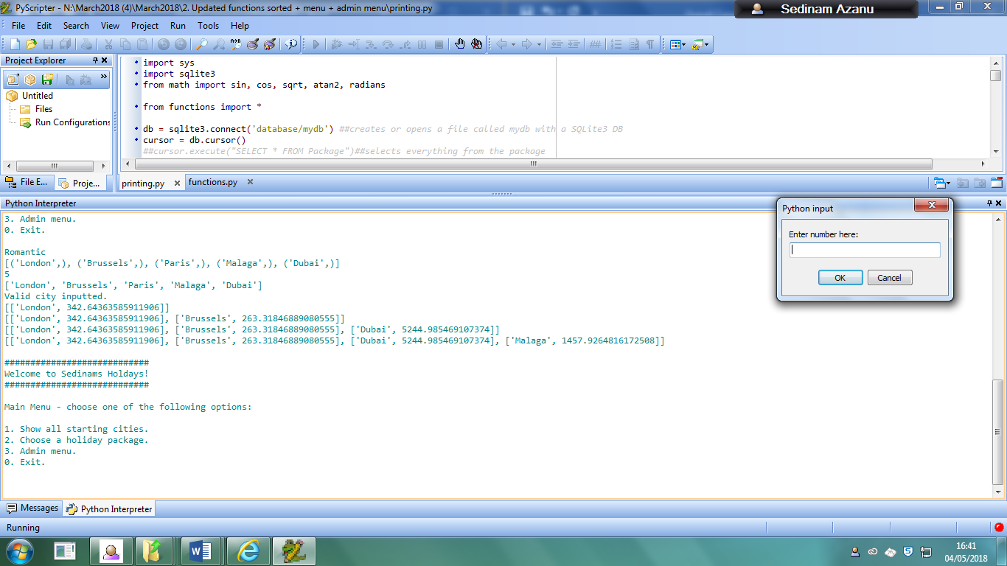

This shows that no distance comparison is outputted as a result when the user enters a negative value.

### 17: Entering in a string when deciding how many cities the user wants to visit

When using the holiday function, if the user inputs a string value when trying to input the number of cities they want to visit, this would happen:

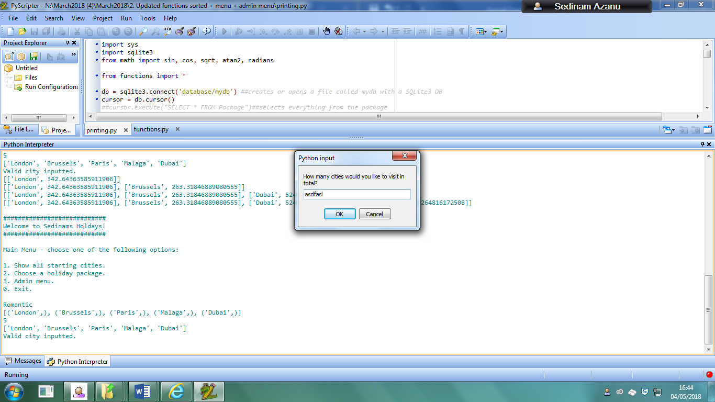

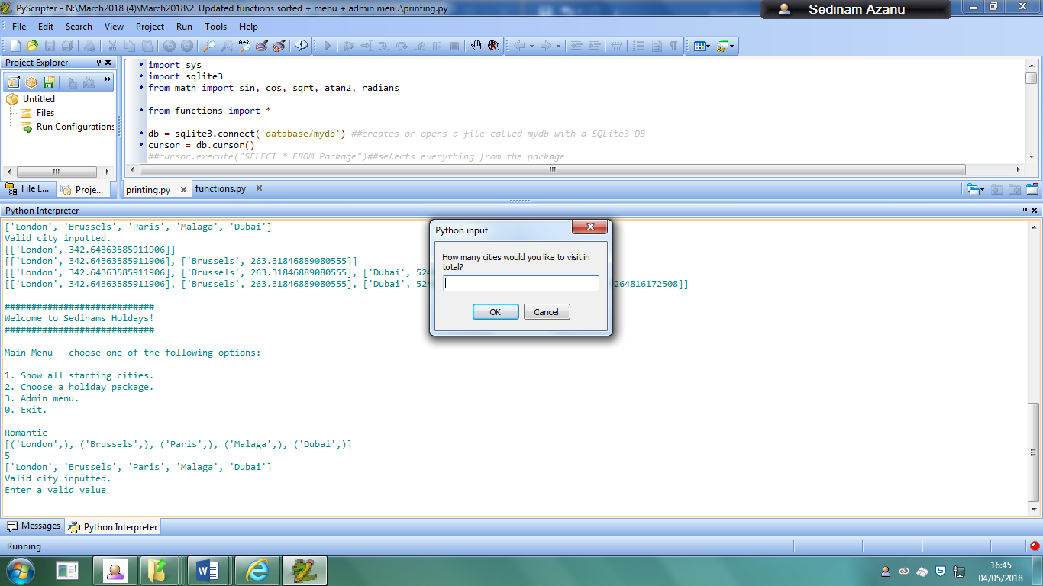

This shows that if the user inputs any sort of string value due to using a try function, it would just catch the error and tell the user that the value that they inputted is invalid.

### 18: Entering any other username and password when trying to get access to the admin menu

When the user enters a wrong username and password, they will be given 3 chances before being returned to the main menu

This is the first message given when an incorrect input is given

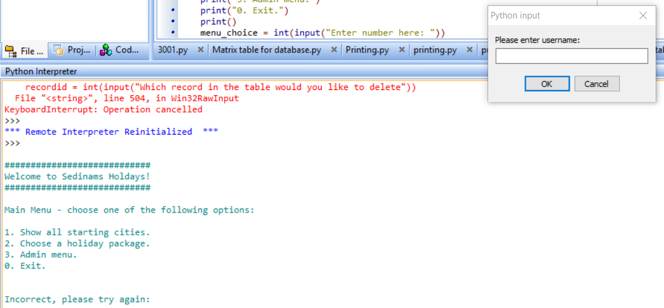

This is the second message:

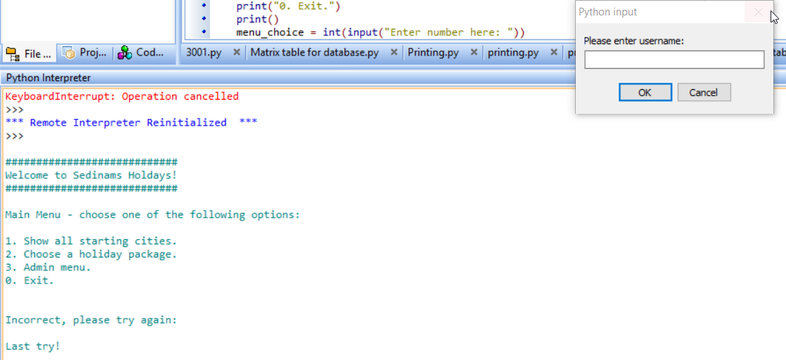

This is the final message then they are returned to the main menu:

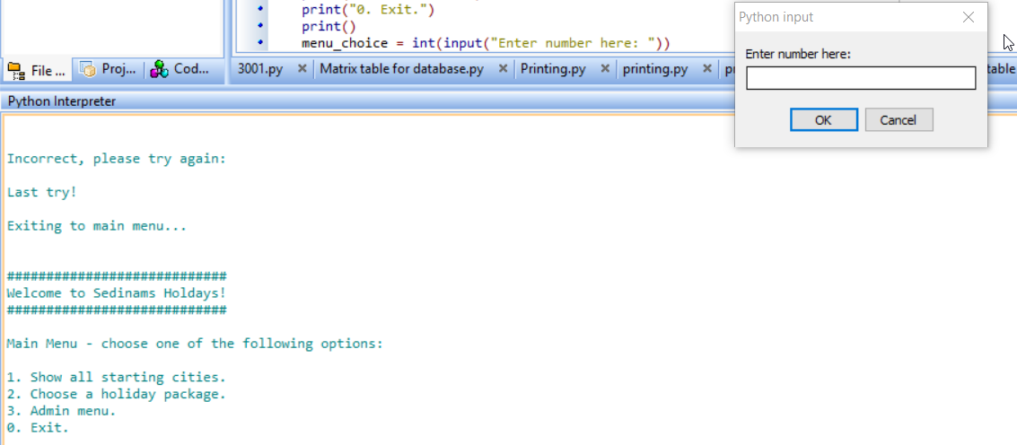

## Usability testing

For my main testing, I decided that it would be useful to get feedback from my stakeholders from earlier that may have future use for the program so that they can see whether the program would be able to meet their needs.

I was able to ask the same 20 people I interviewed in my analysis on their opinions of the program.

The questions I asked them are below:

* 1: How do you plan to use the program in the future (optional)
* 2: When using any of the functions, did you receive any error messages? (Y/N)

If you did, what was error message received?

* 3: Did the program always output what you expected to see? (Y/N)

Did the values received meet your expectations?

* 4: Were the distances output by the program always accurate? (Y/N)

If not, please give an example of what incorrect value was output

* 5: On a scale of 1-5, rate the usability of the program (1-5)
* 6: Did you have any difficulties navigating through the program? If Yes, state what problems were encountered.
* 7: Which part of the program would you say need improvement and why? (optional if you like them all)
* 8: How would you rate the program overall? (1-5)

The reason for asking these questions is reflecting on the overall program from my perspective only can cause some bias and may not be as responsive for others using the program and may end up encountering errors. The questions help me to know what needs to be fixed and the ways of fixing it in the future.

Results:

Only 2 people actually gave a response to the first question. The first person stated that this program would be useful for planning a holiday in Europe, especially not having to use a program like google to have to find each separate city and their distance from each other. The second person stated that the matrix function would be useful for being able to find certain distances from each other without using a search engine, which could be useful for things like research or homework.

There were no errors for the second question except from two people who stated that the program froze the first time he tried to use it and could not work. However, it started working well when the computer was re-started. I was unsure why this happened, but the respondent used two different computers so it is possible that the computer may have run out of memory or carrying out too many operations at the same time.

For the third question, every single user said the program outputted for them values that they were expecting to see. This therefore means that the functions were running properly and perfectly for the criteria selected.

For the fourth question, six (6) people stated that the values they received were correct, but they were unsure if the value was in miles or kilometres. This made them unsure if the values were correct or not. I feel this is an important piece of information to consider as it would be easier for the user to know if the values were correct if they knew the units.

Regarding the fifth question, 9 out of 20 people gave the program a 5/5 rating

3 people gave the program a 4/5 rating

5 people gave the program a 3/5 rating and 3 people gave the program a 2/5 rating, overall having a mean value of 3.9

This is a fairly good rating, as it is above the average rating of 3, which therefore means that the majority of the users found that the program was very usable for them and it worked well.

For the sixth question, only 5 people say yes and they all stated that they did not have an exit button during the execution which was annoying if they were to make a mistake during the process. I believe this is justified as a user may end up inputting incorrect values of what they want to do in the program and would have to force close the program to exit it, which can potentially cause problems.

Regarding the seventh question, all the users but one stated that the “Find a holiday” function should be made differently, for similar but still different reasons. Nine (9) of the people using the program stated that they would like the distances between each of the cities currently in the list to be outputted, 7 stated that real life information like prices for flights and airlines could be inputted as well. 1 person stated that the program would be better if an interface involving a map was included so that they could see how far the cities are from each other for themselves, and the last two stated that they wished that the function could completely create the holiday for them, create a route and output that to the user. The one person that did not comment on the holiday function said that they could not think of improvements.

For the eighth question one person gave the program a 5/5 rating, 15 out of 20 people gave the overall program a 4/5 rating and 4 people gave the program a 2/5 rating, having a mean score of 3.65, which is a fairly good rating being above the average score. However, due to the lack of a perfect score, this shows to me that I may need to talk with the people I gave the questionnaire to further questions on why they didn’t believe that the program was worth higher than the rating they gave, and how I could potentially improve this in the future.

## Evaluation of solution

### Success criteria

The success criteria from my analysis are:

* The program should be able to take the input of a city that the user is starting from and the package type that the user wants to select. This would output all cities that fall under the same package type, ranking it by their distance from the starting city. For example: If London is the starting city and Paris, Malaga and Brussels were in the same package. When London is inputted, the output would be: London is 199 miles from Brussels, London is 214 miles from Paris, London is 1044 miles from Malaga.
* To display each outputted city with its record so that the information about each city can be shown to the user along with its distance from the starting city. For example, when Brussels is outputted, it would include the package type that the user wants, hotels on offer and any other information that may be useful like the airport, country, and the national language.
* For a distance matrix to be included within the code, so that all the distances between each of the cities can be stored in a database, and for new cities to be able to be inputted so that distances can be found when using the program without having the user to research the distance on the internet every time a holiday is being planned.
* To give the person using my program an option to be able to decide how many cities they want to be able to visit. In my interviews, many people mentioned a specific number of cities they wanted to visit, so being able to give them that choice would appeal to them. This will not include the starting city as it is assumed that is where they will be starting from.
* The interface and results that lists the cities in order, is clear to the user of the program and that they are able to understand what is being shown to them through the program.
* For the user to find easy to change any aspects of the package database that may require changing. For example, if a new record needs to be added or a record needs to be changed, or a record needs to be deleted, those functions can easily be accessed and used without any problems occurring. The maintainability will involve updating and adding new packages and cities that may later be available for offer.
* To have a working program that does not include any errors by testing the potential input mistakes that people may make, and adding validation checks to prevent this from happening.
* To include menus that allow the options for the program to be shown to the user in a clearer way, and include an admin menu so that only authorised users can get access to functions that may change information that exists in the table.

For my 1st criterion, I stated that I should achieve the following:

* For the program to be able to take the input of a city that the user is starting from, and the package type that the user wants to select. This would output other cities that fall under the same package type, and their distance from the starting city in order of ascending size. For example: If London, Paris, Malaga and Brussels were in the same package and London was inputted, the output would be: London is 199 miles from Brussels, London is 214 miles from Paris, London is 1044 miles from Malaga.

I was able to achieve this, as shown with the testing above with tests 6,7,8,9 and 10 due to the fact that I was able to get the output that I was expecting from the program. This feature is the most essential of the program as it allows the user to decide from what is currently in the table of the package that they want to choose for their holiday.



For my 2nd criterion, I stated that I should achieve the following:

* To display each outputted city with its record so that the information about each city can be shown to the user along with its distance from the starting city. For example, when Brussels is outputted, it would include the package type that the user wants, the hotel on offer and any other information that may be useful like the airport, the country, and the national language.

I was able to partially achieve this by creating a function that outputs all the current records in the table to the user when they select the function that does this:

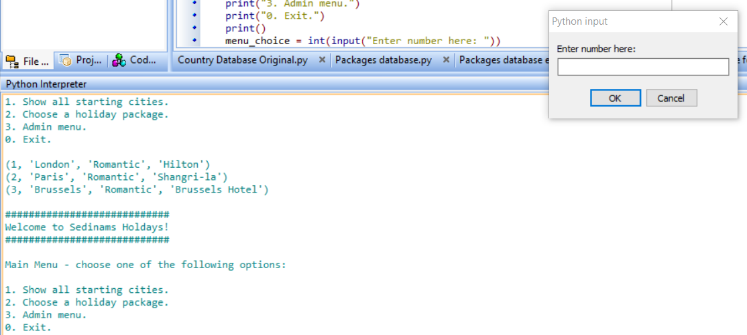

This function was also tested in my test 13 where I tested all the working menu functions.

I was unfortunately unable to have fields that would be able to store the other pieces of information that may be relevant to the city, and only the package type and the hotel according to the city. This therefore means I was not able to fully meet the criteria. The reason I was not able to implement this is because I only wanted to include the essential information that would benefit the user instead of having to have to find out every single piece of extra information, which would have increased the time to input new records each time.

For my 3rd criterion, I stated that I should achieve the following:

* For a distance matrix to be included within the code, so that the distance between each of the cities can be stored in the code, and for new cities to be able to be inputted so that distances can be found when using the program without having the user to research the distance on the internet every time a holiday is being planned.

I was able to achieve this partially by having each of the cities with their latitudes and longitudes on the code, then using the haversine formula to find the distance between them and storing them in a matrix. I intended for this to be in the database as well so that if a new city needed to be added, then I would not have to find the distance between the new city and all the other cities in the list and would only have to know the latitude and longitude information of the city I was adding. When the city count increases to a certain number, it would become very long to be able to try and find all the distances, so this formula helps as I only have to know the name of the city, and its latitude and longitude. I also showed tests of this working in my 6th test where I used the matrix to be able to get the distances into the function. The reason that I inputted 900 was because I just wanted to enter in an unrealistic value that was out of range for the program itself to show how it would be able to deal with the value. The main problem with this is that the program only outputs the distances from the starting city, something which the user could easily search online. A way that I could potentially deal with this in the future therefore is to be able to create a new function that could create a route for the user by repeating the algorithm and finding the shortest distance between all the cities in a limit that the user can set.

For my 4th criterion, I stated that I should achieve the following:

* To give the person using my program an option to be able to decide how many cities they want to be able to visit. In my interviews, many people mentioned a specific number of cities they wanted to visit, so being able to give them that choice would appeal to them. This will not include the starting city as it is assumed that is where they will be starting from.

I was able to partially implement this into my code as shown with the example above where there is an input in the code which asks the user to input how many cities that they want to be able to visit. This means that only the cities that are closest to the starting city will be outputted. This means therefore that the user may not be able to implement a favourite city that they may want to visit. To be given the option of a city that the user may want to visit, they would have to input a large number of cities in the list to be given that option, and if the list is large, it may take a long time to finally find the specific city that may be in the list. This is also shown in my 16th test which shows what happens if the user enters any value. I inputted values 900, which is out of range, 4 which is the maximum number of cities the user could visit from the list, 3 which is a random number in range, 0 which would return an output telling the user to re-enter a value and a negative value, which would not cause an error, but the user would not receive the appropriate output. The 17th test that I did above shows that the user would receive an output telling them to input an appropriate value if they were to input a string.



For my 5th criterion, I stated that I should achieve the following:

* The interface and results that lists the cities in order is clear to the user of the program and that they are able to understand what is being shown to them through the program.

Due to using Pyscripter, there is an interface given already and it is clear to them what is being inputted and outputted. However, I was not able to implement a full interface for the program, and l have to use the print function to show the functions that can be used in the menu. This criterion unfortunately was not met, mainly because the person who may want to use this program may not actually have access to pyscripter, and the program may not show inputs and outputs in the same way that this program does, which could mean that it is more difficult to understand some of the code in the program. Examples of pyscripter being used as an interface to show the menus include my 12th, 13th, 14th and 15th test, each showing the way that inputs can be used to access different parts of the program.

For my 6th criterion, I stated that I should achieve the following:

* For the user to have an easy time being able to change any aspects of the database that may require changing. For example, if a new record needs to be added or a record needs to be changed, those functions can easily be accessed and used without any problems occurring. The maintainability will be regarding updating and adding new packages and cities that may later be available for offer.

I was able achieve this by creating an admin menu where users that have admin access to the database can directly change information in the tables by adding new records, editing current records or deleting current records in the table, as shown above. The user can change any aspects of the table by adding a new record to the table, editing a current record that exists in the table or deleting one that currently exists. The tests for my admin menu are shown in my 15th test. The 15th test shows me being able to access each of these functions from the menu. My 1st, 3rd and 4th test show these functions working in action for the user.

For my 7th criterion, I stated that I should achieve the following:

* To have a working program that does not include any errors by testing the potential input mistakes that people may make and adding validation checks to prevent this from happening.

To do this, I tested potential erroneous values that the user can potentially enter, as shown above with my erroneous value tests. The program fortunately does not have any errors when any out of range values are inputted in, and therefore this criterion in the program has been met. This is also shown in all my tests as validation is used so that users cannot input specific values that are not in range. The erroneous tests I tested out were my 2nd test, 5th test, 7th test, 9th test, 12th test, 14th test, 16th test, 17th test and 18th test, each showing how the program reacts to unexpected inputs during the running of the program.

For my 8th criterion, I stated that I should achieve the following:

* To include menus that allow the options for the program to be shown to the user in a clearer way and include an admin menu so that only authorised users can get access to functions that may change information that exists in the table.

I was able to create the two menus that allowed the user to gain access to each of the programs main functions, which has been shown in my above testing where if the user inputs incorrect values in range, they would be given an error and told to input a correct value which means that the validation in this is fully working which means that this criterion was fully met for the program. The testing for my menus are shown in my testing from test 12 to test 15

### **Limitations**

One of the biggest limitations in my project as I stated before in my success criteria is that the latitudes and the longitudes of each of the cities in my program are stored in an array in the code. This meant that new cities would have to be directly added to the code, rather than the user being able to input the city and its information. This means that if the user adds a new city to the record and it doesn’t exist in that array, the distance would not be found. To overcome that, I would have to store the information in a database with its own table rather than in the code so that the user does not have to directly edit the code and can solely rely on the program itself to add more cities with their latitudes and longitudes.

The next limitation of my program is that it only outputs results in kilometres instead of miles. I also did not put in any print information that states what unit the distances are measured in. This means that the user may not know the proper unit that the program is using. To counteract this, I could add in an output that states what unit the distances are measured in or add a function that allows the user to decide which unit of distance would be better for them to use.

Another limitation, I believe my program has, is the fact that the user cannot exit out of a function whilst it is being used, so if they accidentally input an incorrect function to use, they will have to go through with the function until it is complete. A way I believe I could counteract this would be to include an exit value where if the person using the program inputs this value, they can be returned to the main menu so that they are not forced to change any values that they do not want to change.

A further problem with my program as mentioned before is the fact that not all of the relevant information for the records was able to be stored. I believe that a way I could fix this would be to create further tables to place in my database, one that has the records of each of the cities, along with their latitude and longitude, as well as city information like national languages and currency. I could link the package table to it by including a primary key, for example CityID which would be for each city as there may be multiple packages with the same city in them and using that as a foreign key in the package table.

Another limitation of my program is that when they input which city they want to visit, the distances are only found between the starting city and all the other cities that remain in the list, and the distances between those cities are not stated in the program. This may be a problem, as two cities could end up being near one city, but actually rather far from each other. To fix this, I could also write code that outputs all the cities that remain in the list and the distance between those cities in order so the user knows how far they all are from each other.

The final limitation I believe my program has, is the fact that I was not able to provide a proper interface for my program. The program I am using, pyscripter does make it easy for the user by providing pop ups which tell the user what to input, and outputs that show the user results of their inputs. However, if they used the normal python, it would be much more difficult to know how to correctly input values. A way I could counteract this would be by creating a function which provides the user with a proper interface with inputs that they can put into the menu, functions of the program, and outputs they may receive.

### Maintenance

I was able to annotate the main functions of my code, so that someone who wants to edit aspects of the code will find it easy to be able to understand the main functions of the code and change it properly.

If the user looking at the code wants to be able to add more cities for example, they would have to add the city and its latitude and longitude to the array to be able to add further cities. The information they would need to research themselves is the latitude and the longitude of the city.

Another issue is due to using an older version of python, the code may have to be adapted in the future so that it can be more suited for people who may not have the older versions of python.

### Further development

In the future to develop my program further, I could start including information that may help the user get a plan for their trip by creating functions that allow the user to decide the city they want to start from, and each of the cities that they want to be able to visit so that the output they receive can be the dates of when they could travel, the order in which they would be able to travel in, and any places of interest that the user could end up visiting. Airlines that are also recommended to the users could also be included, whether the user wants to find the cheapest price possible, or they want to take their favourite airline to the area that they want to go to, also having predicted prices in the program. The reason why I did not include flight prices originally was due to the wide range of prices that a user can be given as a result, and the fact that they are changing constantly, so a specific predicted price depending on the airline and the time from the departure date would be useful to the user.

Another thing that I can look to do in the future with my program is to implement a new algorithm that instead finds the shortest distance between several cities for the user to visit. For example, in a list containing 7 cities, one city would be chosen as the starting city, and the other 6 would be compared to find the shortest distance between each of them. The city with the shortest distance away from the starting city would be taken, the initial starting city removed from the list and the algorithm repeated until the route found consists of a number of cities that the user wanted to visit.